



SOFTWARE DEVELOPMENT PROJECT (AAPP006-4-2)

Prepared by:

FOONG WAI KEAT (TP 060033) (Leader)  
VANNESS GOH CHING YI (TP 061175)

LEE JIAN WEN (TP 061430)

LIM JIA XUAN (TP 059385)

Intake:

UCDF 2005 ICT (SE)

Lecturer:

MISS SALASIAH BINTI SULAIMAN

Due By: 10th April 2022

Table of Contents

1.0 Acknowledgement 4

2.0 Abstract 5

3.0 Workload Matrix 6

4.0 Introduction 8

4.1 Project Background 8

4.2 Problem Context 8

4.3 Proposed Solution 9

4.4 Project Objectives 10

4.5 Project Scope 10

5.0 Project Plan 11

5.1 System Development Methodology 11

5.2 Gantt Chart 14

6.0 System Hierarchy Chart 15

7.0 Context Diagram 21

8.0 Data Flow Diagram Level 0 22

9.0 Data Flow Diagram Level 1 23

9.1 Manage Account Process – Foong Wai Keat 23

9.2 Payment Process – Lee Jian Wen 25

9.3 Register Process - Vanness Goh Ching Yi 26

9.4 Login Process – Lim Jia Xuan 28

10.0 Data Dictionary 29

11.0 Entity Relation Diagram 50

12.0 Pseudocode and Flowchart 51

Flowchart - Foong Wai Keat 51

Flowchart – Lee Jian Wen 80

Flowchart – Lim Jia Xuan 83

Flowchart - Vanness Goh Ching Yi 92

13.0 Screen Design and User Manual 93

13.1 Admin 93

13.2 Guest 109

13.4 Member 116

14.0 Report Design and User Manual 131

15.0 Test Plan 134

15.1 Unit Testing 134

15.2 User Acceptance Test 164

16.0 Source Code 179

17.0 Conclusion 240

18.0 Reference 241

19.0 Appendix 242

19.1 Installation Guide 242

19.2 Meeting Minutes 259

19.3 Issues 261

# 1.0 Acknowledgement

I would like to express my deepest thanks and gratitude to all who have helped me to complete and implement these ideas in this project

Next, I extremely grateful to my lecturer who had provided me with the opportunity to progress on the assignment topic to creating an e-commerce platform which also helped me in providing massive assignment details and enable me came across many new things and knowledge.

This project would not have been possible without aid from my family member who had helped me a lot in providing ideas for code development, code structure, and guide me to complete this assignment.

# 2.0 Abstract

GFG, Game For Gamers is a small company which sells associated categories of video games for various customers. However, the sales of GFG was greatly affected due to various issues, mainly global issues and staffs issues. Thus, GFG has decided to develop an online platform to aid the sales of video games and enhance additional features which would improve user experience while using the online platform. Waterfall system development methodology would be chosen for the development of the software. It is expected to encounter various limitations during the development of the software. The development is expected to complete within the time frame without issues.

# 3.0 Workload Matrix

|  |  |  |  |  |
| --- | --- | --- | --- | --- |
| **Tasks** | **Foong Wai Keat TP 060033** | **Lee Jian Wen TP 060729** | **Lim Jia Xuan**  **TP 059385** | **Vanness Goh Ching Yi**  **TP 061175** |
| **Introduction** | 50% | 20% | 20% | 10% |
| **Abstract and Acknowledgement** | 70% | 10% | 10% | 10% |
| **Gantt Chart** | 45% | 20% | 17.5% | 17.5% |
| **Methodology** | 45% | 20% | 17.5% | 17.5% |
| **Context Diagram** | 70% | 10% | 10% | 10% |
| **Level 0 DFD** | 70% | 10% | 10% | 10% |
| **Entity Relationship Diagram** | 70% | 10% | 10% | 10% |
| **System Hierarchy Chart** | 40% | 20% | 20% | 20% |
| **Data Dictionary** | 40% | 20% | 20% | 20% |
| **Screen design and User Manual** | 60% | 20% | 20% | 0% |
| **Report Design and User Manual** | 52.5% | 15% | 17.5% | 15% |
| **Unit Testing** | 55% | 15% | 25% | 5% |
| **User Acceptance Test** | 50% | 15% | 15% | 20% |
| **Significant Codes** | 40% | 15% | 20% | 20% |
| **Perceived Limitation** | 50% | 15% | 17.5% | 17.5% |
| **Code Snippets** | 65% | 15% | 25% | 0% |
| **Perceived Assumption** | 50% | 17.5% | 17.5% | 15% |
| **Group Effort** | 40% | 20% | 20% | 20% |
| **Compilation and other tasks** | 100% |  |  |  |
| **Signature** | Foong | Jian Wen |  | Vanness |

# 4.0 Introduction

## 4.1 Project Background

Game for Gamers, in short GFG, is a small company which sell various kinds of video games in its physical premise. Example of categories of games available on website include racing, shooting, adventure, role-playing, stimulation and so on. In addition, most games available by GFG company are capable to play on different video game consoles such as computer, Playstation 4 (PS4), Playstation 5 (PS5), XBOX and so on. The video games available by GFG company would be displayed on the catalogue of video games provided by GFG company.

The customers of GFG varies greatly within the range of 16 to 65 years old regardless of gender and race. Moreover, customers of GFG mainly consists of people who are interested with latest games and certain classic unique video games. Customers who intend to purchase video games could have a look on the catalogue provided by GFG company and seek for their desired game.

Due to the frequent update of video game catalogue, the company is well known for capable to allow latest video games being available in store. Moreover, GFG company is famous for providing objective review and reasonable price for its games.

## 4.2 Problem Context

Due to recent global issues, GFG company has decide to establish its own official website. A few months ago, the Malaysia government has declared to launch nationwide lockdown to stop the COVID-19 pandemic outbreak from spreading in the country. Due to the lockdown, majority premises and business which includes physical video game stores except business which provides essential services are prohibited from operating. This results GFG company to experience a great drop of sales as the physical video games could not be sold out. However, when the lockdown ends and the government launches the national recovery plan, the sales tend difficult to return to the original sales as customers were used to enjoy online video games and mobile games during the lockdown.

In addition, the physical premise of GFG company is facing with several difficulties with its operation during the national recovery phase. Due to popularity of GFG physical premise, staffs in the premise are facing issues to control the number of customers in the premise during peak hours. Furthermore, the premise also is running out staffs since majority staffs are on leave and claimed that they would work after the last phase of the national recovery plan.

To add on, customers of GFG company are tired from searching through massive list of games on catalogue with different genre and available on different game consoles. Besides that, customer also demand to view reviews made by other gamers regarding the game to avoid from purchasing terrible games with low ratings and poor comments.

## 4.3 Proposed Solution

Hence, the company has decided to reduce the dependency against the physical premise of the company through developing an online platform to provide physical video games for customers and resolve issues of lack of staffs and demand to view video game reviews along with issue of searching for games.

The solution for the issues of searching games would be applying a filter system to filter the genres of video games based on the preference and desire of customer. Moreover, a search bar feature would be added which allows customers to search for the title of games which match with the input and acknowledge detailed information of game which match with the input. As for issue of customer reviews, a feedback system would be developed which allows only members to leave comments regarding the game which could be viewed by customers.

## 4.4 Project Objectives

The main objective that GFG electronic commerce system is to establish a user friendly for all types of users while using it. This include allowing customers understand its features and could register easily as a member to purchase their desired games. Besides that, the project is aimed to allow all users to search games easily through filtering the genre and searching the title of video games which they are interested with. Furthermore, the system must enable all customers to view the reviews made by members regarding the game which allows them to have a clearer understanding regarding the content, gameplay, and art of the game.

## 4.5 Project Scope

There are several project scopes to be achieved during the development of this project. For instance, users must be capable to view, filter through genres and video game console of available games by GFG company. The feedback system must allow only members to comment while allowing guests and members to view it. Meanwhile, the search bar needs to accept user input and provide the exact games with title which match with the input.

In addition, guests must be capable to register as member after providing all necessary personal details and purchase video game as a member. When the project is upon completion, the project would need to undergo maintenance to ensure the system is capable to provide consistent stable and bug free performance. Lastly, the system would need to be capable to access across different electronic devices through web browser.

# 5.0 Project Plan

## 5.1 System Development Methodology

This project was completed with implementation of Waterfall Methodology. It is a step-by-step process where each stage is completed will move to the next stage before the next stage is carry out (Waterfall Methodology - A Complete Guide | Adobe Workfront, 2022). It consists of five stages which are Requirement analysis, System Design, Implementation, Testing, Deployment and Maintenance. The advantages of using this method are it is suitable and easy to use for small projects. Moreover, it can ensure the task in this project remains as fixed as possible all through the development process due to the requirement having been stated and remain unmodified (Sharma Lakshay, 2021). Besides, it can help to predict the publication date of the finished product and cost as the phases in this project is set in the Gannt Chart which it can helps to measure the progress.

In the first stage, many types of requirements will be gathered for the second stage of Waterfall Methodology to design what the system shall look like and how the system should function. For instance, user requirements are one of the requirements needs to fulfil on what kind of services should provide which written by the customer. Moreover, system requirements will be collected to describe the system’s functions which consist of two types, functional and non-functional requirement. Functional requirements of the system will be gathered to identify how the system should do in a certain situation or certain inputs by the user. For example, the user of our system should be able to search for specific types of games in our system. Besides, non-functional requirements will be accumulated to identify the performance of the system for instance, the user should be able to log in their account into our system in less than 2 second. The ways that we collect all the requirements are through brainstorming among our group members as well as we research the articles of an existing system (Requirement Gathering Techniques, 2020). All the requirements will then be recorded in Software Requirement Document (SRD).

After all the first staged completed, System Design stage will be conduct which includes the process of planning to choose what hardware and software to use for example database management system (DBMS), programming languages, network framework and user interface (Zulqadar Amna, 2019). During this process, some steps will be done such as how the system will receive the input from user, design features for the users to utilize the system, design how the input and output physical layout, decide how the data can be create, read, updated, and delete. Then, logical modelling will be conduct such as context diagram and data flow diagram to ensure the developer know how the data travel through processes in the system. At the end of this stage, a prototype will be created to find out any usability issues and thus it can save time and cost for the project (Stevens Emily, 2021).

The next stage is implementation where the developer team will start to write code after System Design stage has been completed. This stage is the longest phase in Waterfall Methodology because it needs to write many codes to build functions for the system depending on the SRD. It can become longer if there are some changes made on the requirements. Before implementation stage start, our member would need to draw flowcharts and create Entity Relationship Diagram (ERD) for the system. Then, the developers will start to use the selected programming language in the second stage of Waterfall Methodology and write the code based on the SRD. During the coding process, the developer would need to follow some rules such as the code written able to develop a safe, secure, dependable, testable, repairable, and portable system (Perforce, 2021). Furthermore, the developer would need to consider using some programming tools like RAD studio, Linux, Collaborator, Studio 3T and Kite (Martin Matthew, 2022).

After the coding process has completed, the code will be then tested to confirm whether the system is functioning well as stated in the SRD. The benefits of testing stage in Waterfall Methodology are it can find out the mistakes in the system created and debug it (Martin Matthew, 2022). The system will be tested in two types of tests which there are unit test and user acceptance testing. Unit test is focus on testing out each code function of the system. Test plan will be documented for Unit test which record test procedure, test data, expected result and actual result. On the other hand, User acceptance testing is a type of test which the end user or client will involve in testing the system before it proceeds to deploy the system. This user acceptance testing is given to end user by filling up a form which rate 1 to 5 from very poor to very good.

Once the system test has done, then the system is then deployed to the real environment where the end user can use the system (Rana Kuldeep, 2020). Before the system is deployed, the system will be tested to install and conduct another test to make sure successful installation. An instruction manual will be created by project team for the end user to know how to use the system and repair the issue faced (Deployment Phase in SDLC - Video & Lesson Transcript | Study.Com, n.d.). Then the system will be delivered to the end user once the system has deployed. After deployment stage, the system will need to be update occasionally for new features that provide more stable of the system. During the maintenance stage, monitoring the system will be conducted to find any errors or bugs in the system and provide updates to the system. There are four types of system maintenance in System Maintenance stage. Firstly, corrective maintenance is usually initiated by the end user in daily usage. Subsequently, the developer will fix the error reported by the end user.

Next, preventive maintenance is where the developer will investigate the part of the system likely to have problems. This type of maintenance can increase the user satisfaction and decrease downtime of the system as the problem has been avoided. Besides, adaptive maintenance is an authorization of changes in the observing, use or other functional details of a metallic structure or object to prevent corrosion from spreading from one piece of the metal where it is now present to another (What Is an Adaptive Maintenance? - Definition from Corrosionpedia, n.d.). Last but not least, perfective maintenance is to transform the system to become more systematic, reliable and maintainable. The importance of this stages is to ensure the end users have a better experience when using the system.

## 

## 5.2 Gantt Chart

Figure 1: Gantt Chart

# 6.0 System Hierarchy Chart

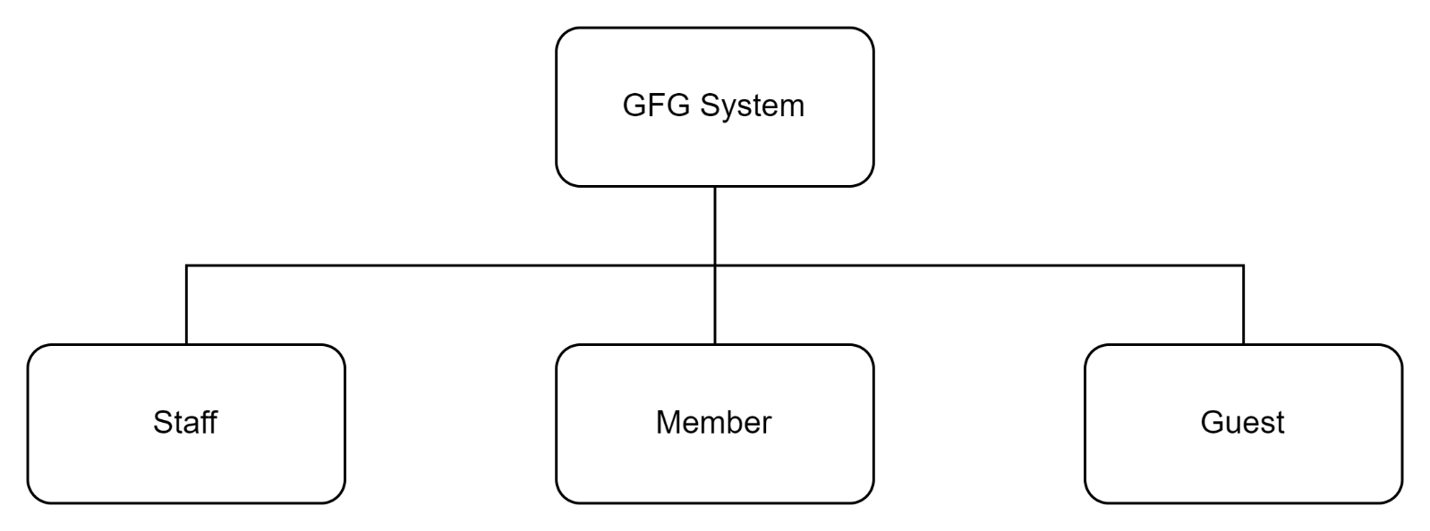

Figure 2: Type of users in system hierarchy chart

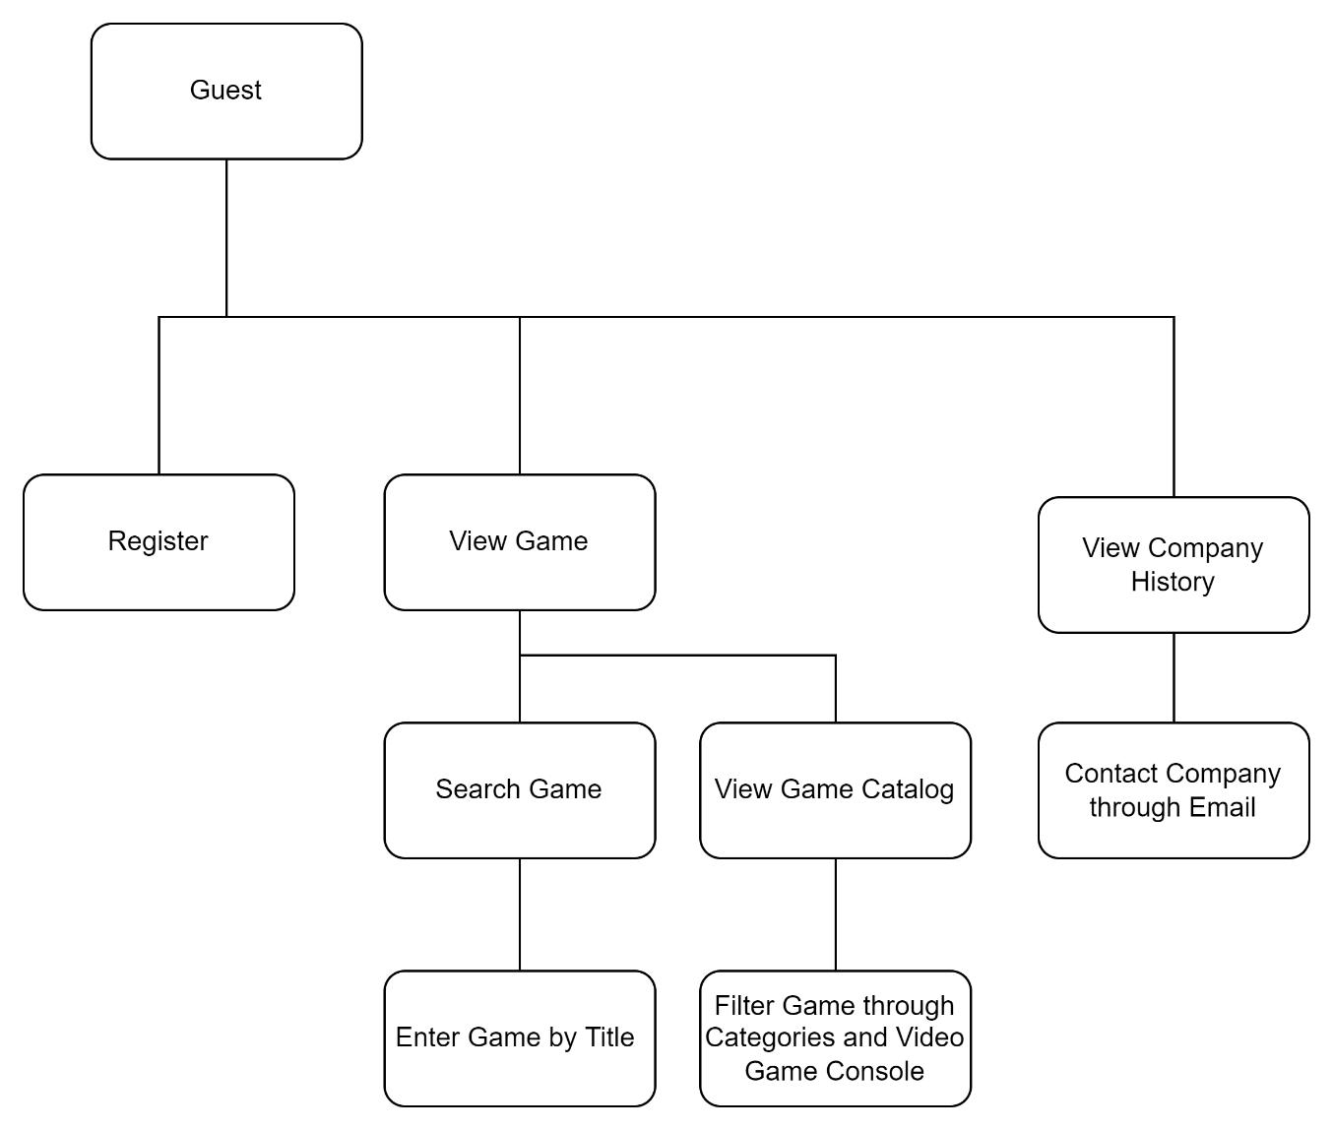

Figure 3: Authorities of Guest

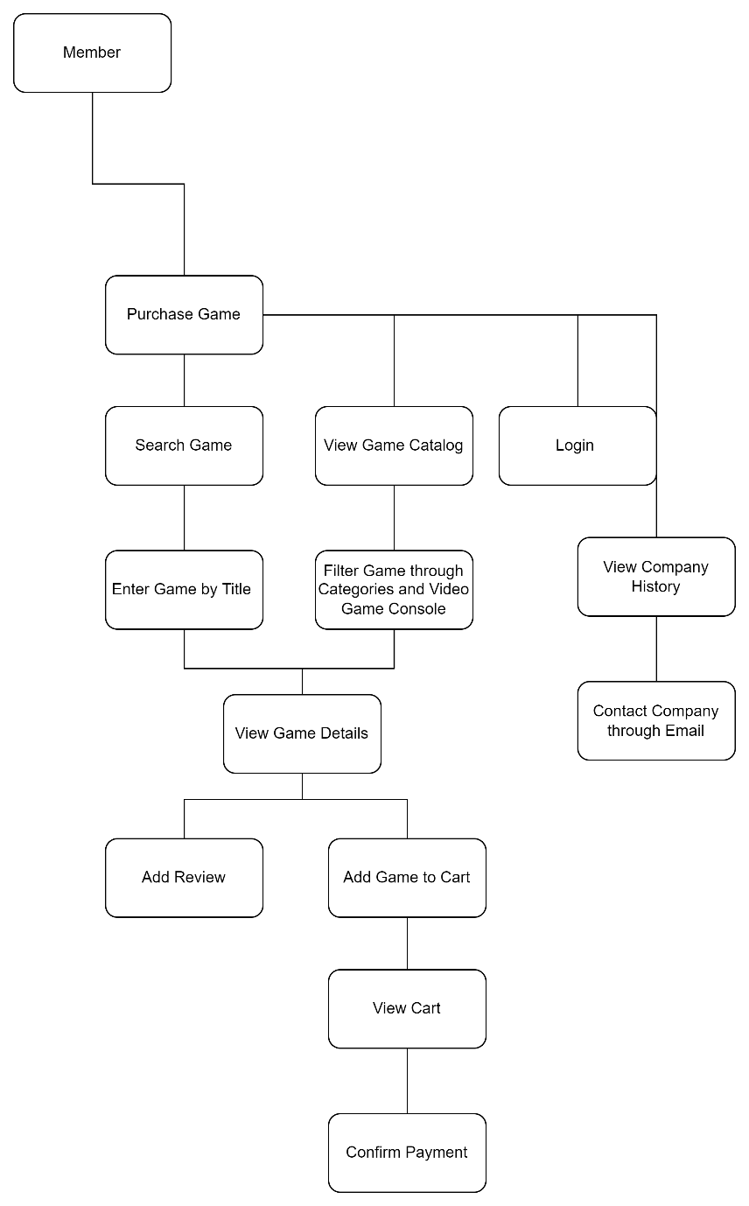

Figure 4: Authorities of Member

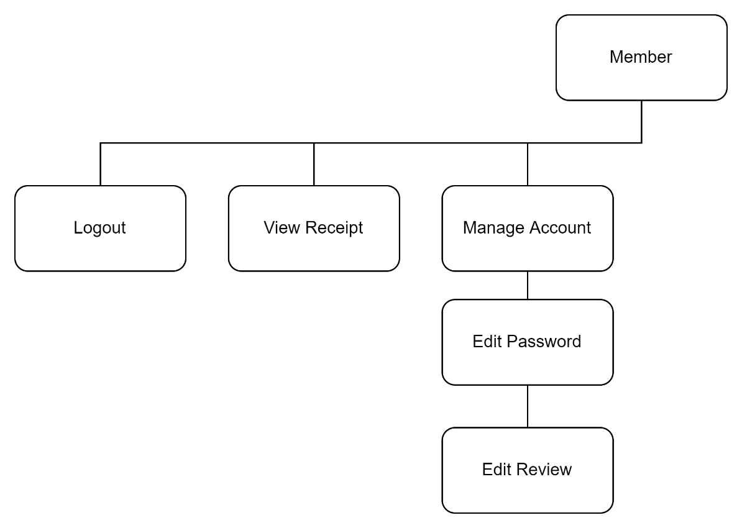

Figure 5: Authorities of Member

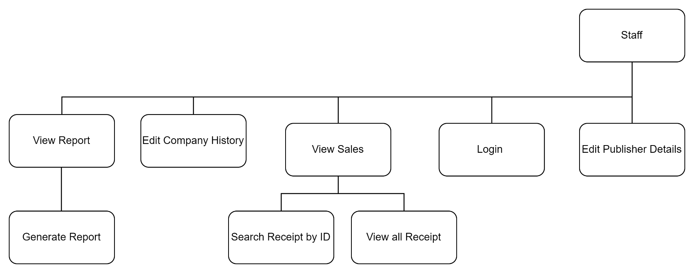

Figure 6: Authorities of Admin

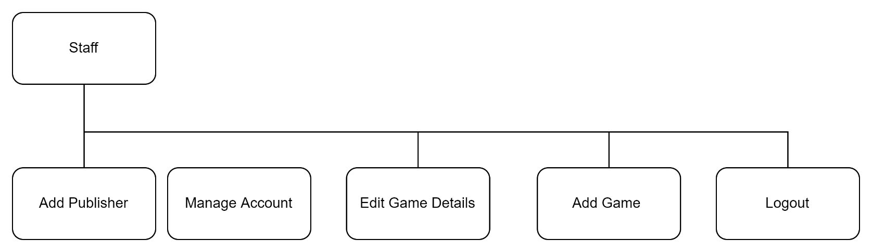

Figure 7: Authorities of Admin

# 7.0 Context Diagram

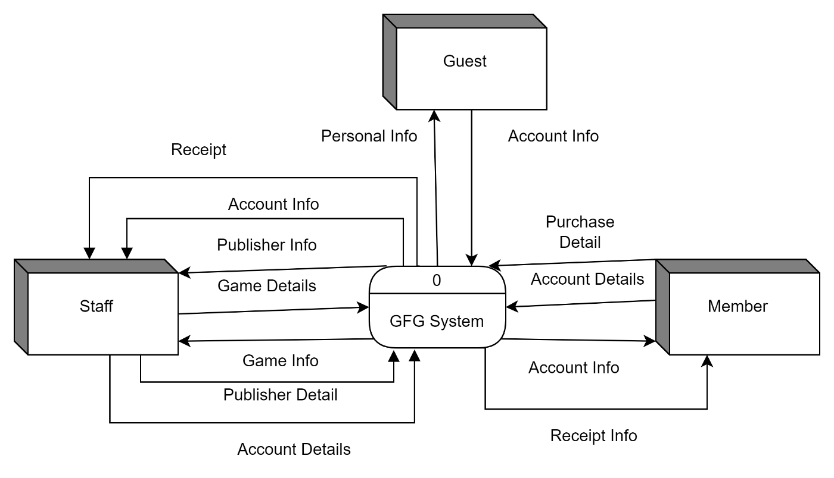

Figure 8: Context Diagram

# 8.0 Data Flow Diagram Level 0

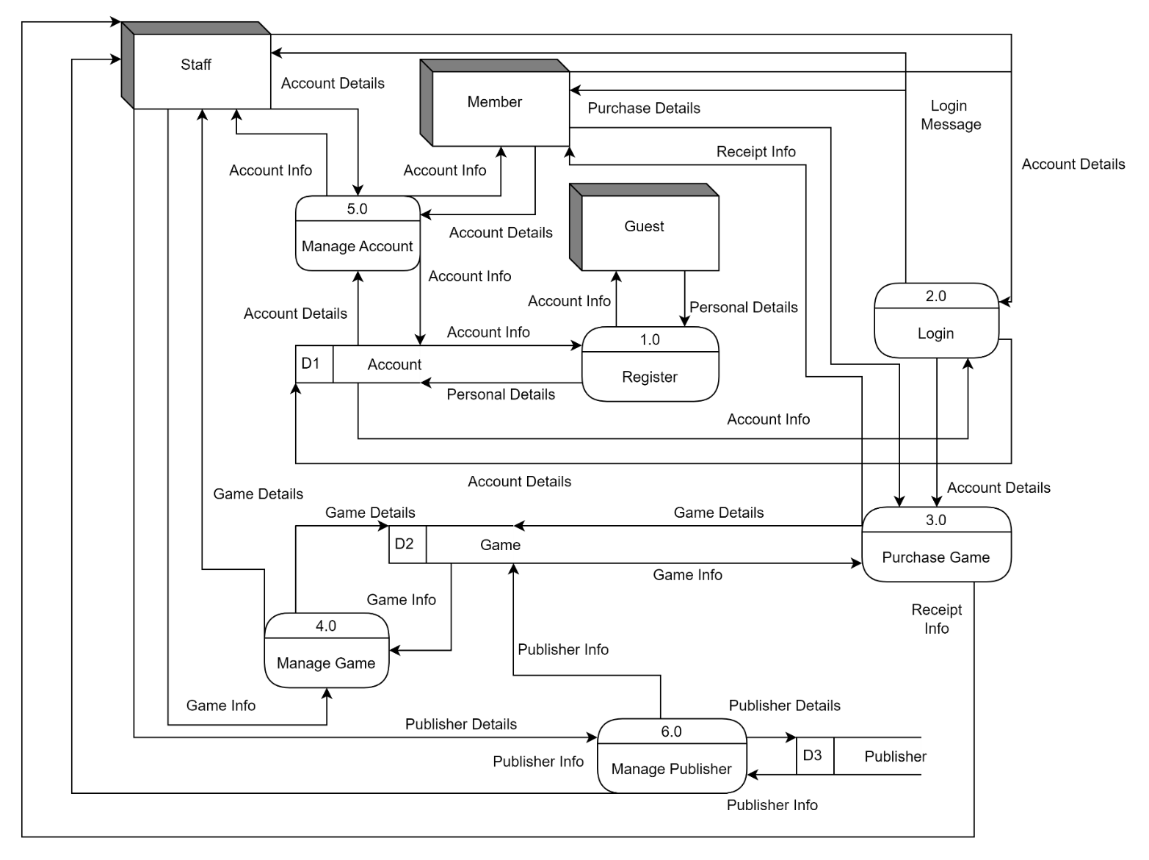

Figure 9: DFD Level 0

# 9.0 Data Flow Diagram Level 1

## 9.1 Manage Account Process – Foong Wai Keat

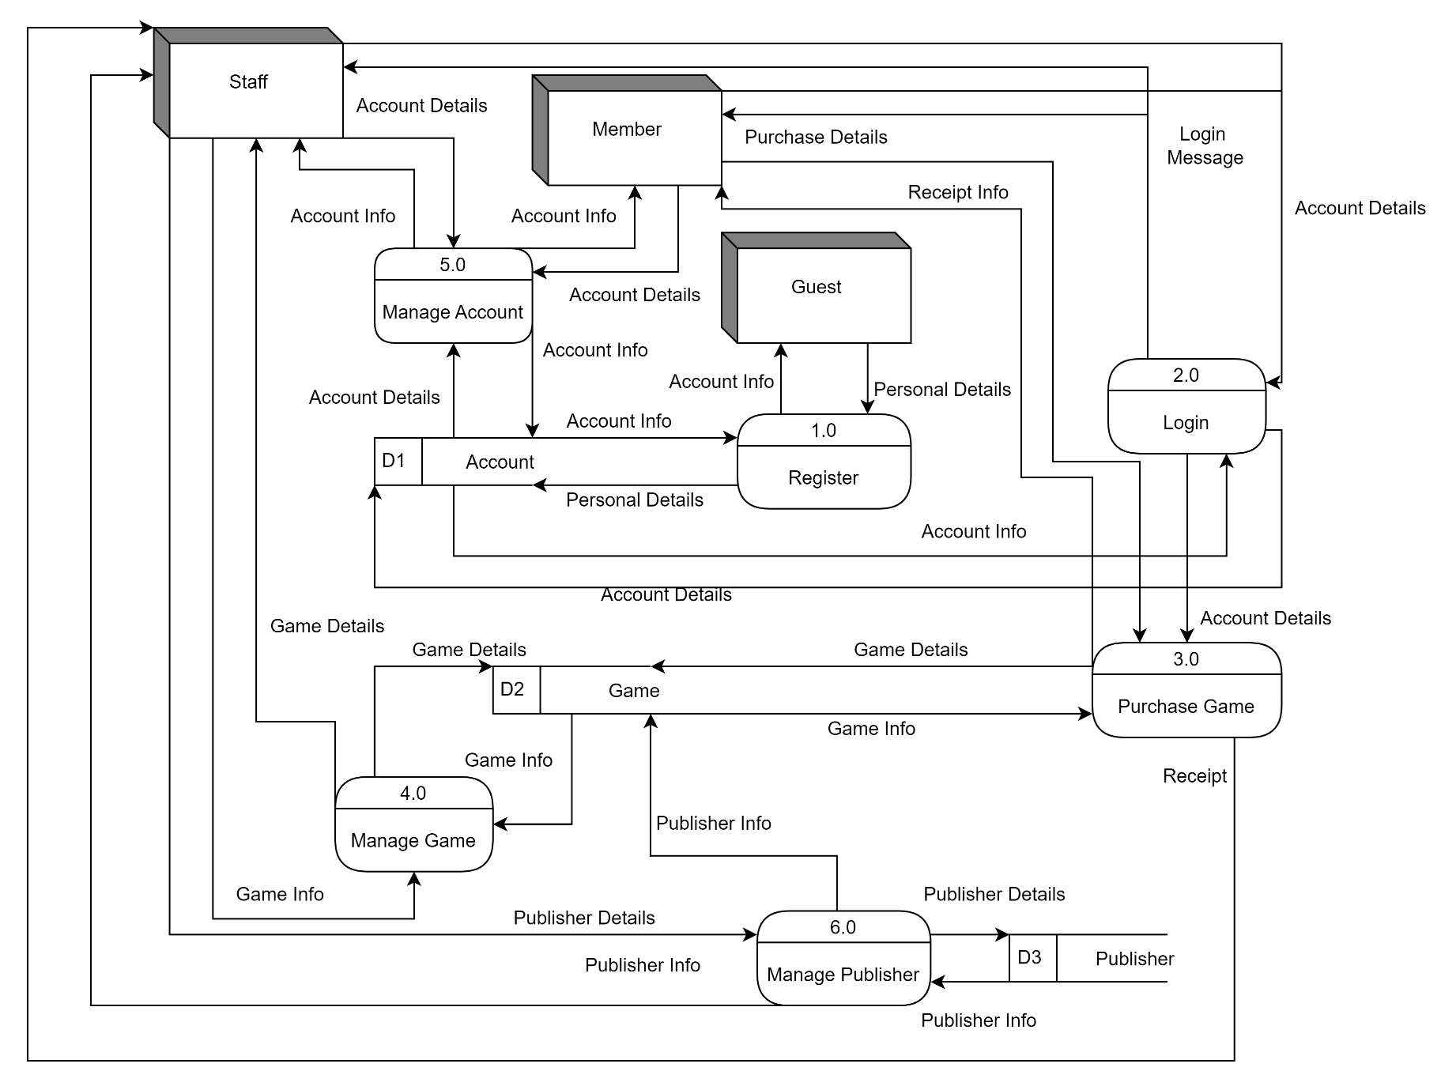

Figure 10: DFD Level 1

## 9.2 Payment Process – Lee Jian Wen

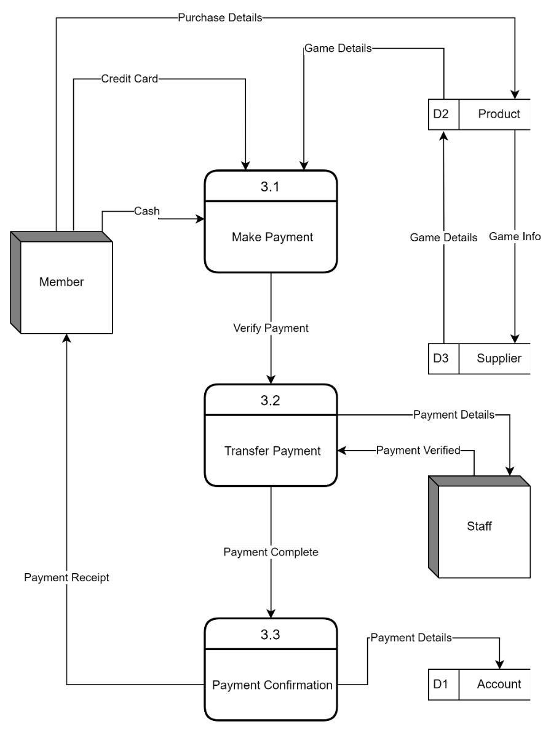

Figure 11: DFD Level 1

## 9.3 Register Process - Vanness Goh Ching Yi

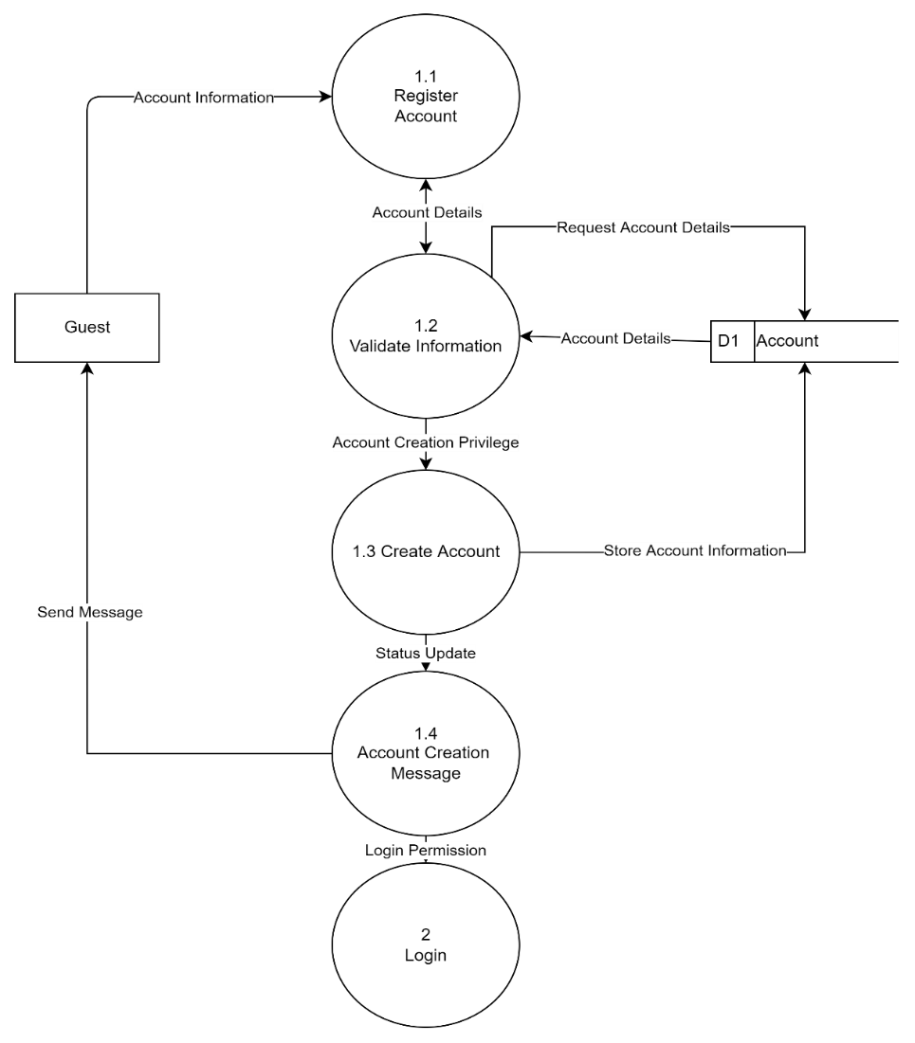

Figure 12: DFD Level 1

## 9.4 Login Process – Lim Jia Xuan

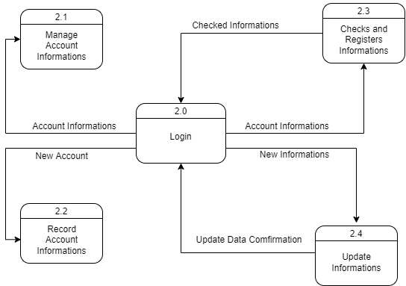

Figure 13: DFD Level 1

# 10.0 Data Dictionary

Process

|  |  |
| --- | --- |
| Name: | 1.0 Register |
| Description: | Received personal details would be recorded in Account data store and create an account based on the personal details |
| Input Data Flow: | Personal Details |
| Output Data Flow: | Account Info |

External Entity

|  |  |
| --- | --- |
| Name: | Guest |
| Description: | Guest would provide personal details to create an account and capable to login by entering their personal details |
| Input Data Flow: | Account Info |
| Output Data Flow: | Personal Details |

Data store

|  |  |
| --- | --- |
| Name: | Account |
| Description: | Store personal details and create and login of account with personal detail |
| Input Data Flow: | Personal Details |
| Output Data Flow: | Account Info |
| Data Structure | Account Info=  Account_ID + Name + Member_Telephone + Member_Email + Password + Member_Address + Bank_Card_No + User_Type |

Data Flow

|  |  |
| --- | --- |
| Name: | Personal Details |
| Description: | Data entered by guest used to create an account to login the system |
| Origin/Data Source: | Guest External Entity |
| Destination/Sink: | Register Process |
| Data Structure | Personal Details =  Account_ID + Name + Member_Telephone + Member_Email + Password + Member_Address + Bank_Card_No + User_Type |

|  |  |
| --- | --- |
| Name: | Personal Details |
| Description: | Data received to create an account |
| Origin/Data Source: | Register Process |
| Destination/Sink: | Account Data Store |
| Data Structure | Personal Details =  Account_ID + Name + Member_Telephone + Member_Email + Password + Member_Address + Bank_Card_No + User_Type |

|  |  |
| --- | --- |
| Name: | Account Info |
| Description: | Data of account used to login the account and access the system |
| Origin/Data Source: | Register Process |
| Destination/Sink: | Guest External Entity |
| Data Structure | Account Info =  Account_ID + Name + Member_Telephone + Member_Email + Password + Member_Address + Bank_Card_No + User_Type |

|  |  |
| --- | --- |
| Name: | Account Info |
| Description: | Data used to login an account |
| Origin/Data Source: | Account Data Store |
| Destination/Sink: | Register Process |
| Data Structure | Account Info =  Account_ID + Name + Member_Telephone + Member_Email + Password + Member_Address + Bank_Card_No + User_Type |

Process

|  |  |
| --- | --- |
| Name: | 2.0 Login |
| Description: | Received account details would be compared to data in Account data store and grant user to access to the system when correct account details are entered |
| Input Data Flow: | Account Details, Account Info |
| Output Data Flow: | Account Details, Login Message |

External Entity

|  |  |
| --- | --- |
| Name: | Member |
| Description: | Member would provide account details to login their account and capable access the system with the account |
| Input Data Flow: | Login Message |
| Output Data Flow: | Account Details |

|  |  |
| --- | --- |
| Name: | Staff |
| Description: | Staff would provide account details to login their account and capable access the system with the account |
| Input Data Flow: | Login Message |
| Output Data Flow: | Account Details |

Data store

|  |  |
| --- | --- |
| Name: | Account |
| Description: | Store account details and compare of input account details with existing account details |
| Input Data Flow: | Account Details |
| Output Data Flow: | Account Info |
| Data Structure | Account Details =  Member_Email + Password + User_Type |

Data Flow

|  |  |
| --- | --- |
| Name: | Account Info |
| Description: | Data which will be shown if an account which match with the entered account details exist |
| Origin/Data Source: | Account Data Store |
| Destination/Sink: | Login Process |
| Data Structure | Account Details =  Account_ID + Name + Member_Telephone + Member_Email + Password + Member_Address + Bank_Card_No |

|  |  |
| --- | --- |
| Name: | Account Details |
| Description: | Data used to compare with existing account data in the account table of database |
| Origin/Data Source: | Login Process |
| Destination/Sink: | Account Data Store |
| Data Structure | Account Details =  Member_Email + Password + User_Type |

|  |  |
| --- | --- |
| Name: | Account Details |
| Description: | Data of account used to login an account and access the system |
| Origin/Data Source: | Member External Entity |
| Destination/Sink: | Login Process |
| Data Structure | Account Details =  Member_Email + Password + User_Type |

|  |  |
| --- | --- |
| Name: | Account Details |
| Description: | Data of account used to login an account and access the system |
| Origin/Data Source: | Staff External Entity |
| Destination/Sink: | Login Process |
| Data Structure | Account Details =  Member_Email + Password + User_Type |

|  |  |
| --- | --- |
| Name: | Login Message |
| Description: | Used to inform member that they have successfully login into their account |
| Origin/Data Source: | Login Process |
| Destination/Sink: | Member External Entity |
| Data Structure | Login Message =  “Login Successfully” |

|  |  |
| --- | --- |
| Name: | Login Message |
| Description: | Used to inform staff that they have successfully login into their account |
| Origin/Data Source: | Login Process |
| Destination/Sink: | Staff External Entity |
| Data Structure | Login Message =  “Login Successfully” |

Process

|  |  |
| --- | --- |
| Name: | 3.0 Purchase Game |
| Description: | Received account details and game details would be added into a cart. When the purchase of game cart is confirmed, the details of games in the cart would be recorded in database while the detail of games in game data store would be updated. |
| Input Data Flow: | Purchase Details, Account Details, Game Info |
| Output Data Flow: | Receipt Details, Game Details |

External Entity

|  |  |
| --- | --- |
| Name: | Member |
| Description: | Member would provide purchase details to add games into cart |
| Input Data Flow: | Receipt Details |
| Output Data Flow: | Purchase Details |

Data store

|  |  |
| --- | --- |
| Name: | Game |
| Description: | Store details of games |
| Input Data Flow: | Game Details |
| Output Data Flow: | Game Info |
| Data Structure | Game Info =  Game_ID + Title + Video_Game_Console + Publisher_ID + Quamtity + Description + Game_Pic |

Data Flow

|  |  |
| --- | --- |
| Name: | Account Details |
| Description: | Data of account which purchase the game |
| Origin/Data Source: | Login Process |
| Destination/Sink: | Purchase Game Process |
| Data Structure | Account Details =  Account_ID |

|  |  |
| --- | --- |
| Name: | Purchase Details |
| Description: | Data of game purchased |
| Origin/Data Source: | Member External Entity |
| Destination/Sink: | Purchase Game Process |
| Data Structure | Purchase Details =  Game_ID + Total_Price + Title + Game_Pic + Quantity |

|  |  |
| --- | --- |
| Name: | Receipt Info |
| Description: | Data of the list of purchased video game |
| Origin/Data Source: | Purchase Game Process |
| Destination/Sink: | Member External Entity |
| Data Structure | Receipt Info =  Cart_ID + Game_ID + Total_Price + Title + Game_Pic + Quantity |

|  |  |
| --- | --- |
| Name: | Game Details |
| Description: | Data of game which has been added and purchased which will change the details of games in game table of database |
| Origin/Data Source: | Purchase Game Process |
| Destination/Sink: | Game Data Store |
| Data Structure | Game Details =  Game_ID + Total_Price + Title + Game_Pic + Quantity |

|  |  |
| --- | --- |
| Name: | Game Info |
| Description: | Detail information of the purchase after the purchase is complete |
| Origin/Data Source: | Game External Entity |
| Destination/Sink: | Purchase Game Process |
| Data Structure | Game Info =  Cart_ID + Account_ID + Game_ID + Total_Price + Title + Game_Pic + Quantity + Date_of_Purchase |

|  |  |
| --- | --- |
| Name: | Receipt Info |
| Description: | Detail information of the purchase which is shown to staff |
| Origin/Data Source: | Purchase Game Process |
| Destination/Sink: | Staff External Entity |
| Data Structure | Receipt Info =  Cart_ID + Account_ID + Game_ID + Total_Price + Title + Game_Pic + Quantity + Date_of_Purchase |

Data Flow

|  |  |
| --- | --- |
| Name: | Account Details |
| Description: | Data used to differentiate carts and purchase made by customers |
| Origin/Data Source: | Member External Entity |
| Destination/Sink: | Purchase Game Process |
| Data Structure | Account Details =  Account_ID |

|  |  |
| --- | --- |
| Name: | Purchase Details |
| Description: | Data used to add type and quantity of games into cart |
| Origin/Data Source: | Member External Entity |
| Destination/Sink: | Purchase Game Process |
| Data Structure | Purchase Details =  Total_Price + Title + Game_ID + Game_Pic + Quantity |

|  |  |
| --- | --- |
| Name: | Game Info |
| Description: | Used to Display the details of games in cart |
| Origin/Data Source: | Game Data Store |
| Destination/Sink: | Purchase Game Process |
| Data Structure | Game Info =  Title + Price + Publisher_ID + Quantity + Game_Pic |

|  |  |
| --- | --- |
| Name: | Receipt Details |
| Description: | Used to show member details of games which has been purchased |
| Origin/Data Source: | Purchase Game Process |
| Destination/Sink: | Member External Entity |
| Data Structure | Receipt Details =  Cart_ID + Account_ID + Total_Price + Title + Game_ID + Game_Pic + Quantity + Date_of_purchase |

|  |  |
| --- | --- |
| Name: | Game Details |
| Description: | Data of Game which is added to cart |
| Origin/Data Source: | Purchase Game Process |
| Destination/Sink: | Game Data Store |
| Data Structure | Game Details =  Title + Price + Publisher_ID + Quamtity + Game_Pic |

Process

|  |  |
| --- | --- |
| Name: | 4.0 Manage Game |
| Description: | The details of video game would be stored into game record and game information may be added, modified or deleted by staff |
| Input Data Flow: | Game Info |
| Output Data Flow: | Game Details |

External Entity

|  |  |
| --- | --- |
| Name: | Staff |
| Description: | Staff would provide game info into game details |
| Input Data Flow: | Game Info |
| Output Data Flow: | Game Details |

Data store

|  |  |
| --- | --- |
| Name: | Game |
| Description: | Store details of games |
| Input Data Flow: | Game Details |
| Output Data Flow: | Game Info |
| Data Structure | Game Info =  Game_ID + Title + Video_Game_Console + Publisher_ID + Quantity + Description + Game_Pic |

Data Flow

|  |  |
| --- | --- |
| Name: | Game Info |
| Description: | Used to display the details of a game added by staff |
| Origin/Data Source: | Game Data Store |
| Destination/Sink: | Manage Game Process |
| Data Structure | Game Info =  Title + Price + Publisher_ID + Quantity + Game_Pic |

|  |  |
| --- | --- |
| Name: | Game Info |
| Description: | Game data which is added, deleted or modified by staff |
| Origin/Data Source: | Staff External Entity |
| Destination/Sink: | Manage Game Process |
| Data Structure | Game Info =  Title + Price + Publisher_ID + Quantity + Game_Pic |

|  |  |
| --- | --- |
| Name: | Game Details |
| Description: | Used to display the details of games from game table of database |
| Origin/Data Source: | Manage Game Process |
| Destination/Sink: | Staff External Entity |
| Data Structure | Game Details =  Title + Price + Publisher_ID + Quantity + Game_Pic |

|  |  |
| --- | --- |
| Name: | Game Details |
| Description: | Game data entered by staff and stored into the game table |
| Origin/Data Source: | Manage Game Process |
| Destination/Sink: | Game Data Store |
| Data Structure | Game Info =  Title + Price + Publisher_ID + Quantity + Game_Pic |

Process

|  |  |
| --- | --- |
| Name: | 5.0 Manage Account |
| Description: | The details of any accounts would be stored into account record and account information may be added, modified or deleted by staff or admin. |
| Input Data Flow: | Account Details |
| Output Data Flow: | Account Info |

External Entity

|  |  |
| --- | --- |
| Name: | Member |
| Description: | Members will have a function of modifying its own account and the status will be shown as member. |
| Input Data Flow: | Account Details |
| Output Data Flow: | Account Info |

|  |  |
| --- | --- |
| Name: | Staff |
| Description: | Staffs will have a function of adding, modifying and deleting its own account and non-staff's account. The status will be shown as staff. |
| Input Data Flow: | Account Details |
| Output Data Flow: | Account Info |

Data store

|  |  |
| --- | --- |
| Name: | Account |
| Description: | Store every personal detail and verification in login of account with personal details |
| Input Data Flow: | Personal Details |
| Output Data Flow: | Account Info |
| Data Structure: | Account Info=  Account_ID + Name + Member_Telephone + Member_Email + Password + Member_Address + Bank_Card_No + User_Type |

Data Flow

|  |  |
| --- | --- |
| Name: | Account Details |
| Description: | Account details added, deleted or modified by staff |
| Origin/Data Source: | Staff External Entity |
| Destination/Sink: | Manage Account Process |
| Data Structure | Account Details =  Name + Member_Address + Member _Telephone + Member _Email + Password + Bank_Card_No |

|  |  |
| --- | --- |
| Name: | Account Details |
| Description: | Account details added, deleted or modified by member |
| Origin/Data Source: | Member External Entity |
| Destination/Sink: | Manage Account Process |
| Data Structure | Account Details =  Name + Member_Address + Member _Telephone + Member _Email + Password + Bank_Card_No |

|  |  |
| --- | --- |
| Name: | Account Info |
| Description: | Account data which is displayed to staff |
| Origin/Data Source: | Manage Account Process |
| Destination/Sink: | Staff External Entity |
| Data Structure | Account Info =  Name + Member_Address + Member _Telephone + Member _Email + Password + Bank_Card_No + User_Type |

|  |  |
| --- | --- |
| Name: | Account Info |
| Description: | Account data which is displayed to member |
| Origin/Data Source: | Manage Account Process |
| Destination/Sink: | Member External Entity |
| Data Structure | Account Info =  Name + Member_Address + Member _Telephone + Member _Email + Password + Bank_Card_No |

|  |  |
| --- | --- |
| Name: | Account Info |
| Description: | Account data which is stored in account table of database |
| Origin/Data Source: | Manage Account Process |
| Destination/Sink: | Account Data Store |
| Data Structure | Account Info =  Name + Member_Address + Member _Telephone + Member _Email + Password + Bank_Card_No + User_Type |

|  |  |
| --- | --- |
| Name: | Account Details |
| Description: | Account data which will be provided to |
| Origin/Data Source: | Manage Publisher Process |
| Destination/Sink: | Game Data Store |
| Data Structure | Publisher_Info =  Name + Member_Address + Member _Telephone + Member _Email + Password + Bank_Card_No |

Process

|  |  |
| --- | --- |
| Name: | 6.0 Manage Publisher |
| Description: | The details of video game publishers would be stored into publisher record and publisher information may be added, modified or deleted by staff and store as part of details of video games |
| Input Data Flow: | Publisher Details, Publisher Info |
| Output Data Flow: | Publisher Details, Publisher Info |

External Entity

|  |  |
| --- | --- |
| Name: | Staff |
| Description: | Staff would add, modify or delete publisher information |
| Input Data Flow: | Publisher Details |
| Output Data Flow: | Publisher Info |

Data store

|  |  |
| --- | --- |
| Name: | Publisher |
| Description: | Store details of video game publisher |
| Input Data Flow: | Publisher Details |
| Output Data Flow: | Publisher Info |
| Data Structure | Publisher Info =  Publisher _ID + Publisher_Name + Publisher _Address + Publisher_Telephone + Publisher_Email |

Data Flow

|  |  |
| --- | --- |
| Name: | Publisher Details |
| Description: | Data used to store inside the publisher table in database |
| Origin/Data Source: | Manage Publisher Process |
| Destination/Sink: | Publisher Data Store |
| Data Structure | Publisher Details =  Publisher _ID + Publisher_Name + Publisher _Address + Publisher_Telephone + Publisher_Email |

|  |  |
| --- | --- |
| Name: | Publisher Details |
| Description: | Publisher data which is added, deleted or modified by staff |
| Origin/Data Source: | Staff External Entity |
| Destination/Sink: | Manage Publisher Process |
| Data Structure | Publisher Details =  Publisher _ID + Publisher_Name + Publisher _Address + Publisher_Telephone + Publisher_Email |

|  |  |
| --- | --- |
| Name: | Publisher Info |
| Description: | Publisher data which is displayed to staffs |
| Origin/Data Source: | Manage Publisher Process |
| Destination/Sink: | Publisher Data Store |
| Data Structure | Publisher Info =  Publisher _ID + Publisher_Name + Publisher _Address + Publisher_Telephone + Publisher_Email |

|  |  |
| --- | --- |
| Name: | Publisher Info |
| Description: | Publisher data which is provided to Manage Publisher Process and would be shown to staff |
| Origin/Data Source: | Publisher Data Store |
| Destination/Sink: | Manage Publisher Process |
| Data Structure | Publisher Info =  Publisher_ID + Publisher_Name + Publisher_Address + Publisher_Telephone + Publisher_Email |

|  |  |
| --- | --- |
| Name: | Publisher Info |
| Description: | Part of publisher data which will be stored as part of video game details |
| Origin/Data Source: | Manage Publisher Process |
| Destination/Sink: | Game Data Store |
| Data Structure | Publisher Info =  Publisher _ID |

# 11.0 Entity Relation Diagram

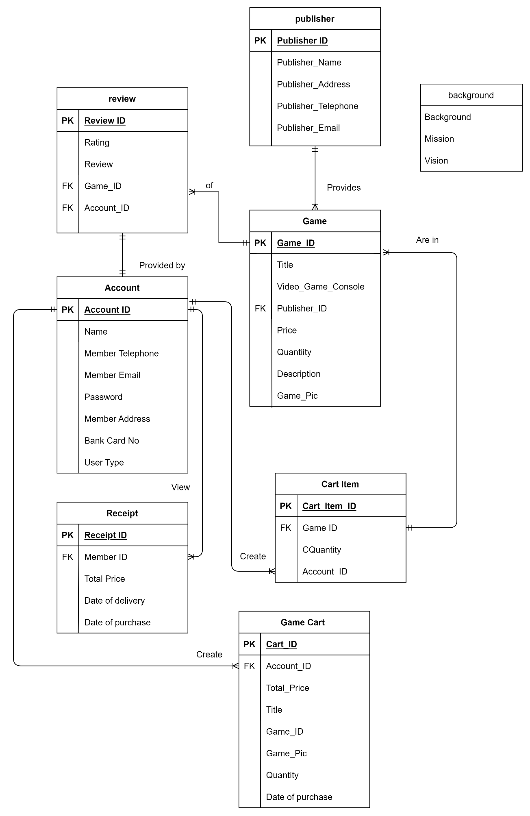

Figure 14: Entity Relation Diagram

# 12.0 Pseudocode and Flowchart

## Flowchart - Foong Wai Keat

Add Game

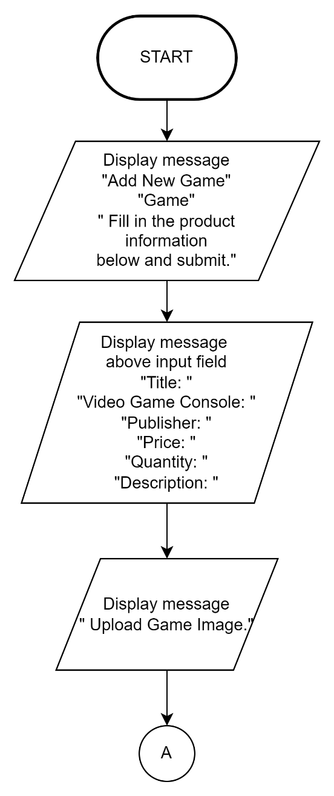

Figure 15: Add Game Process Flowchart

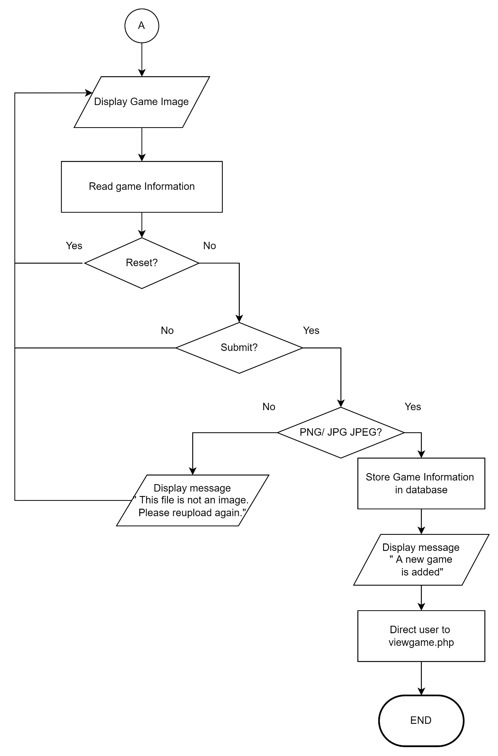

Figure 16: Add Game Process Flowchart

Add Publisher

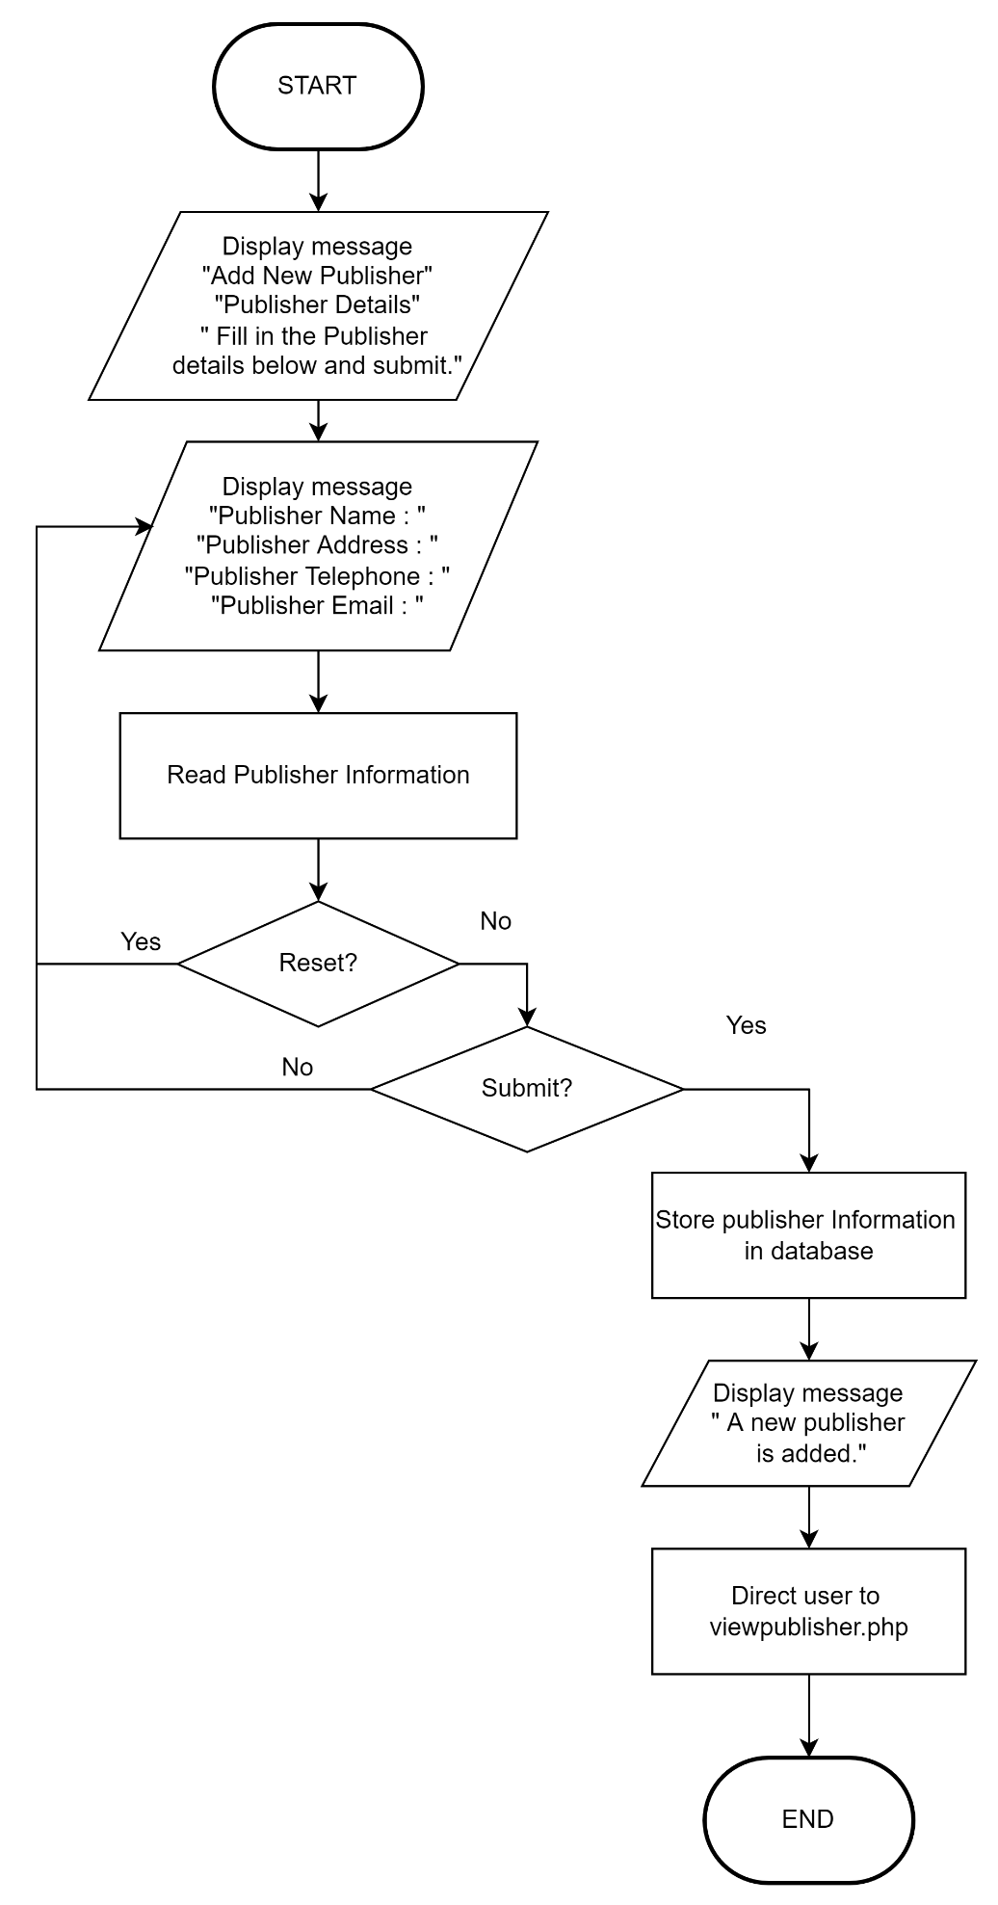

Figure 17: Add Publisher Process Flowchart

Logout

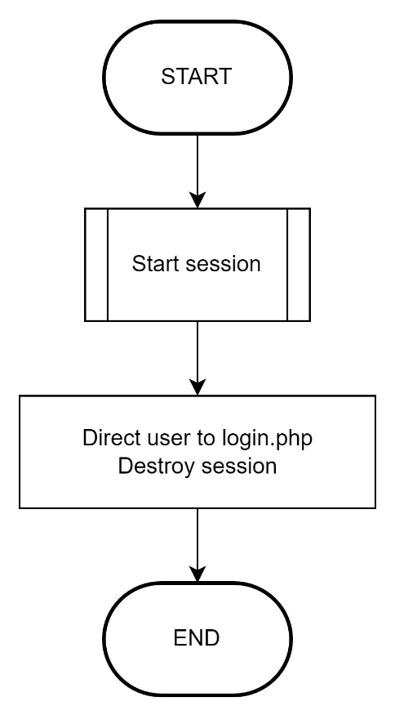

Figure 18: Logout Process Flowchart

Edit Account

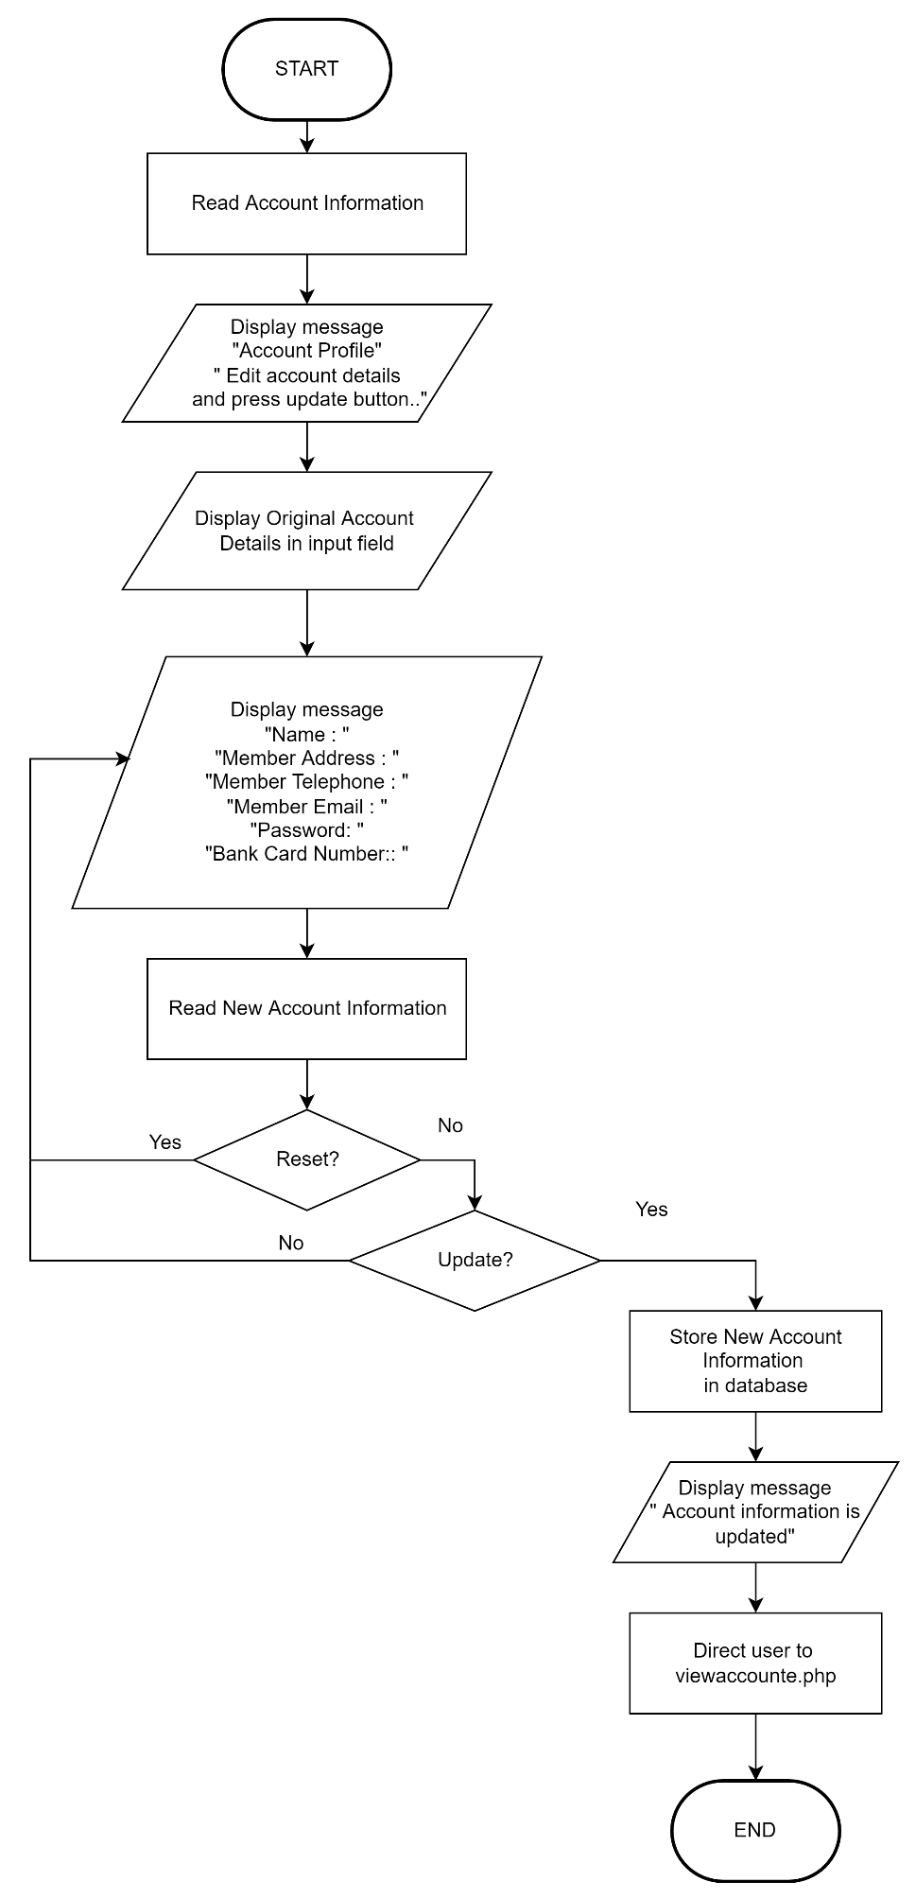

Figure 19: Edit Publisher Process Flowchart

Edit Game

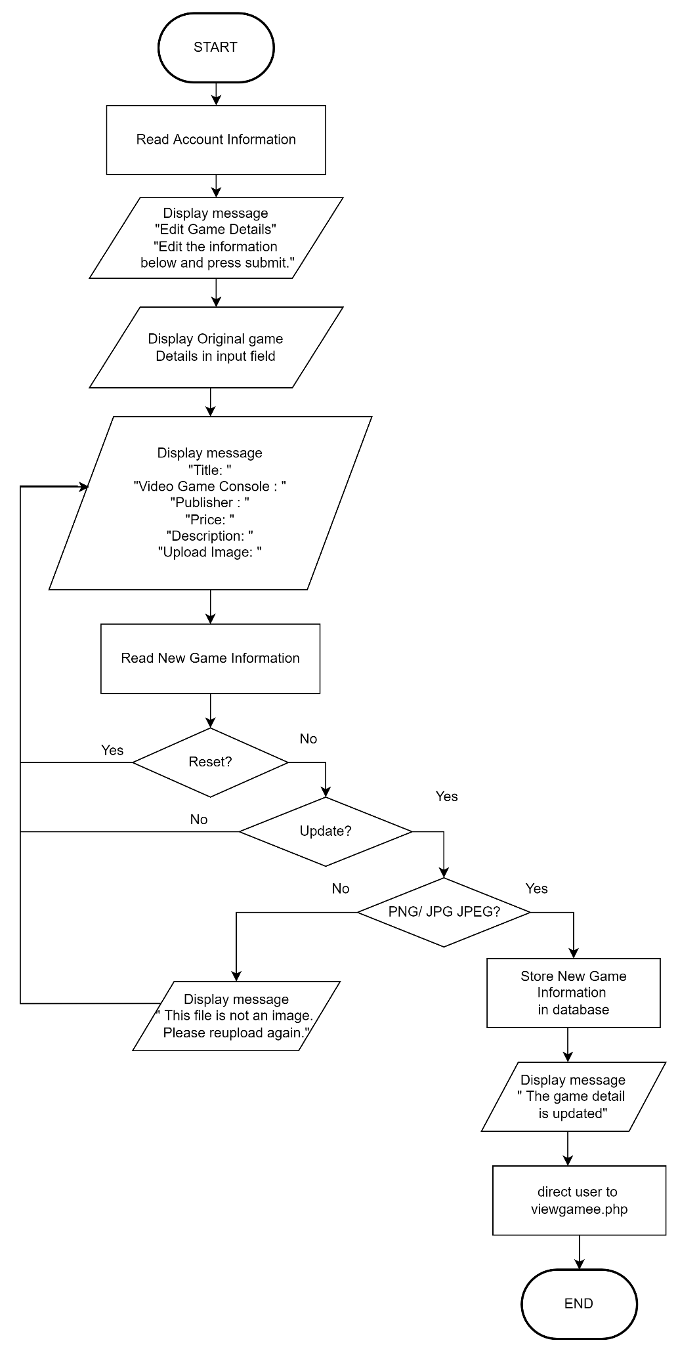

Figure 20: Edit Game Process Flowchart

Delete Account

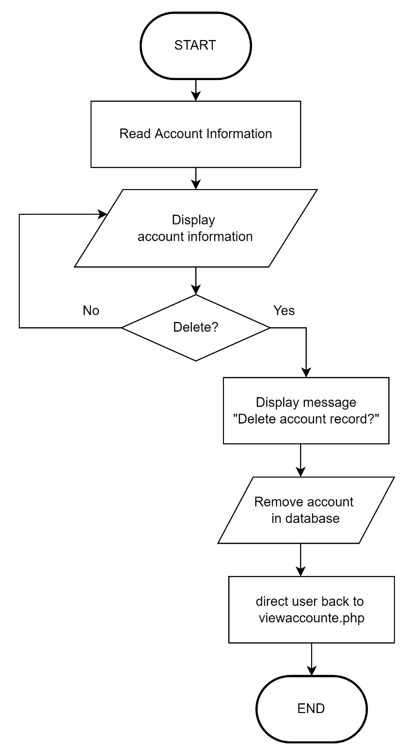

Figure 21: Delete Account Process Flowchart

View All Game

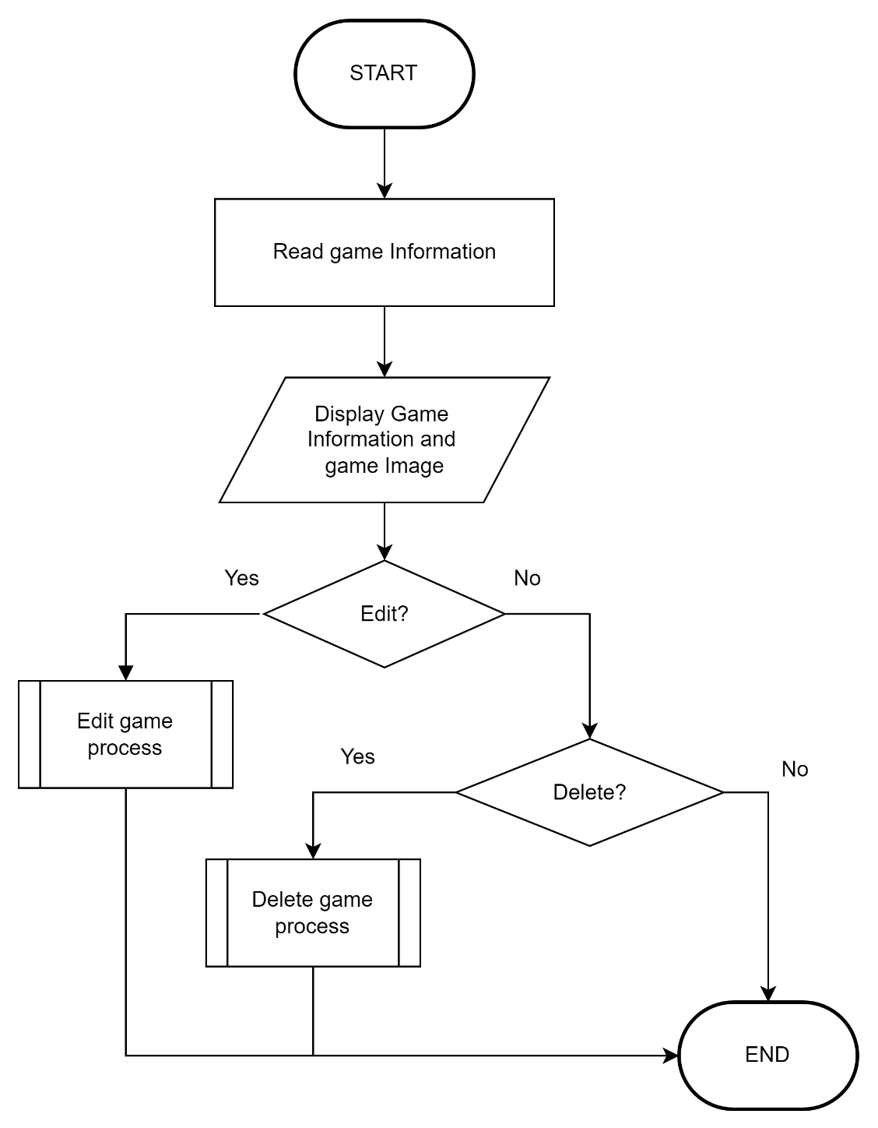

Figure 22: View All Game Process Flowchart

View All Account

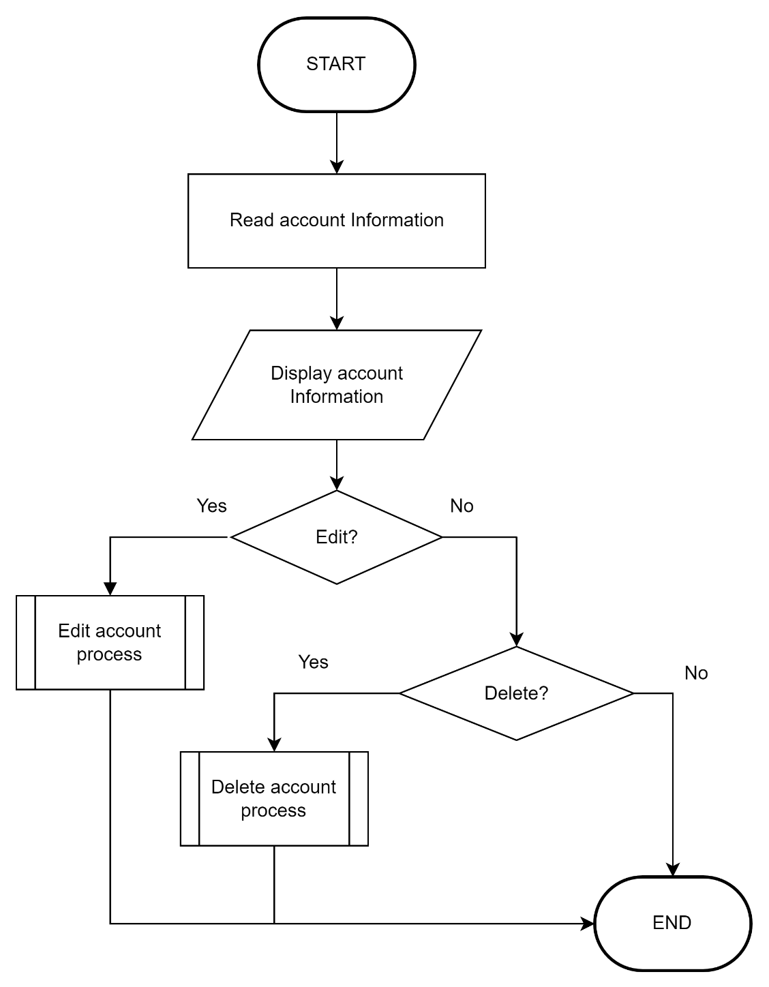

Figure 23: View All Account Process Flowchart

Delete Game Process

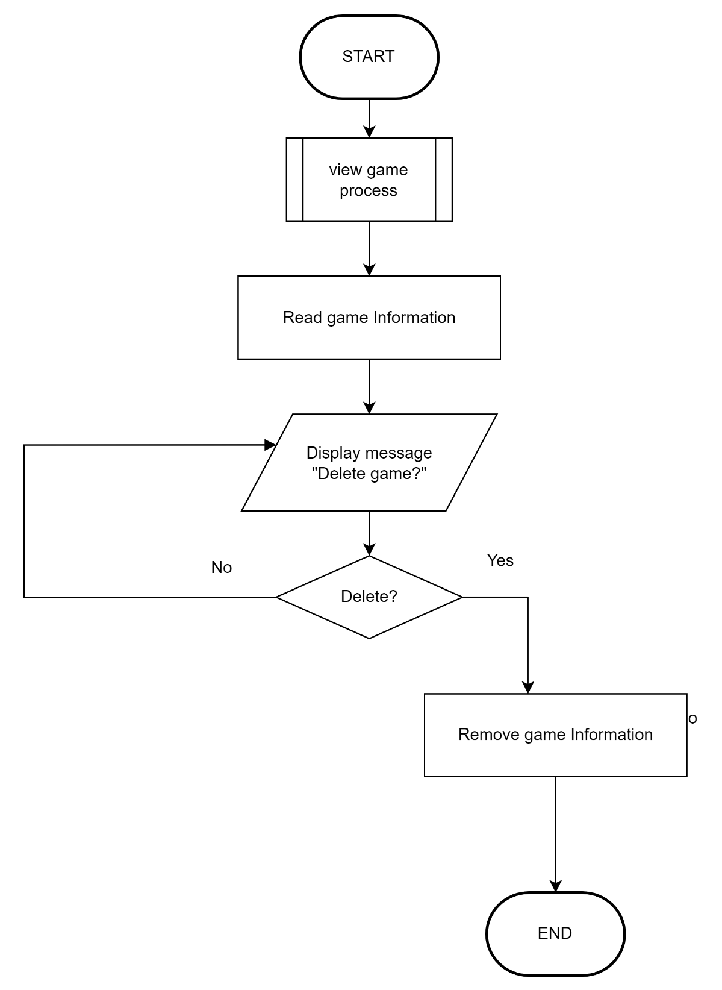

Figure 24: Delete Game Process Flowchart

Delete Account Process

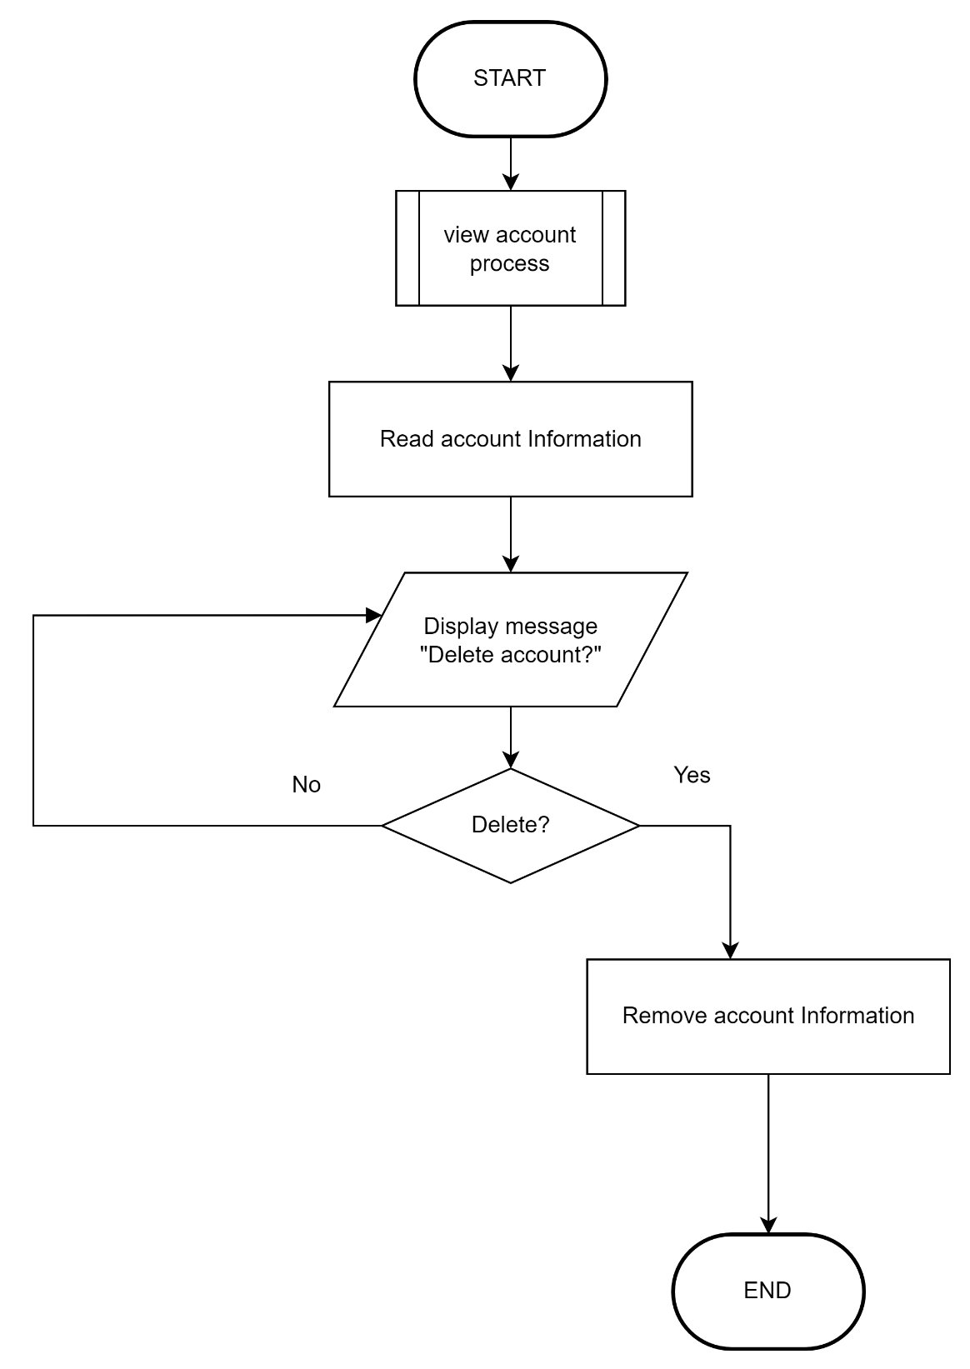

Figure 25: Delete Account Process Flowchart

Add Review

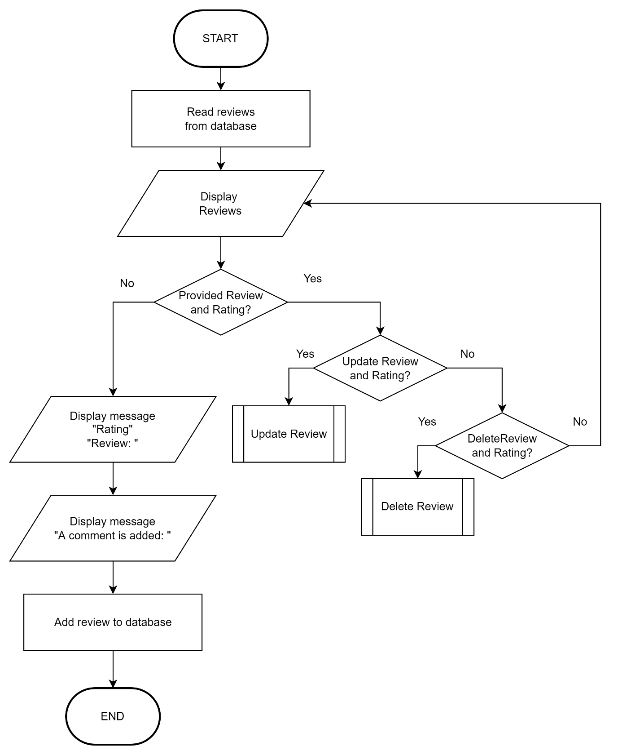

Figure 26: Add Review Process Flowchart

Update Review

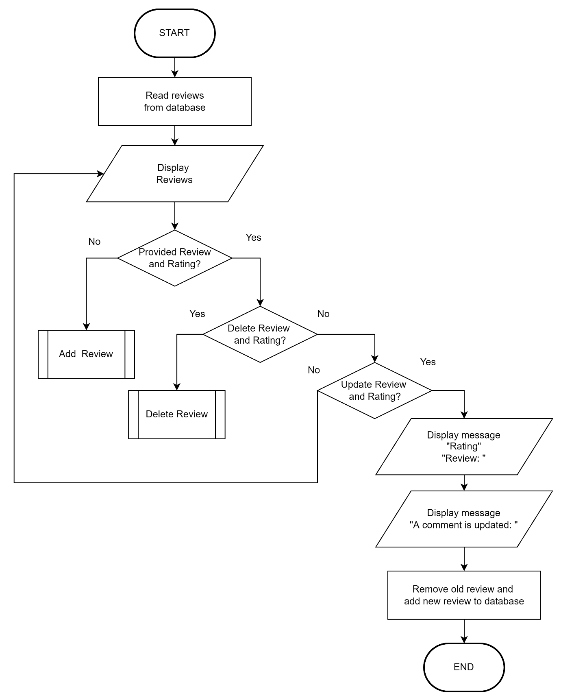

Figure 27: Edit Review Process Flowchart

Delete Review

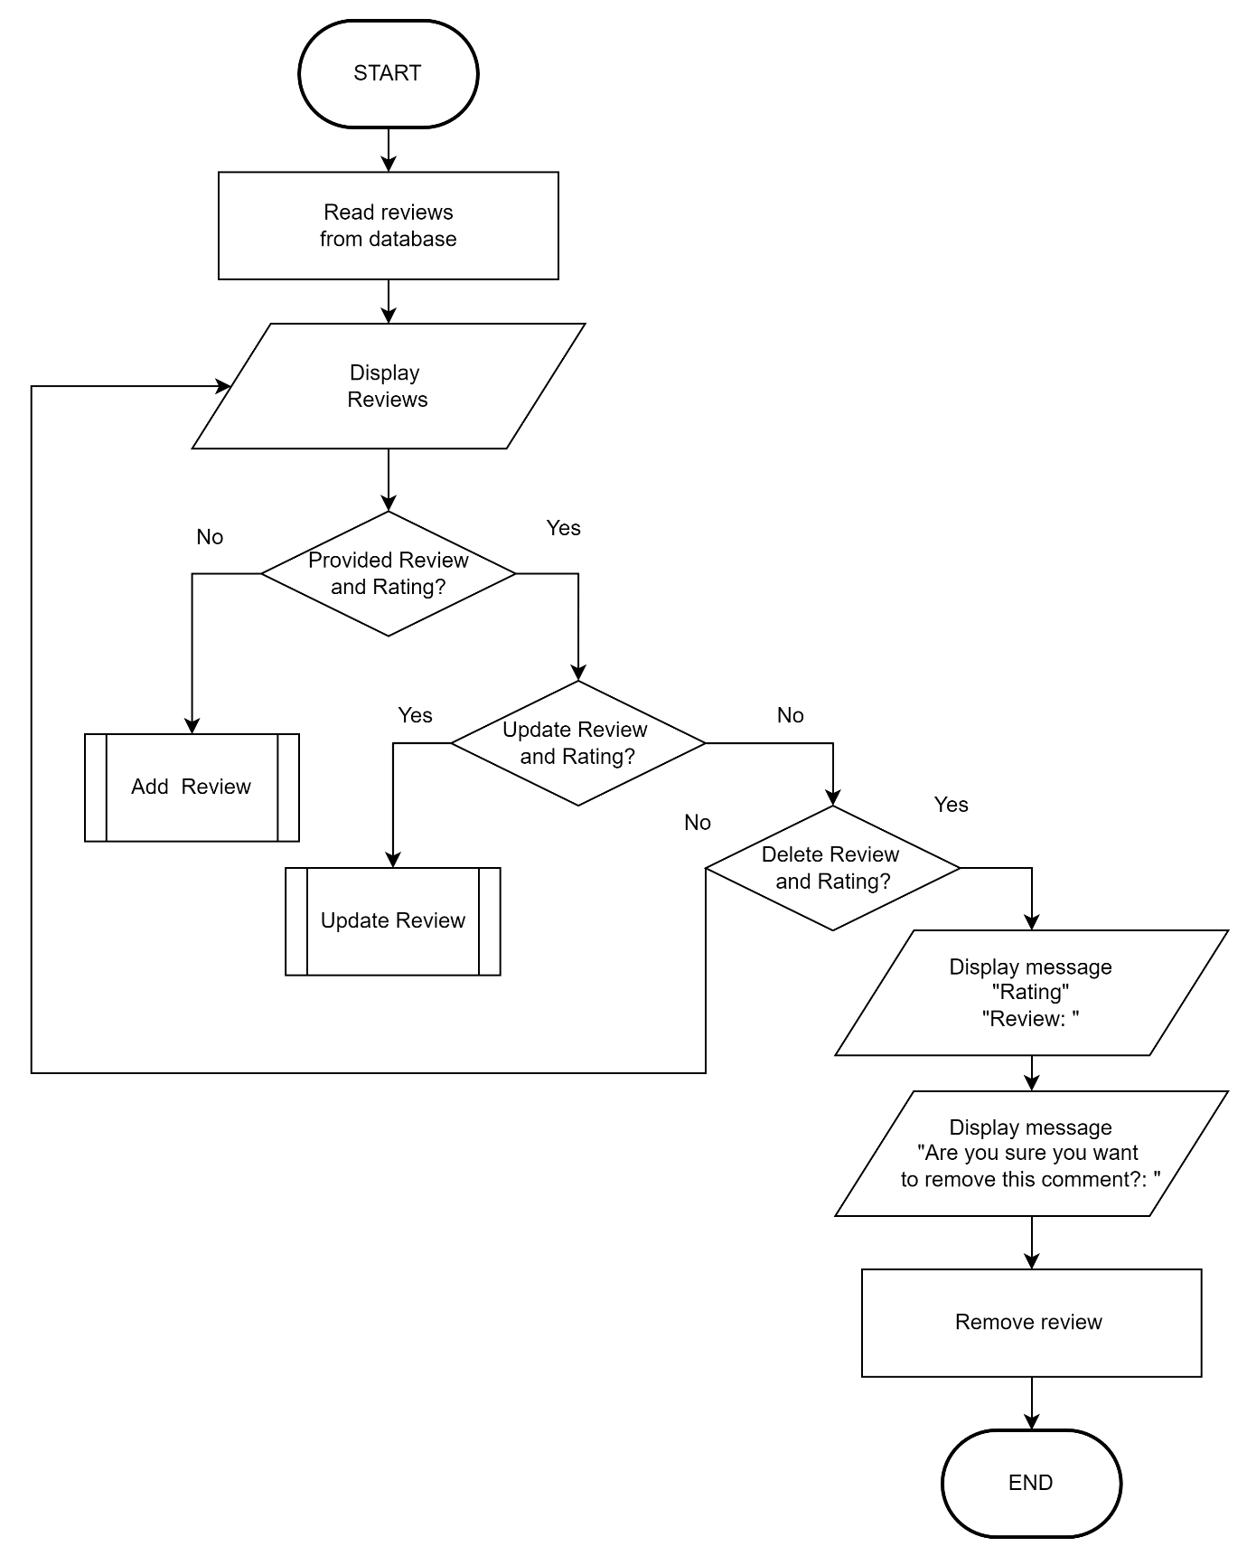

Figure 28: Delete Review Process Flowchart

Add Game To Cart

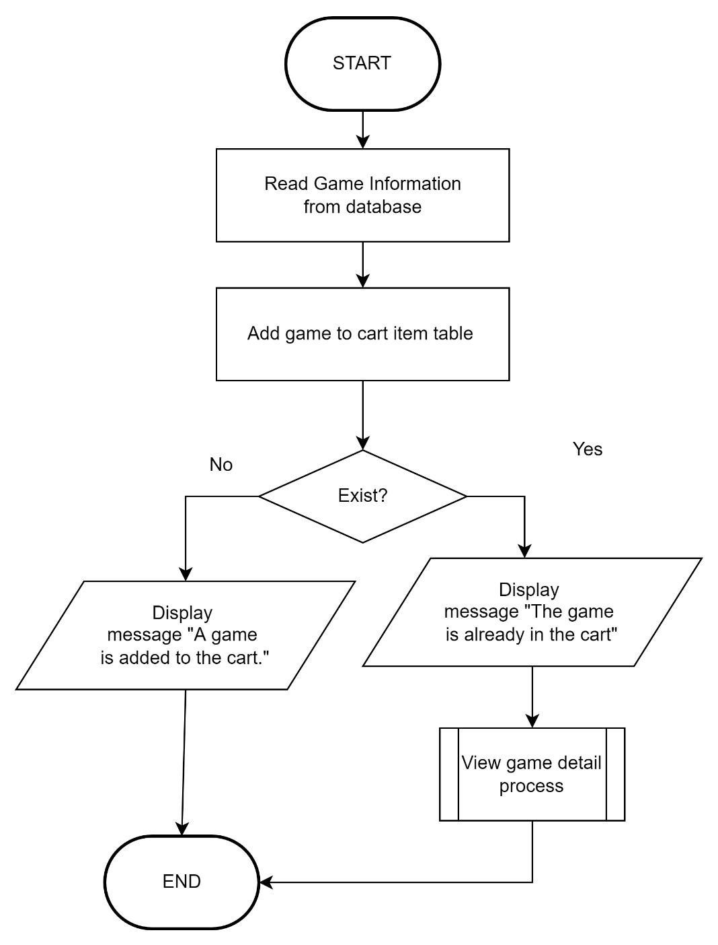

Figure 29: Add Game To Cart Process Flowchart

Update Cart

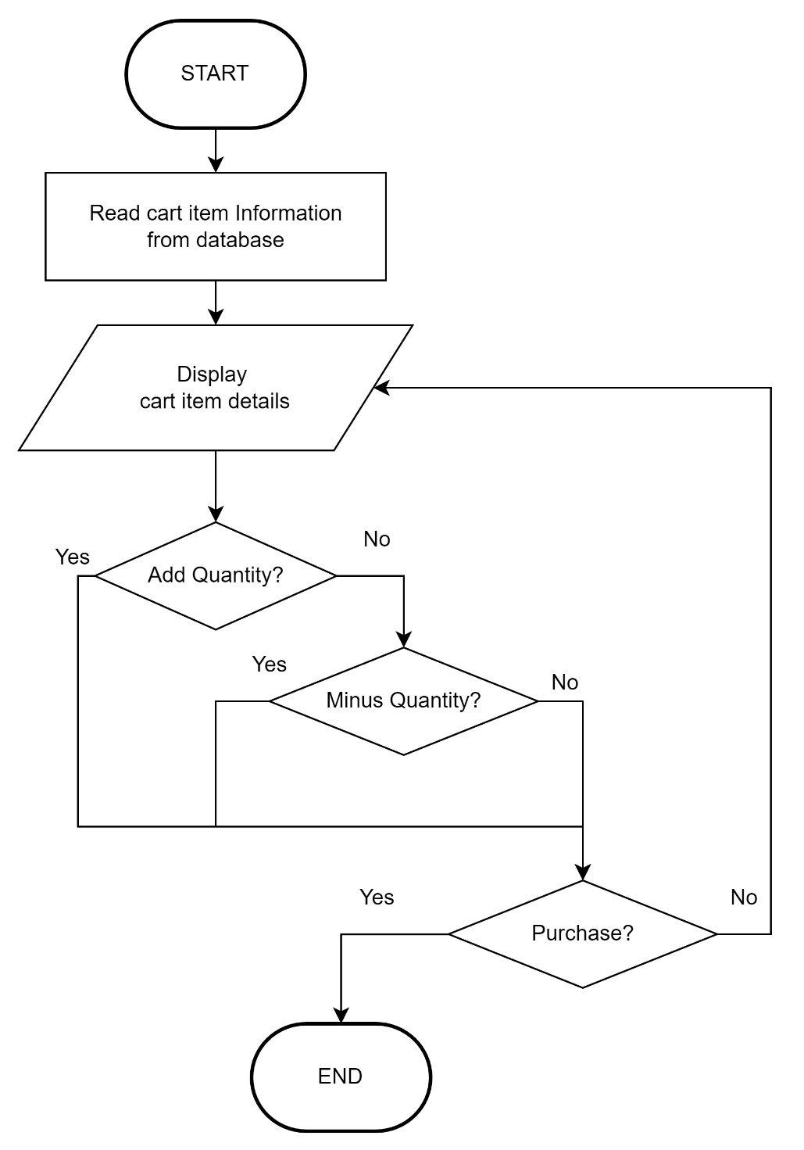

Figure 30: Update Cart Process Flowchart

Delete Cart

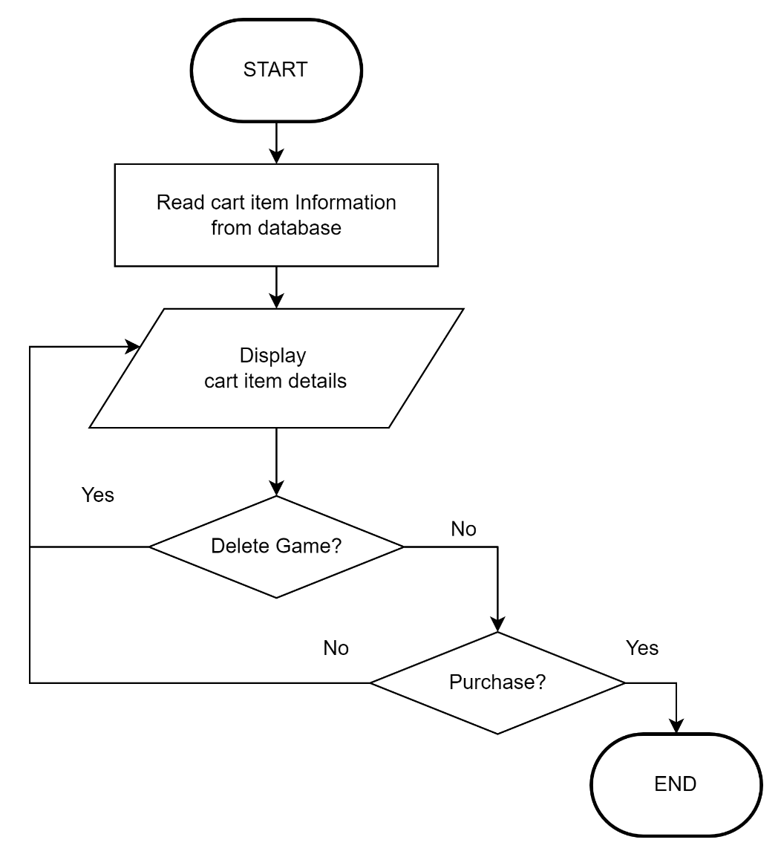

Figure 31: Delete Cart Process Flowchart

View Cart

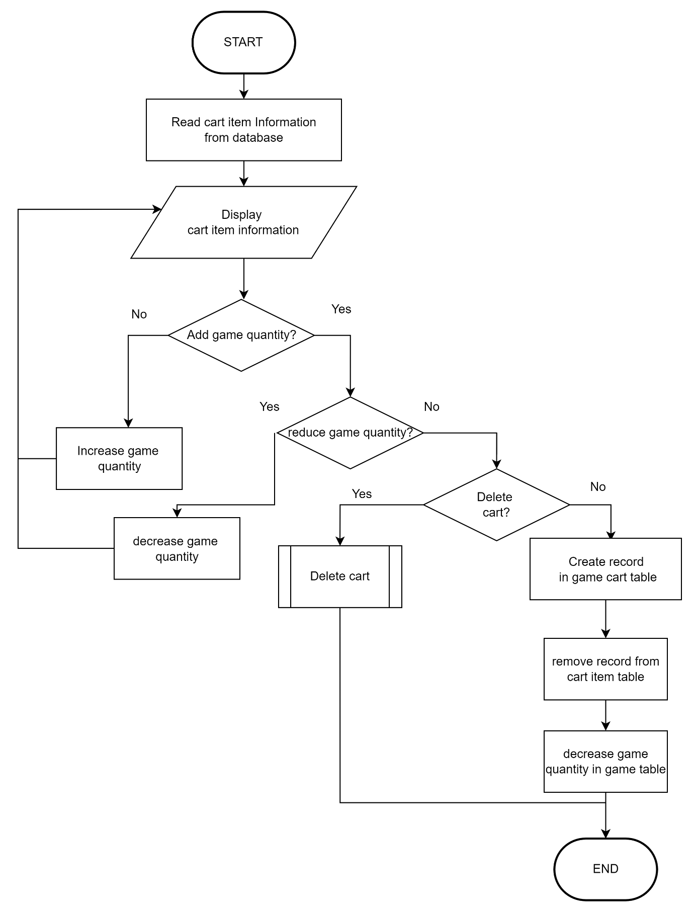

Figure 32: View Cart Process Flowchart

Search Game

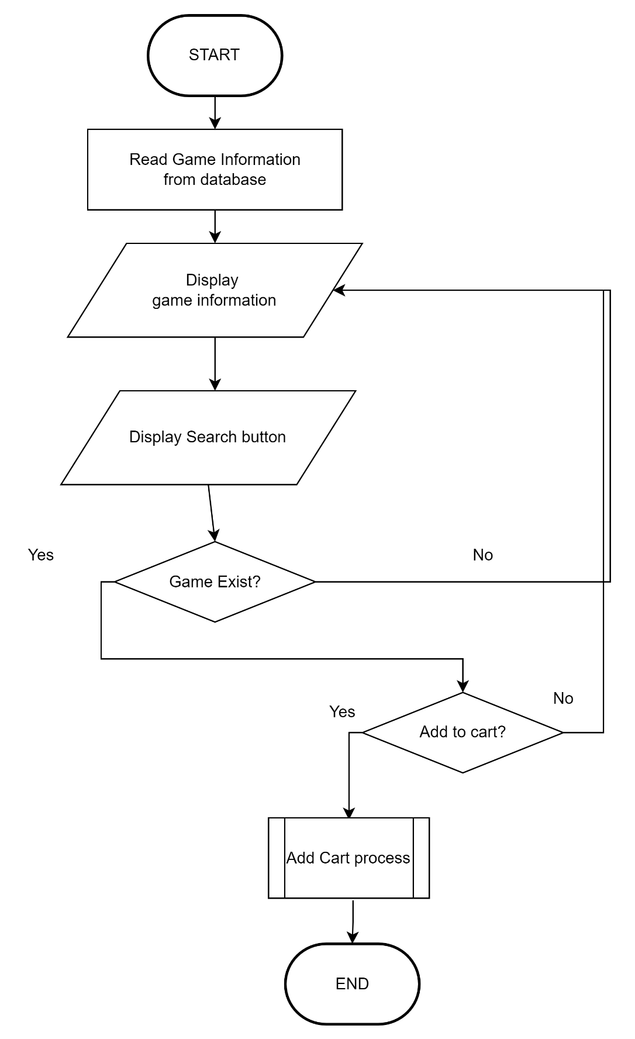

Figure 33:Search Game Process Flowchart

Purchase Game

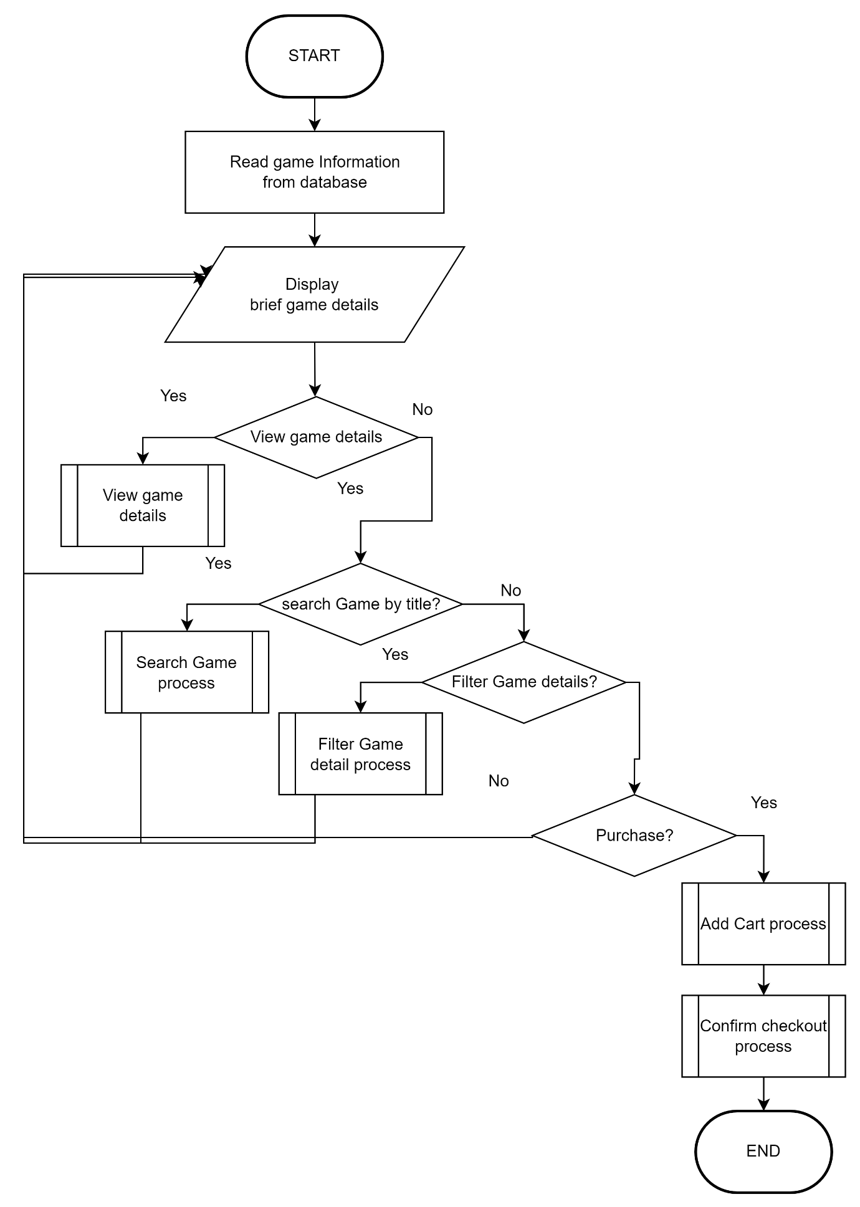

Figure 34: Purchase Game Process Flowchart

Filter Game

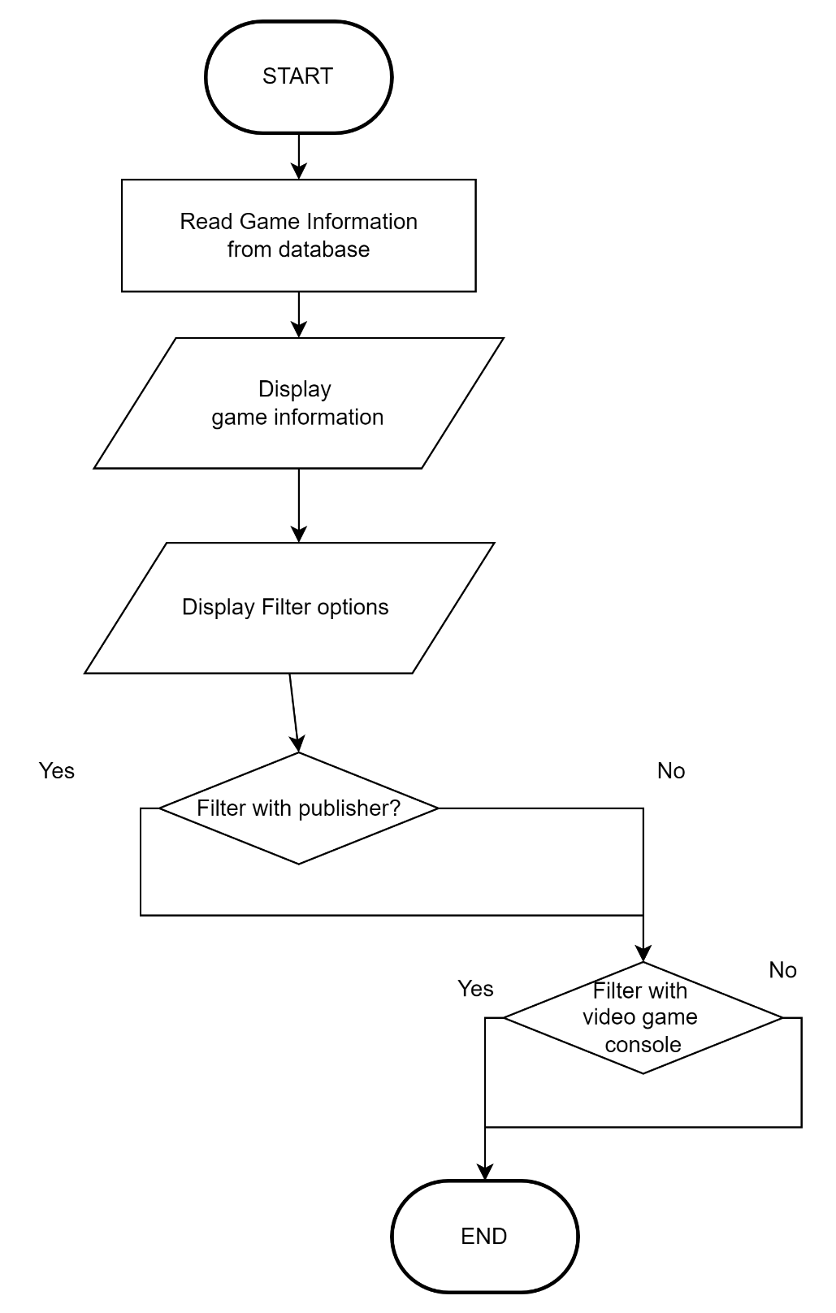

Figure 35: Filter Game Process Flowchart

View Game Detail

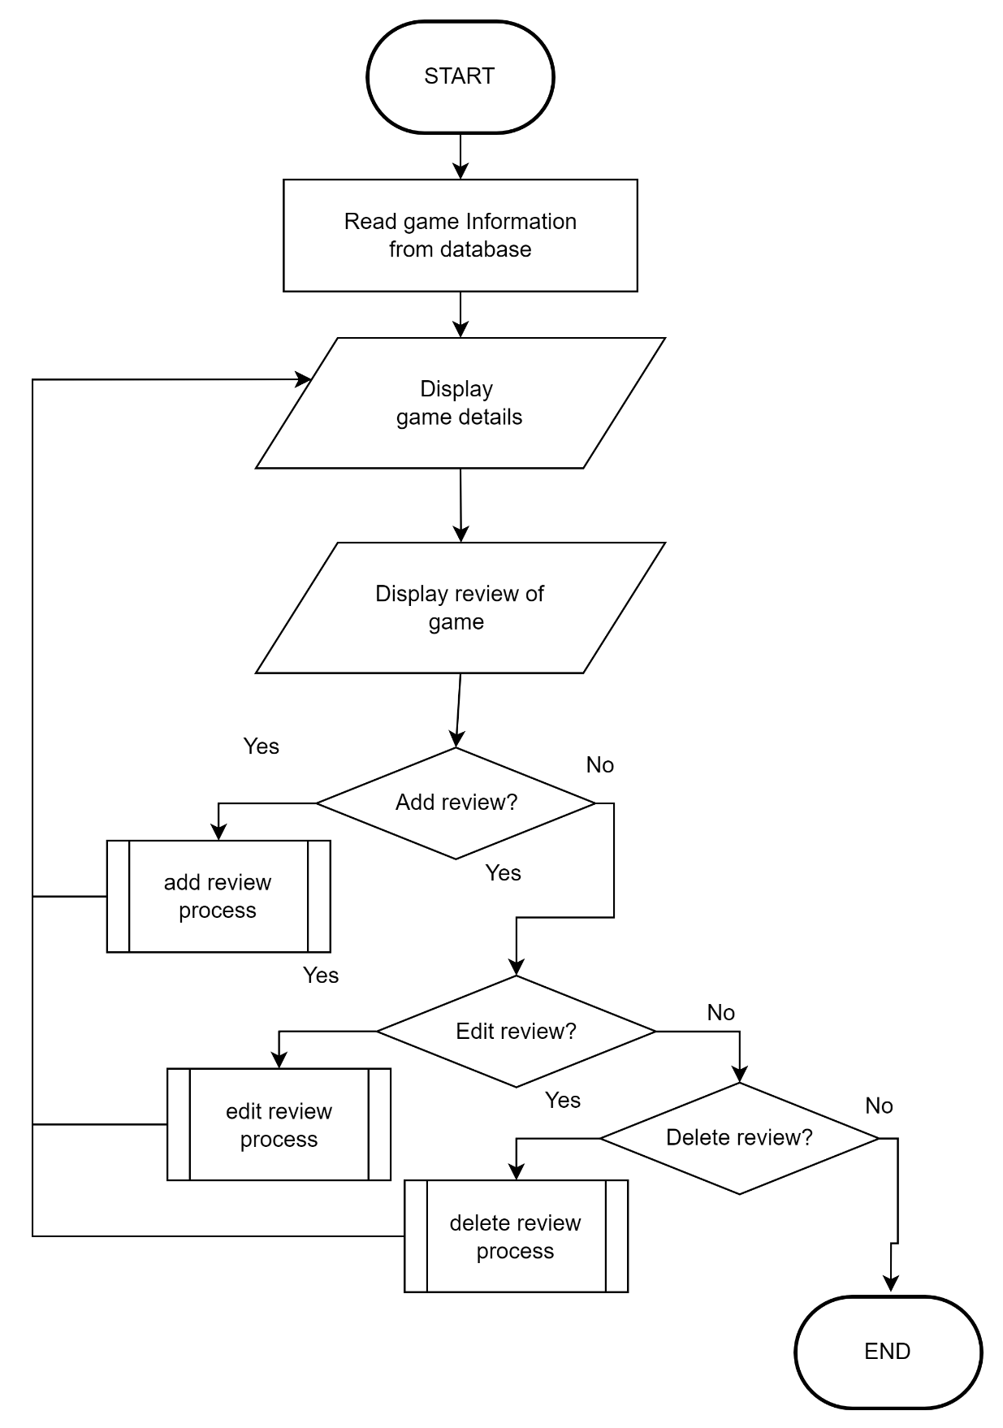

Figure 36: View Game Detail Process Flowchart

Confirm Purchase



Figure 37: Confirm Purchase Flowchart

Member Profile Flowchart

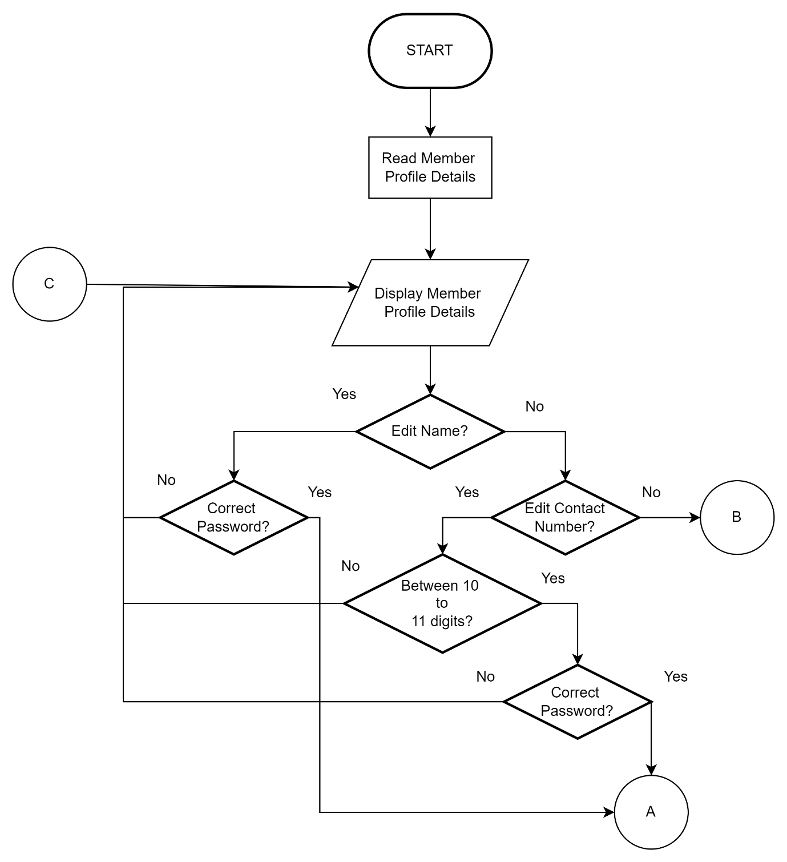

Figure 38: Member Profile Flowchart

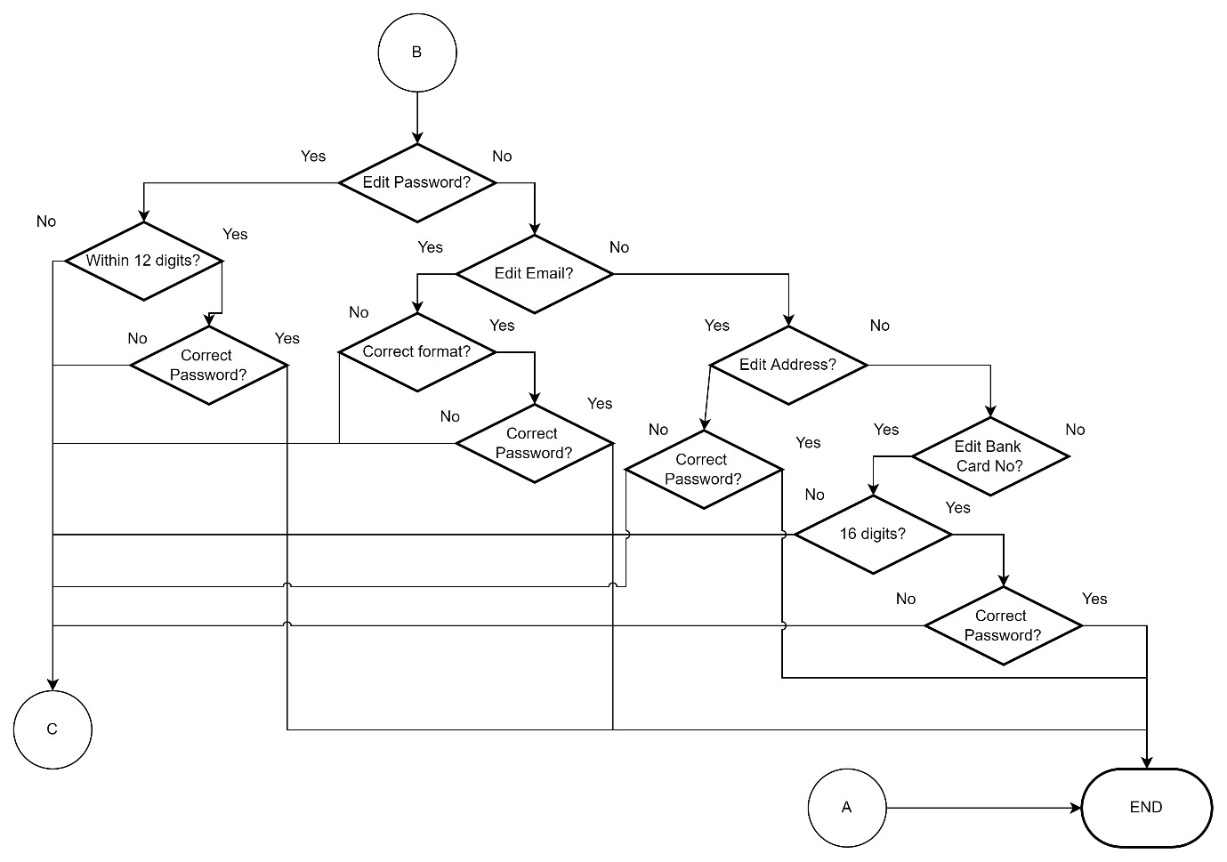

Figure 39: Member Profile Flowchart

Member Purchase History Flowchart

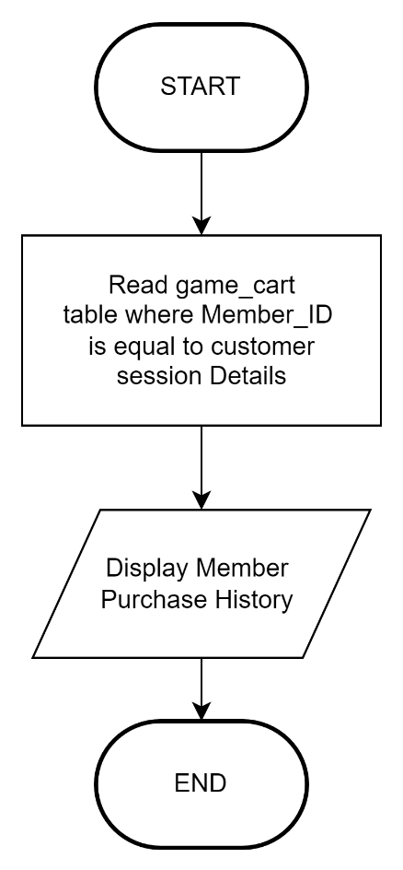

Figure 40: Member Purchase History Flowchart

## Flowchart – Lee Jian Wen

Member Login

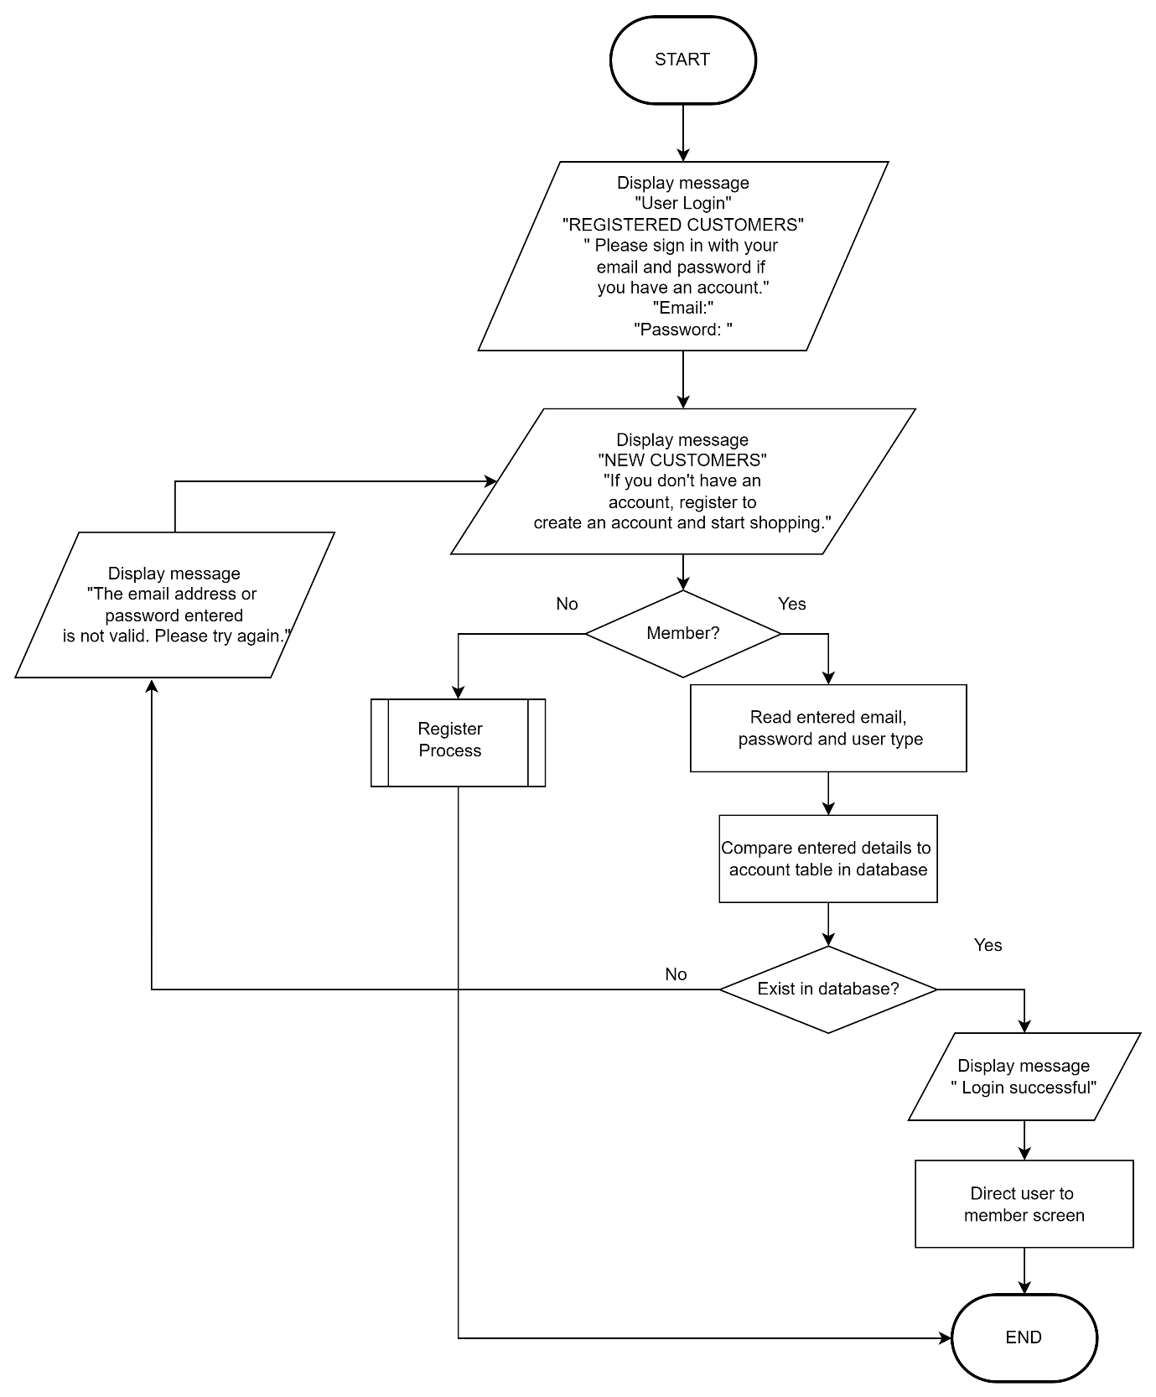

Figure 41: Login Process Flowchart

View Company History

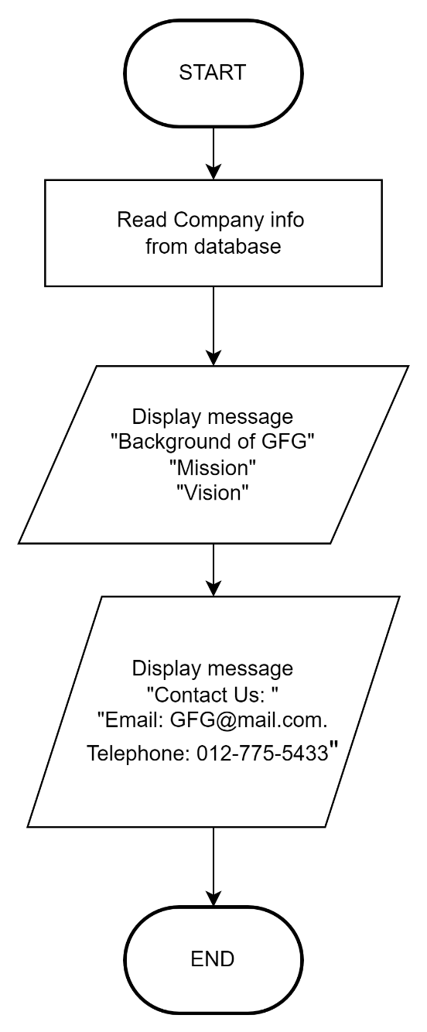

Figure 42: View Company History Process Flowchart

View Company Background

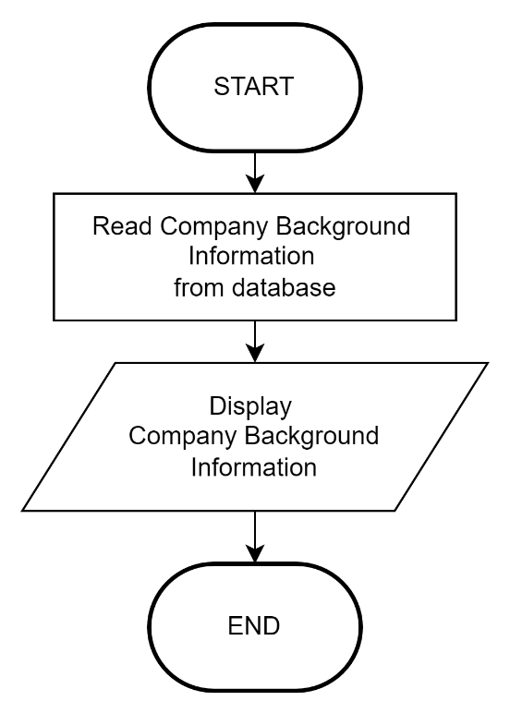

Figure 43: View Company Background Process Flowchart

## Flowchart – Lim Jia Xuan

Staff Login

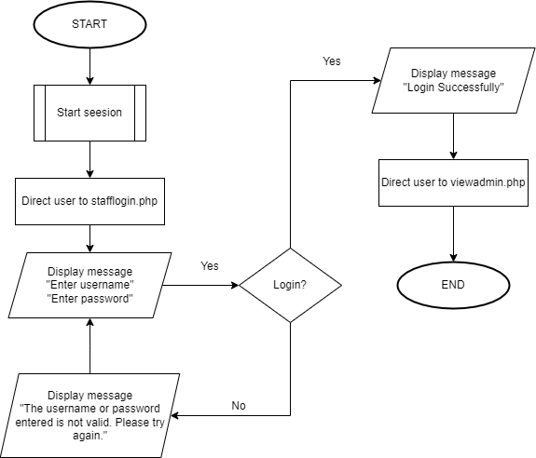

Figure 44: Staff Login Process Flowchart

View Receipt

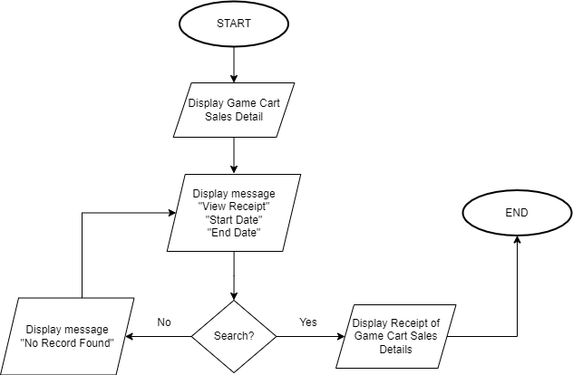

Figure 45: View Receipt Process Flowchart

Generate Report

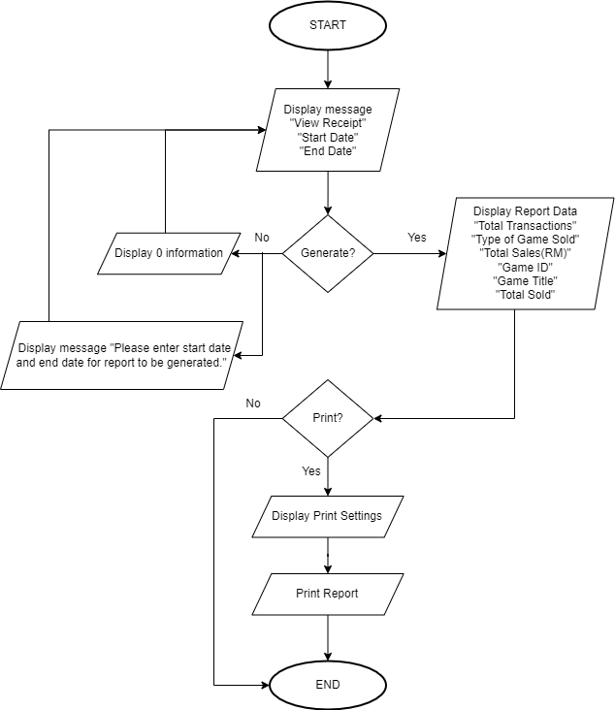

Figure 46: Generate Report Process Flowchart

Edit Company History

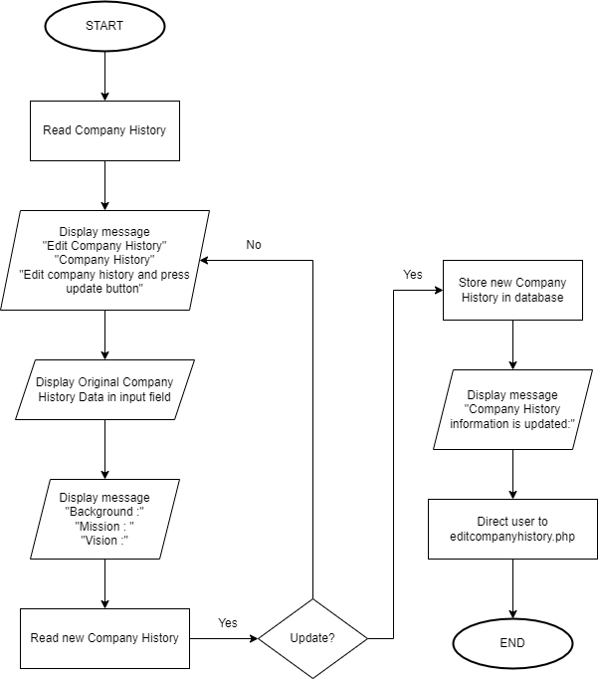

Figure 47: Edit Company History Process Flowchart

View Publisher Details

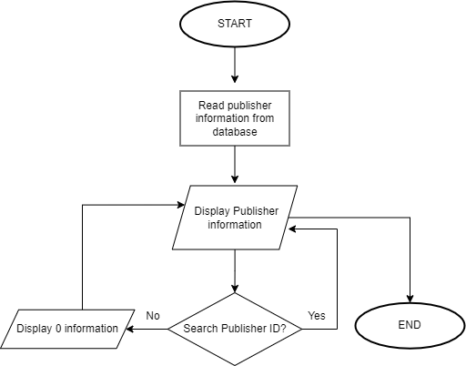

Figure 48:View Publisher Details Process Flowchart

Edit Publisher

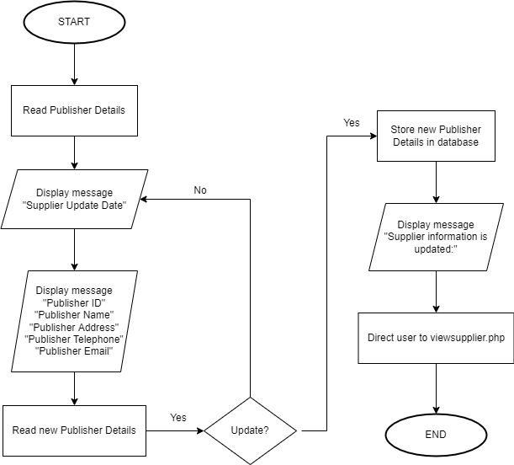

Figure 49:Edit Publisher Process Flowchart

Delete Publisher

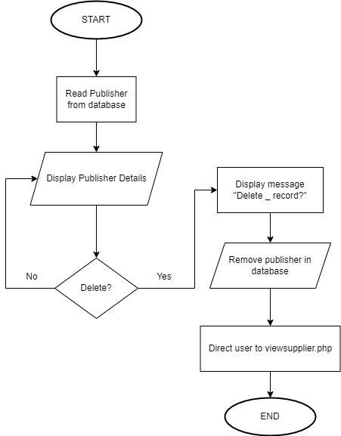

Figure 50: Delete Publisher Process Flowchart

View Sales

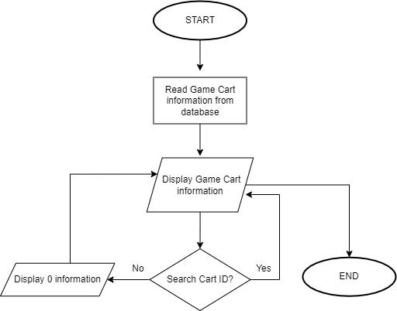

Figure 51: View Sales Process Flowchart

Delete Game Cart from Sales

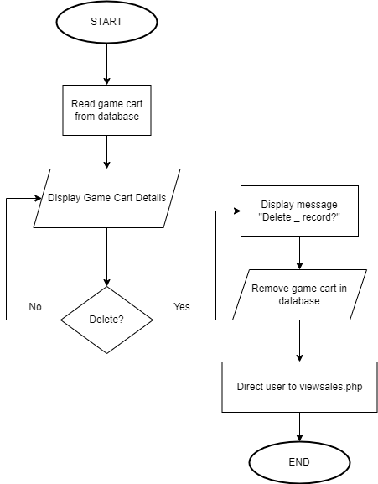

Figure 52: Delete Game Cart from Sales Process Flowchart

## Flowchart - Vanness Goh Ching Yi

Register Flowchart

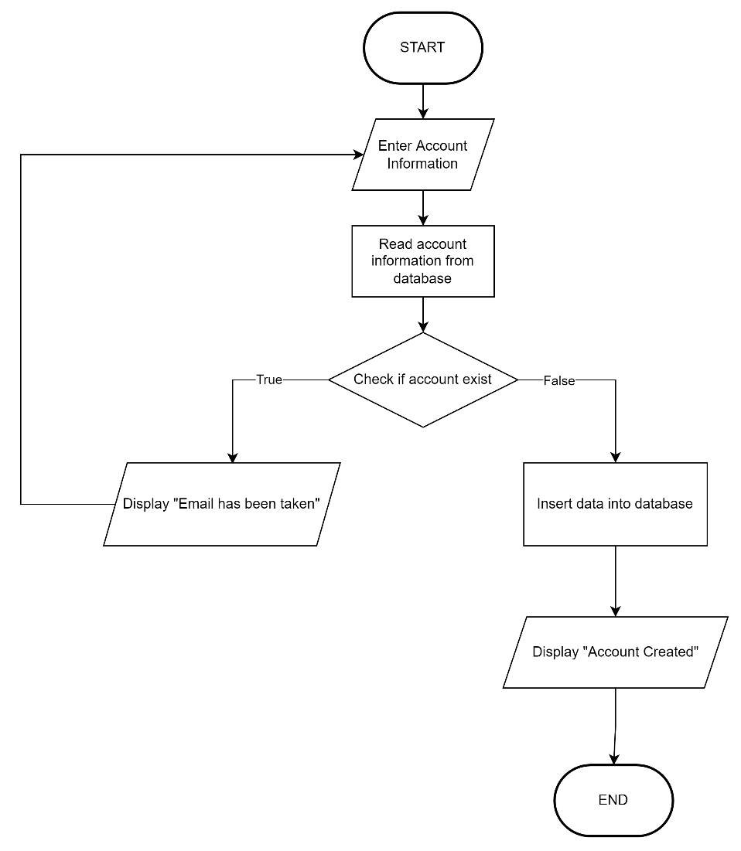

Figure 53: Register Flowchart

Search Game Flowchart

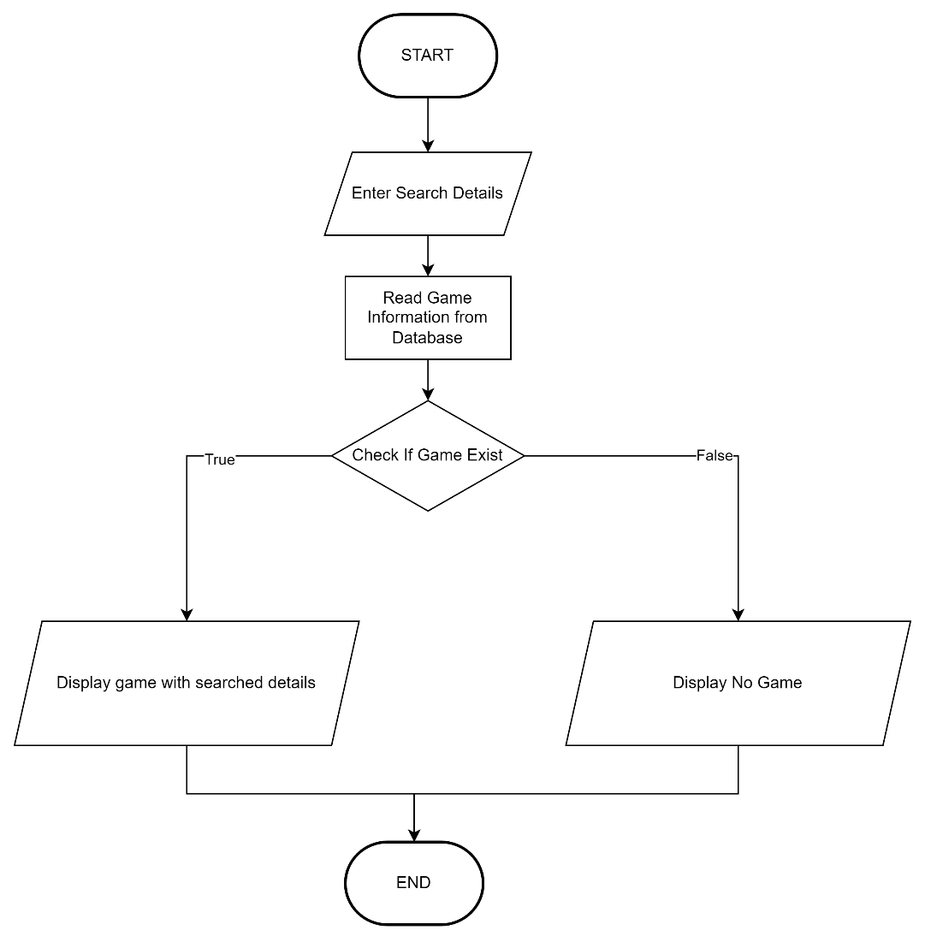

Figure 54: Search Game Flowchart

Filter Game Flowchart

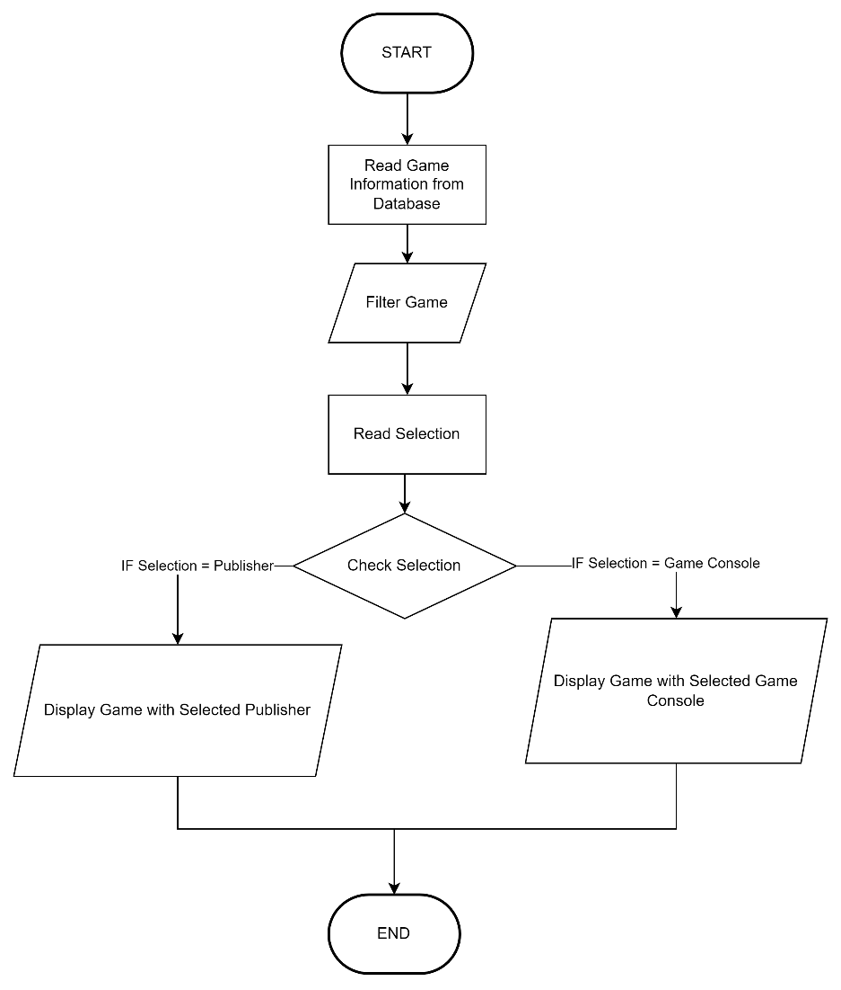

Figure 55: Filter Game Flowchart

Edit Password Flowchart

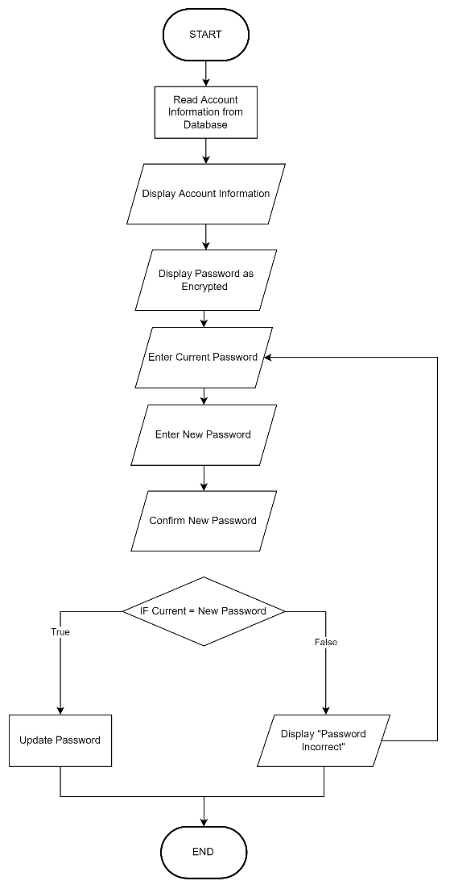

Figure 56: Edit Password Flowchart

Edit Review Flowchart



Figure 57: Edit Review Flowchart

Member View Purchase History Flowchart

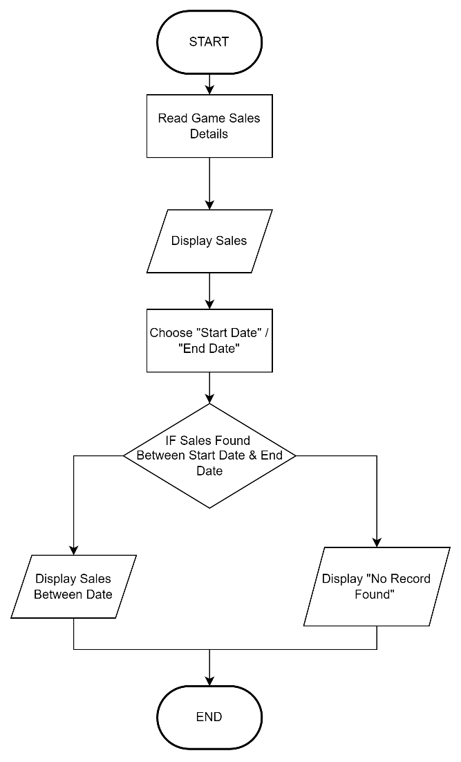

Figure 58: Member View Purchase History Flowchart

# 13.0 Screen Design and User Manual

## 13.1 Admin

Admin Home Screen

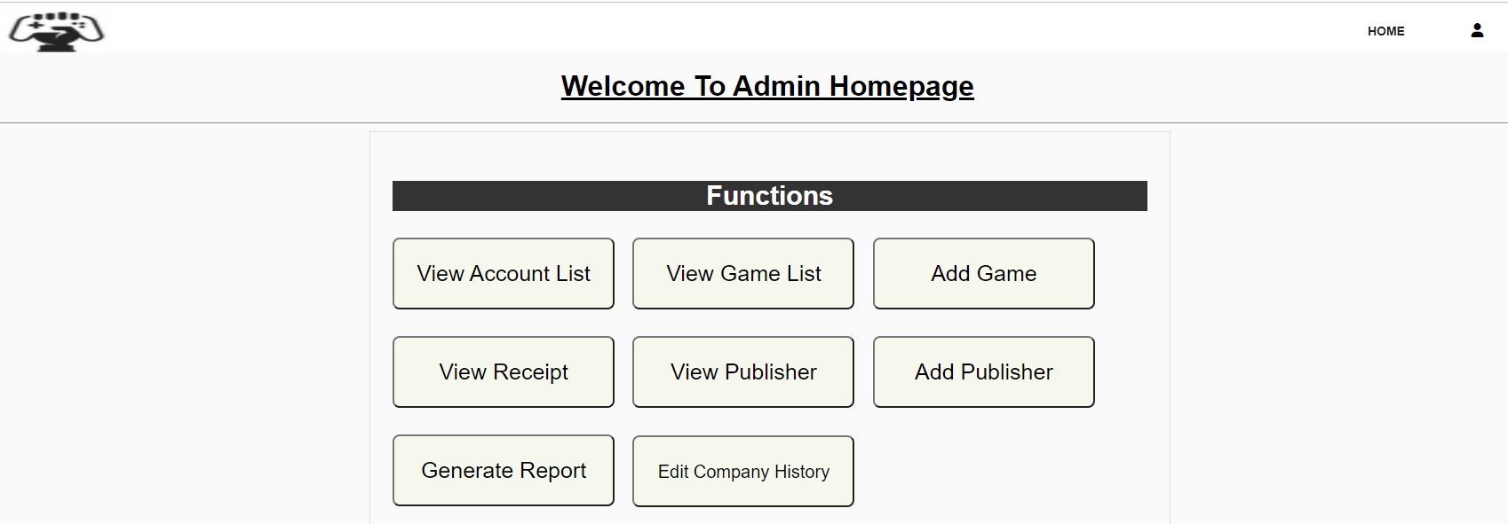

Figure 59: Admin Home Screen

The header of the page is shown as “Welcome to Admin Homepage”. Admin Home screen has 8 different functions that allow staffs or admin of GFG company to operate it. The available features in this screen are View Account List, View Game List, Add Game, View Receipt, View Publisher, Add Publisher, Generate Report and Edit Company History. A Logout button is provided through clicking on the Profile icon.

View All Game Screen

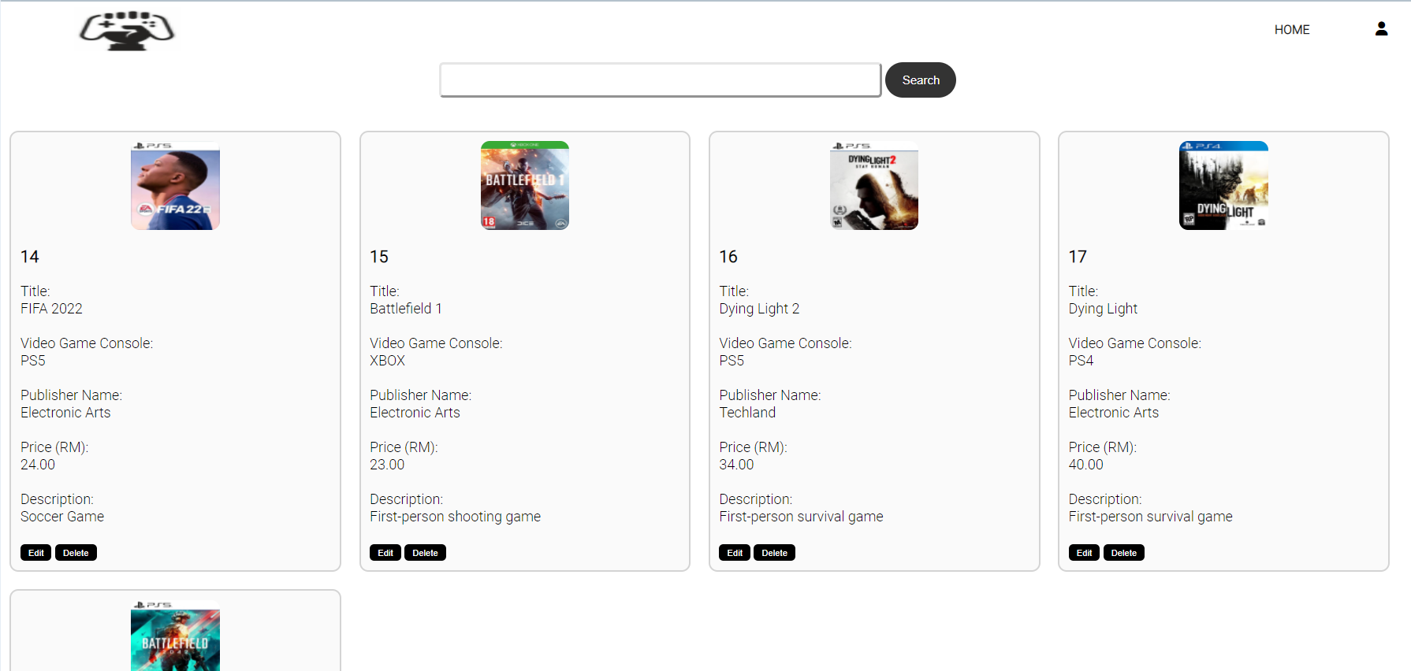

Figure 60: View All Game Screen

This screen would display all games on sale in GFG website. A search bar is provided for the admin to enter the title of games in the text field and filer the games by clicking on the Search button which have similar title as the input in the search bar. In this screen, brief details of games would be displayed. Each game would have a Delete and Edit hyperlink for Admin to decide whether to edit the details of the games or to remove the game from GFG website by clicking on the Delete hyperlink.

Edit Game Detail Screen

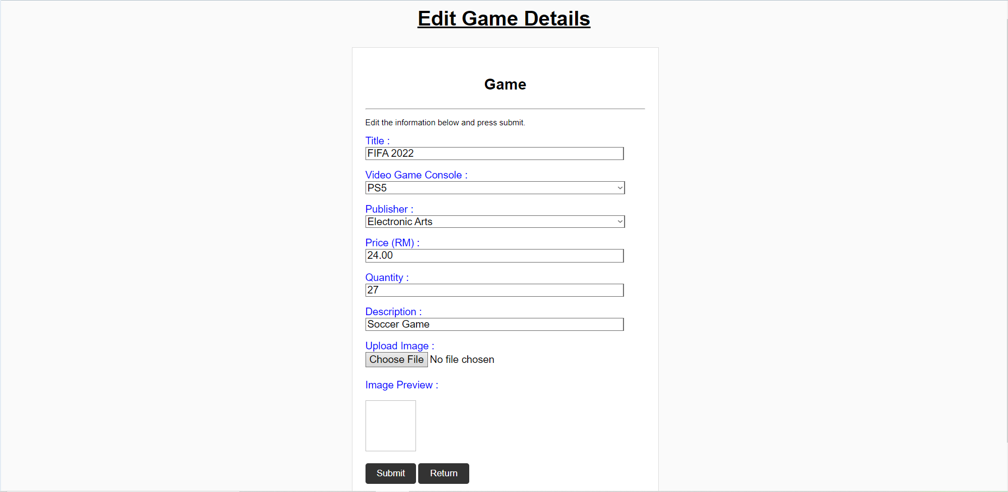

Figure 61: Edit Game Detail Screen

This screen would allow admin to modify the details of games by changing the text in the text field. The original details of the games would be displayed in the text field. When admin has confirmed to apply the updated new game details, admin would need to click on the Submit button. Otherwise, admin could click on the Return button and return to the View All Game screen.

Add Game Screen

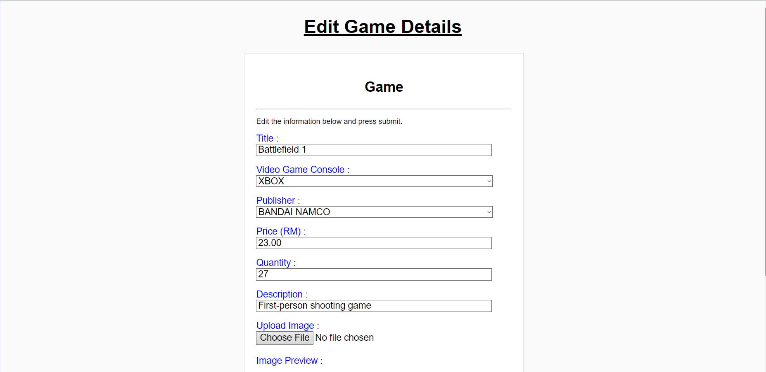

Figure 62: Add Game Screen

This screen enable admin to provide details of a video game to be available on GFG website. After providing details of the video game, admin would need to click on Submit button to confirm to add the new video game on GFG website. A Reset button is provided to clear all text fields.

Add Publisher Screen

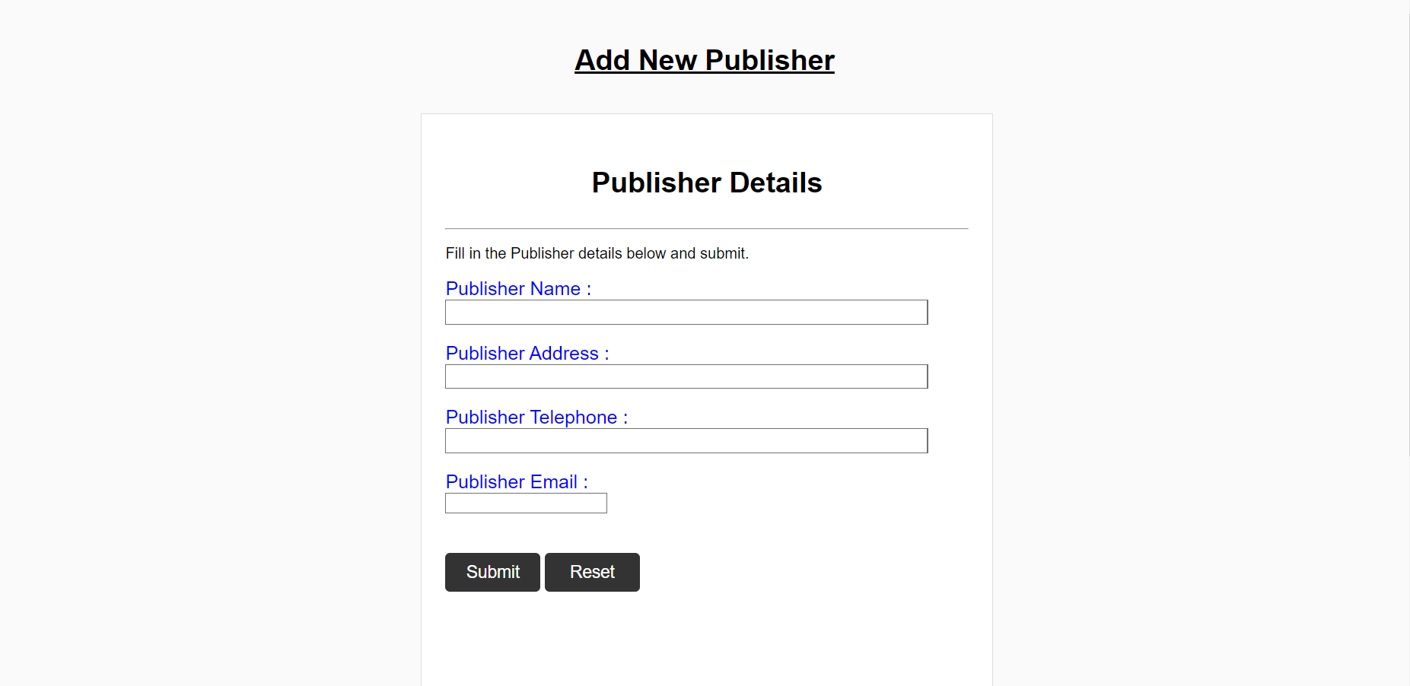

Figure 63: Add Publisher Screen

This screen allows admin to add a video game publisher into gfg database. After filling in details into the text fields, admin could confirm to add the publisher by clicking om the Submit button. If the admin would like to reset all text fields, the admin could click on Reset button.

View All Account Screen

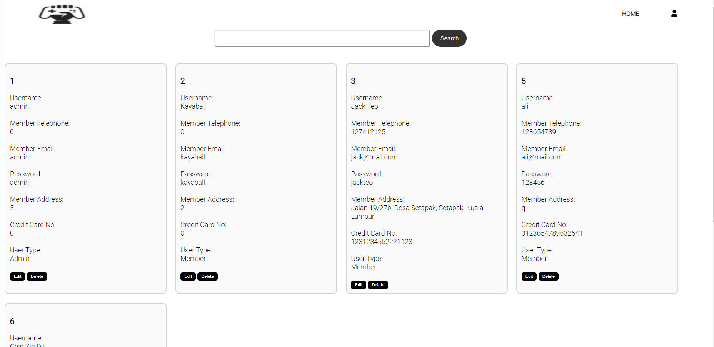

Figure 64: View All Account Screen

This screen displays all details of accounts recorded in account table of gfg database. A search bar is provided for the admin to enter name of account into the text field, and only show accounts with similar name after clicking on the Search button. An Edit hyperlink is provided for the admin to access to Edit Account screen to modify details of the account. Meanwhile, a Delete hyperlink is also provided to enable admin to delete account permanently from account table.

Edit account Screen

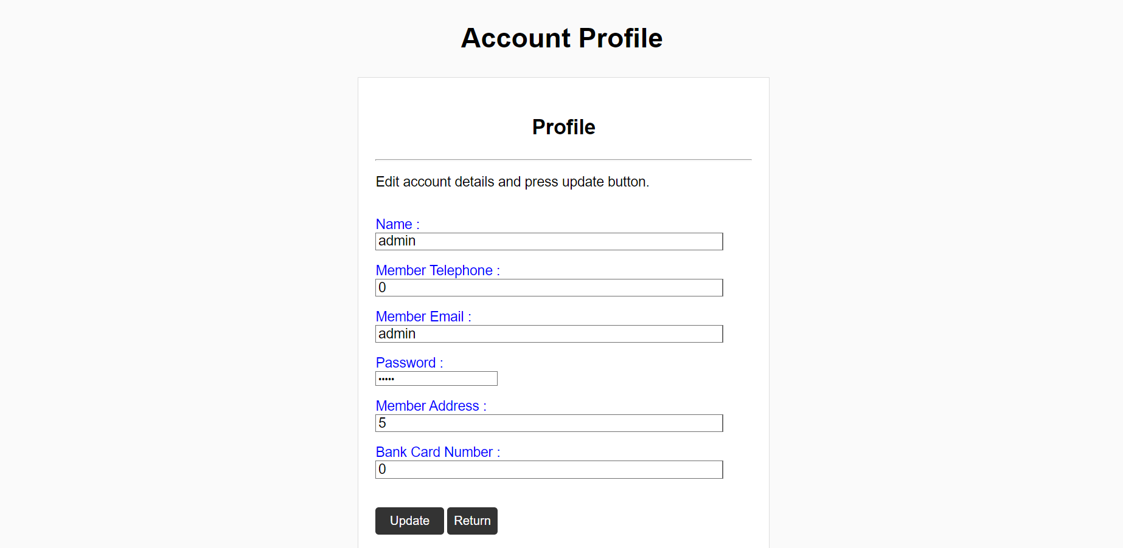

Figure 65: Edit account Screen

This screen allows admin to modify the information for accounts by changing the texts in the text field. When the admin is satisfied with the changes made, admin could click on Submit button to replace the old account details with the new account details. However, if the admin does not want to change any account information, admin could exit this page by clicking on the Return button.

View Receipt Screen

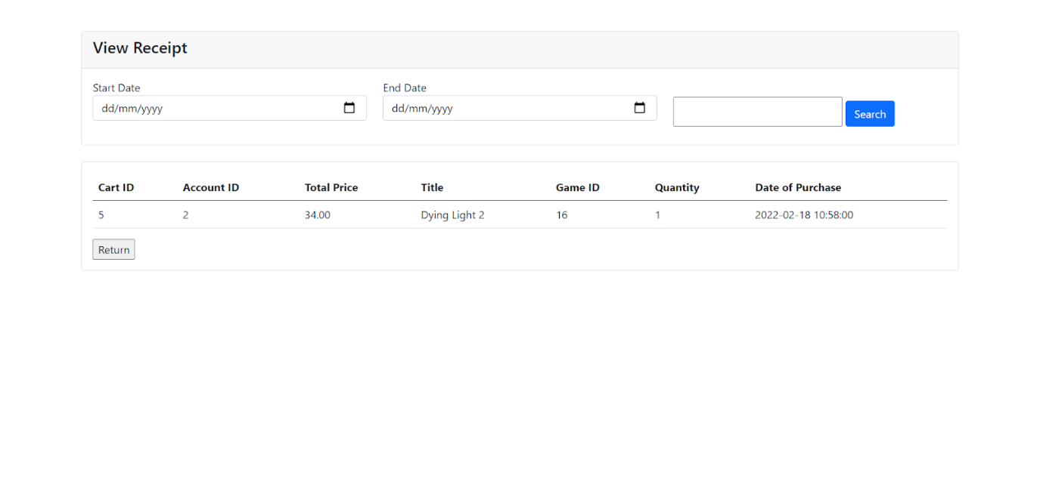

Figure 66: View Receipt Screen

This is a view receipt screen that shows the details of the purchase that customers have made. It has a function of filtering the date of purchase by filling in the Start Date and End Date followed with clicking the search button. After selecting the start date and end date, staff also can search cart ID and name of customer within a certain period of time. When staff finish viewing the view receipt screen, staff can press the Return button to return to the admin page.

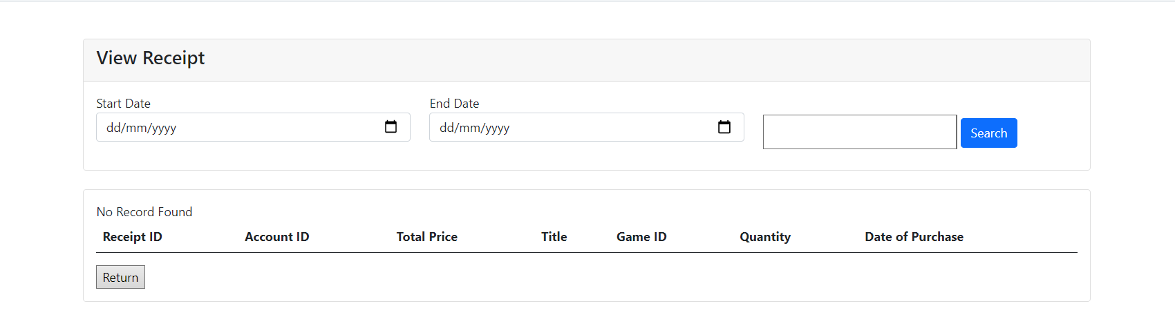

Figure 67: Record of Receipt does not Found Page

If there is no purchase made within the duration of start date or end date or no customer name or which does not have any date of purchase, it will show a message of “No Record Found”, same goes to search for a cart ID which does not exist (figure).

Generate Report Screen

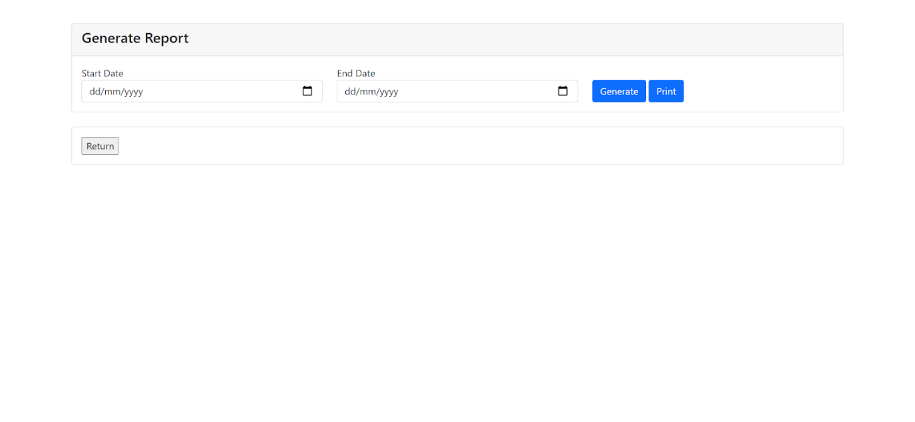

Figure 68: Generate Report Screen

This is a generated report screen when staff clicked the Generate button. It has 3 buttons which are “Generate”, “Print” and “Return” buttons. The return button is to return to the Admin Home Screen.

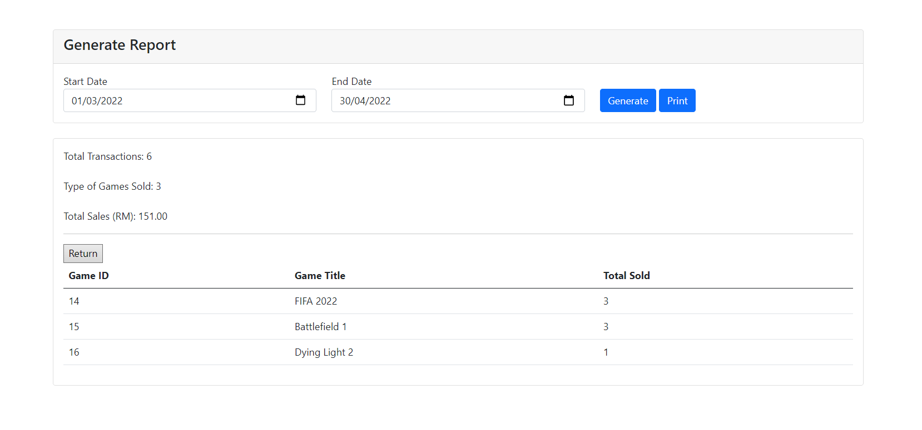

Figure 69: Details of Sales Report

This is a generated report page which shows the details of the game cart sales that games have sold. It has a function of date of purchase filter by clicking the generate button. Staff need to select the start date and end date before clicking the generate button. After generating the dates, it will show the details of game cart sales which are total transactions, type of games sold, total sales (RM), game ID, game title and total sold.

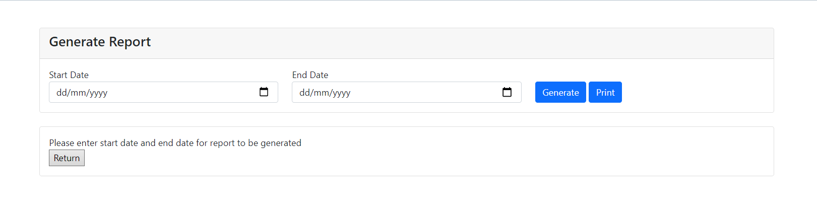

Figure 70: Example of Date Validation

If it does not select any date, it will show a message of “Please enter start date and end date for report to be generated”.

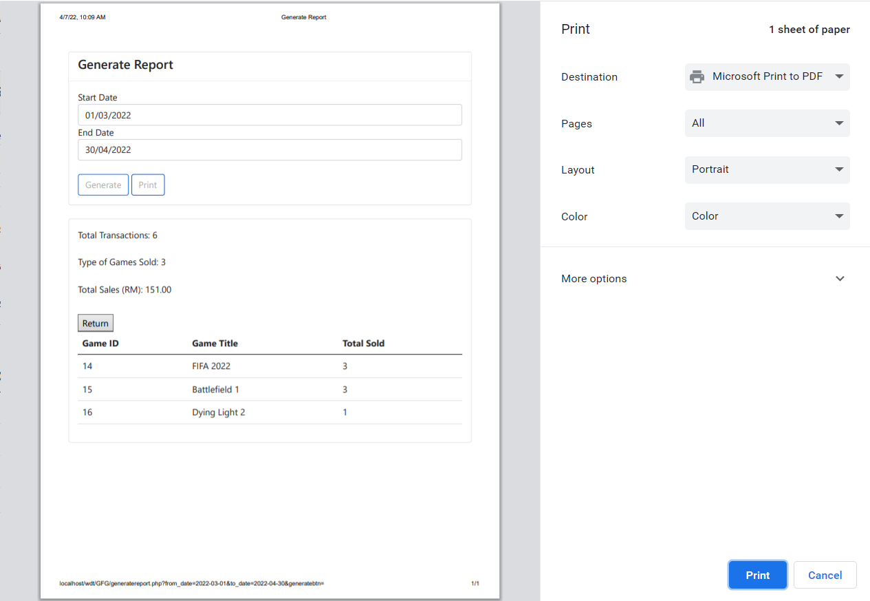

Figure 71: Print Report Screen

When staff finish generating the report, staff is able to press the Print button to print out the report. It is also free to set any adjustment for the print settings.

Edit Company History Screen

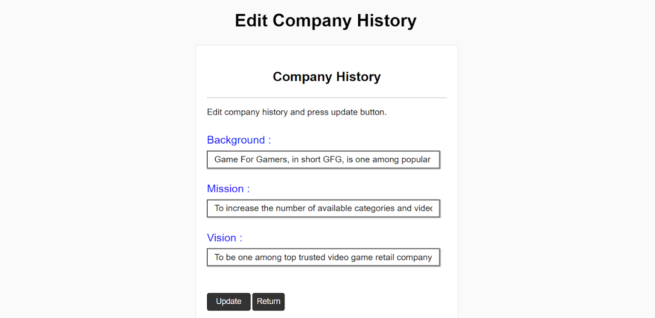

Figure 72: Edit Company History Screen

This is the edit company history page that allows staff to change company history’s contents. It only has 2 function buttons which are “Update” and “Return” buttons. The return button is to return to the admin page.

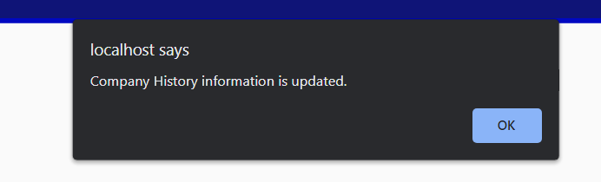

Figure 73: Company History Updated Message

When staff finishes updating the contents of company history, it will show an alert message “Company History information is updated.”

View Publisher Screen

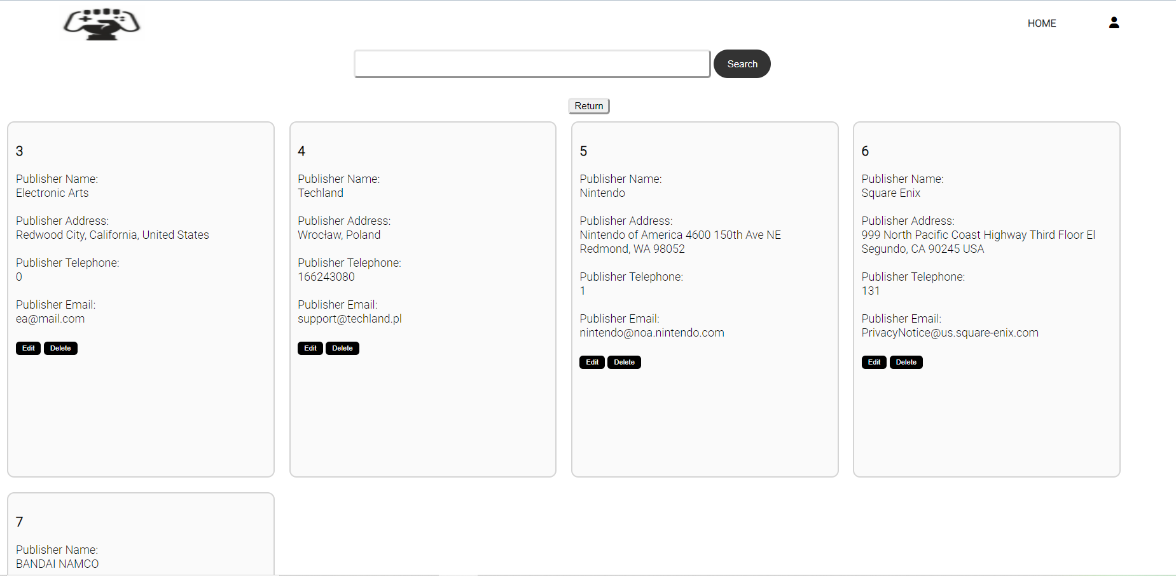

Figure 74: View Publisher Screen

This is an edit supplier details screen that allows staff to modify supplier details and delete publisher’s account. Publisher detail has its own ID as shown as Publisher ID. It also shows its name, address, telephone number and email. When the staff wants to delete the publisher’s record, it will pop out a delete confirmation message. Staff can search supplier record by searching their Publisher ID. When staff finish viewing the View Publisher Screen, staff can click the return button is to return to the Admin Home Screen.

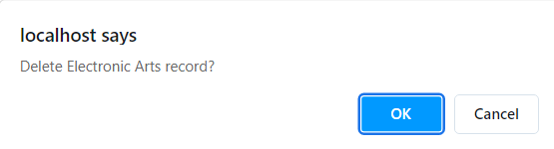

Figure 75: Delete Supplier Account Confirmation Message

Edit Publisher Detail Screen

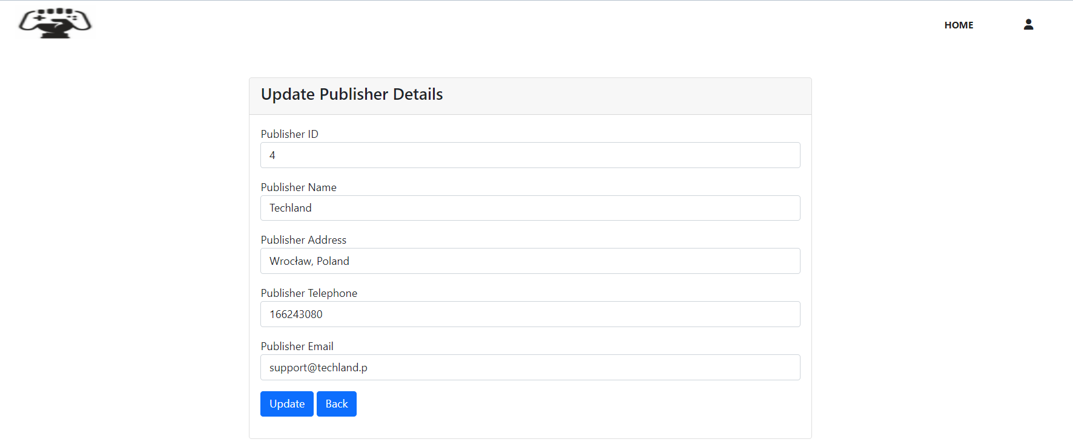

Figure 76: Edit Publisher Detail Screen

This is the screen of Edit Publisher Detail Screen. When staff is editing one publisher account, the publisher ID must insert correctly or else it does not update the supplier information. Staff can click update data when they finish inserting the information and it will pop out an alert message that says, “Publisher information is updated.” (figure).



Figure 77: Publisher Information Updated Message

View Game Screen

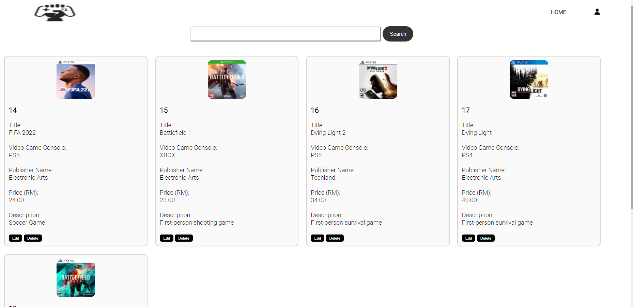

Figure 78: View Game Screen

This is the view sales page which allows staff to view the games sold by GFG company. It has provided details of the game such as Game ID, type of video game console, publisher and so on. Furthermore, it also has a delete function for staff to delete the game. When the staff wants to delete the game, it will pop out a delete confirmation message.

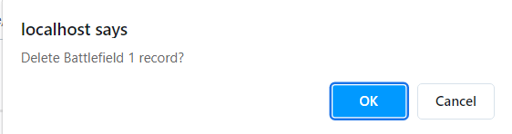

Figure 79: Delete Game Message

## 13.2 Guest

Guest Home Screen



Figure 80: Guest Home Screen

This image is the Guest Home Screen. This screen will be displayed to all user when they click on GFG folder in Wampserver. all users could choose either to view the video game catalog of GFG company, GFG compnay details or to login into the system.

Register Screen

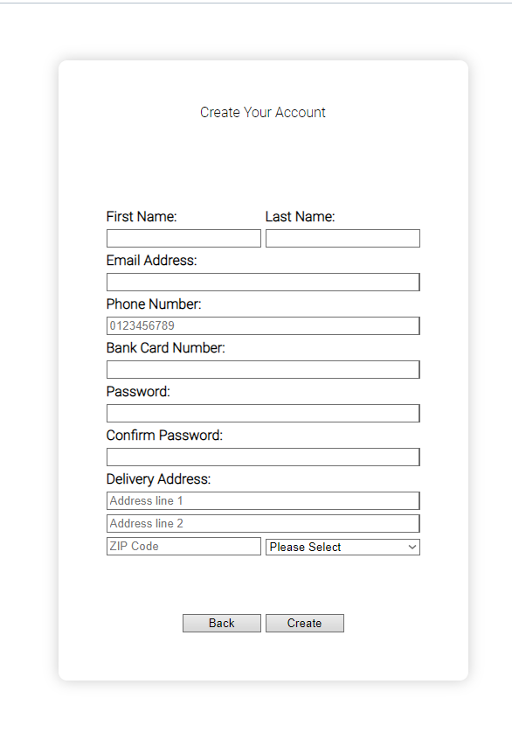

Figure 81: Register Screen

This diagram above is the Register screen for GFG system. Guests could register as members of GFG Company through filling up details into the text field of the Register screen. After filling up all text fields and fulling the requirements, guest would need to click on the Create button to complete registration as member. A Back button is provided to enable guest to return to the Login Screen.

Login Screen

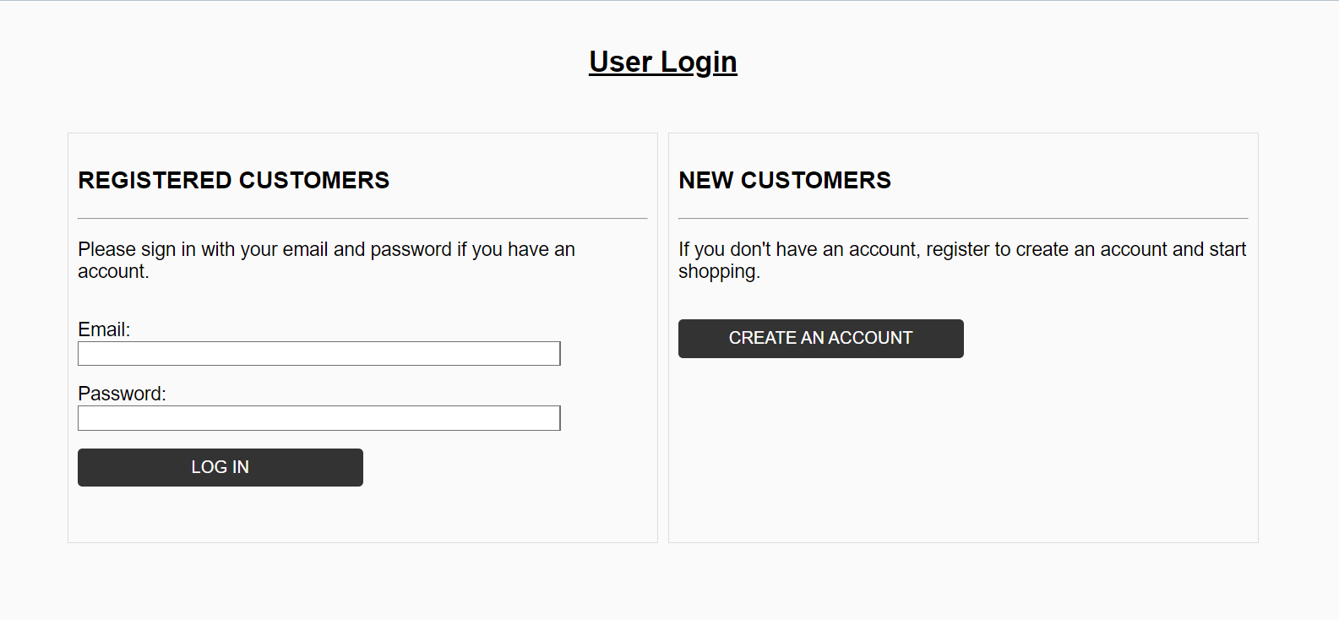

Figure 82: Login Screen

This is the GFG company login page which allows admin and member to login. It has two fields which are the Email and the Password. In the Email field is to insert email and the Password field is to insert password. When the email and password are correctly inserted, it will show a sign “Login Successfully”. If not correctly inserted, it will show a sign “The username or password entered is not valid. Please try again”. Guests can register an account for themselves as a customer of GFG by clicking the “CREATE AN ACCOUNT” button.

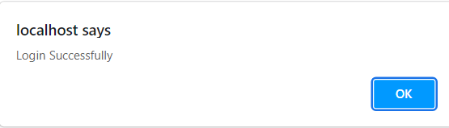

Figure 83: Login Successfully Message

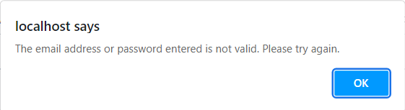

Figure 84: Login Unsuccessfully Alert Message

Guest Catalog Screen

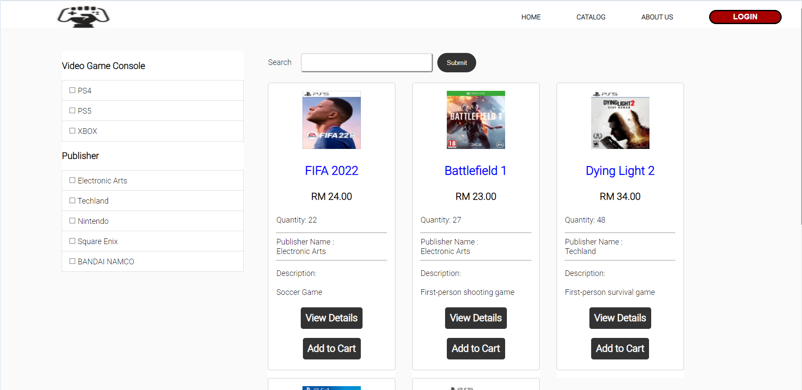

Figure 85: Guest Catalog Screen

The guest will be able to view the available games in GFG website which includes the stock quantity, publisher name, description, price, and name of the games. The guest able to check more information of the games that they interested by pressing the button “View Details”.

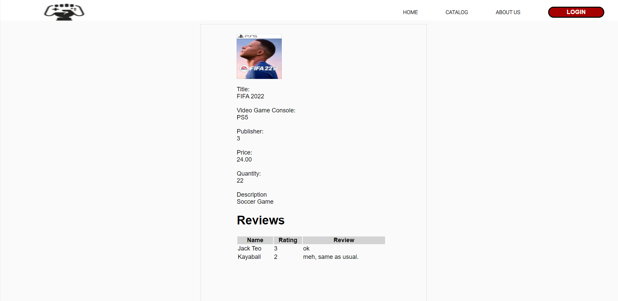

Figure 86: Guest View Game Details Page

The guest will see more information of the game such as Video Game Console, Publisher, and reviews. Int the “Reviews” section, the guest can view the rating by number 1 to 5 which from lowest to highest rating. Besides, review which written in words by GFG customer with their GFG account name will be shown in the “Reviews” section for guest.

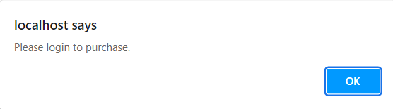

Figure 87: Guest Add to Cart *Message*

If the guest clicks on the “Add to Cart” button while they are not logged in to GFG website, the system will prompt a message “Please login to purchase.” to guest.

The guest can search specific games by typing the title of the game in the search box located at the top of the View Game Page. Next, the guest will see related games which match with the title name entered by guest as shown in the diagram below.

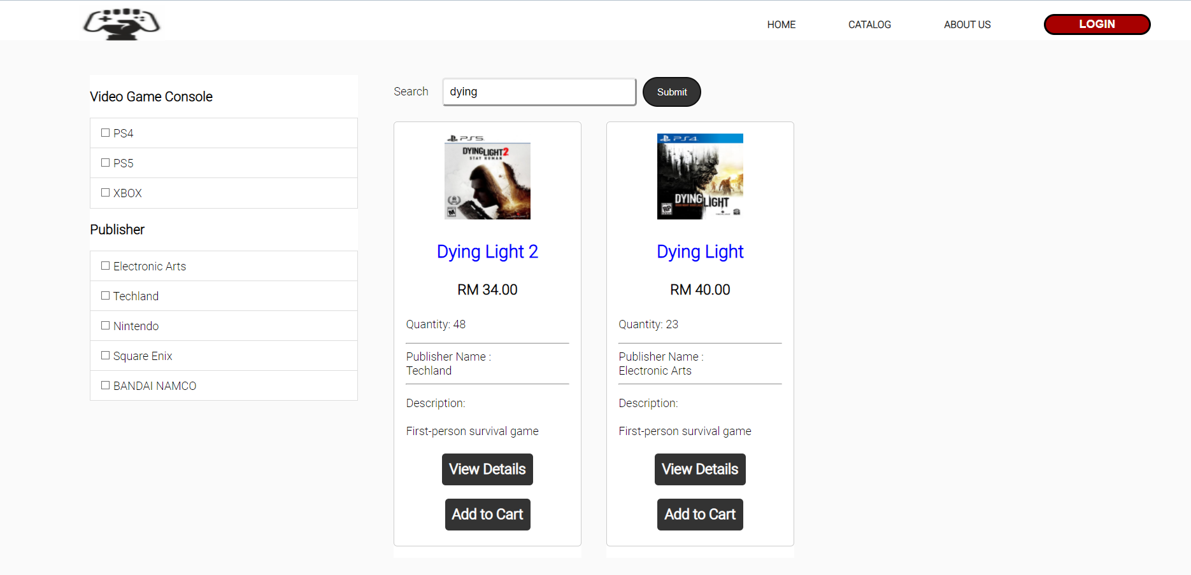

Figure 88: Guest Search Game by Title

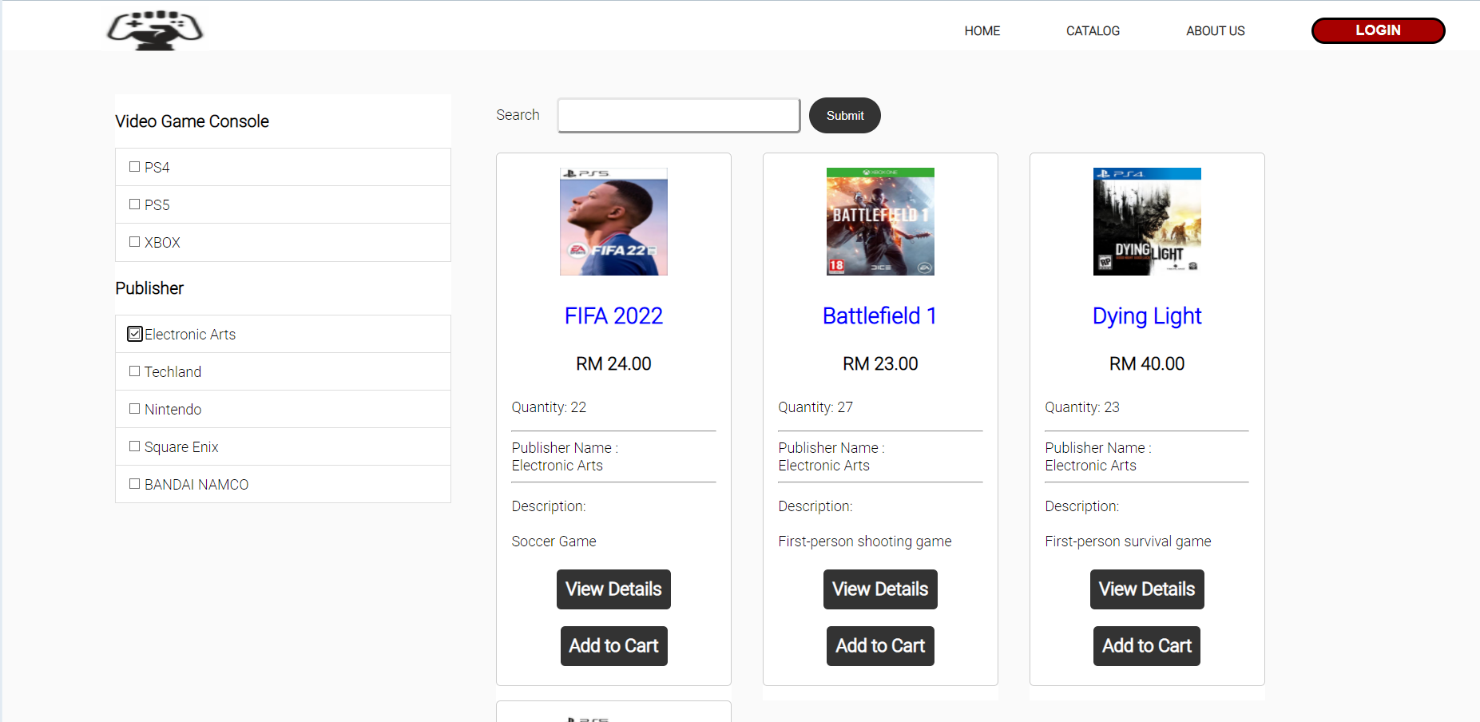

Figure 89: Guest Filter Game

The guest can also search their game by selecting the categories of Video Game Console and Publisher. By ticking the button on the left side of the page which include different categories, the guest can filter the games that they want to see.

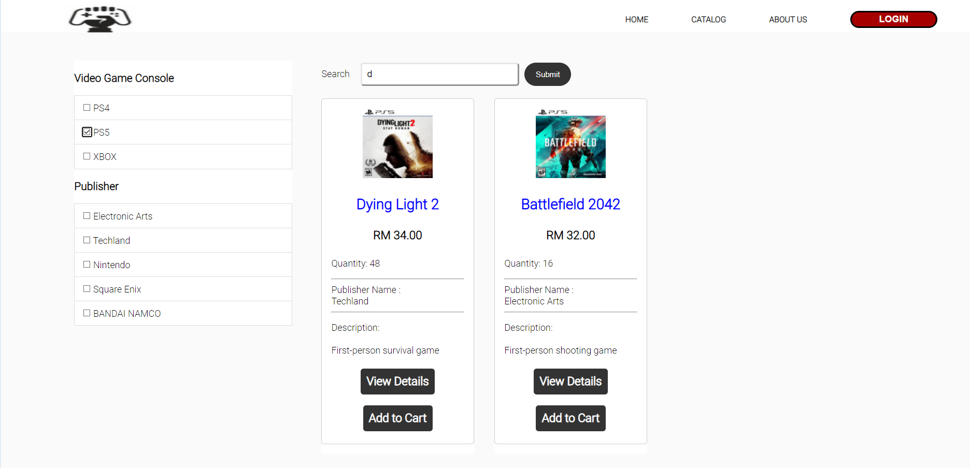

Figure 90: Guest Filter through Video Game Console

The guest will see the message “No Game Found” prompt if they had tick the categories which the games does not match with it as shown in the diagram above.

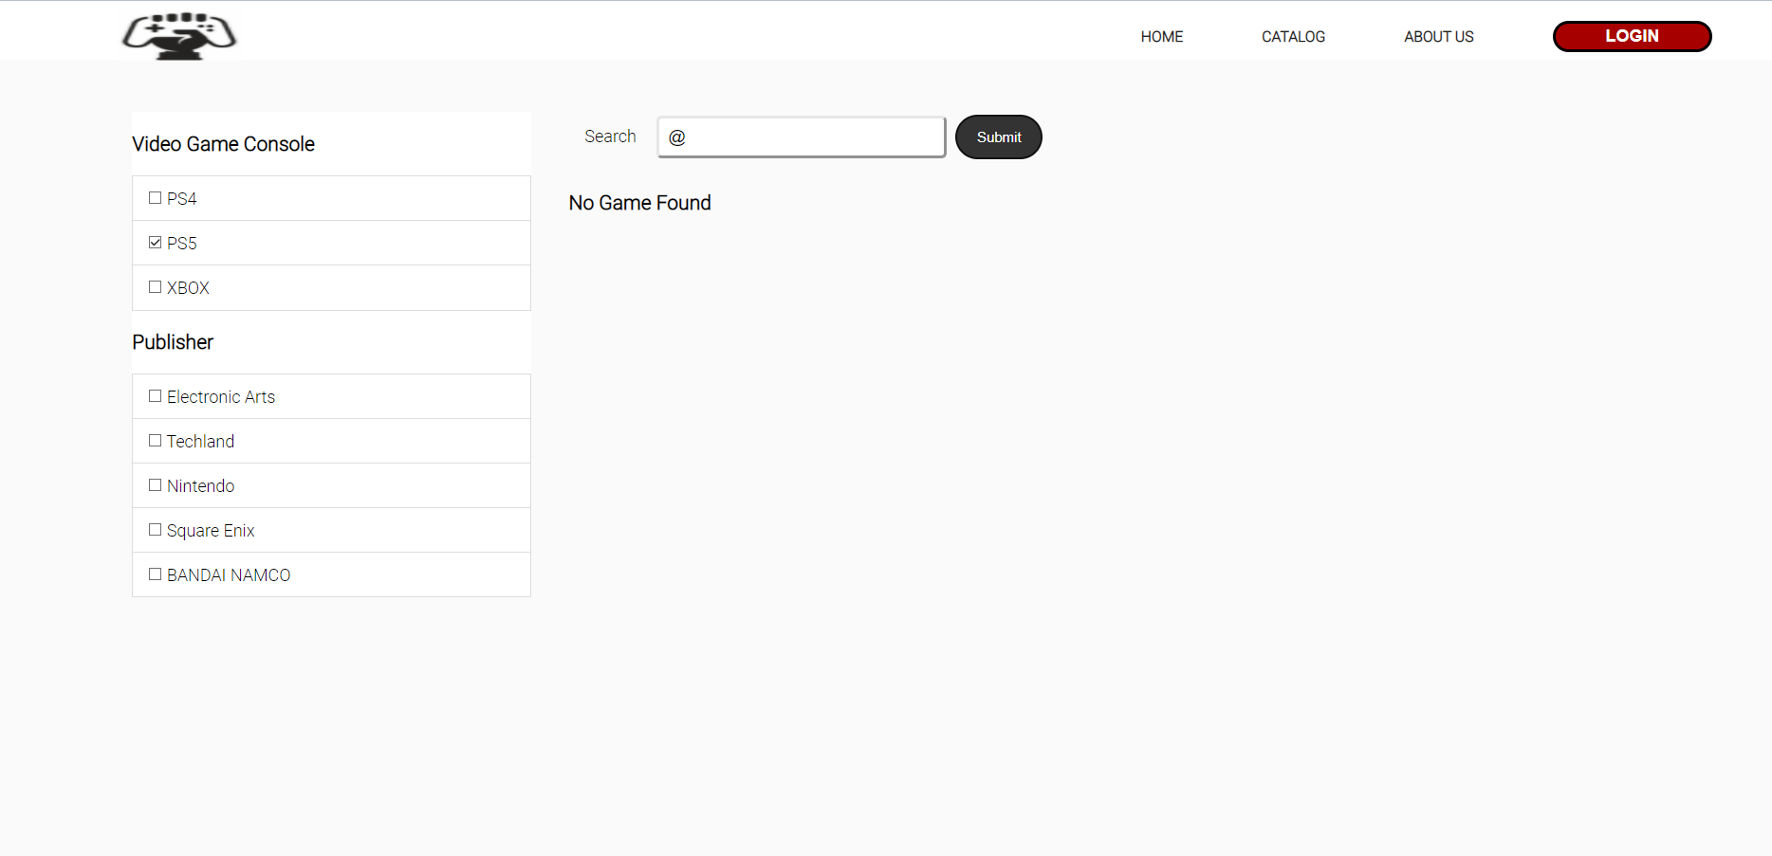

Figure 91: No Game Found

GFG Company Background and Contact Screen

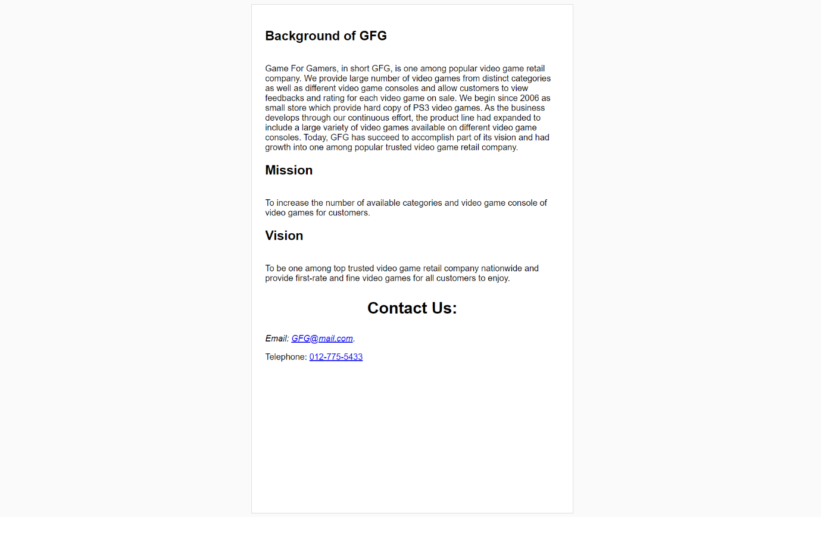

Figure 92: GFG Company Background and Contact Screen

The guest can also view the company history and contact GFG by either clicking the hyperlink for email or telephone.

## 13.4 Member

Member Home Screen



Figure 93: Member Home Screen

After member of GFG has entered the right email and password, they will be directed to the Member Home Screen. Member could access to catalog, company details, shopping cart, purchase history and account profile through this screen.

Member View Games Screen

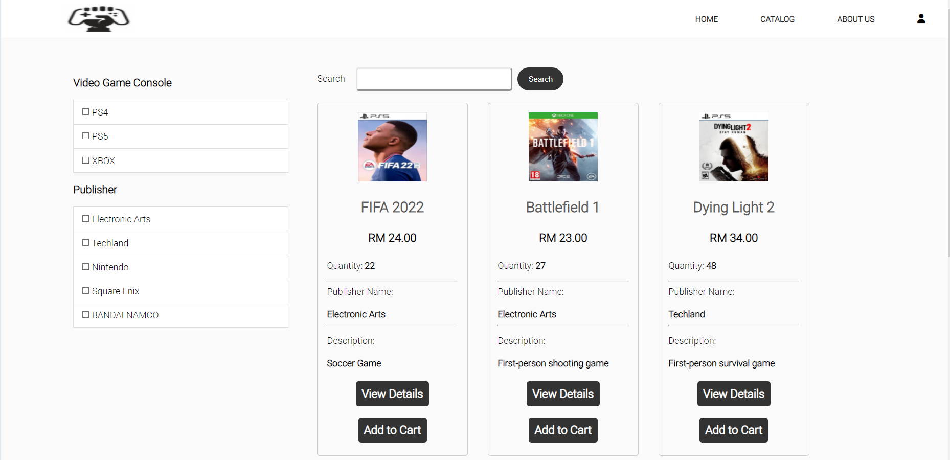

Figure 94: Member View Games Screen

After the member has log in successfully to GFG system, they can access the certain features similar with guest. For example, search the game by entering the game title, view game catalogue, filter game by Video Game Console or Publisher. However, the Add to Cart button will add the game to cart instead of informing users to login.

Member of GFG can provide their rating to the specific game after clicking on View Details button. The member able to give the rating of the game by open up the “Please select” button and select the rating they desired and add comment by typing their words in the box as shown in the diagram below.

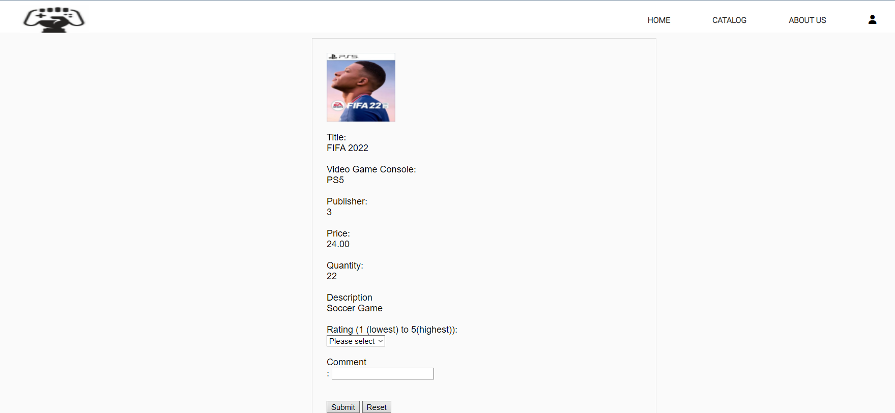

Figure 95: Member View Game Details Page



Figure 96:Reviews

Then, the member should click “Submit” button to add their rating and comment for the game in the “Reviews” section. A message “A comment is added.” will prompt out to the user as shown in the diagram below.

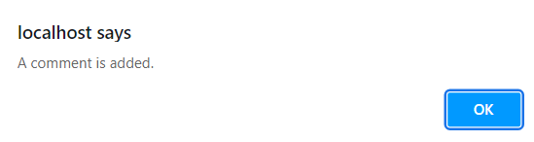

Figure 97: Comment Successful Message

Once the member clicks on “OK” button, they will see a new line of review has been added as shown in the diagram below.

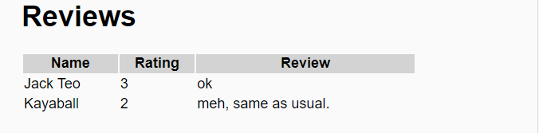

Figure 98: New Review

The member can also update their review by changing their rating and comments before they click on the “Update” button. Moreover, they can also delete their reviews to the game by clicking the “Delete” button.

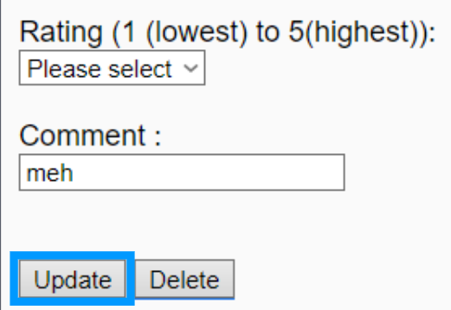

Figure 99: Update Comment button

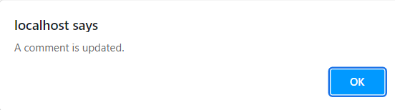

Figure 100: Comment Update Message

After the member click on the “Delete” button, the system will show a message to the user for confirmation to delete their review. A message “A comment is deleted” will be shown to the user after they click on “OK” button as shown below.

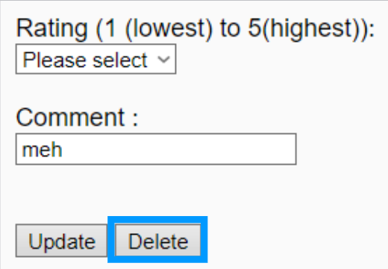

Figure 101: Delete Comment button

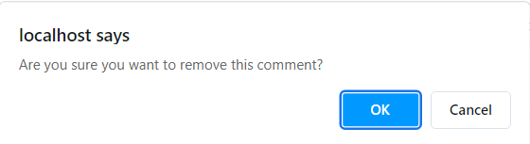

Figure 102:Comment Delete Confirmation Message

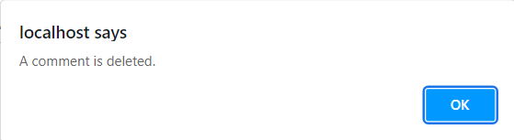

Figure 103: Comment Delete Successful Message

Cart Screen

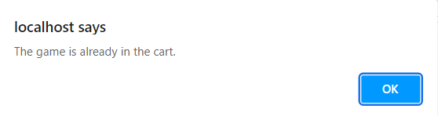

Figure 104: Game to Cart Succuss Message

The member can add their desired game to cart by clicking the “Add to Cart” button on View Game Page. Then, a message “A game is added to the cart” will shown to the user and they will see their selected game has been added to “My Cart” as shown below.

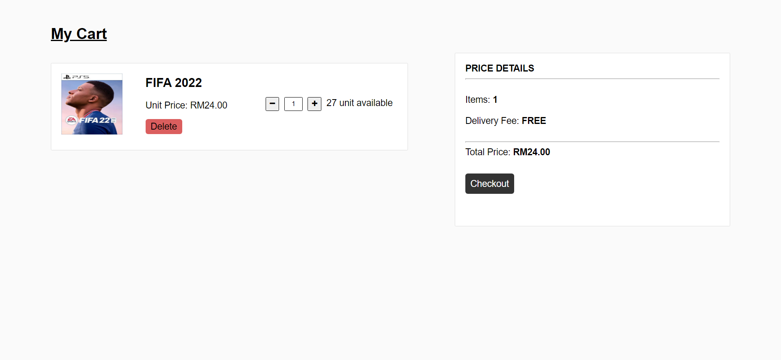

Figure 105: Member Cart Screen

The member can increase the amount of the game by pressing the “+” icon and the system will prompt a message “You have reached the maximum quantity.” if the user had entered the maximum amount of the unit as shown in the diagram below.

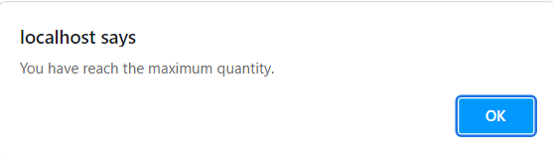

Figure 106: Quantity Up To Maximum Message

The member can checkout their payment by clicking the “Checkout” button in black colour box and a message “Are you sure you want to check out?” will be shown to user as shown in the diagram below.

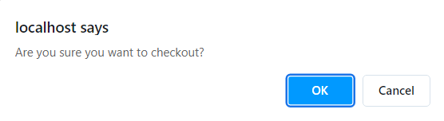

Figure 107: Confirm Checkout Message

After the member click on “OK” button on checkout page, a message “Successful” will be prompt to the user.

The member can delete the game from the cart by pressing the “Delete” button in dark red colour.

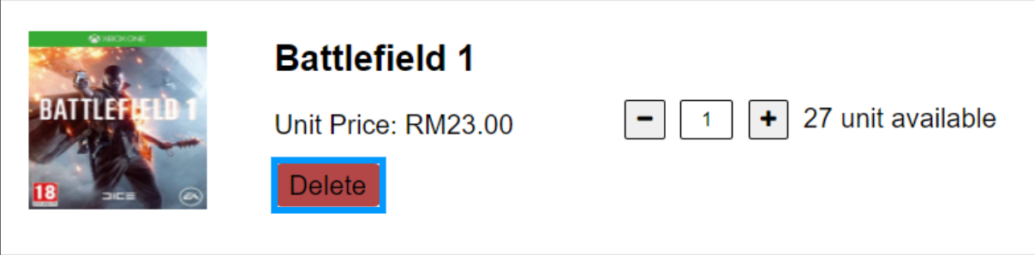

Figure 108: Delete Button

Then, a message “Are you sure you want to remove this from the cart?” will prompt to the user and the user click “OK” button, the game will then be removed from the cart as shown in the diagram below.

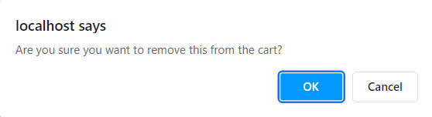

Figure 109: Confirmation to Remove Game from Cart Message

Company Details Screen

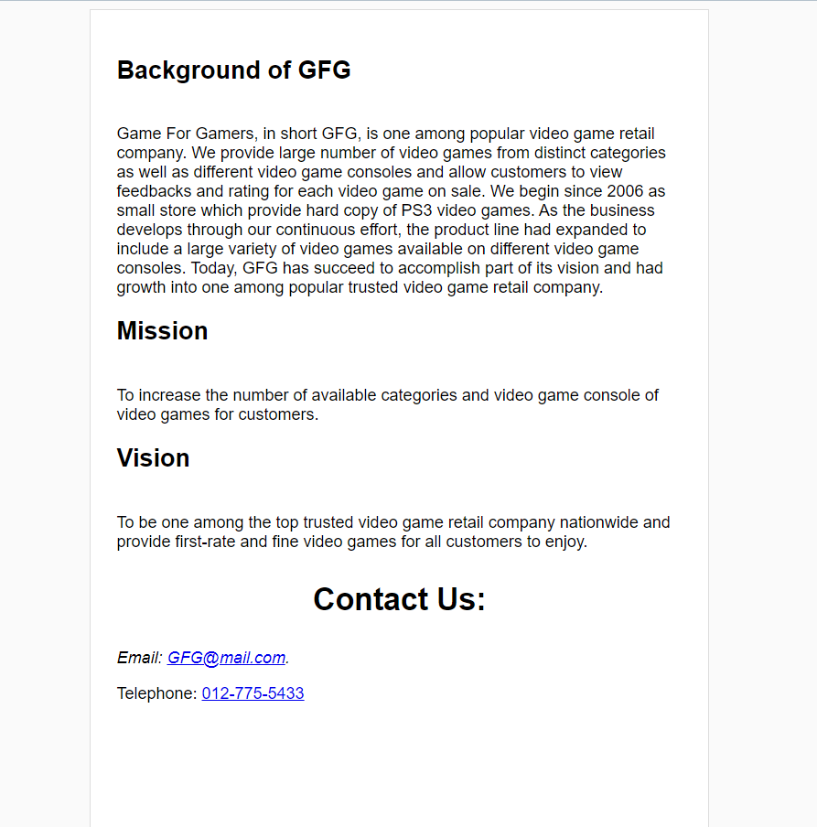

Figure 110: Company Details Screen

This screen is the screen which shows the details of GFG company which could be accessed through Member Home Screen. The background, mission and vision of GFG company is displayed in this screen. Member could contact GFG company via telephone through the telephone number hyperlink or email with the email hyperlink.

Member Profile Screen

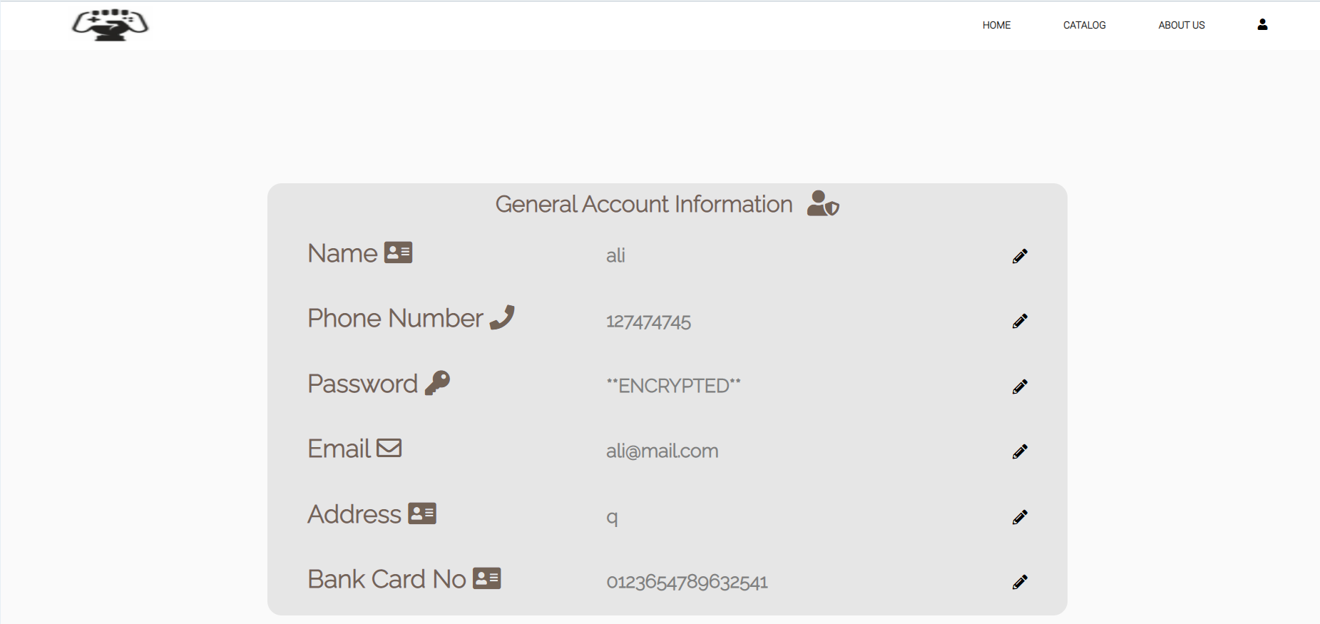

Figure 111: Member Profile Screen

This diagram above is the Member Profile Screen. The details of the account would be shown on this screen. Member could edit their personal details through clicking the pencil icon beside the particular section.

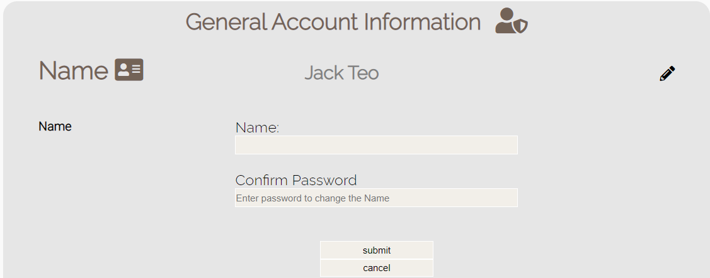

Figure 112: Name Tab

When the pencil icon is clicked, a tab will be shown below the section. For the image above, member will need to enter the new name and enter the right password followed with clicking on the Submit button to confirm the new name to be applied for the account. The Cancel button is mean to clear the text fields.

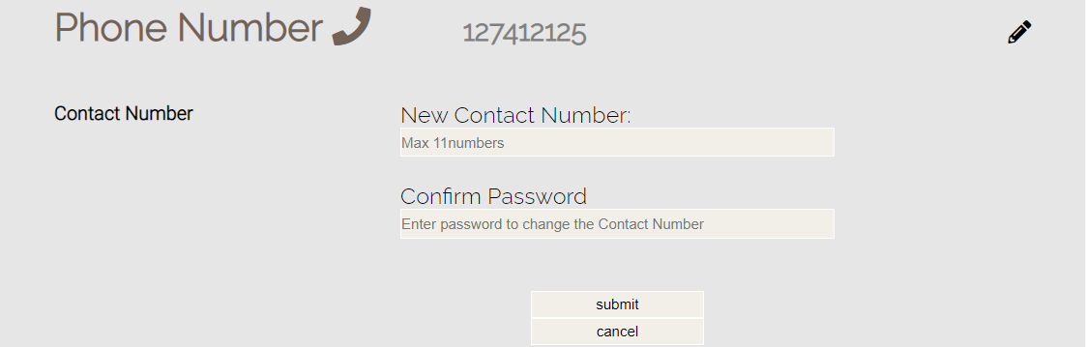

Figure 113: Phone Number Tab

As shown in the diagram above, the phone number tab is very similar to the other tabs but only with requirement to enter at least 10 digits in the text field to change the phone number.

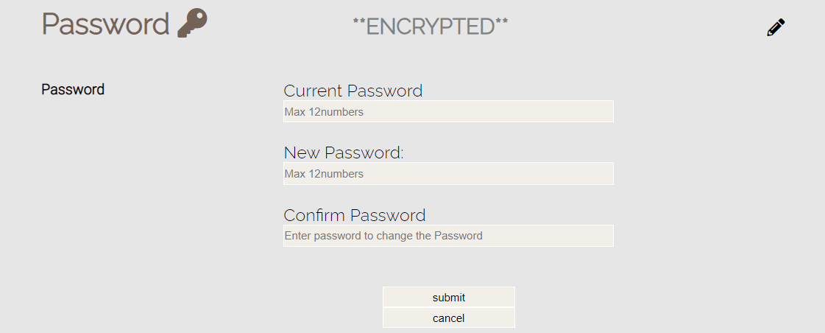

Figure 114: Password Tab

Different from the other tabs, the password tab will not show the password of the account. It is required for the member to enter the old password to confirm implementation of new password which is within 12 digits. To be noted that the new password will need to be entered twice to apply the new password.

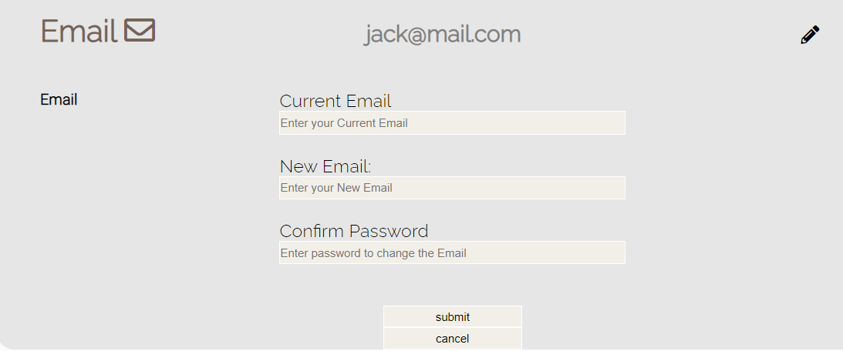

Figure 115: Email Tab

As for the email tab, it is very similar with the other tab. However, the new email must consist of the right format to replace the old email which is consist of “@” and “.com”.

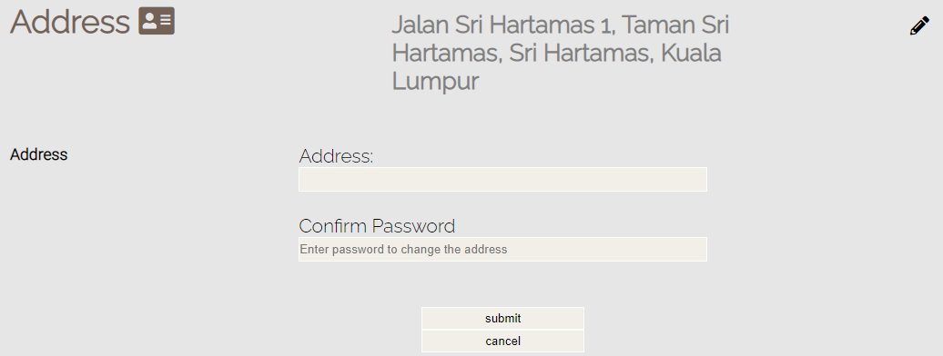

Figure 116: Address Tab

The image above is the Address tab. Similar with other tabs, member could view the current delivery address and edit it by entering new address, right password followed with clicking on the Submit button.

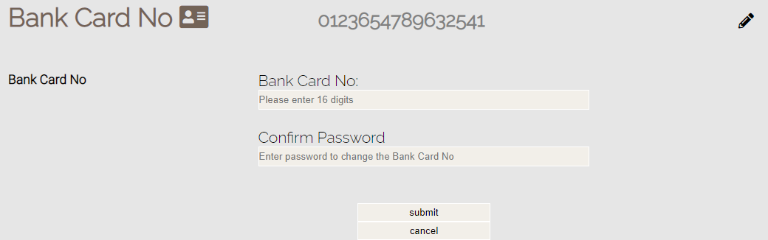

Figure 117: Bank Card No Tab

The image above is the Bank Card No tab. Similar with other tabs, member could see the bank card number and edit it by entering new bank card number within 16 digits, right password followed with clicking on the Submit button.

Member Purchase History Screen

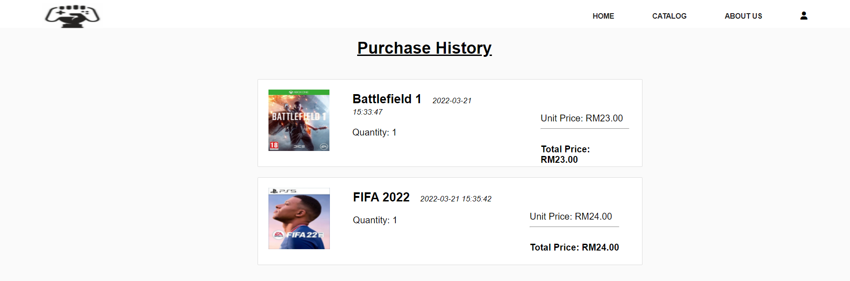

Figure 118: Member Purchase History Screen

This screen is the Member Purchase History Screen. It enables member to view past purchases made with the account.



Figure 119: No Purchase Has Been Made Screen

If no purchase has been made with this account, this screen will show and inform member that no purchases had been made with this account.

# 14.0 Report Design and User Manual

Report Generate Screen

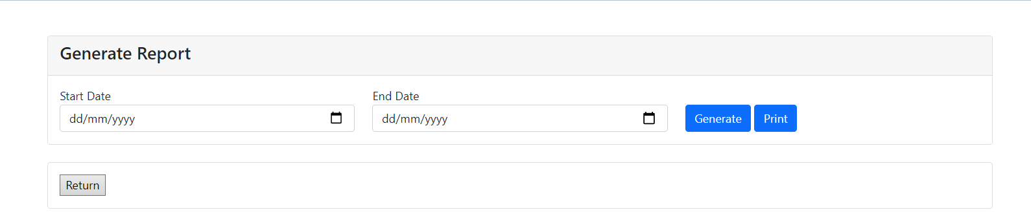

Figure 120: Report Generate Screen

The screen above is the report generate screen. Staff would only need to enter the start date and end date for report to be generated followed with clicking on the Generate button to generate report. a Print button is situated beside the Generate button to print the generated report.

Generated Report Screen

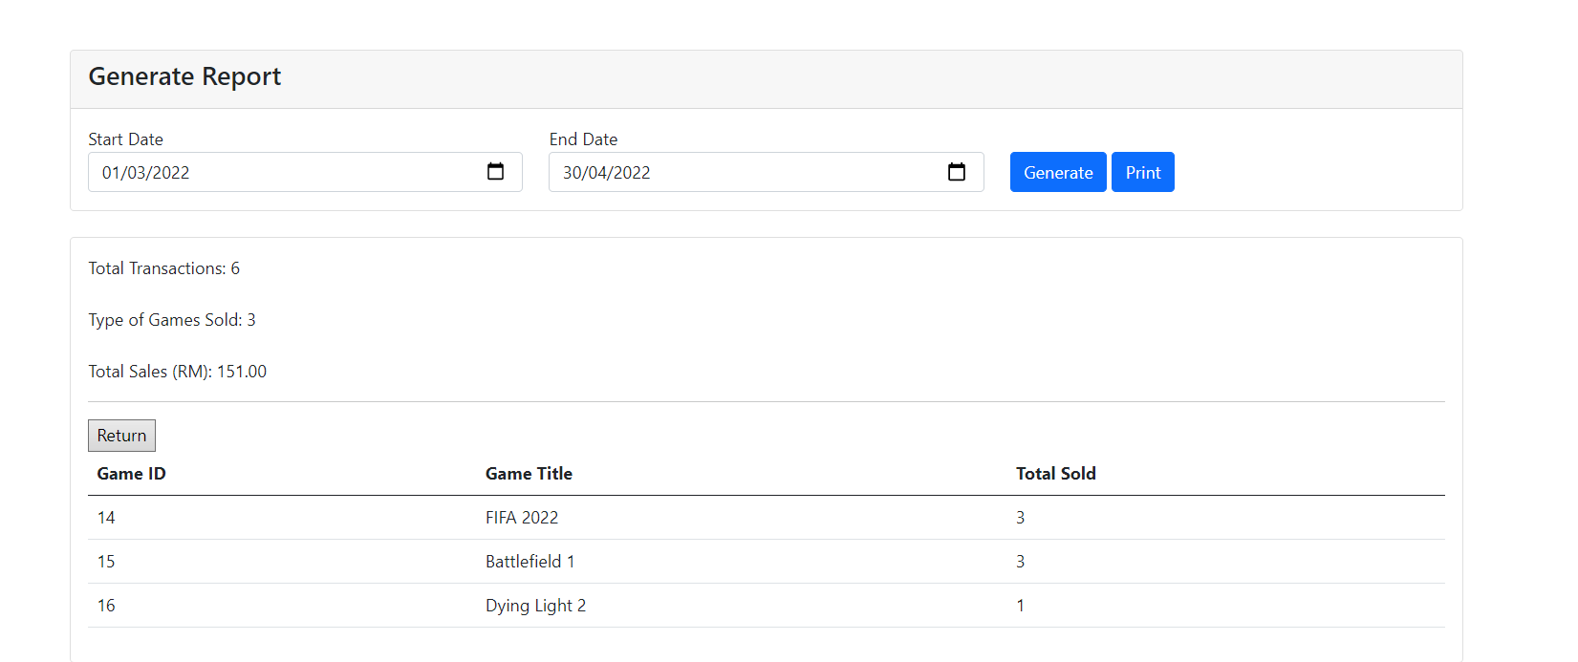

Figure 121: Generated Report Screen

The figure above is the screen which the report is generated. As shown in the figure above, the number of transactions, types of games sold and total sales during the period would be displayed.

A table would be positioned at below to enable staffs to view the ID of game, title of game and number of games being sold during the period. This would enable staff to analyse the latest popular game among gamers during the period.

Print Report Screen

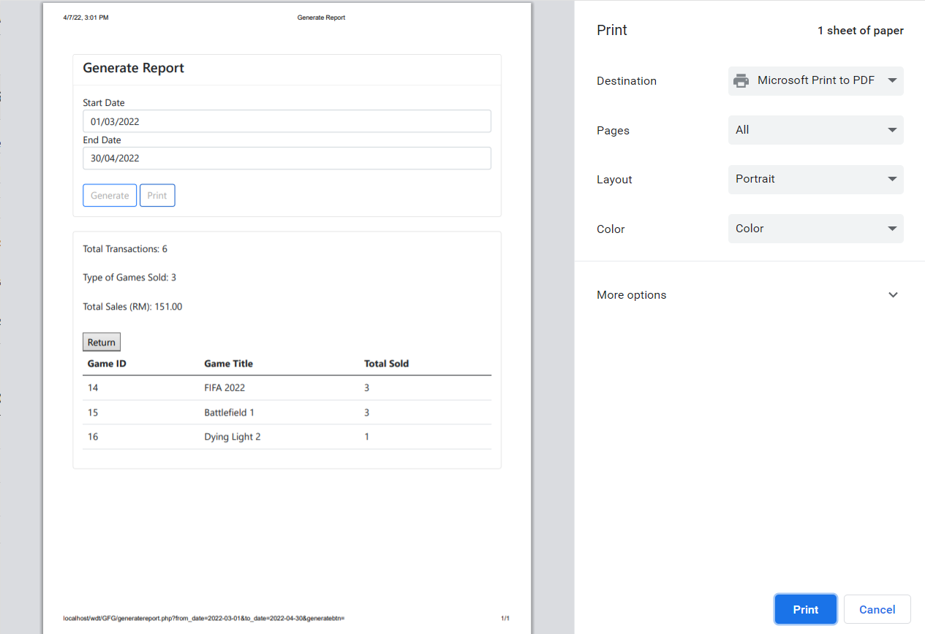

Figure 122: Print Report Screen

The diagram above is the interface design of the generated sales report from Generate Sales Report screen. As shown in the figure above, the total sales of GFG company within a certain duration could be generated through entering the date into the two date pickers. As a demonstration, the report of March has been generated. The number for total transactions made; amount for types of game sold and total sales made in the duration will be displayed.

In additional, the type of game sold will be displayed in the table below. To be detailed, the ID of video games, Title of game and amount of the game is sold are displayed in the table. This would enable company to generate clear analysis for popular games among gamers and enable the company to launch better business strategies and prepare better future business development plans.

# 15.0 Test Plan

## 15.1 Unit Testing

|  |  |  |  |  |  |  |  |
| --- | --- | --- | --- | --- | --- | --- | --- |
| Test Case | Test Unit | Test Procedures | Test Data | Expected Result | Actual Result | Status | Remarks |
| 1 | Add Publisher | 1. Insert publisher name, email, telephone and address 2. Click on Submit button | Name: Electronic Arts  Email: ea@mail.com  Telephone: 0  Address: Redwood City, California, United States | A message of “A new publisher is added.” pops out and publisher details is inserted into database | A message of “A new publisher is added.” pops out and publisher details is inserted into database | Pass | - |
|  | 1. Insert publisher name, email, telephone and address 2. Click on Rest button | Name: Electronic Arts  Email: ea@mail.com  Telephone: 0  Address: Redwood City, California, United States | All field are cleared | All field are cleared | Pass | - |
|  | 1. Insert publisher name, email, telephone and address 2. Click on Submit button | Name: Electronic Arts  Email: ea@mail.com  Telephone: 0  Address: Redwood City, California, United States | Submit failed and request to fill in correct format of email | Submit failed and request to fill in correct format of email | Pass | - |
|  | 1. All fields are left empty 2. Click on Submit button | - | Submit failed and request to fill in in all fields | Submit failed and request to fill in all fields | Pass | - |
|  | 1. Insert publisher name, email, telephone while address field is left empty 2. Click on Submit button | Name: Electronic Arts  Email: ea@mail.com  Telephone: 0 | Submit failed and request to fill in address field | Submit failed and request to fill in address field | Pass | - |
|  | 1. Insert publisher name, address, telephone while email field is left empty 2. Click on Submit button | Name: Electronic Arts  Telephone: 0  Address: Redwood City, California, United States | Submit failed and request to fill in address field | Submit failed and request to fill in address field | Pass | - |
|  | 1. Insert publisher email, address, telephone while name field is left empty. 2. Click on Submit button | Telephone: 0  Email: ea@mail.com  Address: Redwood City, California, United States | Submit failed and request to fill in address field | Submit failed and request to fill in address field | Pass | - |
|  | 1. Insert publisher name, address, email while telephone field is left empty. 2. Click on Submit button | Name: Electronic Arts  Email: ea@mail.com  Address: Redwood City, California, United States | Submit failed and request to fill in address field | Submit failed and request to fill in address field | Pass | - |

|  |  |  |  |  |  |  |  |
| --- | --- | --- | --- | --- | --- | --- | --- |
| Test Case | Test Unit | Test Procedures | Test Data | Expected Result | Actual Result | Status | Remarks |
| 2 | Edit Game | 1. Click on Delete hyperlink of a game | - | A message of “Delete [Title] record?.” pops out | A message of “Delete [Title] record?.” pops out | Pass | - |
|  | 1. Click on Delete hyperlink of a game 2. Click on Ok button of the alert box | - | The game is removed from database | The game is removed from database | Pass | - |
|  | 1. Search field is left empty 2. Click on Search button | - | The display of games remains same | The display of games remains same | Pass | - |
|  | 1. The search field is filled in with Title of a game in the database 2. Click on Search button | “FIFA 2022” is filled in | Only record of FIFA 2022 is shown | Only record of FIFA 2022 is shown | Pass | - |
|  | 1. The search field is filled in with Title of a game not in the database 2. Click on Search button | “FIFA 2026” is filled in | No games are shown | No games are shown | Pass | - |
|  | 1. Click on Edit hyperlink 2. Update details of FIFA 2022 3. Click on Update button | Title: FIFA 2022  Video game console: PS5  Publisher: EA  Price: 24.00  Quantity: 27  Description: Soccer game  Image (name): image_2022-02-18_155215.pn | A message of “The game detail is updated” shows up and details of game is updated in database | A message of “The game detail is updated” shows up and details of game is updated in database | Pass | - |
|  | 1. Click on Edit hyperlink 2. Click on Update button | Title: FIFA 2022  Video game console: PS5  Publisher: EA  Price: 24.00  Quantity: 27  Description: Soccer game | Submit failed and request to fill in image field | Submit failed and request to fill in image field | Pass | - |
|  | 1. Click on Edit hyperlink 2. Update game title 3. Click on Update button | Title: FIFA 2023 | A message of “The game detail is updated” shows up and details of game is updated in database | A message of “The game detail is updated” shows up and details of game is updated in database | Pass | - |
|  | 1. Click on Edit hyperlink 2. Update video game console 3. Click on Update button | Video game console: PS4 | A message of “The game detail is updated” shows up and details of game is updated in database | A message of “The game detail is updated” shows up and details of game is updated in database | Pass | - |
|  |  | 1. Click on Edit hyperlink 2. Update publisher 3. Click on Update button | Publisher: Techland | A message of “The game detail is updated” shows up and details of game is updated in database | A message of “The game detail is updated” shows up and details of game is updated in database | Pass | - |
|  |  | 1. Click on Edit hyperlink 2. Update price 3. Click on Update button | Price: 25.00 | A message of “The game detail is updated” shows up and details of game is updated in database | A message of “The game detail is updated” shows up and details of game is updated in database | Pass | - |
|  |  | 1. Click on Edit hyperlink 2. Update quantity 3. Click on Update button | Quantity: 30 | A message of “The game detail is updated” shows up and details of game is updated in database | A message of “The game detail is updated” shows up and details of game is updated in database | Pass | - |
|  |  | 1. Click on Edit hyperlink 2. Update description 3. Click on Update button | Description: Football game | A message of “The game detail is updated” shows up and details of game is updated in database | A message of “The game detail is updated” shows up and details of game is updated in database | Pass | - |
|  |  | 1. Click on Edit hyperlink 2. Update image 3. Click on Update button | Image (name): image_2022-02-18_155216.pn | A message of “The game detail is updated” shows up and details of game is updated in database | A message of “The game detail is updated” shows up and details of game is updated in database | Pass | - |

|  |  |  |  |  |  |  |  |
| --- | --- | --- | --- | --- | --- | --- | --- |
| Test Case | Test Unit | Test Procedures | Test Data | Expected Result | Actual Result | Status | Remarks |
| 3 | Edit Account | 1. Click on Delete hyperlink of an account | - | A message of “Delete [Member_ID] record?.” pops out | A message of “Delete [Member_ID] record?.” pops out | Pass | - |
| 1. Click on Delete hyperlink of an account 2. Click on Ok button of the alert box | - | The account is removed from database | The account is removed from database | Pass | - |
| 1. Search field is left empty 2. Click on Search button | - | The display of account remains same | The display of account remains same | Pass | - |
| 1. The search field is filled in with Name of an account in the database 2. Click on Search button | “Ali” is filled in | Only record of Ali is shown | Only record of Ali is shown | Pass | - |
| 1. The search field is filled in with Name of an account not in the database 2. Click on Search button | “Noel” is filled in | No accounts are shown | No accounts are shown | Pass | - |
| 1. Click on Edit hyperlink 2. Update details of Ali 3. Click on Update button | Name: Lim | A message of “Account information is updated.  ” shows up and details of account is updated in database | A message of “Account information is updated.  ” shows up and details of account is updated in database | Pass | - |
| 1. Click on Edit hyperlink 2. Update details of Ali 3. Click on Update button | Member Telephone: 0127258963 | A message of “Account information is updated.  ” shows up and details of account is updated in database | A message of “Account information is updated.  ” shows up and details of account is updated in database | Pass | - |
| 1. Click on Edit hyperlink 2. Update details of Ali 3. Click on Update button | Email: 2@mail.com | A message of “Account information is updated.  ” shows up and details of account is updated in database | A message of “Account information is updated.  ” shows up and details of account is updated in database | Pass | - |
| 1. Click on Edit hyperlink 2. Update details of Ali 3. Click on Update button | Password: lim | A message of “Account information is updated.  ” shows up and details of account is updated in database | A message of “Account information is updated.  ” shows up and details of account is updated in database | Pass | - |
| 1. Click on Edit hyperlink 2. Update details of Ali 3. Click on Update button | Member Address: 01 Taman Seri Tua | A message of “Account information is updated.  ” shows up and details of account is updated in database | A message of “Account information is updated.  ” shows up and details of account is updated in database | Pass | - |
| 1. Click on Edit hyperlink 2. Update details of Ali 3. Click on Update button | Bank Card Number: 0123456741 | A message of “Account information is updated.  ” shows up and details of account is updated in database | A message of “Account information is updated.  ” shows up and details of account is updated in database | Pass | - |

|  |  |  |  |  |  |  |  |
| --- | --- | --- | --- | --- | --- | --- | --- |
| Test Case | Test Unit | Test Procedures | Test Data | Expected Result | Actual Result | Status | Remarks |
| 4 | Login | 1. Enter account email address and password 2. Click login button | Email address:  ali@mail.com Password: 123456 | A message of “Login Successful.” pops out and access to member home page | A message of “Login Successfully.” pops out and access to member home page | Pass | - |
| 1. Enter incorrect account email address and correct password 2. Click login button | Email address:  Abu  Password: 123456 | A message of “The email address or password entered is not valid. Please try again.  ” pops out | A message of “The email address or password entered is not valid. Please try again.  ” pops out | Pass | - |
| 1. Enter correct account email address and incorrect password 2. Click login button | Email address:  ali@mail.com Password: 12345 | A message of “The email address or password entered is not valid. Please try again.  ” pops out | A message of “The email address or password entered is not valid. Please try again.  ” pops out | Pass | - |
| 1. Enter staff email and password 2. Click login button | Username:  admin  Password: admin | A message of “Login Successfully.” pops out and access to admin page | A message of “Login Successfully.” pops out and access to admin page | Pass | - |
| 1. Enter incorrect staff username and correct password 2. Click login button | Usernames:  admi  Password: admin | A message of “The username or password entered is not valid. Please try again.” pops out | A message of “The username or password entered is not valid. Please try again.” pops out | Pass | - |
| 1. Enter correct staff username and incorrect password 2. Click login button | Email address:  admin  Password: admi | A message of “The username or password entered is not valid. Please try again.” pops out | A message of “The username or password entered is not valid. Please try again.” pops out | Pass | - |

|  |  |  |  |  |  |  |  |
| --- | --- | --- | --- | --- | --- | --- | --- |
| Test Case | Test Unit | Test Procedures | Test Data | Expected Result | Actual Result | Status | Remarks |
| 5 | Game Catalog | 1. Search field is left empty 2. Click on Search button | - | The display of games remains same | The display of games remains same | Pass | - |
| 1. The search field is filled in with Title of a game in the database 2. Click on Search button | “2022” is filled in | Only record of FIFI 2022 is shown | Only record of FIFI 2022 is shown | Pass | - |
| 1. The search field is filled in with Title of a game not in the database 2. Click on Search button | “Us” is filled in | No games are shown | No games are shown | Pass | - |
| 1. A member log in and click on View Details button of FIFA 2022 | - | The member is directed to a page with detailed information and review of FIFA 2022 | The member is directed to a page with detailed information and review of FIFA 2022 | Pass | - |
| 1. A guest access to the Catalog and click on View Details button of FIFA 2022 | - | The guest is directed to a page with detailed information and review of FIFA 2022 | The guest is directed to a page with detailed information and review of FIFA 2022 | Pass | - |
| 1. A member log in and click on Add to Cart button of FIFA 2022 | - | A message of “A game is added to the cart.” shows up. | A message of “A game is added to the cart.” shows up. | Pass | - |
| 1. A guest clicks on Add to Cart button of FIFA 2022 | - | A message of “Please login to purchase.” shows up. | A message of “Please login to purchase.” shows up. | Pass | - |
| 1. Click on a check box of PS5 on Video Game Console column | - | Only video games available in PS5 are shown | Only video games available in PS5 are shown | Pass | - |
| 1. Click on a check box of Techland on Publisher column | - | Only video games published by Techland (Dying Light series) are shown | Only video games published by Techland (Dying Light series) are shown | Pass | - |
| 1. A member log in and click on Add to Cart button of FIFA 2022 when quantity is 0 | - | A message of “Currently this game is out of stock. Please wait for arrival of new stock” shows out | A message of “Currently this game is out of stock. Please wait for arrival of new stock” shows out | Pass | - |

|  |  |  |  |  |  |  |  |
| --- | --- | --- | --- | --- | --- | --- | --- |
| Test Case | Test Unit | Test Procedures | Test Data | Expected Result | Actual Result | Status | Remarks |
| 6 | Comment | 1. Access catalog page without log in as member | - | Capable to view reviews provided by members | Capable to view reviews provided by members | Pass | - |
| 1. Access catalog page as member 2. Fill in Rating and Comment Field 3. Click on Submit button | Rating: 4  Comment: ok | A message of “A comment is added.” pops out and the comment is shown below | A message of “A comment is added.” pops out and the comment is shown below | Pass | - |
| 1. Access catalog page as member 2. Edit in Rating and Comment Field 3. Click on Update button | Rating: 3  Comment: meh | A message of “A comment is updated.” pops out and the comment is shown below | A message of “A comment is updated.” pops out and the comment is shown below | Pass | - |
| 1. Access catalog page as member 2. Click on Delete button | - | A message of “A comment is deleted.” pops out and the comment is removed | A message of “A comment is deleted.” pops out and the comment is removed | Pass | - |

|  |  |  |  |  |  |  |  |
| --- | --- | --- | --- | --- | --- | --- | --- |
| Test Case | Test Unit | Test Procedures | Test Data | Expected Result | Actual Result | Status | Remarks |
| 7 | Company Profile | 1. Access Company Profile page | - | Company profile (background, vision and mission) are displayed | Company profile (background, vision and mission) are displayed | Pass | - |
| 1. Access Company Profile page 2. Click on email hyperlink | - | User to be directed to mail application to send email to GFG company | User to be directed to mail application to send email to GFG company |  |  |
| 1. Access Company Profile page 2. Click on telephone number hyperlink | - | User to be directed to use to contact GFG company with the telephone number | User to be directed to use to contact GFG company with the telephone number |  |  |

|  |  |  |  |  |  |  |  |
| --- | --- | --- | --- | --- | --- | --- | --- |
| Test Case | Test Unit | Test Procedures | Test Data | Expected Result | Actual Result | Status | Remarks |
| 8 | Game Cart | 1. Access game cart after adding a game into the cart 2. Click add button 3. Click on Checkout button 4. Confirm purchase | Item:2 | The number shown at items row becomes 2 and price become twice the original price.  A message of “Are you sure to you want to checkout” pops out followed with a message of “Successful!” pops out. Member would be directed to member home page | The number shown at items row becomes 2 and price become twice the original price.  A message of “Are you sure to you want to checkout” pops out followed with a message of “Successful!” pops out. Member would be directed to member home page | Pass | - |
| 1. Access game cart after adding a game into the cart 2. Click add button followed with minus button 3. Click on Checkout button 4. Confirm purchase | Item:1 | The number shown at items row becomes 1 and price remain the original price.  A message of “Are you sure to you want to checkout” pops out followed with a message of “Successful!” pops out. Member would be directed to member home page | The number shown at items row becomes 1 and price remain the original price.  A message of “Are you sure to you want to checkout” pops out followed with a message of “Successful!” pops out. Member would be directed to member home page | Pass | - |
| 1. Access game cart after adding a game into the cart 2. Click minus button 3. Click Ok button | - | A message of “Are you sure to remove this game from cart?” pops out followed with display of “ | A message of “Are you sure to remove this game from cart?” pops out followed with display of “Cart is empty” | Pass | - |
| 1. Access game cart after adding a game into the cart 2. Click Delete button | - | A message of “Are you sure to remove this game from cart?” pops out followed with display of “Cart is empty” | A message of “Are you sure to remove this game from cart?” pops out followed with display of “Cart is empty” | Pass | - |

|  |  |  |  |  |  |  |  |
| --- | --- | --- | --- | --- | --- | --- | --- |
| Test Case | Test Unit | Test Procedures | Test Data | Expected Result | Actual Result | Status | Remarks |
| 9 | Add game | 1. Access add game screen 2. Click Submit button | - | A message of “Please fill up this field” shows out and create game fails | A message of “Please fill up this field” shows out and create game fails | Pass | - |
| 1. Access add game screen 2. Fill in all fields 3. Click Submit button | Title: FIFA 2022  Video Game Console: PS5  Publisher ID: 3  Price: 24.00  Quantity: 22  Description: Soccer Game:  Game Pic: image_2022-02-18_155215.png | A message of “A new game is added.” pops out followed with staff would be directed to admin home page | A message of “A new game is added.” pops out followed with staff would be directed to admin home page | Pass | - |
| 1. Access add game screen 2. Fill in all fields 3. Click Reset button | Title: FIFA 2022  Video Game Console: PS5  Publisher ID: 3  Price: 24.00  Quantity: 22  Description: Soccer Game:  Game Pic: image_2022-02-18_155215.png | All text fields are cleared | All text fields are cleared | Pass | - |

|  |  |  |  |  |  |  |  |
| --- | --- | --- | --- | --- | --- | --- | --- |
| Test Case | Test Unit | Test Procedures | Test Data | Expected Result | Actual Result | Status | Remarks |
| 10 | Generate Report | 1. Click on Generate button while Start date and End date are empty | - | No report is generated and message of “Please enter start date and end date for report to be generated” shows out | No report is generated and message of “Please enter start date and end date for report to be generated” shows out | Pass | - |
| 1. The Start date is filled up 2. Click on Generate button | Start Date: 1/3/2022 | No report is generated and message of “Please ensure the start date is before the end date.” is shown | No report is generated and message of “Please ensure the start date is before the end date.” is shown | Pass | - |
| 1. The End date is filled up 2. Click on Generate button | End Date: 31/3/2022 | No report is generated and message of “Please enter start date and end date for report to be generated.” is shown | No report is generated and message of “Please enter start date and end date for report to be generated.” is shown | Pass | - |
| 1. Both Start date and End date are filled up 2. Click on Generate button | Start Date: 1/3/2022 End Date: 31/3/2022 | A report within March is generated | A report within March is generated | Pass | - |
| 1. Both Start date and End date are filled up but the End date is earlier than Start date 2. Click on Generate button | End Date: 1/3/2022 Start Date: 31/3/2022 | No report is generated and message of “Please ensure the start date is before the end date.” is shown | No report is generated and message of “Please ensure the start date is before the end date.” is shown | Pass | - |

|  |  |  |  |  |  |  |  |
| --- | --- | --- | --- | --- | --- | --- | --- |
| Test Case | Test Unit | Test Procedures | Test Data | Expected Result | Actual Result | Status | Remarks |
| 11 | View Receipt | 1. Enter the View Receipt Screen | - | All receipts are shown | All receipts are shown | Pass | - |
| 1. Click on Search button while Start date, End date and Search field are empty | - | No receipts are shown and message of “Please enter both start date and end date to view receipt during the period” shows out | No receipts are shown and message of “Please enter both start date and end date to view receipt during the period” shows out | Pass | - |
| 1. The Start date is filled up 2. Click on Search button | Start Date: 1/3/2022 | No receipts are shown and message of “Please ensure the end date is entered” shows out | No receipts are shown and message of “Please ensure the end date is entered” shows out | Pass | - |
| 1. The End date is filled up 2. Click on Search button | End Date: 31/3/2022 | No receipts are shown and message of “Please enter both start date and end date to view receipt during the period” shows out | No receipts are shown and message of “Please enter both start date and end date to view receipt during the period” shows out | Pass | - |
| 1. The Star Date and End date is filled up 2. The search fill is filled with a Receipt ID which exists 3. Click on Search button | Start Date: 1/3/2022 End Date: 31/3/2022  Search Field: 7 | Receipt with ID 7 in March is shown | Receipt with ID 7 in March is shown | Pass | - |
| 1. The Star Date and End date is filled up 2. The search fill is filled with an account name which exists 3. Click on Search button | Start Date: 1/3/2022 End Date: 31/3/2022  Search Field: Kayaball | All receipts made by account name Kayaball during the duration are shown | All receipts made by account name Kayaball during the duration are shown | Pass | - |
| 1. The Star Date and End date is filled up 2. The search fill is filled with a Receipt ID which does not exists 3. Click on Search button | Start Date: 1/3/2022 End Date: 31/3/2022  Search Field: qwertz | All receipts made during the duration are shown | All receipts made during the duration are shown | Pass | - |

|  |  |  |  |  |  |  |  |
| --- | --- | --- | --- | --- | --- | --- | --- |
| Test Case | Test Unit | Test Procedures | Test Data | Expected Result | Actual Result | Status | Remarks |
| 12 | Edit Company History | 1. Click on Edit Company History 2. Click Update button | Background: Game For Gamers, in short GFG  Mission: To increase the number of available categories  Vision: To be one among top trusted video game retail | A message of “Company History information is updated.” shows up and the content of company history is updated in database | A message of “Company History information is updated.” shows up and the content of company history is updated in database | Pass | - |
| 1. Click on Edit Company History 2. Update Background content 3. Click Update button | Background: Game For Gamers, in short GFG | A message of “Company History information is updated.” shows up and the content of company history is updated in database | A message of “Company History information is updated.” shows up and the content of company history is updated in database | Pass | - |
| 1. Click on Edit Company History 2. Update Mission content 3. Click Update button | Mission: To increase the number of available categories | A message of “Company History information is updated.” shows up and the content of company history is updated in database | A message of “Company History information is updated.” shows up and the content of company history is updated in database | Pass | - |
| 1. Click on Edit Company History 2. Update Vision content 3. Click Update button | Vision: To be one among top trusted video game retail | A message of “Company History information is updated.” shows up and the content of company history is updated in database | A message of “Company History information is updated.” shows up and the content of company history is updated in database | Pass | - |
|  |  | 1. Click on Edit Company History 2. Click Return button | - | Return to admin page | Return to admin page | Pass | - |

|  |  |  |  |  |  |  |  |
| --- | --- | --- | --- | --- | --- | --- | --- |
| Test Case | Test Unit | Test Procedures | Test Data | Expected Result | Actual Result | Status | Remarks |
| 13 | Edit Supplier | 1. Click on Delete hyperlink of a supplier account | - | A message of “Delete [Publisher_ID] record?.” pops out | A message of “Delete [Publisher_ID] record?.” pops out | Pass | - |
| 1. Click on Delete hyperlink of a supplier account 2. Click on Ok button of the alert box | - | The publisher account is removed from database | The publisher account is removed from database | Pass | - |
| 1. Search field is left empty 2. Click on Search button | - | The display of publisher accounts remains same | The display of publisher accounts remains same | Pass | - |
| 1. The search field is filled in with ID of publisher in the database 2. Click on Search button | “3” is filled in | Only record of publisher ID is 3 is shown | Only display the record publisher ID which is 3 | Pass | - |
| 1. The search field is filled in with not ID of publisher in the database 2. Click on Search button | “Electronic Arts” is filled in | No suppliers are shown | No suppliers are shown | Pass | - |
|  |  | 1. Click on supplier account with the publisher ID is 3 Edit hyperlink 2. Update details 3. Click on Update button | Publisher ID: 3  Publisher Name: Electronic Arts  Publisher Address: Redwood City, California, United States  Publisher Telephone: 0123456789  Publisher Email: [isme@gmail.com](mailto:isme@gmail.com) | A message of “Supplier information is updated. ” shows up and details of publisher account is updated in database | A message of “Supplier information is updated. ” shows up and details of publisher account is updated in database | Pass | - |
|  |  | 1. Click on supplier account with the publisher ID is 4 Edit hyperlink 2. Update details 3. Click on Update button | Publisher ID: 3  Publisher Name: Techland  Publisher Address: WrocÅ‚aw, Poland  Publisher Telephone: 0123456789  Publisher Email: [isme@gmail.com](mailto:isme@gmail.com) | A message of “Supplier information is not updated. Please check the Publisher ID inserted correctly.” shows up and details of publisher account is not updated in database | A message of “Supplier information is updated. ” shows up and details of publisher account is not updated in database | Half Pass | Publisher ID must be correct then only can update the information |
|  |  | 1. Click on one of the supplier accounts Edit hyperlink 2. Click Return button | - | Return to view supplier page | Return to view supplier page | Pass | - |
|  |  | 1. Click on Edit Supplier Detail 2. Click Return button | - | Return to admin page | Return to admin page | Pass | - |
| Test Case | Test Unit | Test Procedures | Test Data | Expected Result | Actual Result | Status | Remarks |
| 14 | Logout | 1. Login as member. 2. Click Logout button 3. Click on back button | - | User is logged out and a “Please Login!” message is shown. | User is logged out and a “Please Login!” message is shown. | Pass | - |
|  |  | 1. Login as admin. 2. Click Logout button 3. Click on back button | - | User is logged out and a “Please Login!” message is shown. | User is logged out and a “Please Login!” message is shown. | Pass | - |

|  |  |  |  |  |  |  |  |
| --- | --- | --- | --- | --- | --- | --- | --- |
| Test Case | Test Unit | Test Procedures | Test Data | Expected Result | Actual Result | Status | Remarks |
| 15 | Member View Purchase History | 1. Login an account as member which has purchased before 2. Click Order button | - | Past purchase records are shown | Past purchase records are shown. | Pass | - |
|  |  | 1. Login an account as member which has no purchased record 2. Click Order button | - | “No order has been made” is shown. | “No order has been made” is shown. | Pass | - |

|  |  |  |  |  |  |  |  |
| --- | --- | --- | --- | --- | --- | --- | --- |
| Test Case | Test Unit | Test Procedures | Test Data | Expected Result | Actual Result | Status | Remarks |
| 16 | Member Profile | 1. Login as member. 2. Click Account button | - | Account information is displayed in General Account Information tab | Account information is displayed in General Account Information tab | Pass | - |
|  |  | 1. Login as member. 2. Click Account button 3. Click on pencil icon | - | A tab is displayed below General Account Information tab which allows member to change user profile | A tab is displayed below General Account Information tab which allows member to change user profile | Pass | - |
|  |  | 1. Login as member. 2. Click Account button 3. Click on pencil icon beside Name section 4. Enter new name and right password | Name: Jack Teo1  Password: jackteo | The name displayed on General Account Information tab is changed | The name displayed on General Account Information tab is changed | Pass | - |
|  |  | 1. Login as member. 2. Click Account button 3. Click on pencil icon beside Name section 4. Enter new name and wrong password | Name: Jack Teo  Password: jack | “Password incorrect” message is displayed and the name is not changed | “Password incorrect” message is displayed and the name is not changed | Pass | - |
|  |  | 1. Login as member. 2. Click Account button 3. Click on pencil icon beside Phone Number section 4. Enter new phone number and right password | Phone Number: 127412125  Password: jackteo | The Phone Number displayed on General Account Information tab is changed | The Phone Number displayed on General Account Information tab is changed | Pass | - |
|  |  | 1. Login as member. 2. Click Account button 3. Click on pencil icon beside Password section 4. Enter new password and wrong old password | New Password: 123456  Confirm Password: 123456  Password: jackte | “Password or new password wrong” message is displayed and the password is not changed | “Password or new password wrong” message is displayed and the password is not changed | Pass | - |
|  |  | 1. Login as member. 2. Click Account button 3. Click on pencil icon beside Password section 4. Enter new password and right old password | New Password: 123456  Confirm Password: 123456  Password: jackteo | Based on localhost database, password is changed | Based on localhost database, password is changed | Pass | - |
|  |  | 1. Login as member. 2. Click Account button 3. Click on pencil icon beside Password section 4. Enter new password which does not match with confirm password and right old password | New Password: 123456  Confirm Password: 12345  Password: jackteo | “Password or new password wrong” message is displayed and the password is not changed | “Password or new password wrong” message is displayed and the password is not changed | Pass | - |
|  |  | 1. Login as member. 2. Click Account button 3. Click on pencil icon beside Name section 4. Enter name and password 5. Click Cancel button | Name: Jack Teo  Password: jack | The text field is reset to blank | The text field is reset to blank | Pass | - |
|  |  | 1. Login as member. 2. Click Account button 3. Click on pencil icon beside Email section 4. Enter new email and right password | Email: jack@mail.com  New email: jackt@mail.com  Password: jackteo | The email displayed on General Account Information tab is changed | The email displayed on General Account Information tab is changed | Pass | - |
|  |  | 1. Login as member. 2. Click Account button 3. Click on pencil icon beside Email section 4. Enter new email and wrong password | Email: jack@mail.com  New email: jackt@mail.com  Password: jackteo | “Email or password incorrect” message is displayed and the email is not changed | “Email or password incorrect” message is displayed and the email is not changed | Pass | - |
|  |  | 1. Login as member. 2. Click Account button 3. Click on pencil icon beside Address section 4. Enter new address and right password | New address: Jalan Sri Hartamas 1, Taman Sri Hartamas, Sri Hartamas, Kuala Lumpur  Password: jackteo | The address displayed on General Account Information tab is changed | The address displayed on General Account Information tab is changed | Pass | - |
|  |  | 1. Login as member. 2. Click Account button 3. Click on pencil icon beside Address section 4. Enter new address and wrong password | New address: Jalan Sri Hartamas 1, Taman Sri Hartamas, Sri Hartamas, Kuala Lumpur1  Password: jackte | “Password incorrect” message is displayed and the address is not changed | “Password incorrect” message is displayed and the address is not changed | Pass | - |
|  |  | 1. Login as member.  2. Click Account button  3. Click on pencil icon beside Address section  4. Enter new bank card number and right password | Bank Card Number: 1111111111111111  Password: jackteo | The email displayed on General Account Information tab is changed | The email displayed on General Account Information tab is changed | Pass | - |
|  |  | 1. Login as member.  2. Click Account button  3. Click on pencil icon beside Address section  4. Enter new bank card number and wrong password | Bank Card Number: 1111111111111111  Password: jackte | “Password incorrect” message is displayed and the bank card number is not changed | “Password incorrect” message is displayed and the bank card number is not changed | Pass | - |

## 

## 15.2 User Acceptance Test

|  |  |
| --- | --- |
| Tester Profile | |
| Test Case No: | 1 |
| Developer Involved: | Foong Wai Keat |
| Name: | Foong Wai Tuck |
| Position: | Admin |
| Email: | Tp053060@mail.apu.edu.my |
| Date: | 8th April 2022 |
| Time: | 10:22 A.M |

Appreciate the participation towards the testing phase of GFG website. Within this User Acceptance Testing (UAT) tester, you are required to carry our tests based on the test cases specified below. Please approach the developer team is have any queries while testing. Thank you for the co-operation.

The scale below symbolizes the rating for the test below:

.1 - Poor . 2 - Moderate • 3 - Satisfied . 4 - Good • 5- Excellent

Please fill in the criteria below based on the scale above

Error Prevention and Correction

|  |  |  |  |
| --- | --- | --- | --- |
| No | Criteria | Rating | Comment |
| 1. | Error messages will be displayed when errors are detected | 5 | Yes, error messages will display when triggered. |
| 2. | Error messages are easy and simple to understand | 4 | Yes, most error messages will describe the errors made. |
| 3. | Error messages are stated precisely | 4 | Most error messages will describe the errors. |
| 4. | Specific process could be cancelled by user | 4 | Yes, most processes can be cancelled by admin. |
| 5. | System is free from any errors and crashes | 5 | No crashes are met when testing. |
| 6. | Error messages displayed have options prompt | 3 | Error messages displayed have does not have options prompt by provide reasons of error. |

Consistency

|  |  |  |  |
| --- | --- | --- | --- |
| No | Criteria | Rating | Comment |
| 1. | Representation symbols and icons are being used consistently | 5 | Yes, similar symbols and icons are being used consistently. |
| 2. | Colour used are consistent | 5 | Most background is white in colour and theme is remained. |
| 3. | Information provided are consistent | 5 | Information provided to admin is consistent. |
| 4. | Formats used are consistent | 3 | Some format used by pages are different from other pages. |
| 5. | Fonts used are consistent | 4 | Most fonts used are consistent except for some pages (edit company background page). |

Performance

User Usability

|  |  |  |  |
| --- | --- | --- | --- |
| No | Criteria | Rating | Comment |
| 1. | Limitations on uncertainty where to input data | 5 | Each input of data is stated clearly. |
| 2. | Data input process takes a lot of time | 5 | Data input process does not take a lot of time. |
| 3. | Functions have limitations and uncertainty | 4 | Most functions do not have limitations and uncertainty |
| 4. | System is user-friendly | 5 | Yes, the overall system is user-friendly |

|  |  |  |  |
| --- | --- | --- | --- |
| No | Criteria | Rating | Comment |
| 1. | Application executed without any error | 5 | Yes, application executed without any error |
| 2. | Application executed without any crashes | 5 | Yes, application executed without any crashes |
| 3. | Application executed without any delay | 5 | Yes, application executed without any delay |
| 4. | Battery drains faster than usual when using the application | 4 | Yes, battery drains a bit faster than usual |
| 5. | Log in verification is time consuming | 5 | No, log in verification is not time consuming |

|  |
| --- |
| Tester Comment |
| The overall theme is too white in colour.  The validation for receipt and report viewing feature could be improved |
| Developer Comment |
| Indeed, the theme for admin screen are too white in colour and there is some wrong display of error message for view receipt and report screen |

|  |  |
| --- | --- |
| Tester Profile | |
| Test Case No: | 2 |
| Developer Involved: | Foong Wai Keat |
| Name: | Chin Xin Da |
| Position: | Member |
| Email: | Tp061071@mail.apu.edu.my |
| Date: | 9/4/2022 |
| Time: | 8:10 P.M |

Appreciate the participation towards the testing phase of GFG website. Within this User Acceptance Testing (UAT) tester, you are required to carry our tests based on the test cases specified below. Please approach the developer team is have any queries while testing. Thank you for the co-operation.

The scale below symbolizes the rating for the test below:

.1 - Poor . 2 - Moderate • 3 - Satisfied . 4 - Good • 5- Excellent

Please fill in the criteria below based on the scale above

Error Prevention and Correction

|  |  |  |  |
| --- | --- | --- | --- |
| No | Criteria | Rating | Comment |
| 1. | Error messages will be displayed when errors are detected | 4 | Most errors will provide error messages |
| 2. | Error messages are easy and simple to understand | 5 | Most error messages are clear to understand |
| 3. | Error messages are stated precisely | 4 | Most error messages are stated precisely |
| 4. | Specific process could be cancelled by user | 4 | There are certain processes will stuck while executing (change member profile) |
| 5. | System is free from any errors and crashes | 4 | A crash is spotted while testing change member profile. Other features are fine |
| 6. | Error messages displayed have options prompt | 3 | Error messages displayed will only show reason of error |

Consistency

|  |  |  |  |
| --- | --- | --- | --- |
| No | Criteria | Rating | Comment |
| 1. | Representation symbols and icons are being used consistently | 5 | Most symbols and icons are used consistently |
| 2. | Colour used are consistent | 5 | Colour used for theme and buttons are consistent |
| 3. | Information provided are consistent | 5 | Most Information provided are consistent |
| 4. | Formats used are consistent | 5 | Most pages have same format |
| 5. | Fonts used are consistent | 5 | Most fonts have same format |

Performance

User Usability

|  |  |  |  |
| --- | --- | --- | --- |
| No | Criteria | Rating | Comment |
| 1. | Limitations on uncertainty where to input data | 4 | Most text fields provide instructions on what to fill in |
| 2. | Data input process takes a lot of time | 4 | If no crash occur, data input process does not take long time |
| 3. | Functions have limitations and uncertainty | 3 | There are certain issues with change member profile page which cause sometimes the page turns white and froze |
| 4. | System is user-friendly | 4 | Overall system is user-friendly, but the cart is too hidden, should be shown in the navigation bar |

|  |  |  |  |
| --- | --- | --- | --- |
| No | Criteria | Rating | Comment |
| 1. | Application executed without any error | 5 | Error does not occur when testing |
| 2. | Application executed without any crashes | 4 | Crash found on member profile page which cause sometimes the page turns white and froze |
| 3. | Application executed without any delay | 4 | Application executed without delay is no crash occurs on member profile page |
| 4. | Battery drains faster than usual when using the application | 4 | Battery drains slightly faster than usual |
| 5. | Log in verification is time consuming | 5 | Rapid login verification |

|  |
| --- |
| Tester Comment |
| Crash happens sometimes on member profile page when changing member profile.  The Cart button is too hidden, need to place on navigation bar. |
| Developer Comment |
| Yes, sometimes crash happens on member profile page due to unknown reason, possibly the validations and sql command need to improve.  Noted. Will try to move the Cart button on navigation bar. (9/4/2022 - due to limited technical skill, the issue could not be fix) |

|  |  |
| --- | --- |
| Tester Profile | |
| Test Case No: | 3 |
| Developer Involved: | Foong Wai Keat |
| Name: | Wong Kai Bo |
| Position: | Guest |
| Email: | kaibo@gmail.com |
| Date: | 8/4/2022 |
| Time: | 12 P.M |

Appreciate the participation towards the testing phase of GFG website. Within this User Acceptance Testing (UAT) tester, you are required to carry our tests based on the test cases specified below. Please approach the developer team is have any queries while testing. Thank you for the co-operation.

The scale below symbolizes the rating for the test below:

.1 - Poor . 2 - Moderate • 3 - Satisfied . 4 - Good • 5- Excellent

Please fill in the criteria below based on the scale above

Error Prevention and Correction

|  |  |  |  |
| --- | --- | --- | --- |
| No | Criteria | Rating | Comment |
| 1. | Error messages will be displayed when errors are detected | 5 | - |
| 2. | Error messages are easy and simple to understand | 5 | - |
| 3. | Error messages are stated precisely | 5 | - |
| 4. | Specific process could be cancelled by user | 5 | - |
| 5. | System is free from any errors and crashes | 4 | Sometimes will stuck at login.php |
| 6. | Error messages displayed have options prompt | 3 | Error messages provides reason instead of options |

Consistency

|  |  |  |  |
| --- | --- | --- | --- |
| No | Criteria | Rating | Comment |
| 1. | Representation symbols and icons are being used consistently | 5 | - |
| 2. | Colour used are consistent | 5 | - |
| 3. | Information provided are consistent | 5 | - |
| 4. | Formats used are consistent | 4 | Some formats for buttons are different (signup.php) |
| 5. | Fonts used are consistent | 4 | Some fonts used are different (signup.php) |

Performance

User Usability

|  |  |  |  |
| --- | --- | --- | --- |
| No | Criteria | Rating | Comment |
| 1. | Limitations on uncertainty where to input data | 4 | The zip code test field should state how much digits |
| 2. | Data input process takes a lot of time | 5 | - |
| 3. | Functions have limitations and uncertainty | 4 | The Create button for signup.php sometimes does not work |
| 4. | System is user-friendly | 5 | - |

|  |  |  |  |
| --- | --- | --- | --- |
| No | Criteria | Rating | Comment |
| 1. | Application executed without any error | 5 | - |
| 2. | Application executed without any crashes | 4 | May stuck in login screen |
| 3. | Application executed without any delay | 5 | - |
| 4. | Battery drains faster than usual when using the application | 4 | Battery drains faster compare to usual state |
| 5. | Log in verification is time consuming | 5 | Quick login verification |

|  |
| --- |
| Tester Comment |
| Sometimes will stuck in login screen |
| Developer Comment |
| Noted. Will handle with the issue.  (9/4/2022 - fixed) |

# 16.0 Source Code

Code to add games to cart

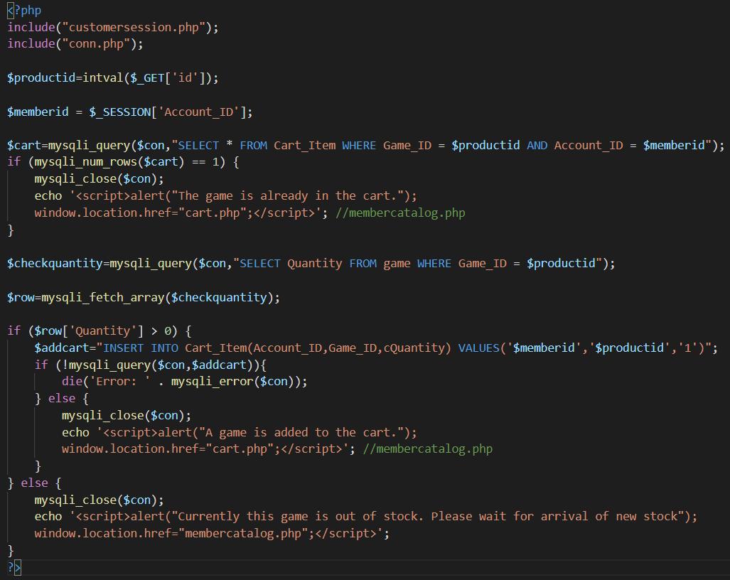

Figure 123

This code above enables games to be added to the cart of the respective member. With sessions, the ID of the added game and ID of member who added the game to cart would be added into the cart which is shown to the particular member. If member tries to add the game into the cart although it already exists in the cart, an alert box of “The game is already in the cart.” would be shown. If the member tries to add the game into the cart although the quantity shown is 0, an alert box of “Currently this game is out of stock. Please wait for arrival of new stock.” would be shown. When the member adds a game into the cart which does not exists in the cart, an alert box of “A game is added to the cart.” would show up.

Code to edit cart

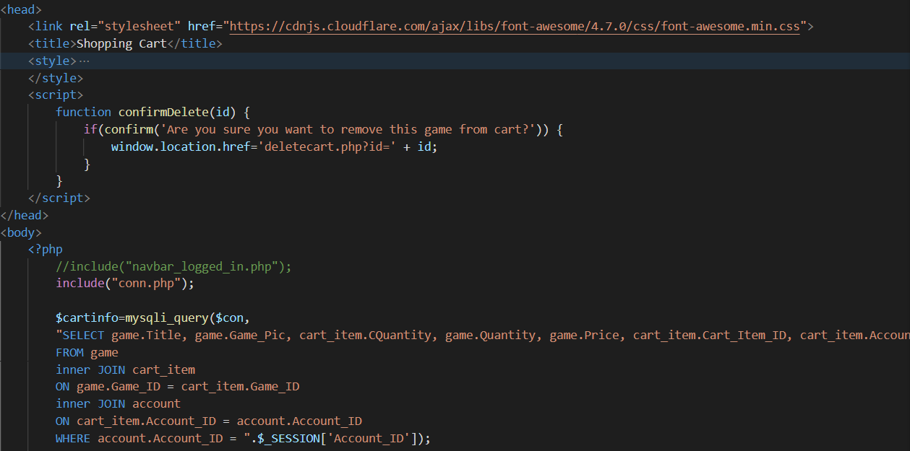

Figure 124

This code would fetch data in the cart table based on the member ID in the session

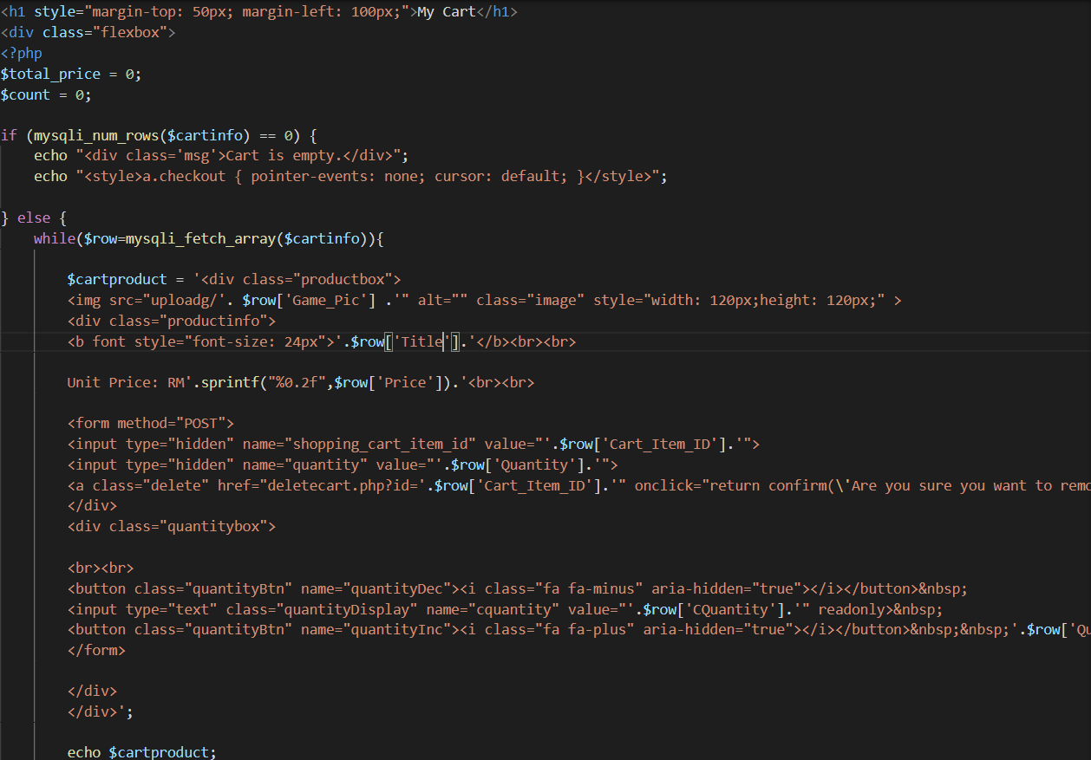

Figure 125

This code above would display the title, image, quantity of game which is added into the cart. An add button and minus button is provided to edit the quantity of game in the game cart. Meanwhile, a delete button is provided to remove the game from the cart.

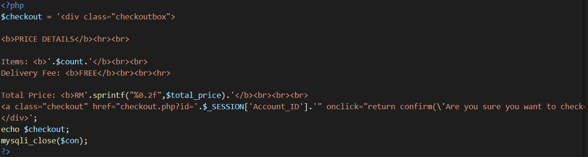

Figure 126

This code would display the sum of games in the cart and a checkout button to confirm the purchase of games in the cart. When the checkout button is pressed, an alert box of “Are you sure you want to checkout?” would show up. When the OK button of the alert box is pressed, the purchase would be confirmed.

Increase quantity

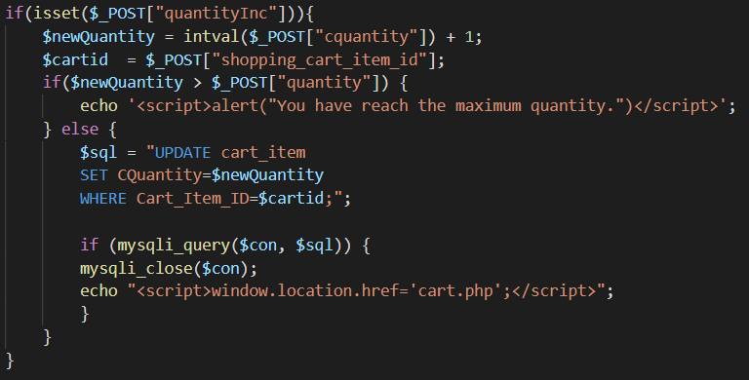

Figure 127

This code above enables the quantity of the game to increase by 1 for each click on the add button by using sql commands to edit the quantity of games in cart_item table of the respective member. When the member intends to add the quantity of games in cart to become beyond the quantity of games in stock, an alert box with message of “You have reach the maximum quantity.” would show up and stops the member to add more games into the cart.

Decrease quantity

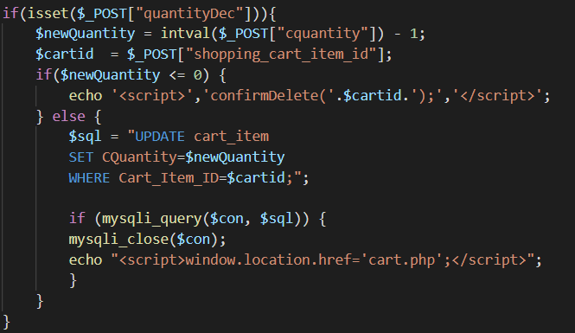

Figure 128

This code above enables the quantity of the game to decrease by 1 for each click on the minus button by using sql commands to edit the quantity of games in cart_item table of the respective member. When the member intends to reduce the quantity of games in cart to become zero, it would trigger the feature of Delete button and the alert box of “Are you sure you want to checkout?” would show up which stops the member to reduce the quantity of games from the cart.

Confirm Payment (checkout.php)

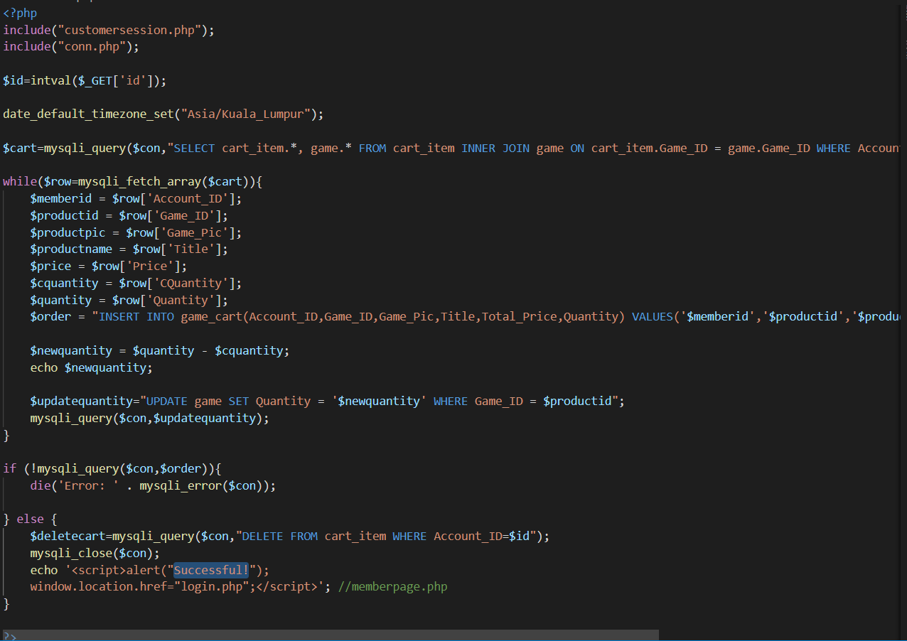

Figure 129

This code above would clear the contents of the cart based on the member ID of the session and store the records in Orders table in the database. The time is set as the local time of Kuala Lumpur in Asia and recorded into the order table. When the process has successed to complete, an alert box of “Successful!” would show up followed with the member directed back to member home page.

Delete cart

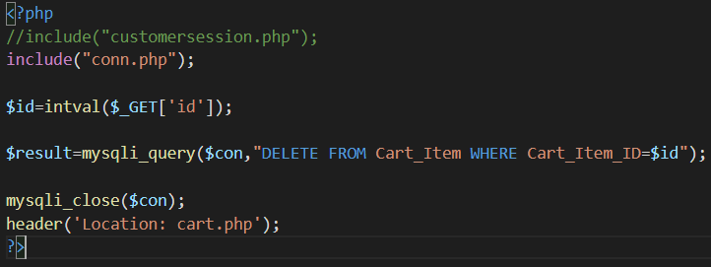

Figure 130

This code will delete the cart in Cart table which have similar member ID with the member ID in the session when the Delete button in the cart page is clicked.

Catalog

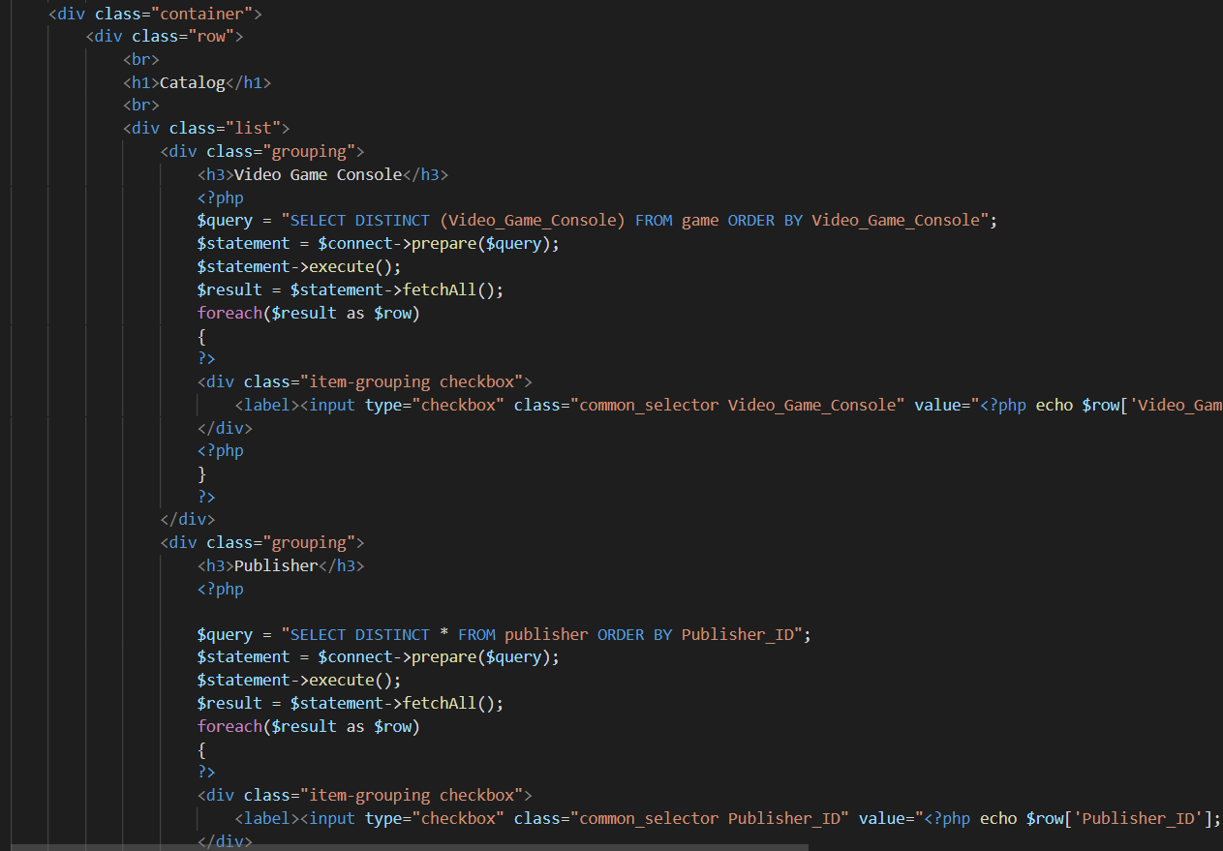

Figure 131

This code would allow users to filter games shown in catalog based on the publisher and video game consoles of games listed in games table of gfg database.

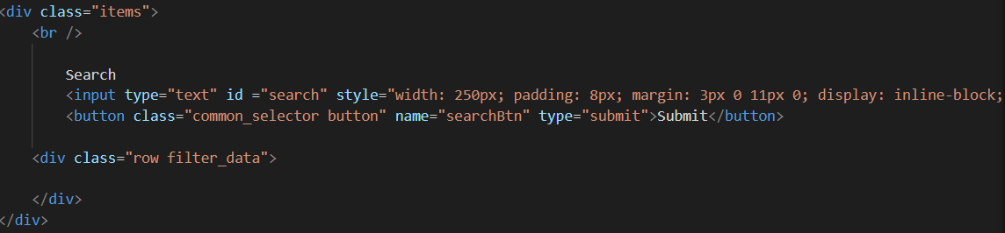

Figure 132

This code above enables users to search games in GFG by entering title of games and click on the Search button.

Fetch game from database (Fetch_data.php)

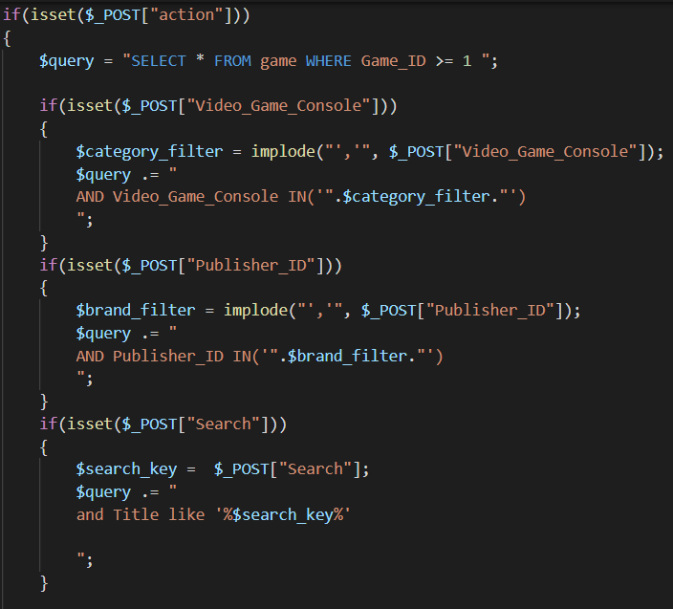

Figure 133

This code above allows the filter to be executed when the check box is clicked or search features in catalog is operated when the Search button is pressed which would affect the display of games in the catalog.

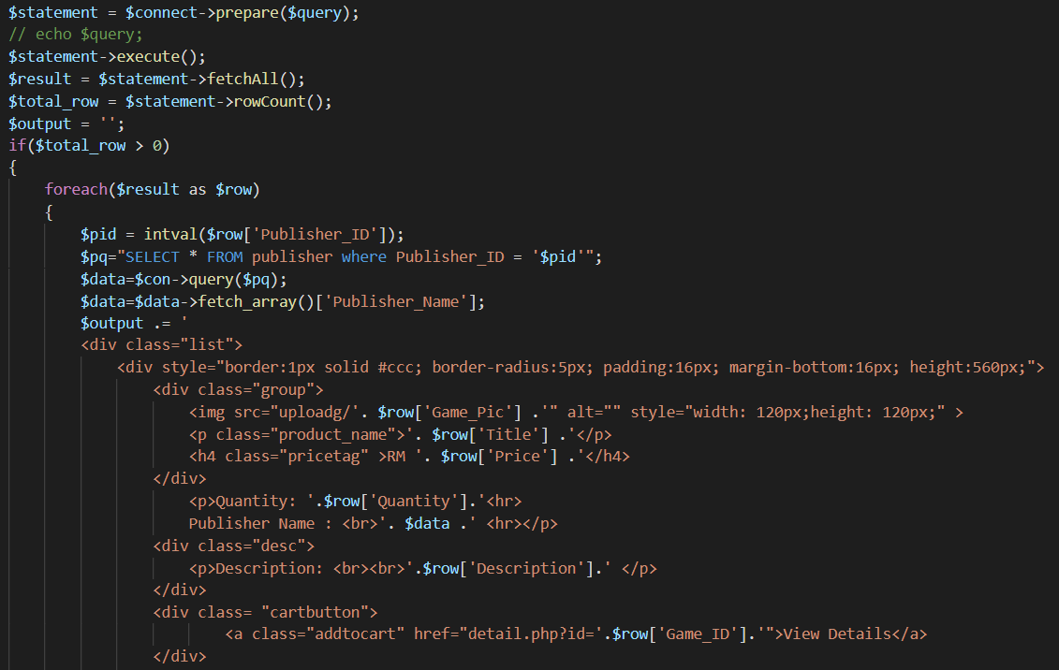

Figure 134

This code above would display brief details of the games in catalog page. A View Details button is provided to enable users to access to details page and view detailed information of the game.

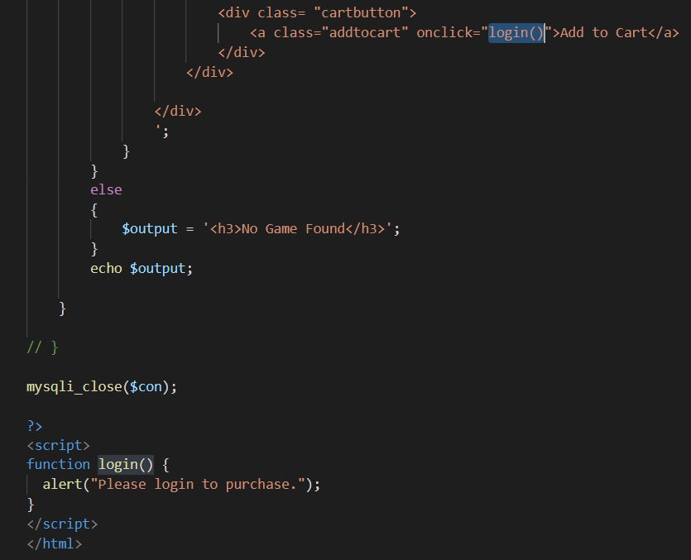

Figure 135

This code displays a Add to Cart button which would direct guests to the login page when they click on the button.



Figure 136

This code would enable member to add the specific game into the cart which could be view in the cart page.

View game detail

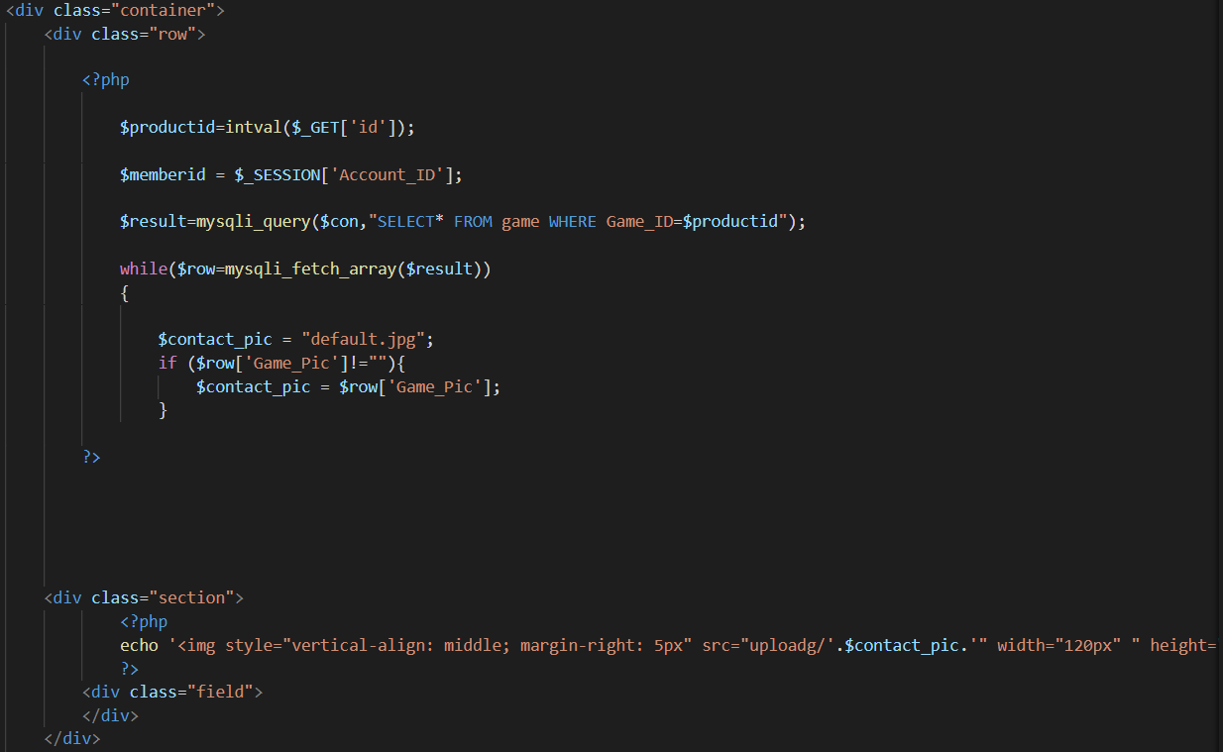

Figure 137

This code would fetch and display image of the game stored in upload folder which have similar name the name of image stored in game table. If there is no image available, a default image with name of default.jpg would be displayed.

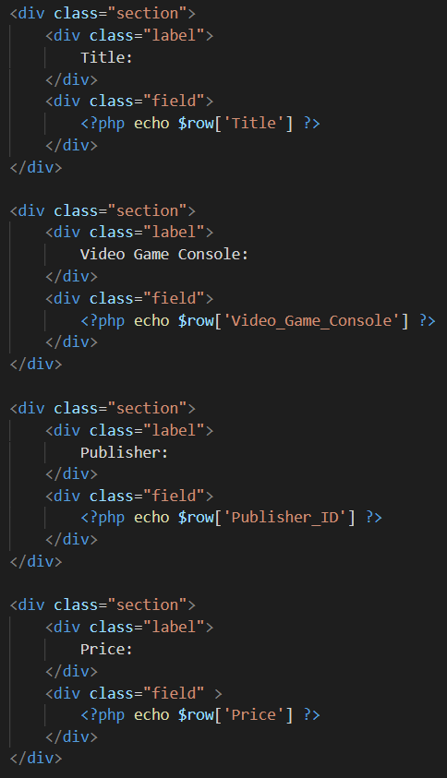

Figure 138

This code would display other detailed information of the game stored in game table of gfg database.

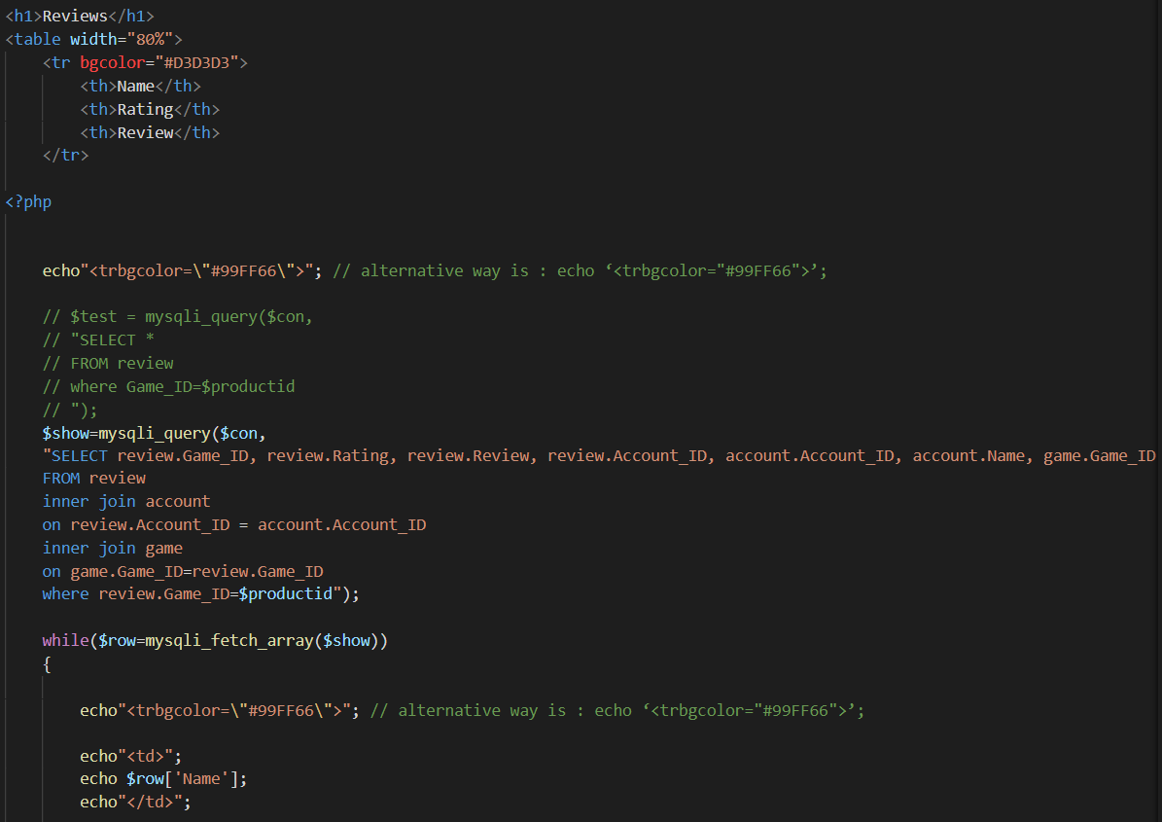

Figure 139

This code would fetch all rating and reviews of the game made by members and display in a table below the detail page which shows detailed information of games.

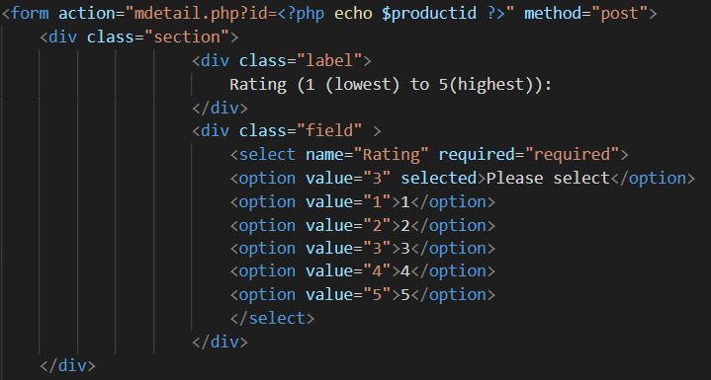

Figure 140

This code provides a drop-down box. The drop-down box allows member to provide rating from 1 to 5 and comments regarding the game.

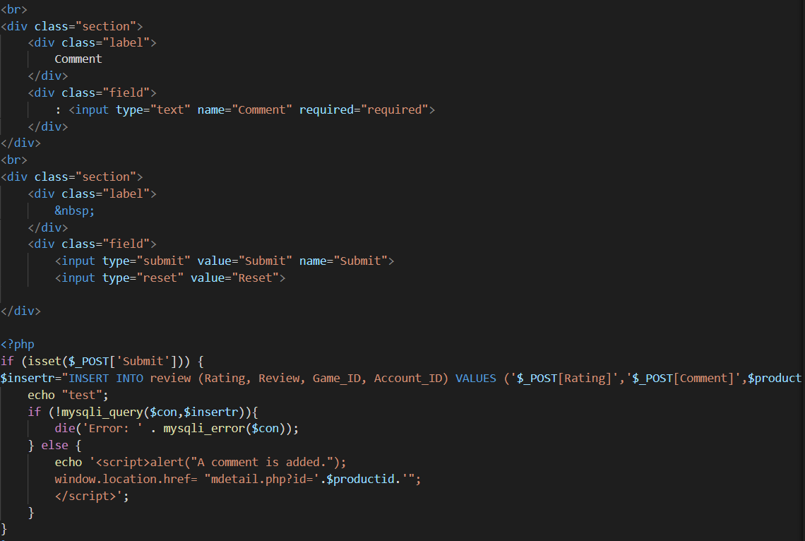

Figure 141

In this code a text field is displayed to enable members to provide comments regarding the game, A Submit button is also included to confirm the submission of comment regarding the game. Meanwhile, a Reset button is also prepared to allow the member to clear the text field. When the Submit button is pressed, the rating and comment would be stored in the review table. When the code has executed successfully, an alert box with message of “A comment is added.” would show up.

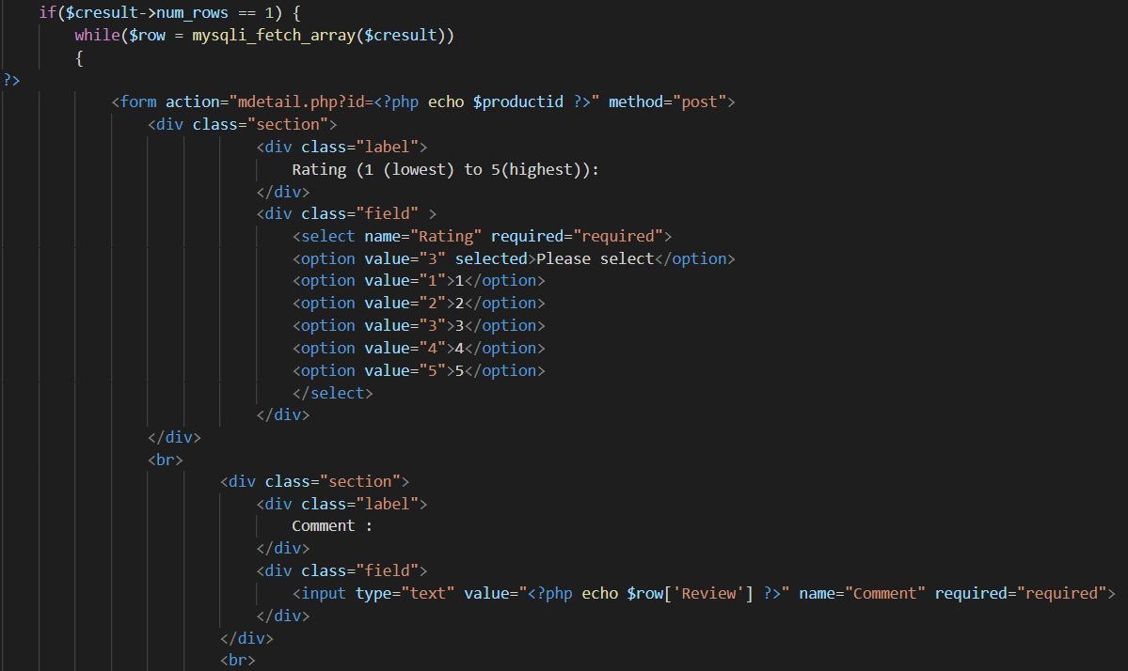

Figure 142

When the member is found to provide a rating and comment in the past, the comment made by the member would display the comments made by the member in the comment field. Member could modify the rating through the dropdown-box and the edit the comments given previously against the game by changing the contents in the text field.

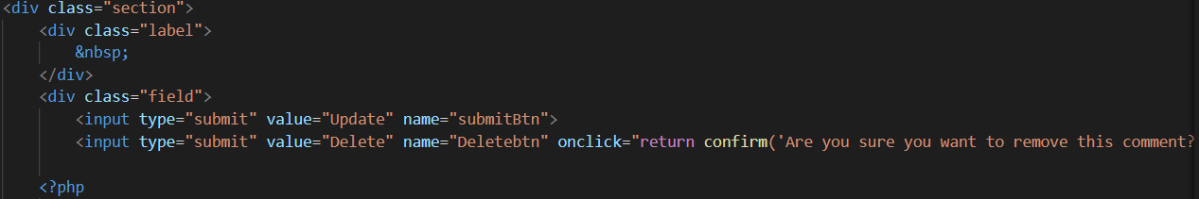

Figure 143

This code shows an Update button and Delete button for members who had previously made reviews of the game.

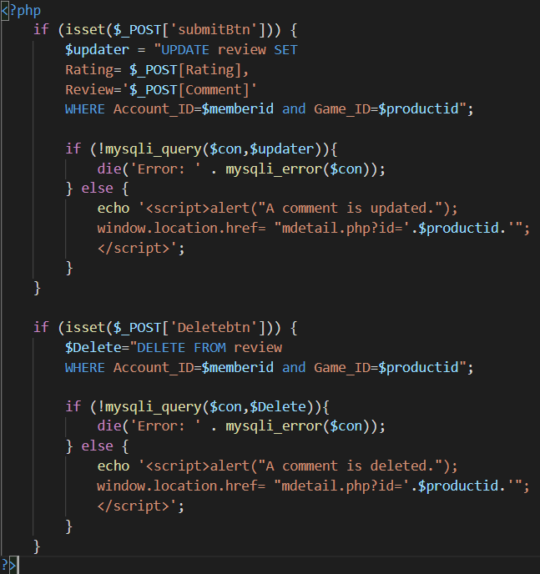

Figure 144

According to this code, when the Update button is clicked, the rating and comments modified by the member would replace the previous rating and comments made by the member. When the process executed successful, an alert box with message of “a comment is updated.” would show up to inform the user that the review has been successfully replaced.

On the other hand, when the Delete button is clicked, the review of member would be removed from review table of the gfg database. When the process has been successfully preformed, an alert box which shows “A comment is deleted.” would pop out and indicate the review is removed.

Login

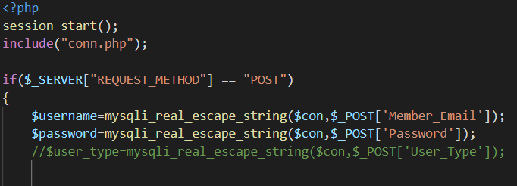

Figure 145

This code above represents part of login.php. at the beginning of this code, the session is activated to provide distinct session based on the and email and password entered.

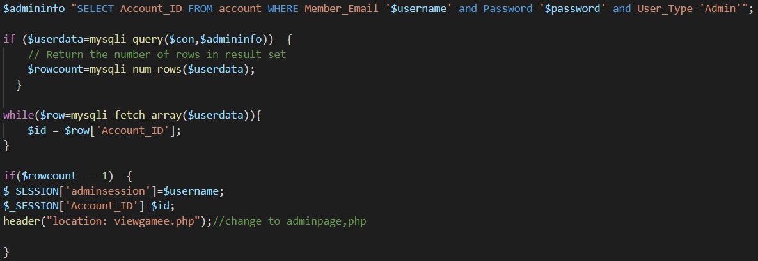

Figure 146

If the email and password entered matches with email and password of an account in account table and the user type of the account is “Admin”, the user would be provided with admin session and granted with access to admin home page.

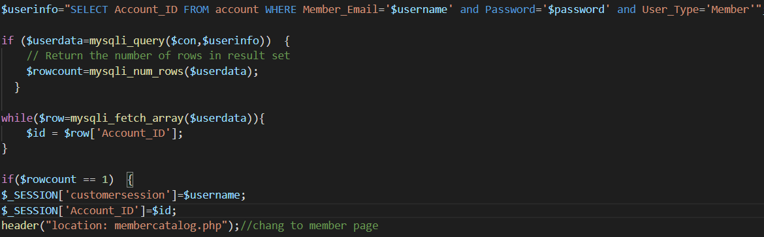

Figure 147

If the email and password entered exists in the account table and the user type of the account is “Member”, the user would be provided with customer session and directed to member home page.



Figure 148

If either email or password entered by the user does not match with any pair of email or password, an alter box with message of “The email address or password entered is not valid. Please try again.” Would shou up and inform the user to renter email and password.

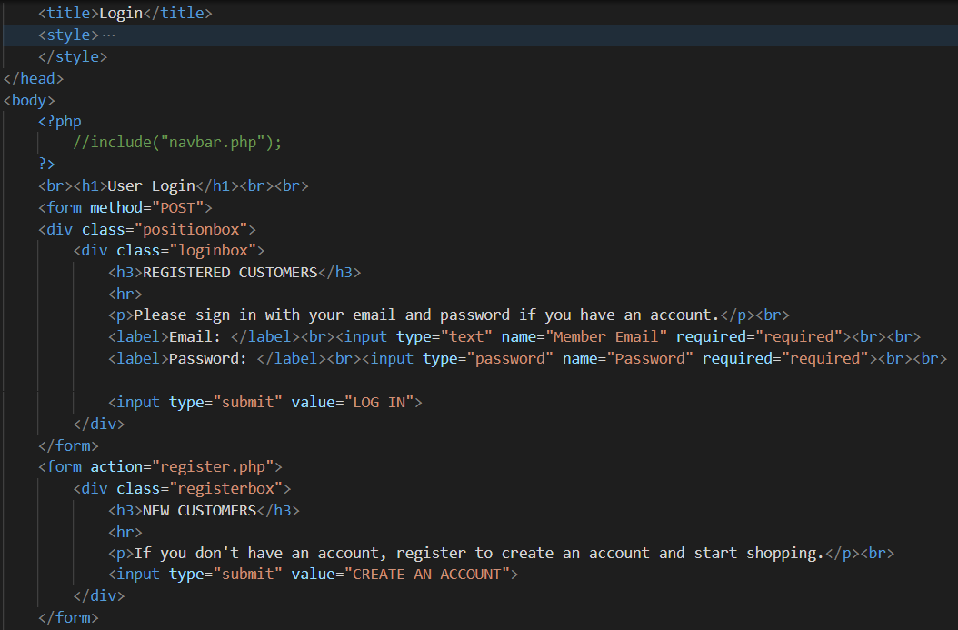

Figure 149

This section of code would display the field for user to enter email address and password along with a submit button to execute the code above. A Create an Account button is situated in the page too to direct guests to the register page and register a member.

View Company Details

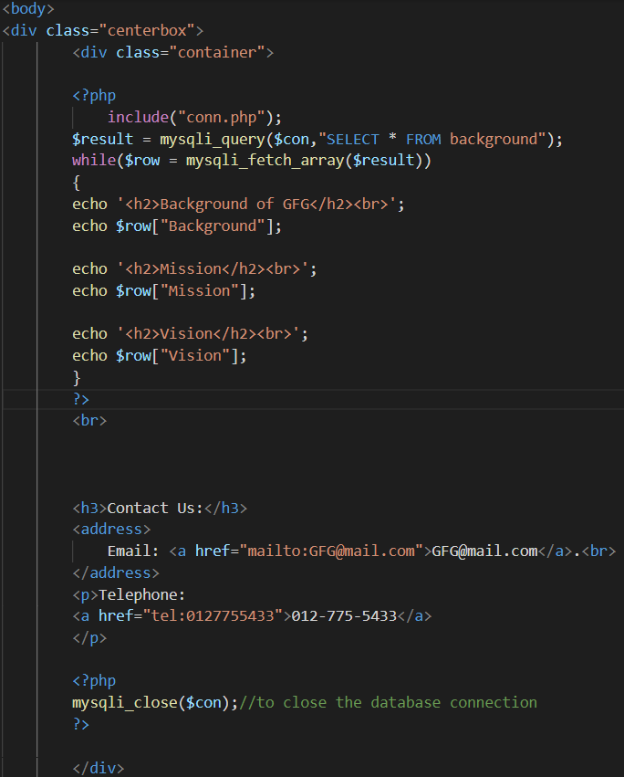

Figure 150

This code above would show the contents in background table and display the Background, Vision and Mission of GFG company accordingly. An email hyperlink and telephone hyperlink are situated below the company details to enable guests or members to contact GFG company through email or telephone.

Add publisher

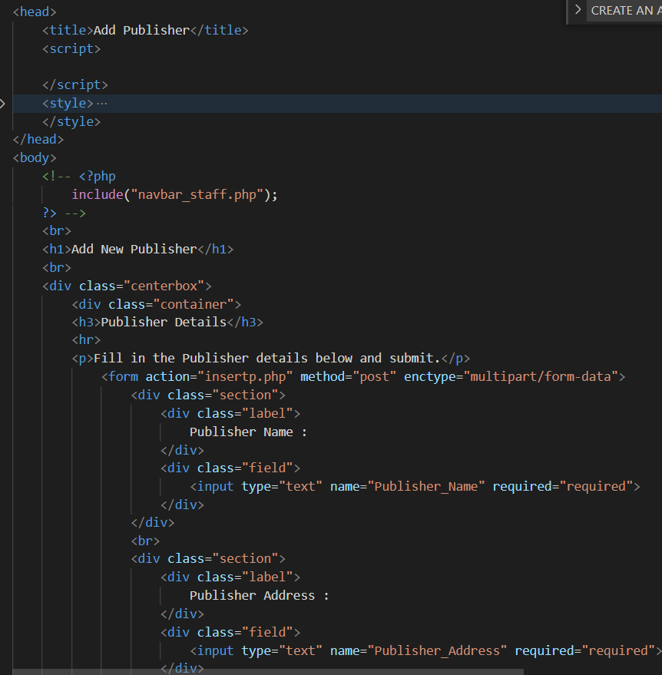

Figure 151

This code displays the text fields to be filled in while registering a publisher.

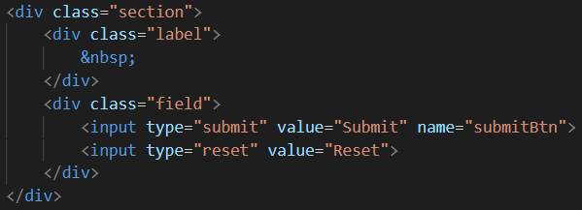

Figure 152

This code would provide 2 buttons, which are Submit button and Rest button. The Reset button would clear all text field above.

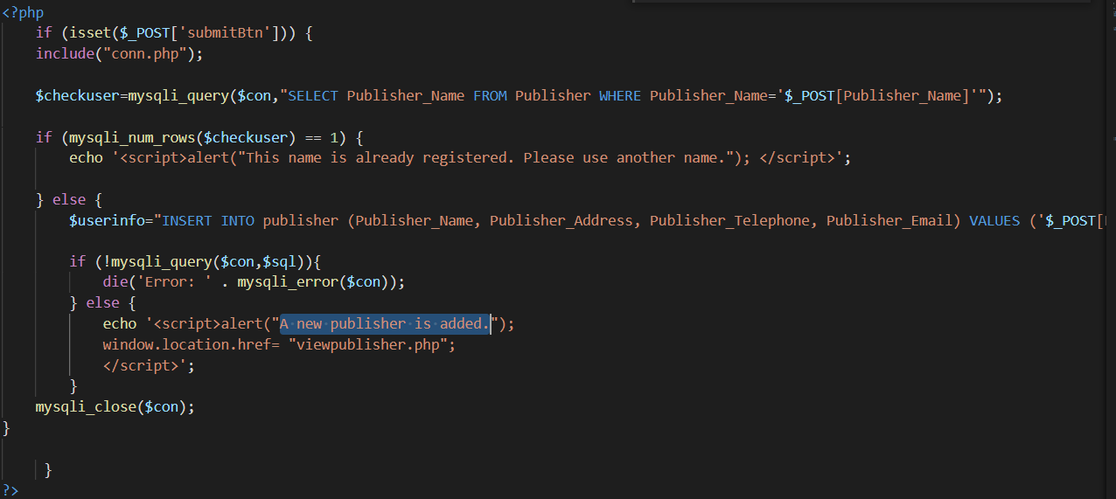

Figure 153

This code would execute when the Submit button is pressed. The code enables the contents in the text field to be stored into publisher table. When the code executes successfully, an alert box which shows “A new publisher is added.” would be displayed followed with the user to be directed to view all publisher page.

Add game

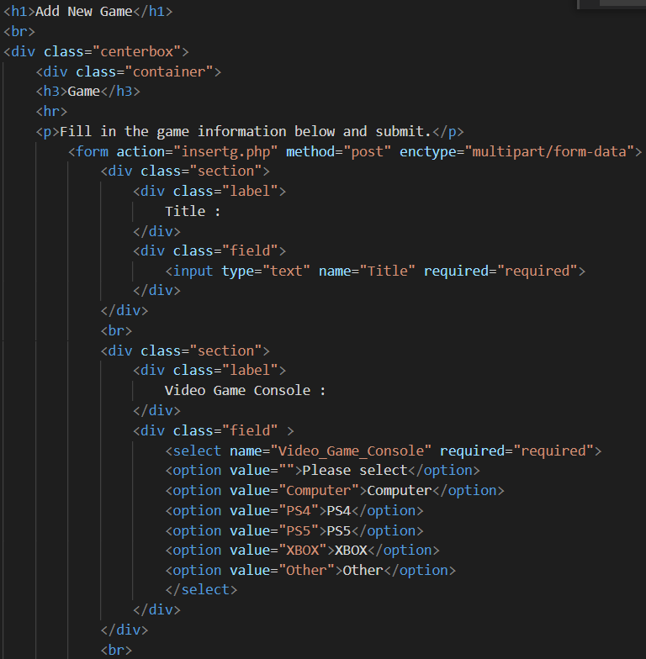

Figure 154

This code would provide text field and drop-down box to be filled in with information of the video game.

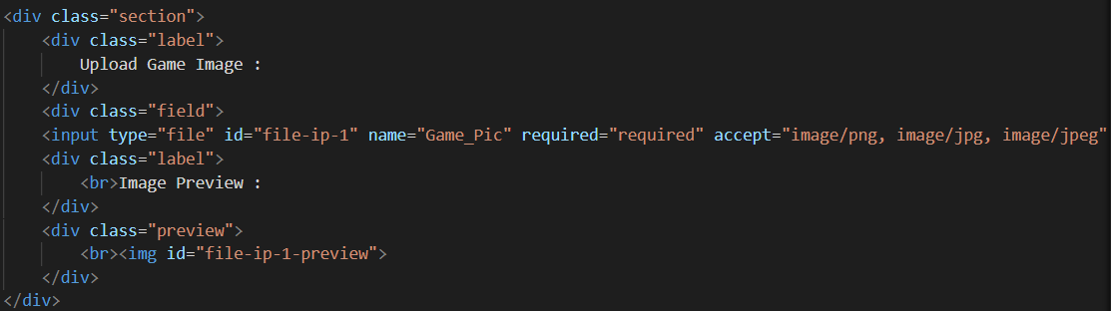

Figure 155

This code allows the admin to upload image of game (files). The file which could be uploaded is restricted to only allow jpg, jpeg and png files to be uploaded. When the file is uploaded, the image of the file could be viewed in a box below.

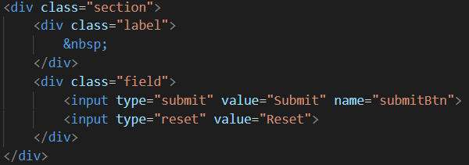

Figure 156

Similar with the register publisher form, 2 button which are Submit and Rest button are included. The Reset button allows all text fields to be cleared.

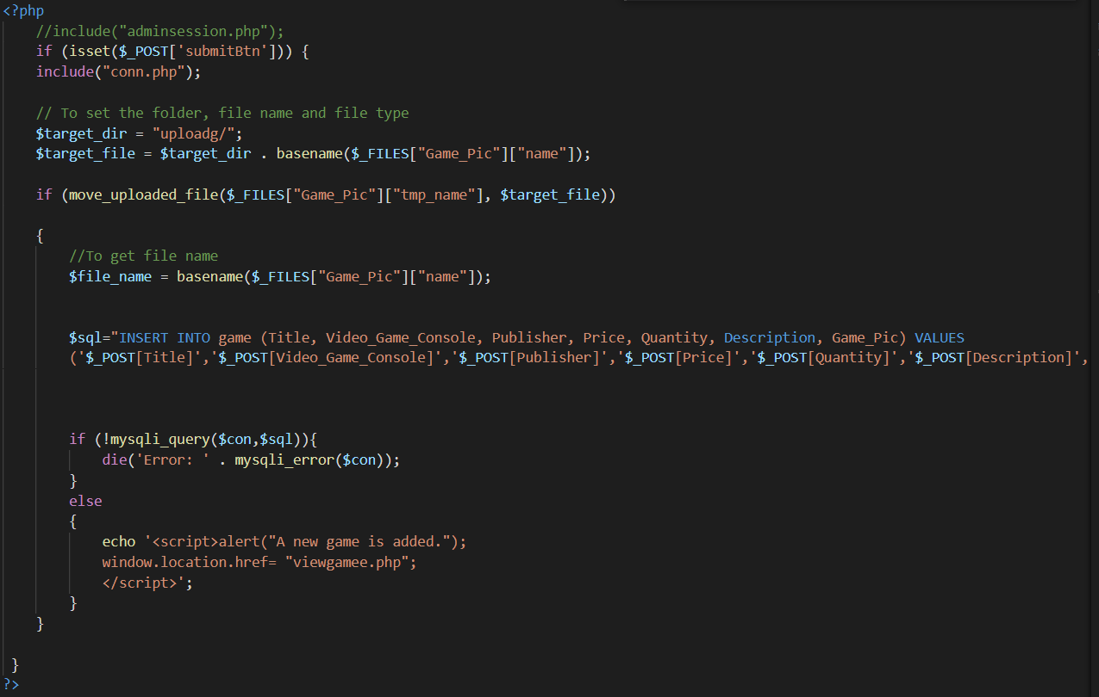

Figure 157

When the Submit button is clicked, all contents in the text field, drop-down box and uploaded image would be uploaded and stored in the columns of game table based on the name of the text field. When the code had succussed to execute, a drop box of “A new game is added.” would be displayed. Later, the admin would be directed to the view all games page.

Logout

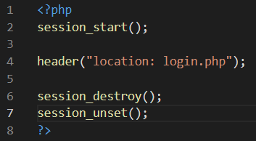

Figure 158

The code above would activate session of member and admin who accessed the page followed with direct the member or admin to login page and destroy and unregister the session.

View game

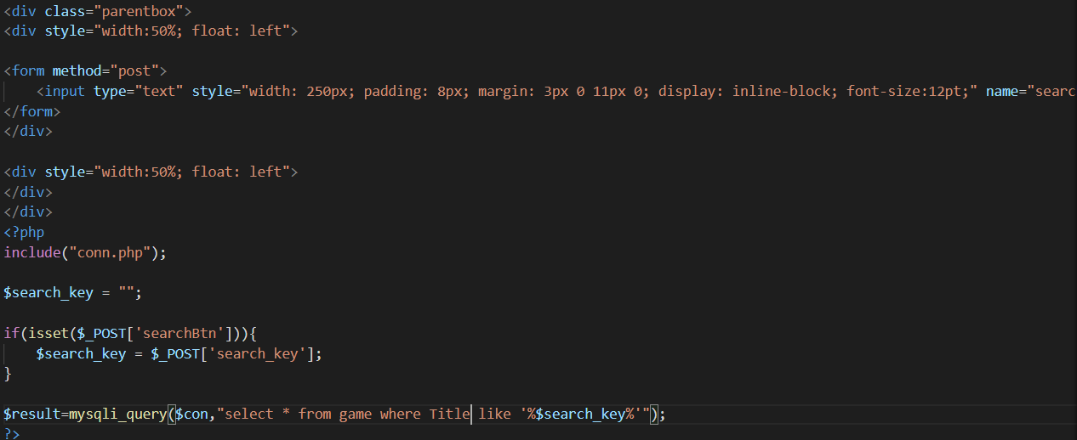

Figure 159

This code would provide a text field for admin to enter title of game to search. When the Search button beside the text field is executed, the games which have alike or related title as the input in the text field would be displayed below.

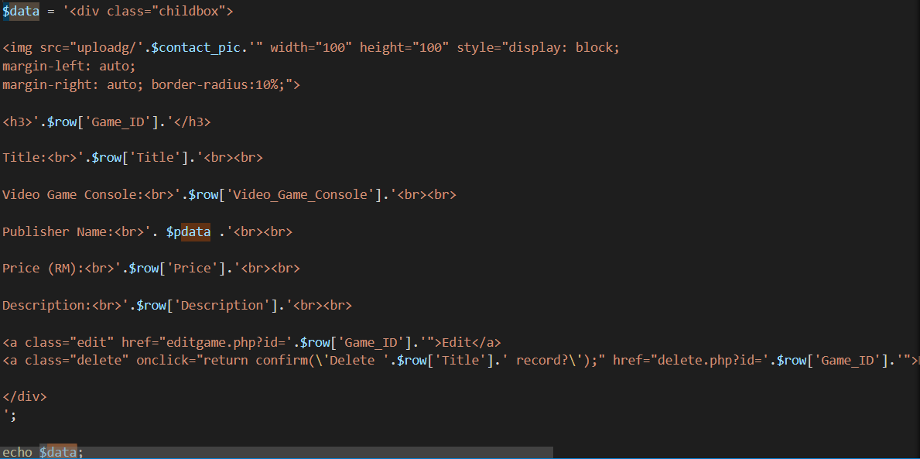

Figure 160

This code would display all details of video games in text located in game table of gfg database.

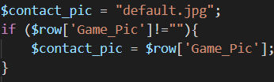

Figure 161

This code would enable the displayed image of video games to be a default image named default.jpg if the name of image is not found in uploadg folder which keeps the images of video games



Figure 162

This code would fetch out images in uploadg folder which has similar name recorded in gfg table. The image is fixed to have a height and width of 100 with PHP code.

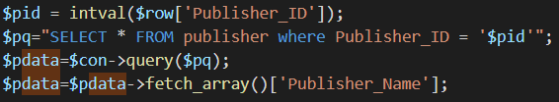

Figure 163

This code would enable the displayed publisher ID to be shown as the publisher’s name.



Figure 164

This code would enable 2 different hyperlinks which are Delete and Edit to be displayed. The Edit hyperlink would direct user to edit game page.

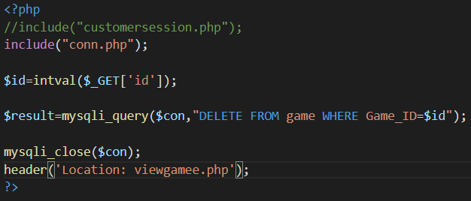

Figure 165

Meanwhile, the Delete hyperlink would activate the delete.php and delete the particular game.

Edit game

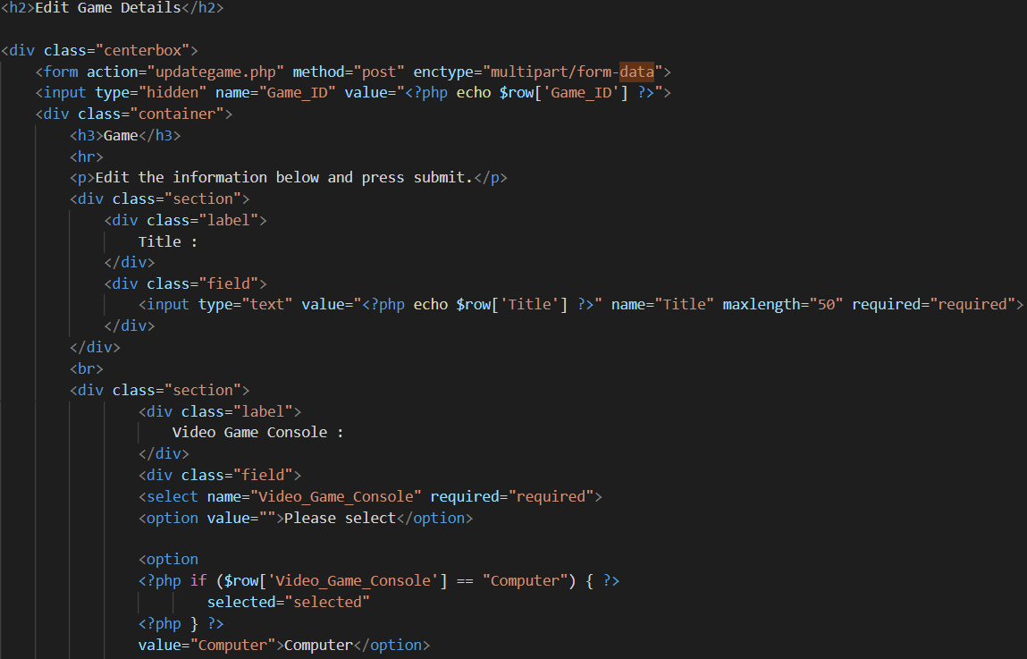

Figure 166

This code would display the drop-down box and text field with the original details of the games filled in the text field.

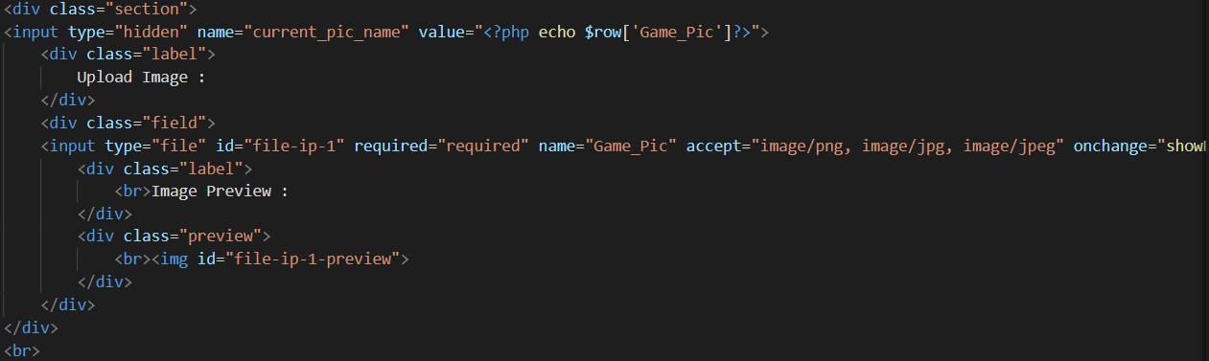

Figure 167

This code has similar function with the upload image code in addgame.php. the uploaded new image would be displayed in the box.

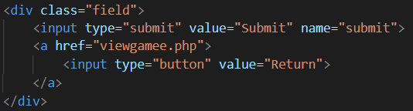

Figure 168

This code would display a Submit button and a Return button. The Return button would direct the admin to the view game page while the Submit button would execute the code below.

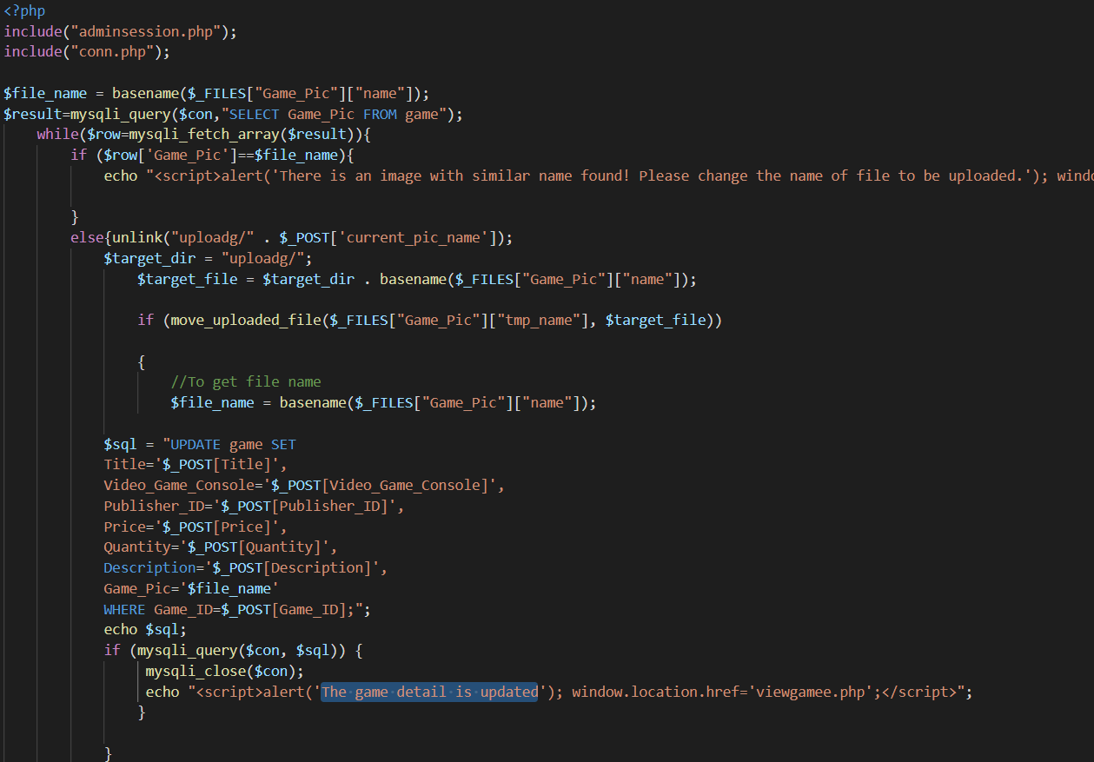

Figure 169

This code would execute when the Submit button is pressed. This code enables the new game details entered text fields and drop-down box to replace original game details in game table. When the code execute completes, an alert box with “The game detail is updated.” would show up and direct the admin to view game page.

View account

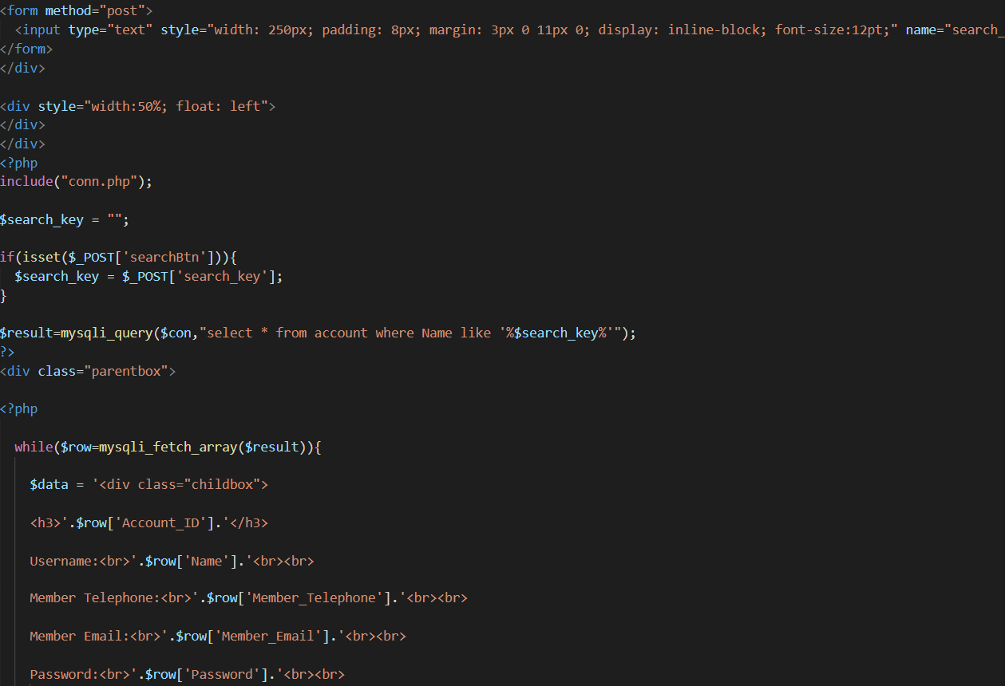

Figure 170

This code consists of a search feature and display accounts from account table feature. A text field is provided for admin to provide input which have similarities with name of accounts in the account table. The detail of accounts with similar name in the text filed would be displayed below.



Figure 171

The code above provides Edit and Delete hyperlink which allows the admin to access editaccount.php to modify details of accounts and delete.php to remove accounts from account table.

Edit account

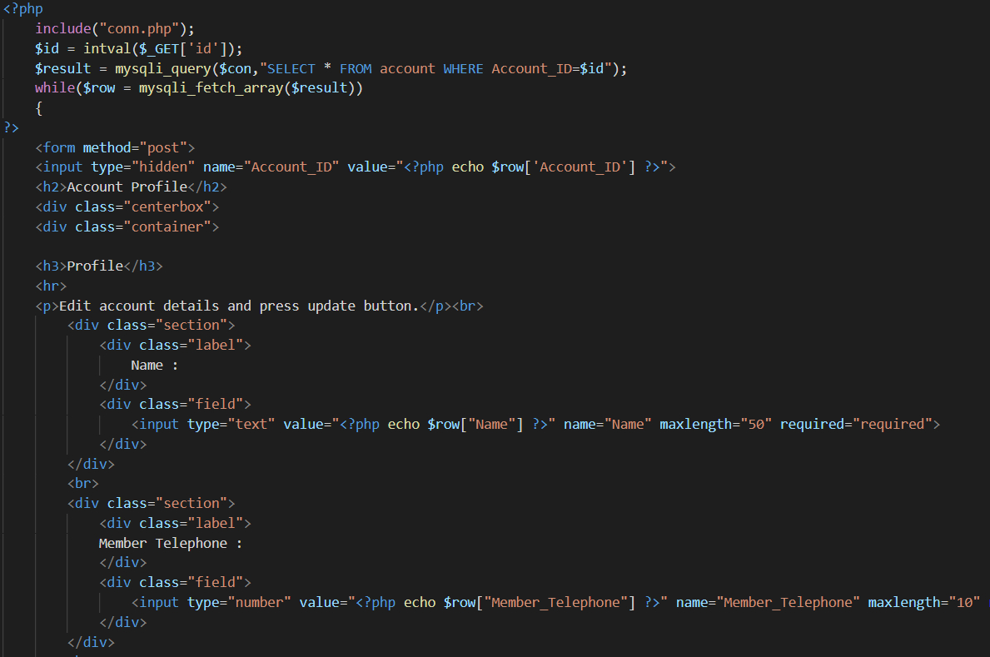

Figure 172

As shown in the image above, the editaccount.php above is linked to data base with conn.php. The code above would provide text field filled in with the original account details.

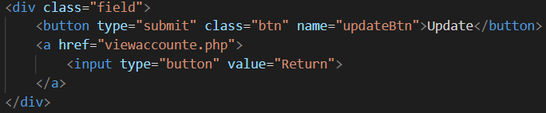

Figure 173

This code would display a Submit button to update the account details in account table with new information in the text field. In additional, a Return button is situated beside the Submit button to enable to admin to return to view account page via the button.

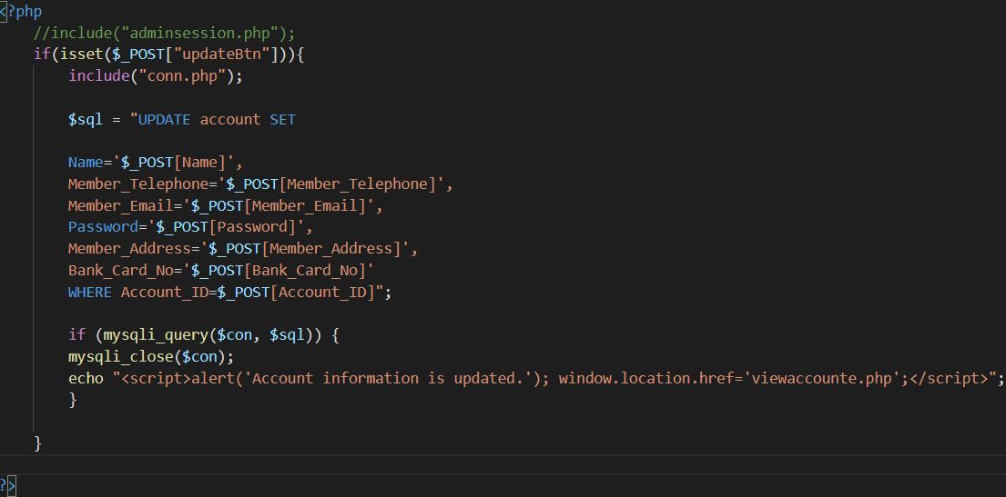

Figure 174

This code would be executed when the Submit button is clicked. Through the sql command, the new contents in the text fields would replace the original details of the account. When the code is executed successfully, an alert box with “Account information is updated.” would appear and the admin would be directed to view account page.

Delete account

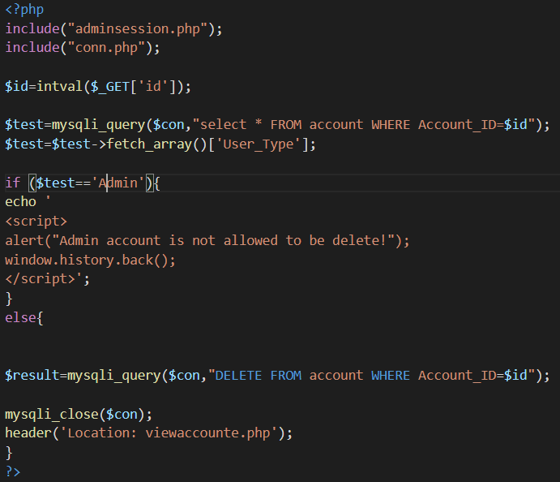

Figure 175

This code would be executed when the Delete hyperlink in view account is clicked. Based on the ID of the account which is clicked, the sql command to delete account from account table would be performed. However, it the user type of the account to be deleted is found to be “Admin”, the delete of the account would be stopped followed with pop out of an alert box with message of “Admin account is not allowed to be deleted!” and the admin would be returned to view account page.

Delete Game

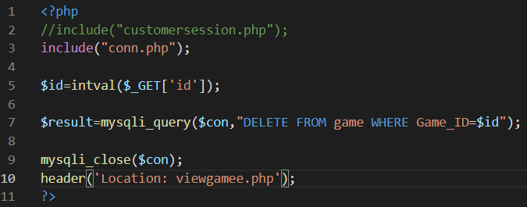

Figure 176

This code would run when the Delete hyperlink of View Game Screen is click. This would result the game record to be removed from game table of gfg database.

Login

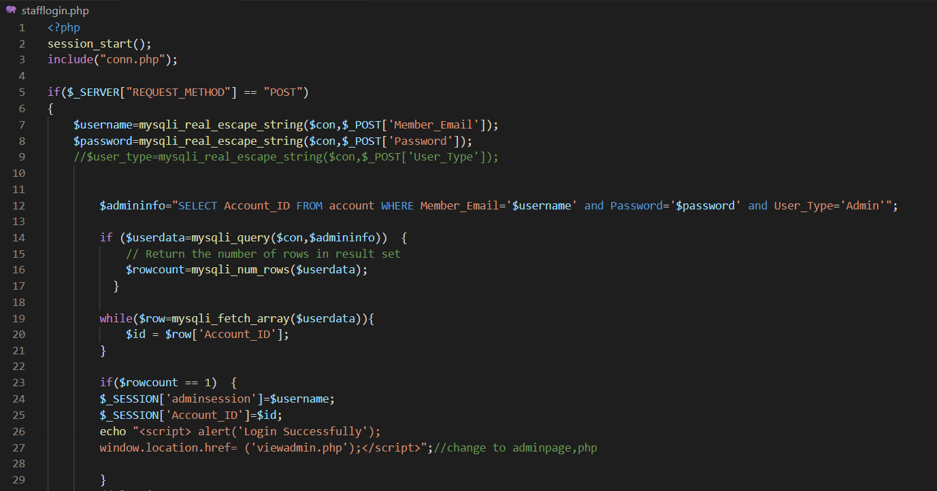

Figure 177

This is the code that is to login. This is the code is required to insert their username and password only can access to admin home screen or member home screen. The username and password are according to the user type in account database to verify it. When user type identified is admin and correct email and password it will pop out a message of “Login Successfully” message and direct user to admin home screen. Meanwhile, if the correct password and email is identified while user type is member, user will be directed to member home screen.

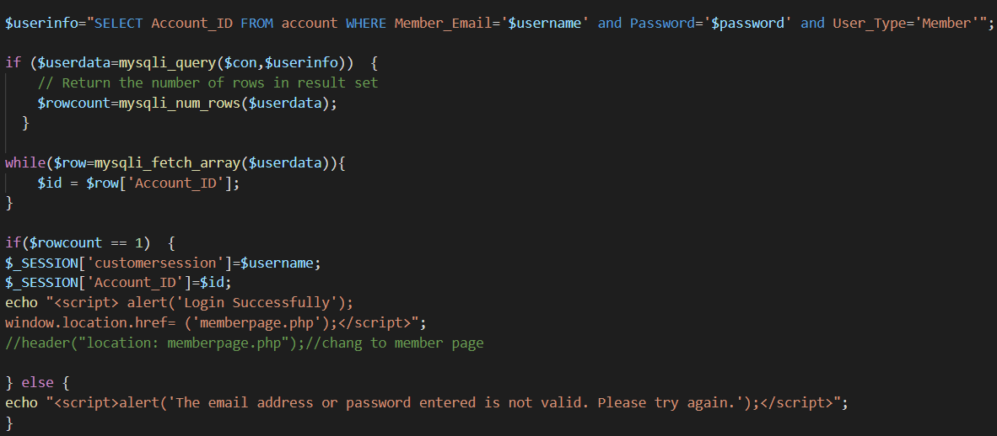

Figure 178

This is the code that a message will pop out “The email address or password is not valid. Please try again.” if staff is inserted the wrong email or password.

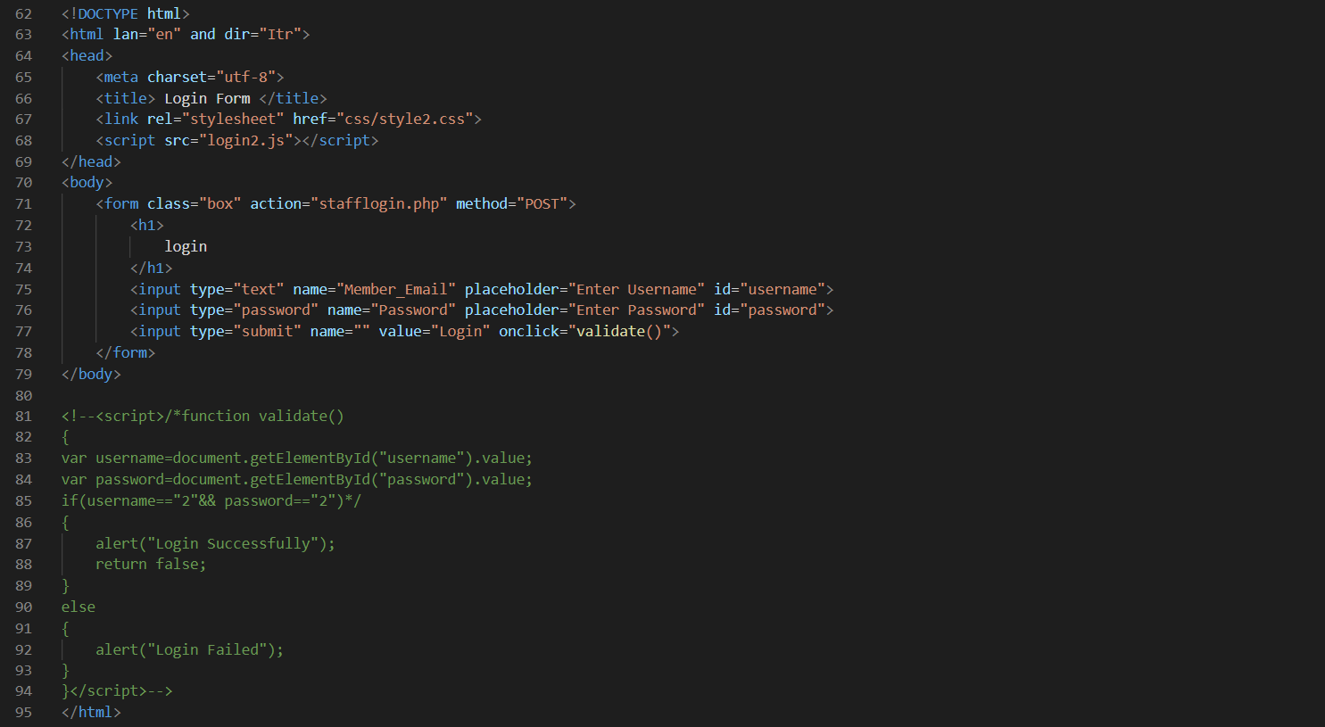

Figure 179

This is the code that display “Enter Email” and “Enter Password” to allow staff to input their username and password into correct space.

Admin Home Screen

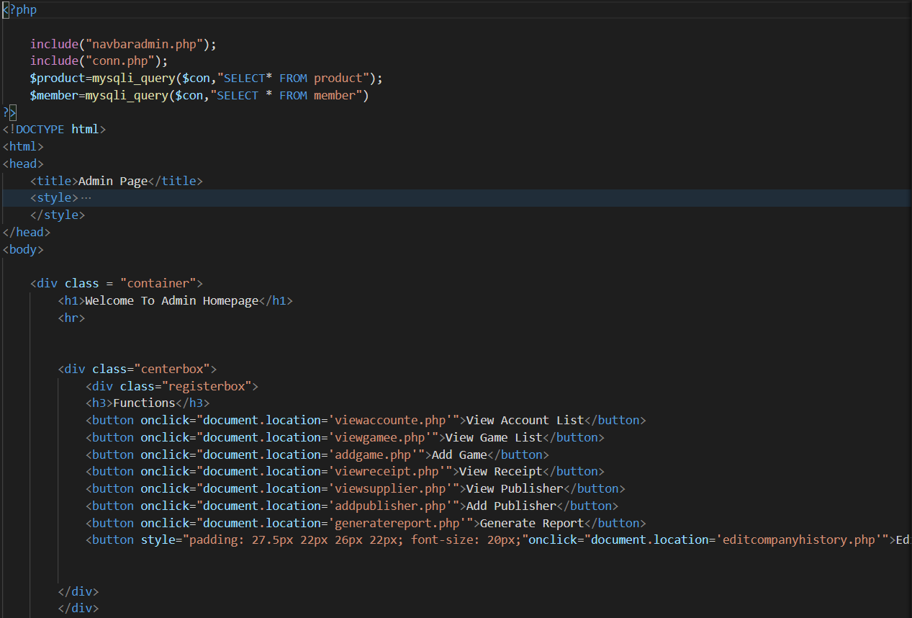

Figure 180

This is the code for admin home screen. The features provided by admin as shown in form of buttons.

View Receipt

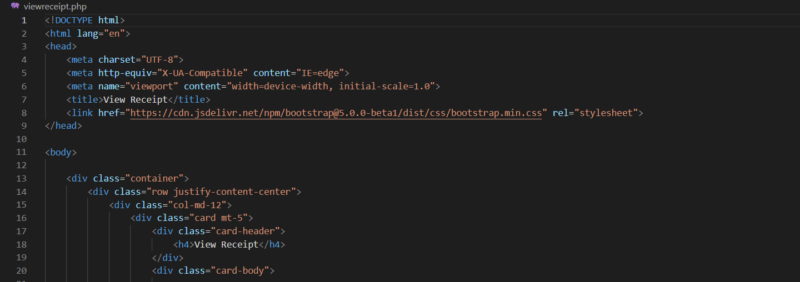

Figure 181

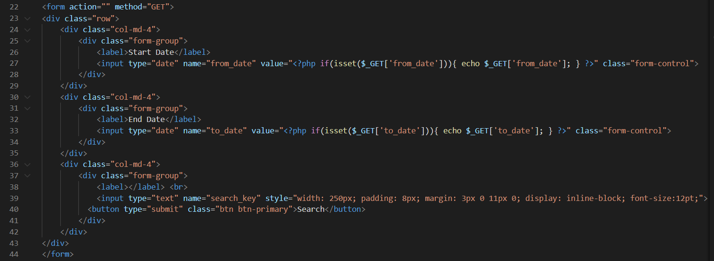

Figure 182

These codes are showing a date filter function as in start date and end date. It has also shown a search button to search game cart ID.

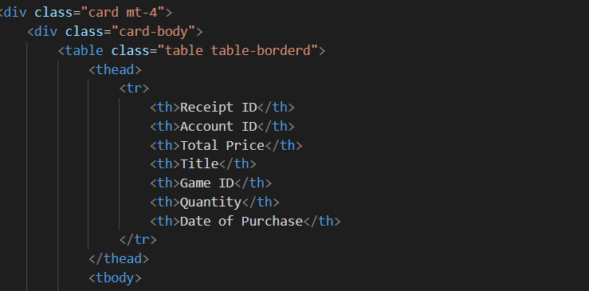

Figure 183

This is the code that will display all the details of game cart in the beginning of the view receipt page.

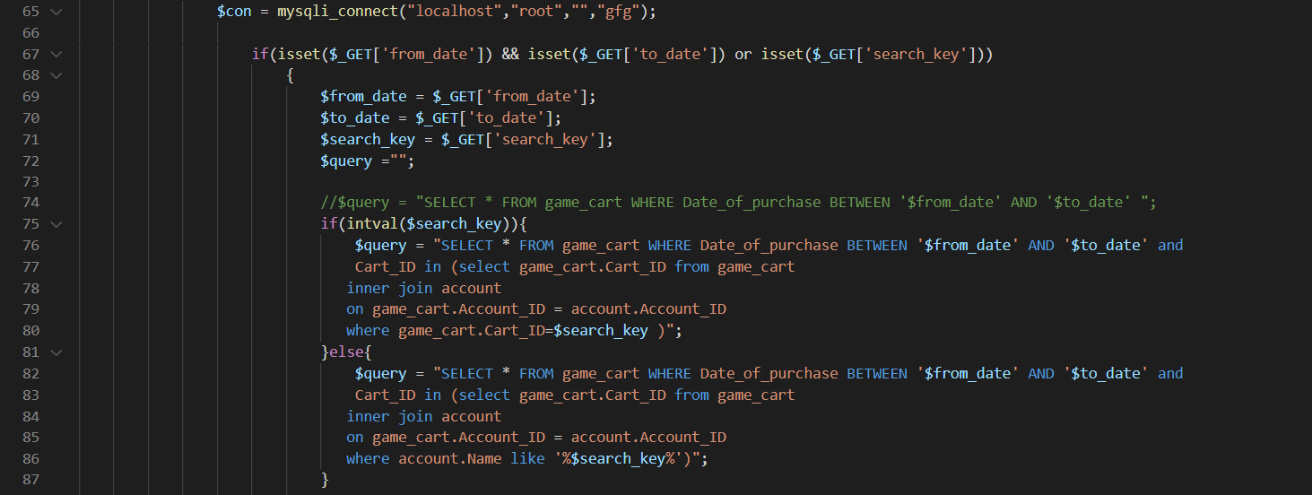

Figure 184

This is the code that connect to the date filter function and game cart ID search function which both data are taken from gfg database and the table of game cart.

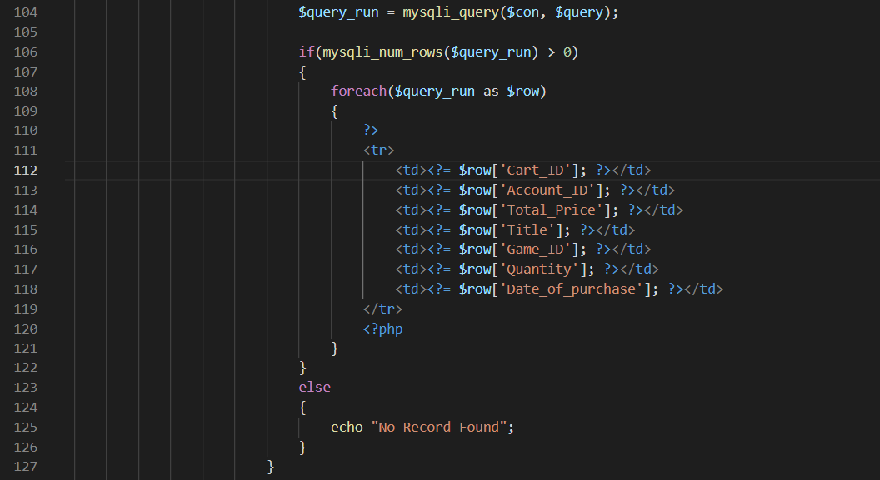

Figure 185

This is the code that shows out game cart data form the date filter function and search button.

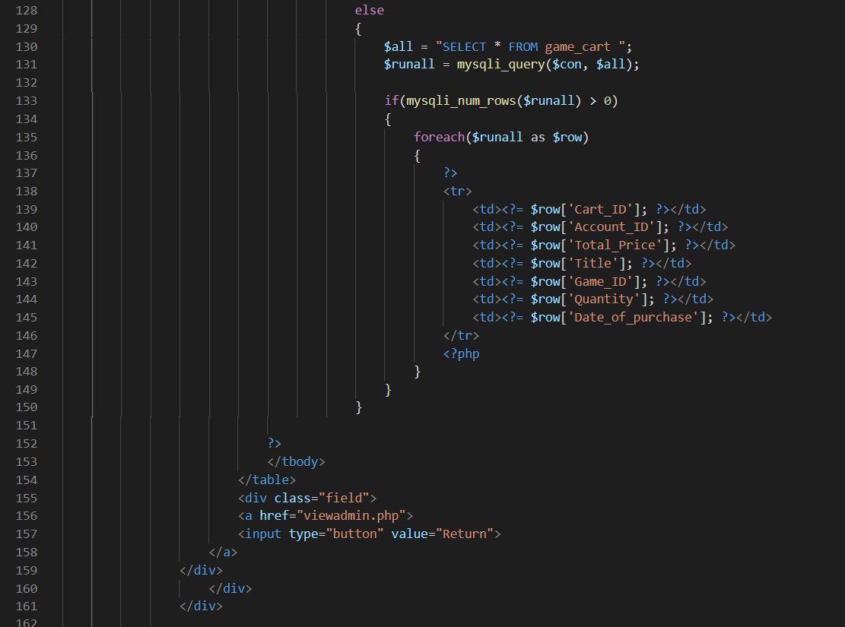

Figure 186

This is the code that display a message of “No Record Found” because the database does not have the data of the date filled in the date filter function or the search button. Moreover, it has a return button to return to admin page.

Generate Report

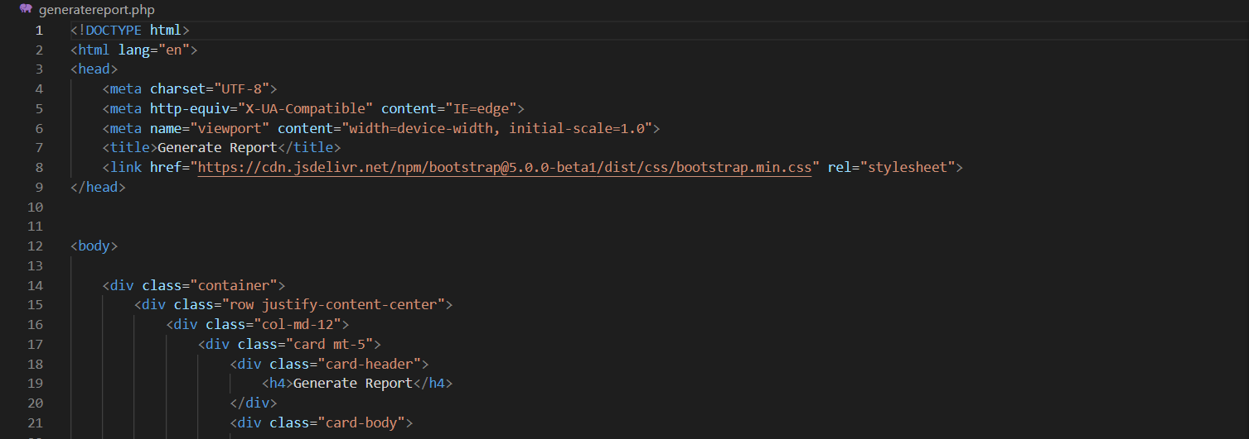

Figure 187

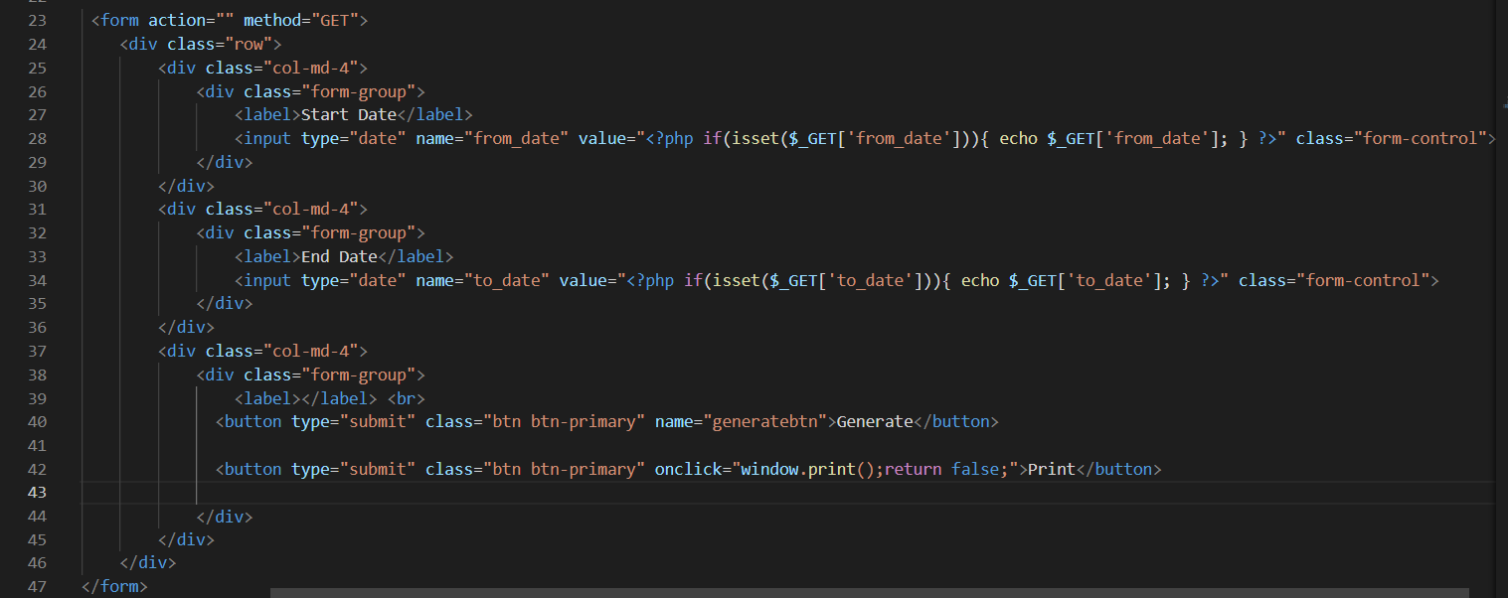

Figure 188

This is the code has same function as date filter function, but the date is in different displayed form. It also has a print function when finish using the date filter function as in generate button.

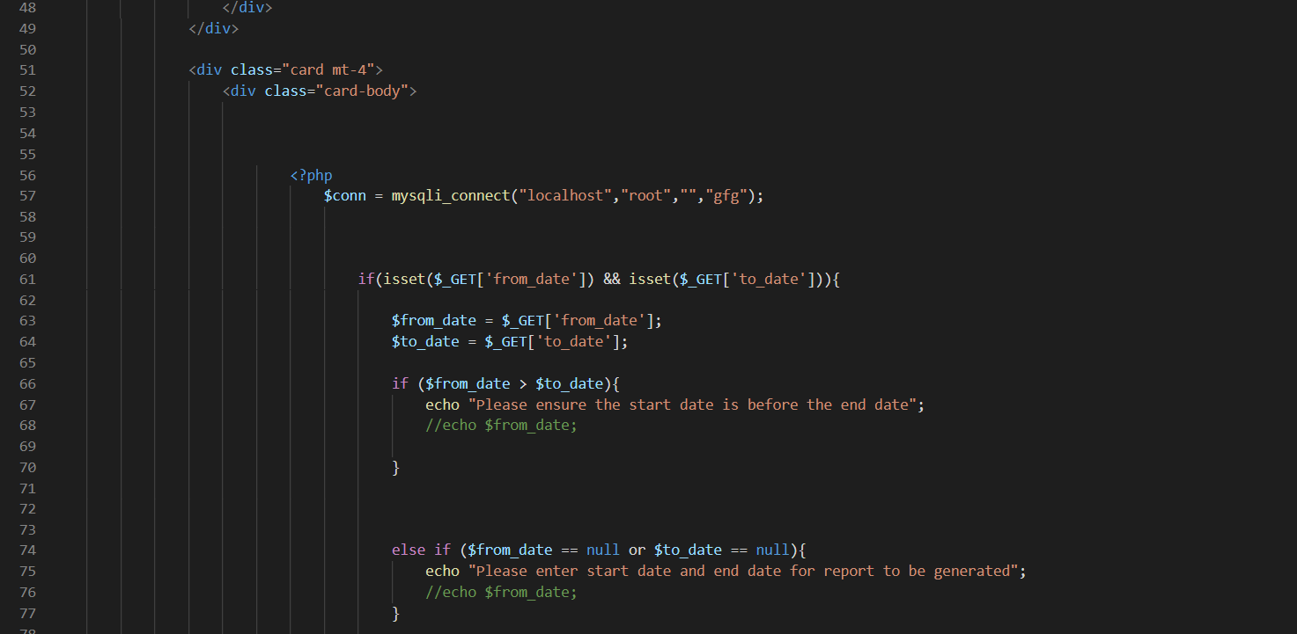

Figure 189

There are a display messages “Please ensure the start date is before the end date” and “Please enter start date and end date for report to be generated” if the staff has input the wrong sequences of date or does not input any of the dates.

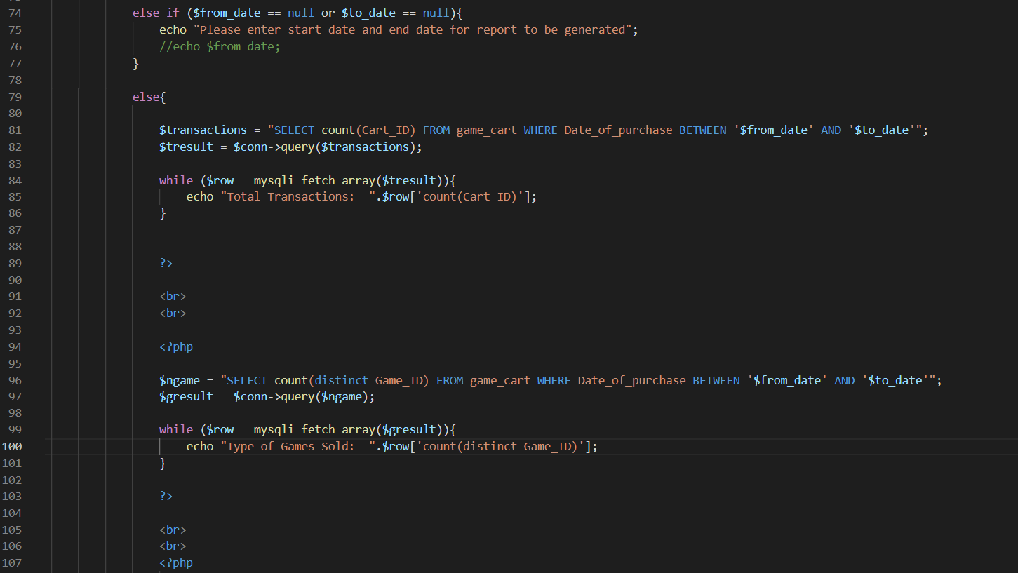

Figure 190

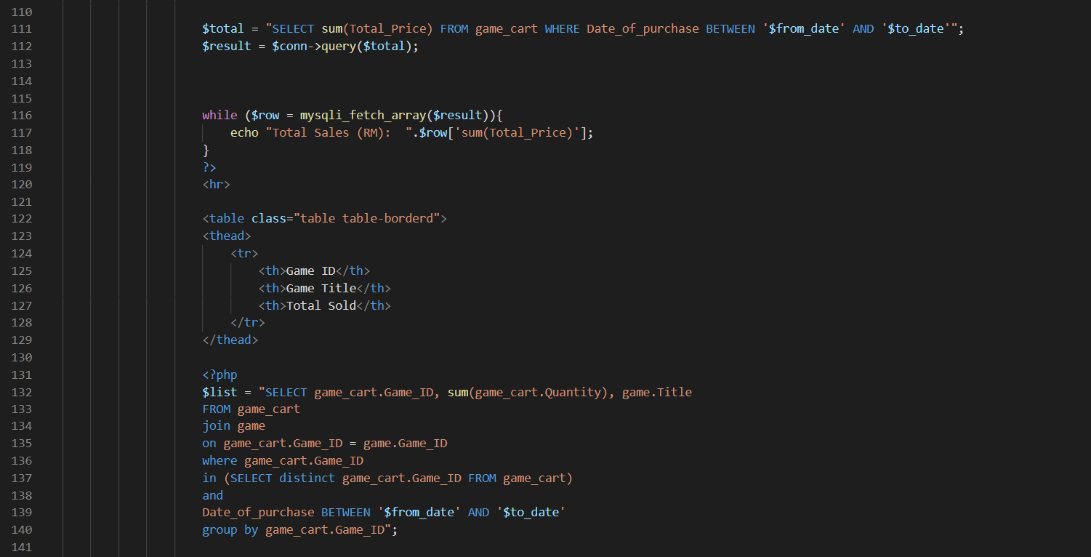

Figure 191

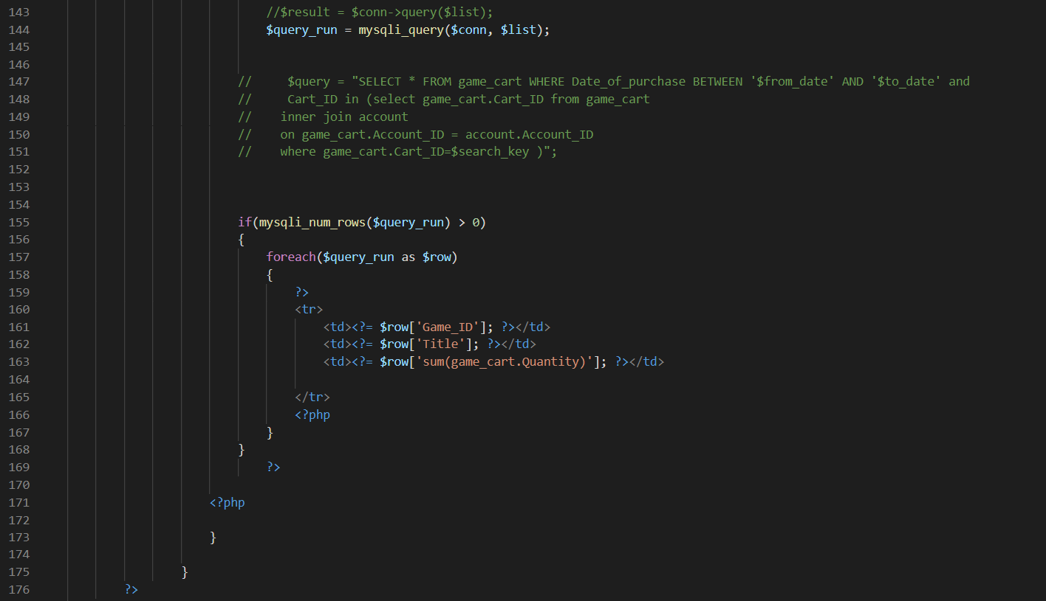

Figure 192

These are the codes that will display the game cart sold details from the date filter function. It will display out the data of total transactions, type of games sold, total sales (RM), game ID, game title and total sold.

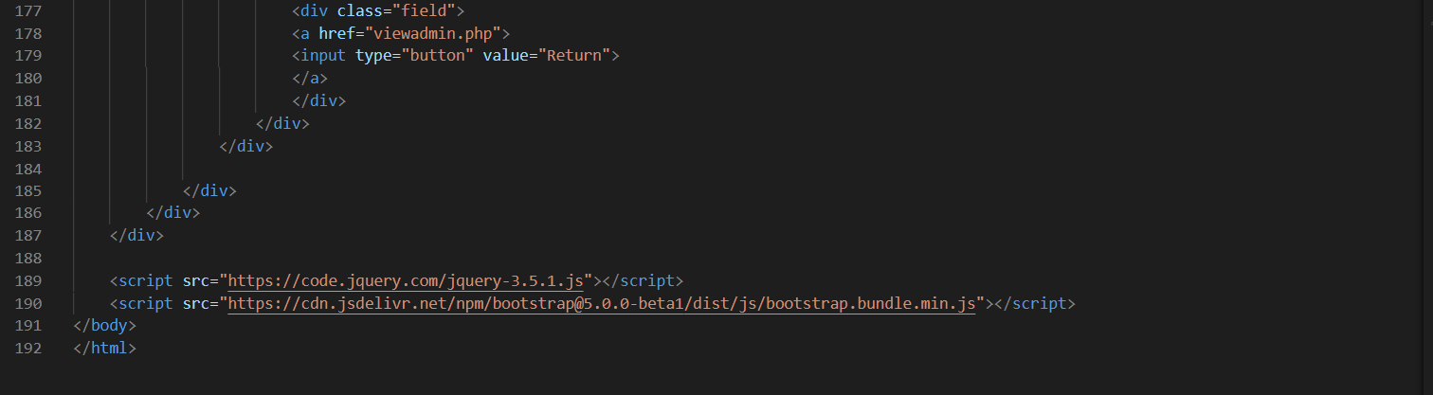

Figure 193

A return button to return to admin page also implied in the code.

Edit Company History

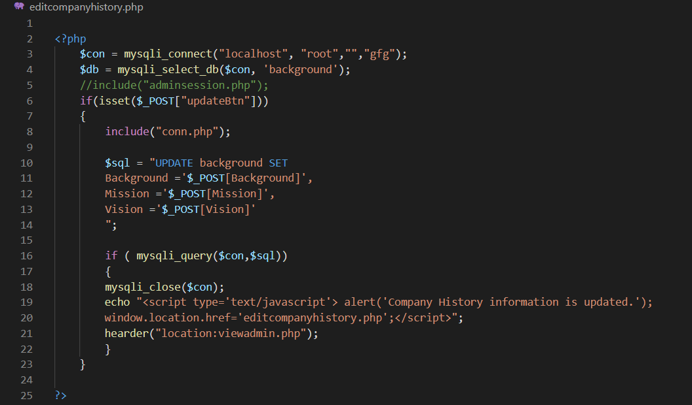

Figure 194

This is the code that is sql part to connect the gfg database of background table and the content is updatable. When staff change the content, it will pop a message “Company History Information is updated.” as alert massage.

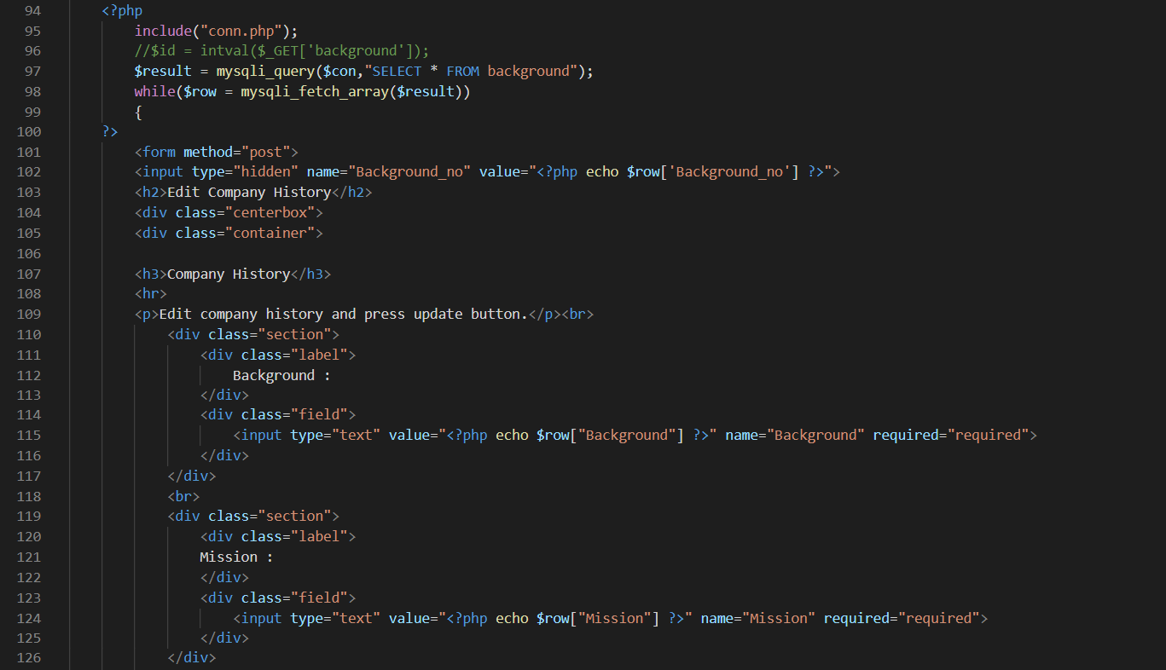

Figure 195

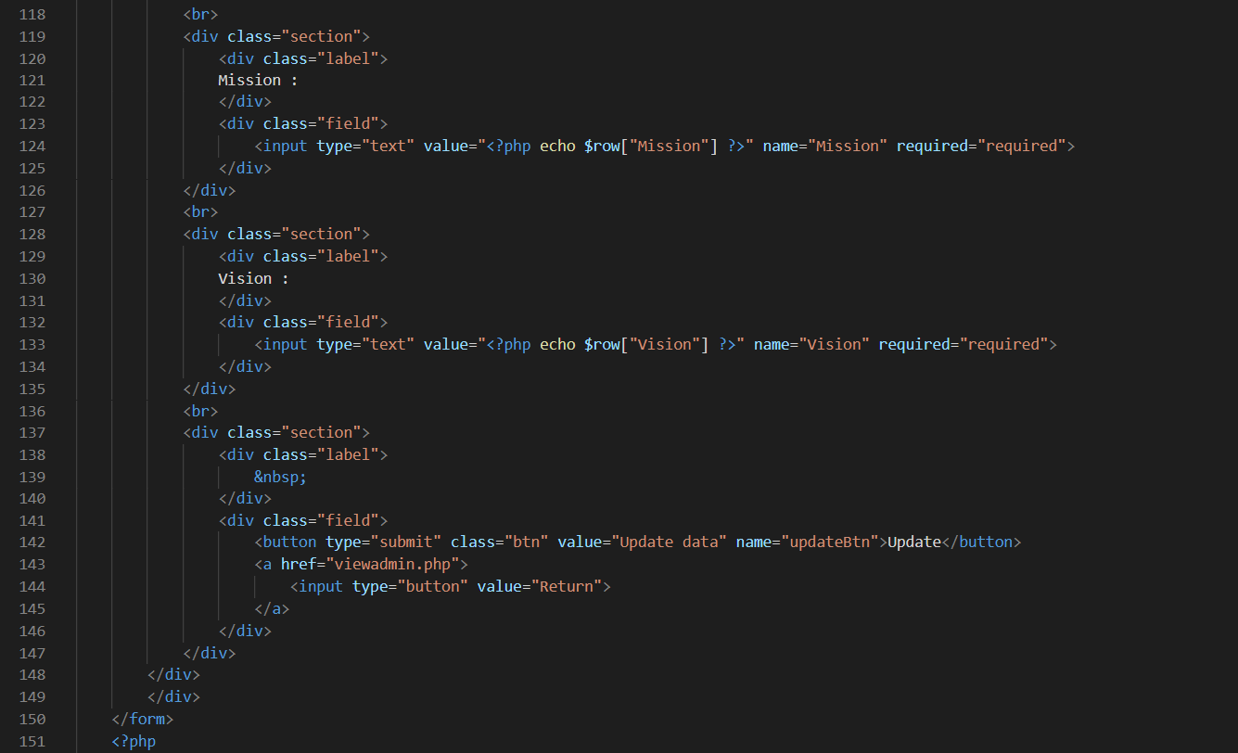

Figure 196

These are the codes which is view as label and the company history of background, mission and vision contents are shown out for modification. When staff finish modifying the contents, it has an update button to update the database. When done updating the background table contents, it will automatically go to admin page. If staff does not want edit company history but accidentally click the edit company history hyperlink button, it has a return button to return to admin page also implied in the code.

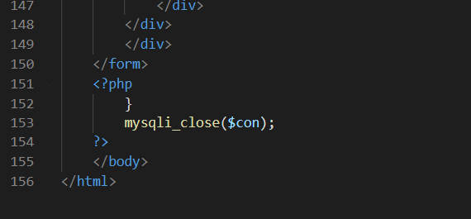

Figure 197

View Supplier

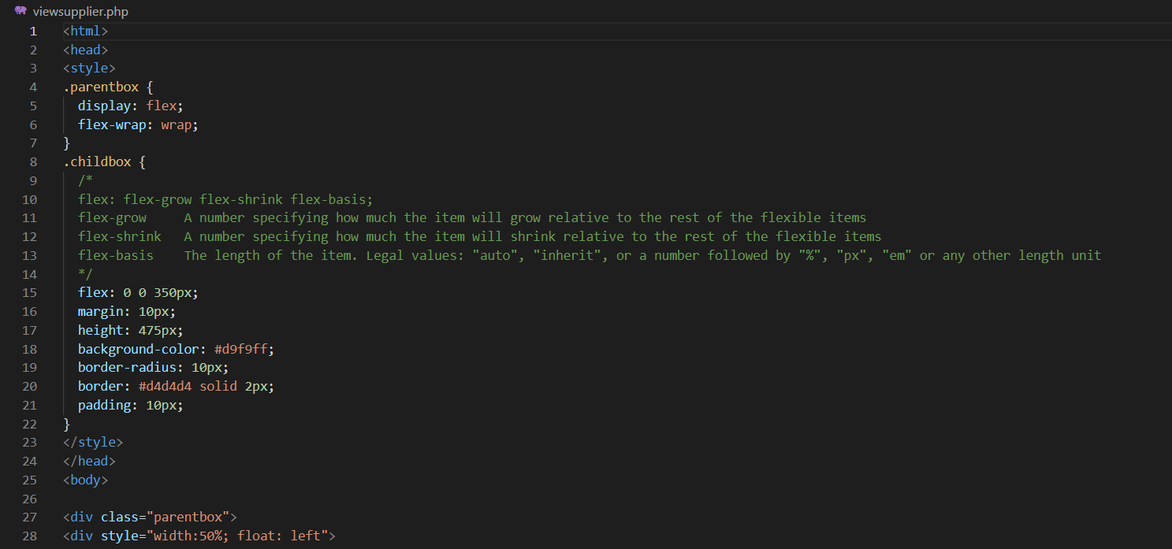

Figure 198

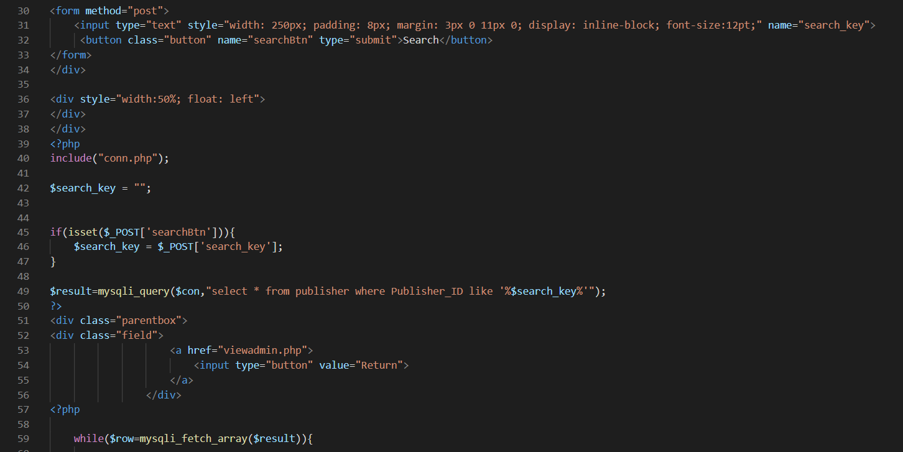

Figure 199

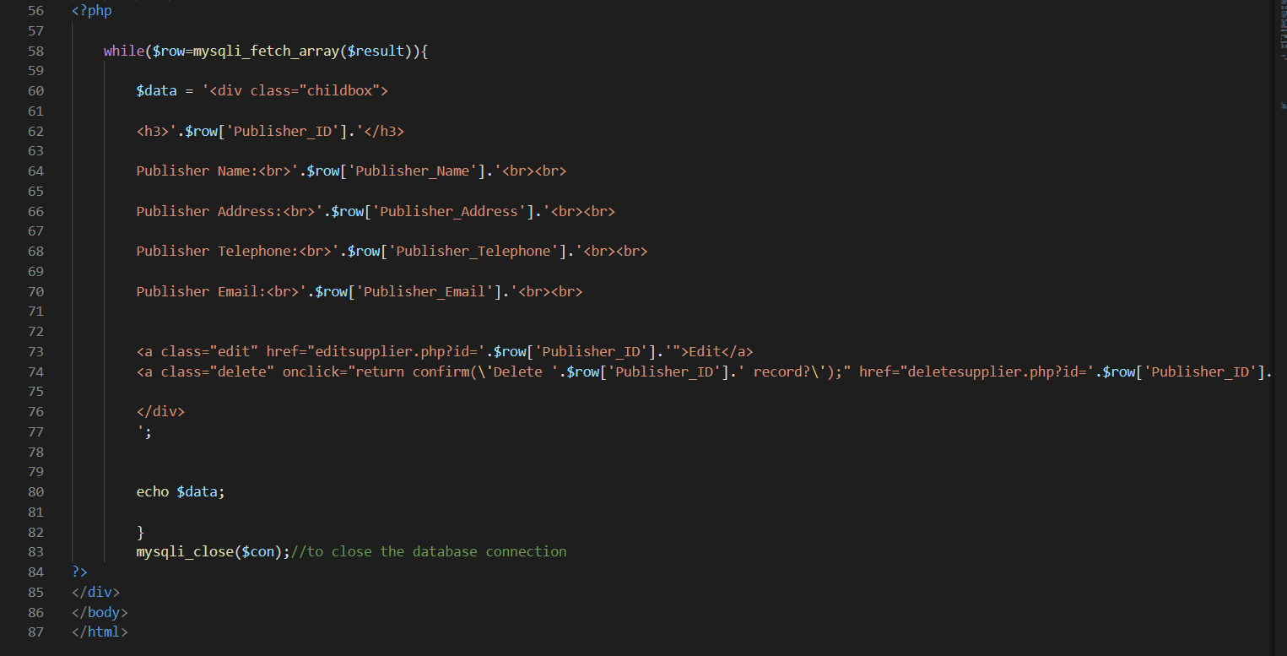

Figure 200

These are the codes that display out all the supplier's data into box lists from the gfg database of publisher table. It has shown the publisher ID, name, address, telephone number and email. Furthermore, it has also provided a search box and button to search specific supplier by search its publisher ID. Besides, it has a return button to return to admin page also implied in the code. A delete supplier account also given in the code, and it will also remove from the database.

Edit Supplier

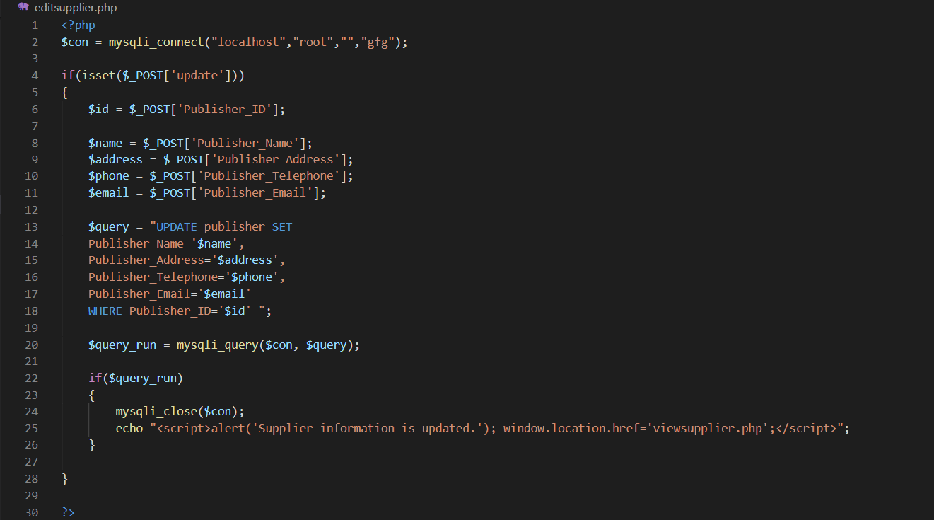

Figure 201

This is the code that can be updated the publisher’s information in the database. Staff is required to insert the publisher ID correctly in order to update the database. If staff does not insert the publisher ID correctly, the publisher in the database will not be updated. When staff finish inserted all the information and has clicked the update data button, it will pop out a message of “Supplier information is updated.” and directly go to the view supplier page.

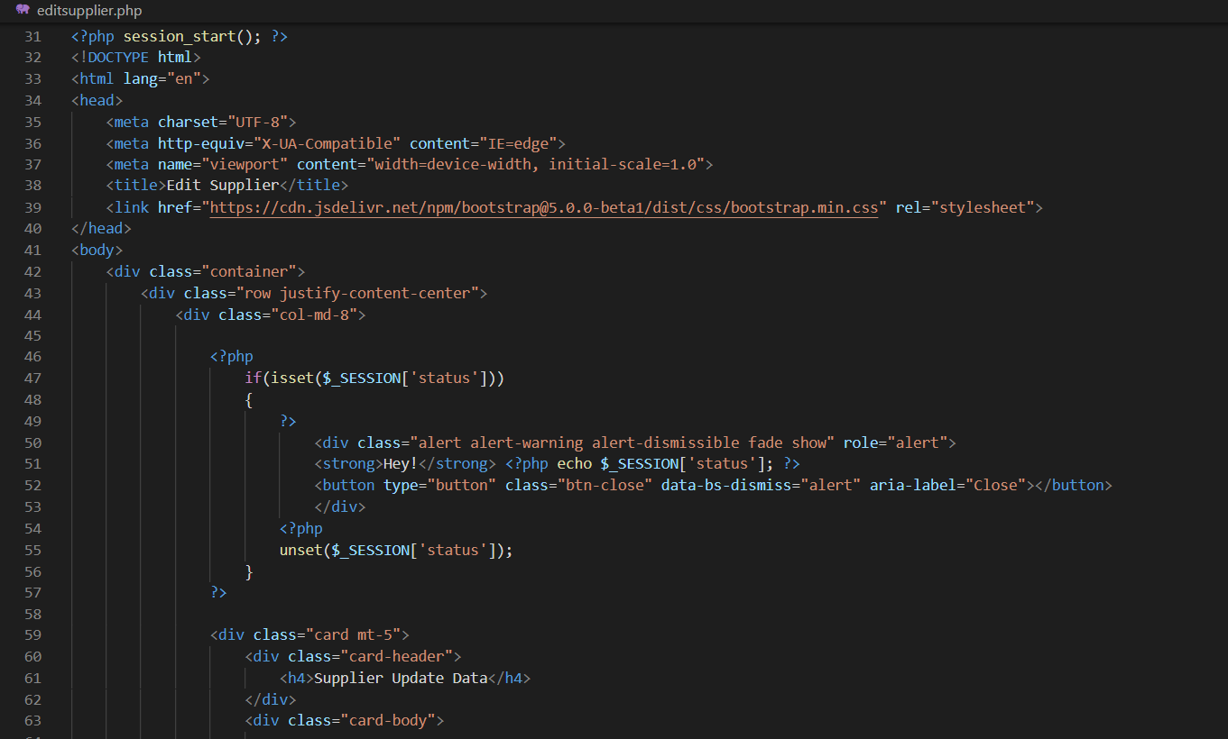

Figure 202

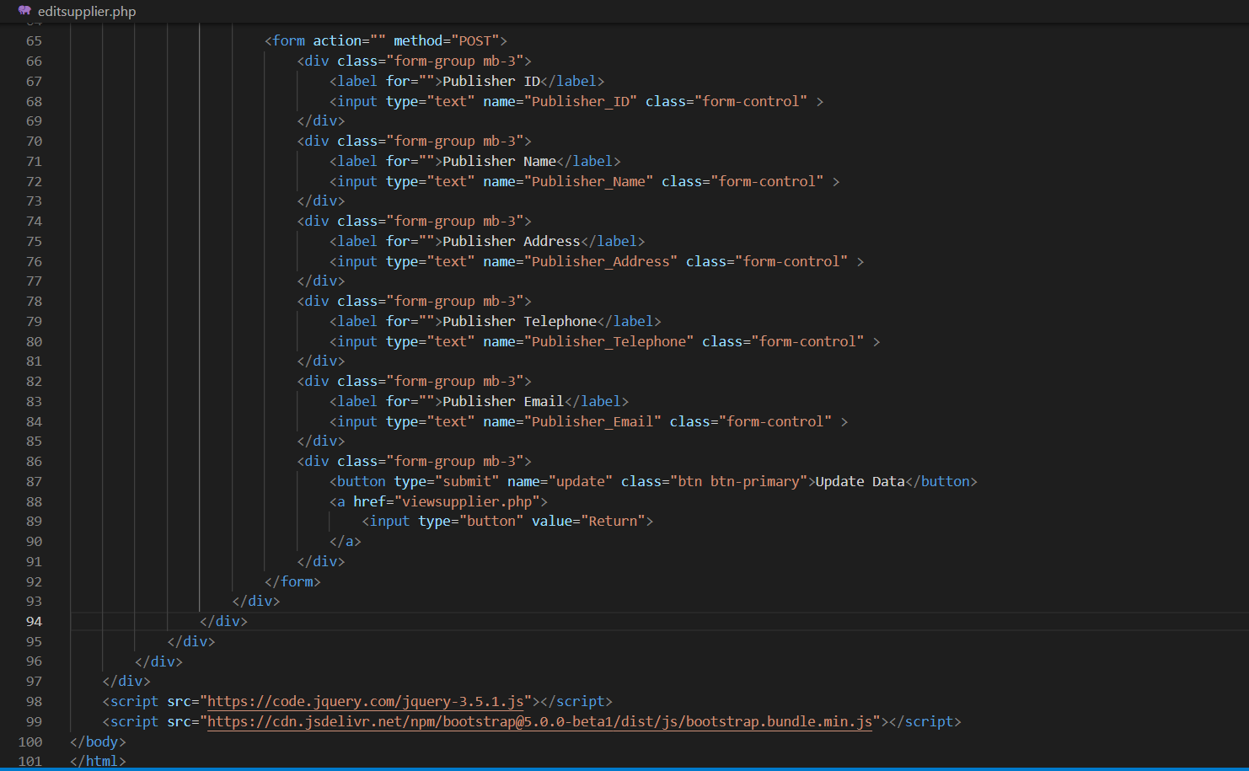

Figure 203

These are the codes that allows staff to insert the correct information according to the labels given. Staff will need to priority insert the publisher ID correctly, or else it will fail to update the supplier details in the database. When finish inserted the publisher ID correctly, staff can continue to insert the supplier information which are publisher name, publisher address, publisher telephone and publisher email. The update data button is just below the supplier update data form. If staff wish to return to view supplier page, the return button is next to update data button.

Delete Supplier

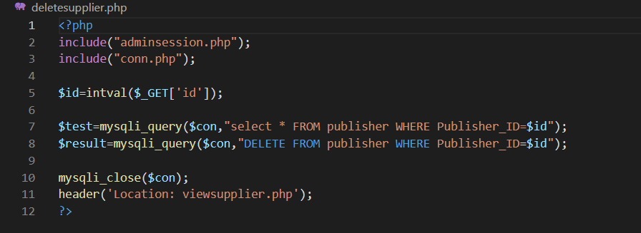

Figure 204

This code would be executed when the Delete hyperlink in view supplier is clicked. Based on the ID of the publisher account in the database, which is clicked, the sql command to delete supplier from publisher table would be performed. However, it with pop out of a confirmation alert box with message of “Delete [Publisher_ID] record?” and staff will have to choose “OK” or “CANCEL” button. If staff choose OK, the record of the supplier account will be removed from the database and will be returned to view supplier page. If staff choose CANCEL, the supplier account will be remaining the same and still stays in the view supplier page.

Delete Game Cart

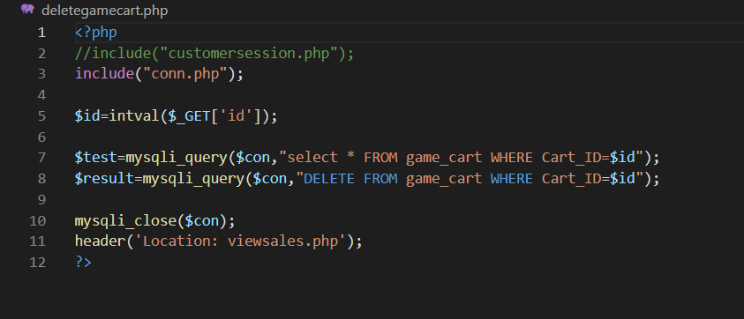

Figure 205

This code would be executed when the Delete hyperlink in view sales is clicked. Based on the ID of the game cart in the database, which is clicked, the sql command to delete game cart details from game cart table would be performed. However, it with pop out of a confirmation alert box with message of “Delete [Cart_ID] record?” and staff will have to choose “OK” or “CANCEL” button. If staff choose OK, the record of the game cart ID will be removed from the database and will be returned to view sales page. If staff choose CANCEL, the game cart will be remaining the same and still stays in the view sales page.

Member Profile

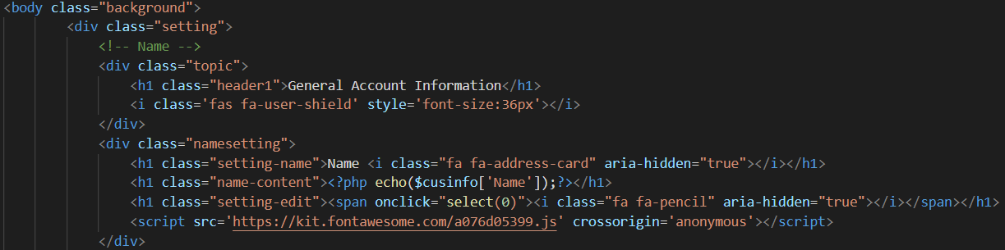

Figure 206

This code above will show the basic information of member in a tab. The information of member will have a small icon beside which will enable a tab to be opened below when the icon is clicked.

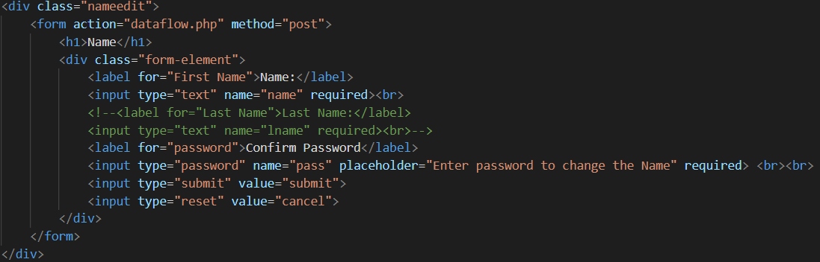

Figure 207

This is the code for the small tab when the icon is clicked. The tab will provide a text field to enter input. For the code above, the text field will accept member’s name. In order to confirm with the changes, member will need to enter the password to apply the changes.

Member View Purchase History

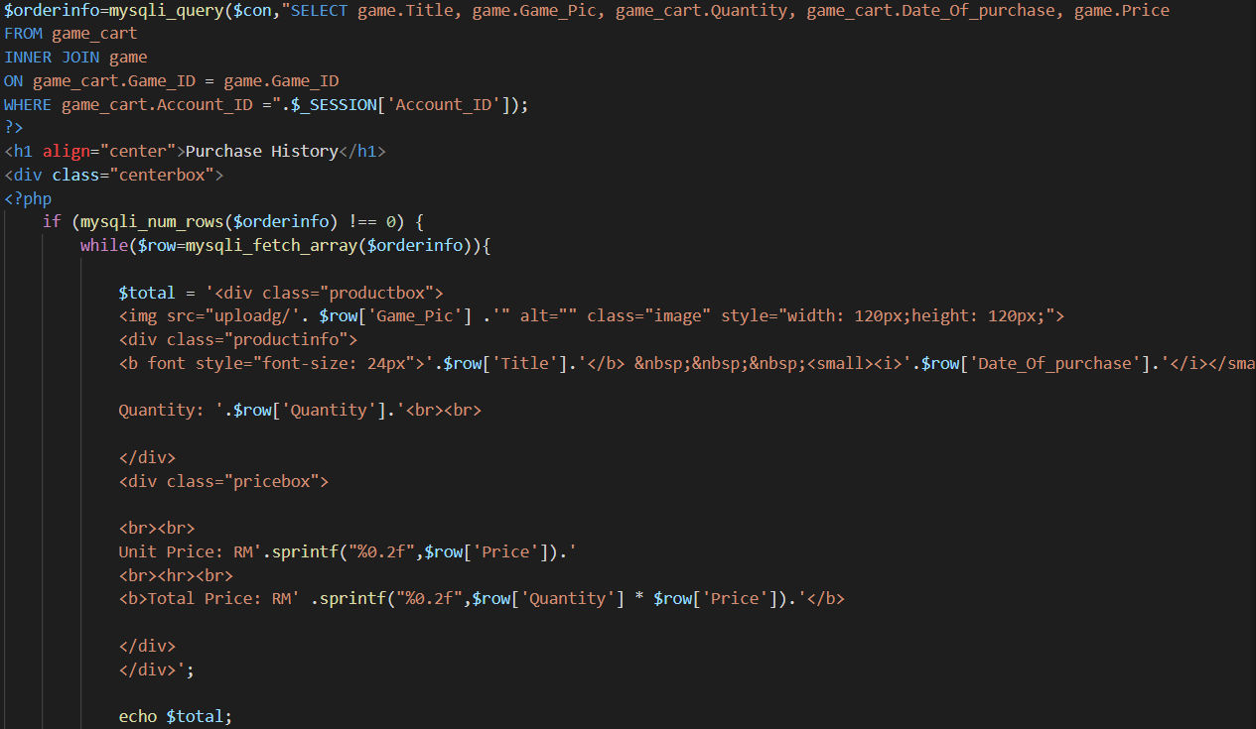

Figure 208

This code will show the purchases made by member. Through comparing the member id from the customer session in navbar.php, the purchases made by member will be shown in boxes.

Register

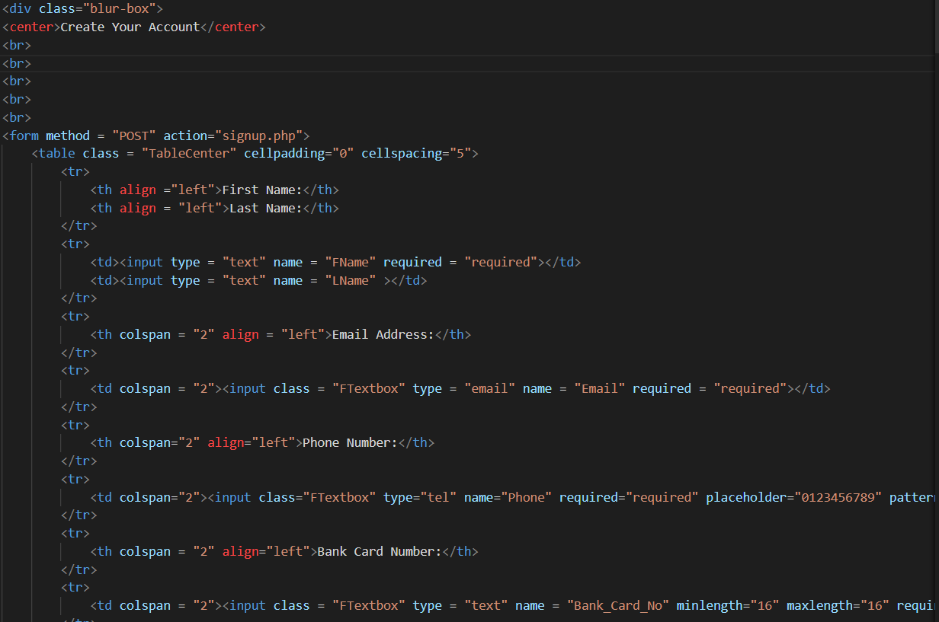

Figure 209

These code above is to display the Register screen. These codes will provide text field for guests to fill up. If all input by guest fulfils the requirements, the details of guest will be recorded in the database which creates an account for the member

Guest Home Screen Code

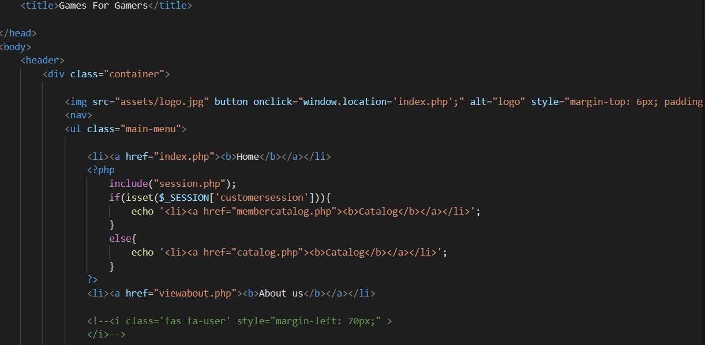

Figure 210: Guest Home Screen

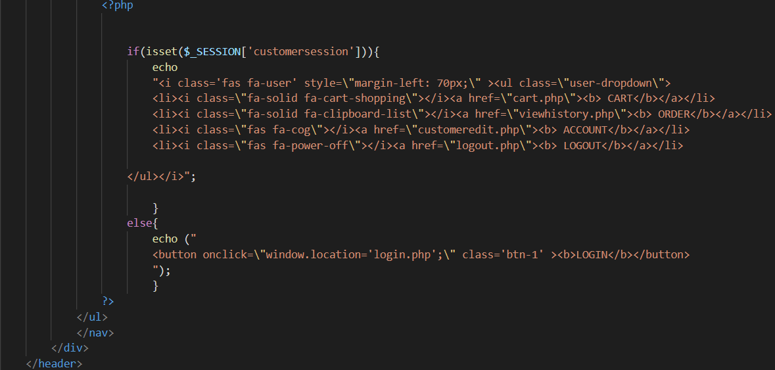

Figure 211: Guest Home Screen

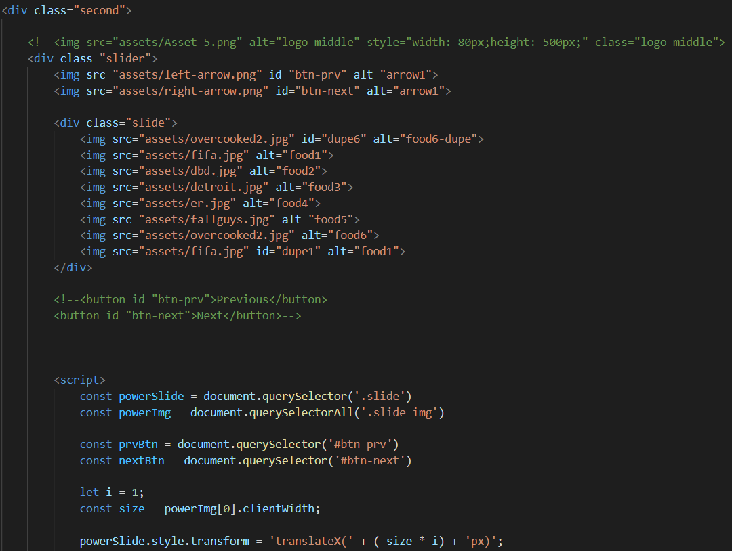

Figure 212: Guest Home Screen

These code above is the code used to display the home screen for guest and member. If customer session is activated (the user has successfully access the system as a member, the display on navbar would be different and direct member to different screens which giest could not access.

# 17.0 Conclusion

In general, the proposed system for the project would be an online e-commerce website named GFG. GFG aims to promote sales of physical form video games in the market. As shown previously above the details for developments of GFG such as proposed solution, system hierarchy chart, project plan and so on, indicates the development of GFG would be propitious as it would contribute to expand of physical games marketing to go beyond national boundary and not restricted to physical premise. However, there would be numerous issues which may be encountered during the development of GFG website.

This includes the issue of image of stock on the website when it became unavailable. The remaining stock for each game would be shown in a field at the game details product screen. When a game is sold out, the remaining stock field would show zero stock remains. Due to insufficient programming and technical skills, we are not capable to apply a card written with “Sold Out” on the image of the sold-out product. This could be troublesome and disappoint of customers who realise that their desired game is unavailable after viewing the product details.

Next, the issue of game delivery after purchase is complete. After the payment is complete, the game would be delivered to the member based on the address in the member’s profile. If the member intends the game to be delivered to another location, the member will need to change the address in the profile in advance before confirm purchase. This may result issues of delivering product to undesired location by customers.

Moreover, the issue to limit contents of comments for games. Due to insufficient experience of coding, the admin is not capable to control the contents made by members. This may result plot, easter eggs, gameplay of game to be exposed for guests and customers while viewing details of the game. In additional, admin could not prohibit vulgar words or quarrels to occur in comment section. Thus, it may result both guests and customers to have bad user experience.

Last but not least, the development of GFG website would be launched as soon as the proposal is approved by the lecturer. The project is targeted to be complete before 8th April 2022 based on Waterfall system development methodology with various knowledge taught during previous semesters. Task delegation among team member would be done to ensure each member are provided with equal workload and project to be complete within proposed time frame. Without any issues, the project would progress according to the project plan and expected to provide exact return as estimated previously and achieve the project scope as well as resolve the problem context stated previously.

# 18.0 Reference

*Deployment Phase in SDLC - Video & Lesson Transcript | Study.com*. (n.d.). Retrieved February 28, 2022, from https://study.com/academy/lesson/deployment-phase-in-sdlc.html#lesson

Martin Matthew. (2022, February 18). *SDLC (Software Development Life Cycle): What is, Phases & Models*. https://www.guru99.com/software-development-life-cycle-tutorial.html

Perforce. (2021, January 20). *Intro to Coding Standards — Coding Rules and Guidelines | Perforce*. https://www.perforce.com/resources/qac/coding-standards

Rana Kuldeep. (2020, July 9). *Waterfall Model in Software Engineering - Features, Advantages & Disadvantages*. https://artoftesting.com/waterfall-model

*Requirement Gathering Techniques*. (2020, February 27). https://www.tutorialspoint.com/business_analysis/business_analysis_requirement_gathering_techniques.htm

Sharma Lakshay. (2021, October 18). *What is WaterFall Model in Software Developement Life Cycle | SDLC*. https://www.toolsqa.com/software-testing/waterfall-model/

Stevens Emily. (2021, December 29). *Design Thinking Stage 4: Your Complete Guide to Prototyping*. https://careerfoundry.com/en/blog/ux-design/design-thinking-stage-four-prototyping/

*Waterfall Methodology - A Complete Guide | Adobe Workfront*. (2022, February 27). https://www.workfront.com/project-management/methodologies/waterfall

*What is an Adaptive Maintenance? - Definition from Corrosionpedia*. (n.d.). Retrieved February 28, 2022, from https://www.corrosionpedia.com/definition/6211/adaptive-maintenance

Zulqadar Amna. (2019, February 19). *SDLC Waterfall Model: The 6 phases you need to know about*. https://rezaid.co.uk/sdlc-waterfall-model/

# 19.0 Appendix

## 19.1 Installation Guide

First, go to any browser and search for WampServer official website as shown in the diagram below. Then scroll down to “DOWNLOADS” section, click on “WAMPSERVER 64 BITS (X64) 3.2.6” button.

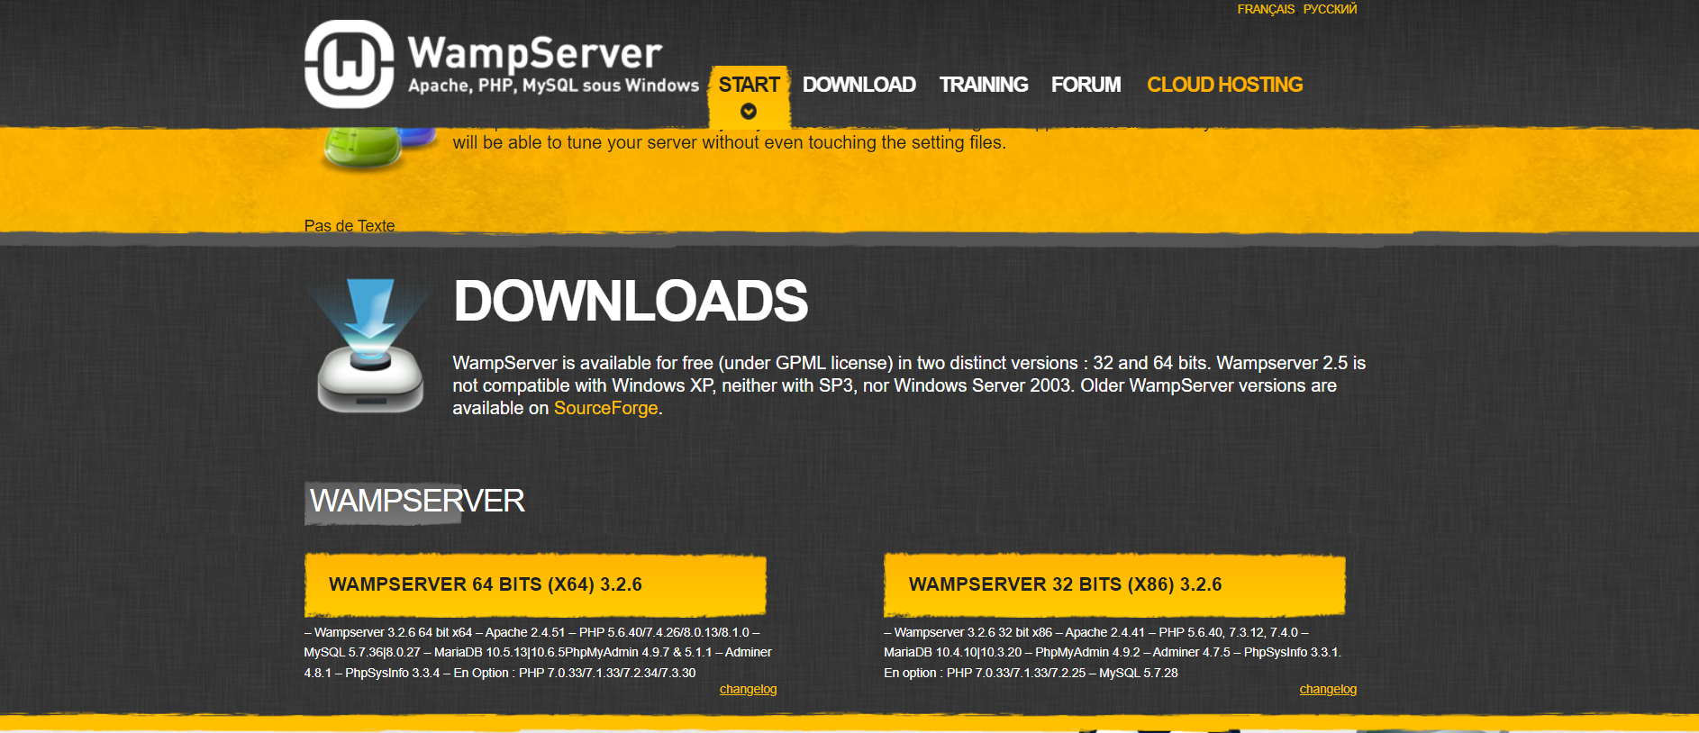

Figure 213: WampServer Official Website

Next, click on the hyperlink “you can download it directly” as shown in the diagram below.

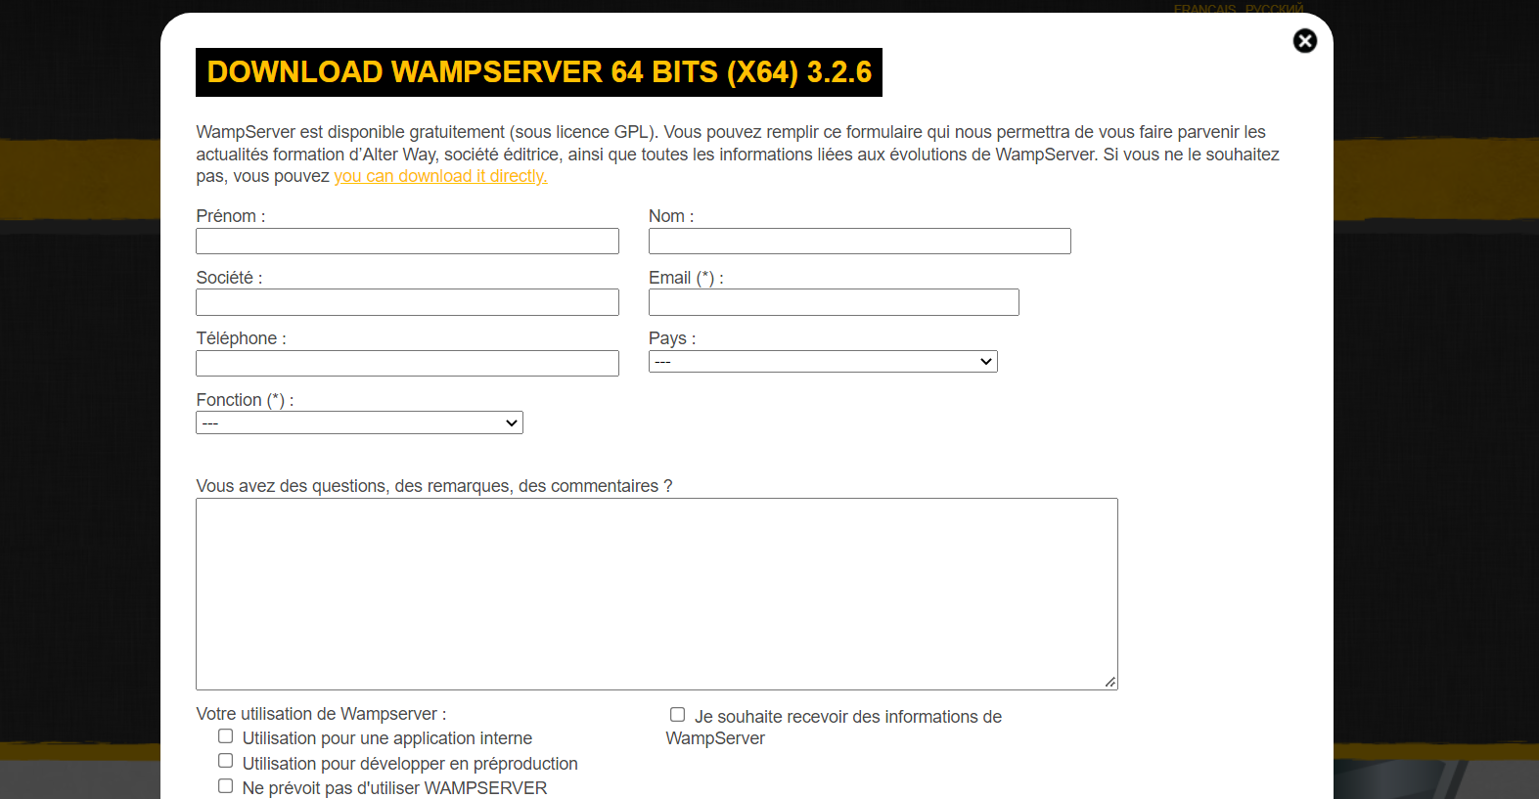

Figure 214: WampServer Website pop-up window

Afterwards, it will bring to a new page and a five second need to be waited so that the WampServer will be started downloading into the computer.



Figure 215: WampServer in Source Forge Website

Once the WampServer has downloaded completely, open it, and click on “OK” button if the system prompts a message “allow this app to make changes to the devices”.

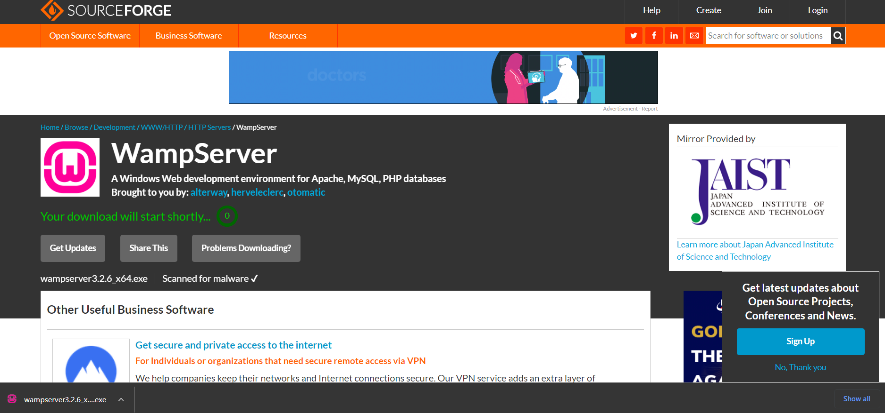

Figure 216: Opening the downloaded WampServer

Subsequently, the setup wizard of WampServer will be shown in the screen. Select the language that preferred and press on “OK” to proceed.

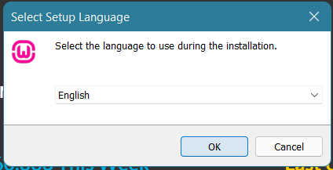

Figure 217: WampServer setup wizard 1

Tick on “I accept the agreement” button to accept the license agreement and click “Next” button to continue the installation of WampServer.

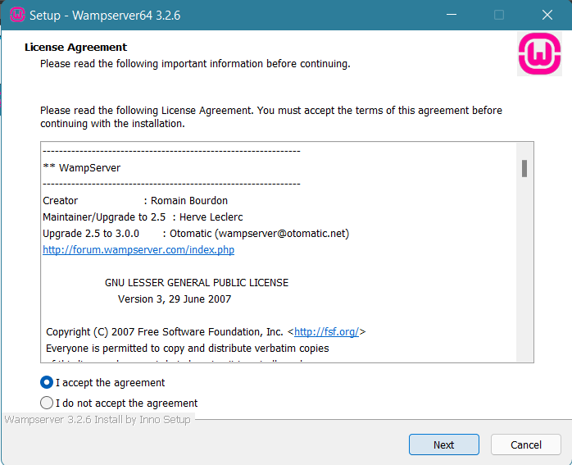

Figure 218: WampServer setup wizard 2

Click on “Next” button as shown in the diagram below.

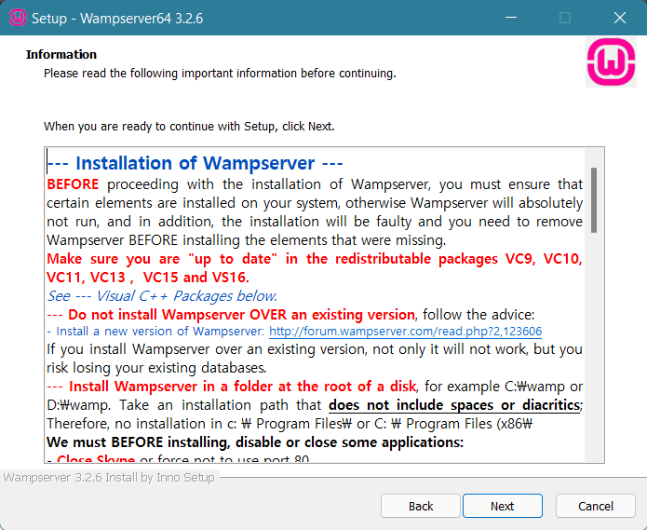

Figure 219: WampServer setup wizard 3

Continue to press on “Next” button if you would like to install the WampServer in a default location which is in the C Drive. On the other hand, click on “Browse” button if you preferred to a different location.

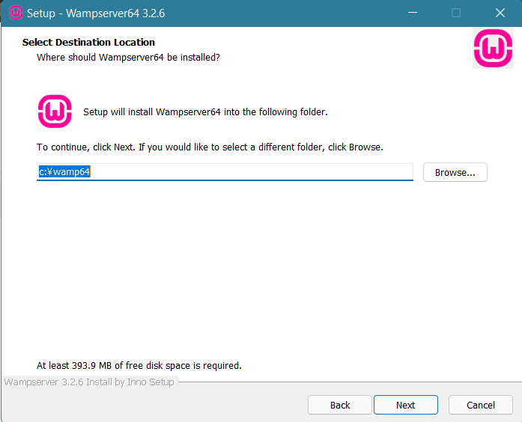

Figure 220:WampServer setup wizard 4

Next, make sure all the components are ticked to ensure the WampServer works smoothly. The system has ticked all the necessary components for itself, click on “Next” button to continue.

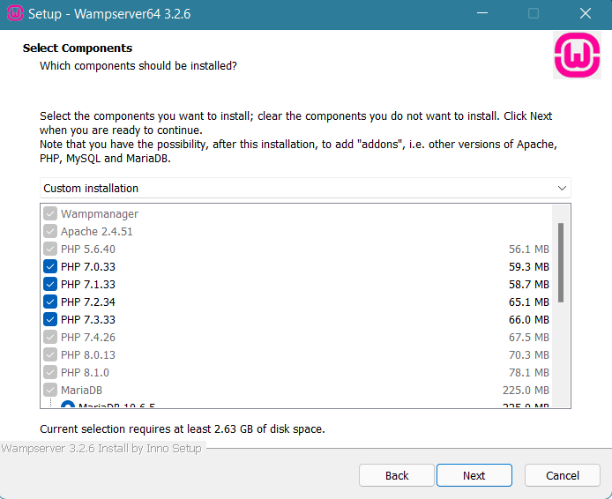

Figure 221: WampServer setup wizard 5

Press on “Install” button as shown below.

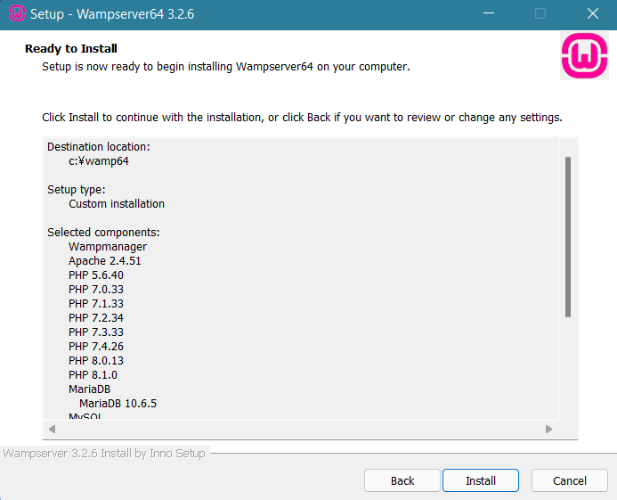

Figure 222: WampServer setup wizard 6

Wait for the installation to complete in few minutes.

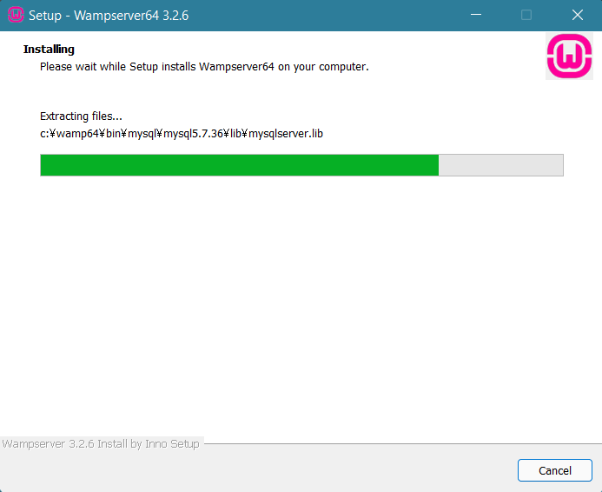

Figure 223: WampServer setup wizard 7

A small pop-up window will appear, click on “No” button if you wish to use Internet Explorer as a “default browser” for WampServer.

If you desired to use another browser such as Chrome, Mozilla Firefox, Opera, etc, click on “Yes” button and search for the browser you desired. Chrome browser will be used as demonstration for the Installation guide.

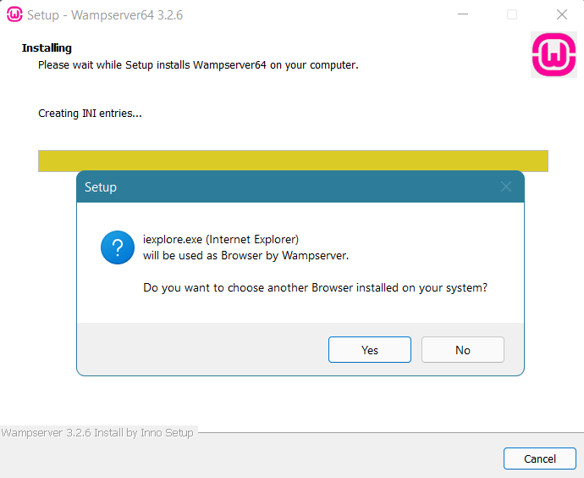

Figure 224: WampServer setup wizard 8

Navigate to C Drive, Program Files (x86), Google, Chrome, Application, and search for chrome.exe and click on “Open” button as shown below.

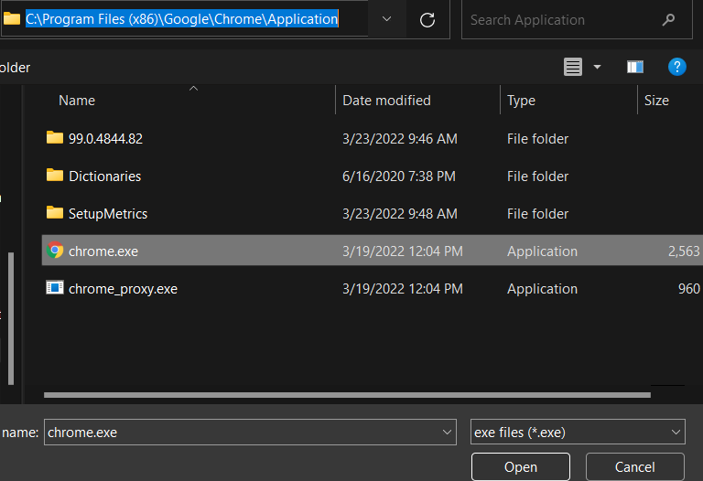

Figure 225: WampServer setup wizard 9

Afterwards, select “No” as there are no others text editor needed to install in this Installation guide. Click on “No” unless you have others text editor and locate the exe file and click at “Open” same as in the previous step.

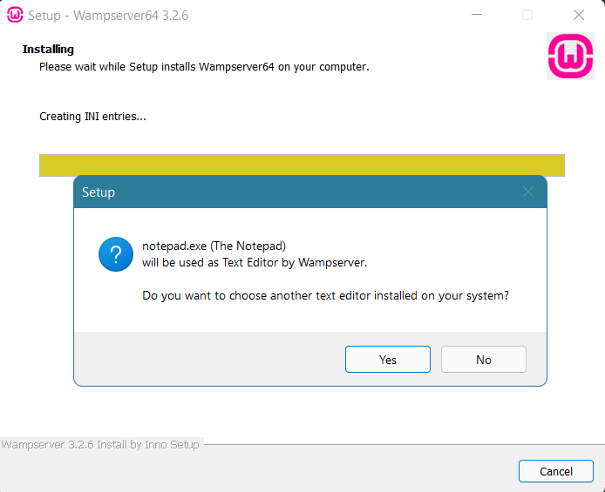

Figure 226: WampServer setup wizard 10

Wait for a thirty second for the system to install WampServer to the computer.

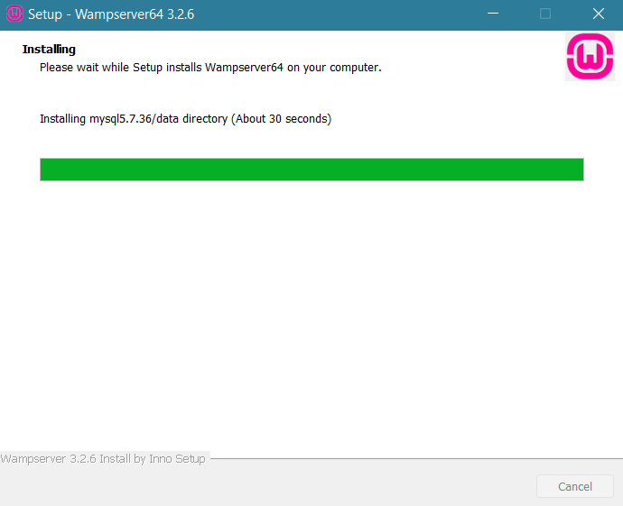

Figure 227: WampServer setup wizard 11

Read the instruction which the information of WampServer will be explained either in text file of pdf file. Click on “Next” button to complete the installation for WampServer.

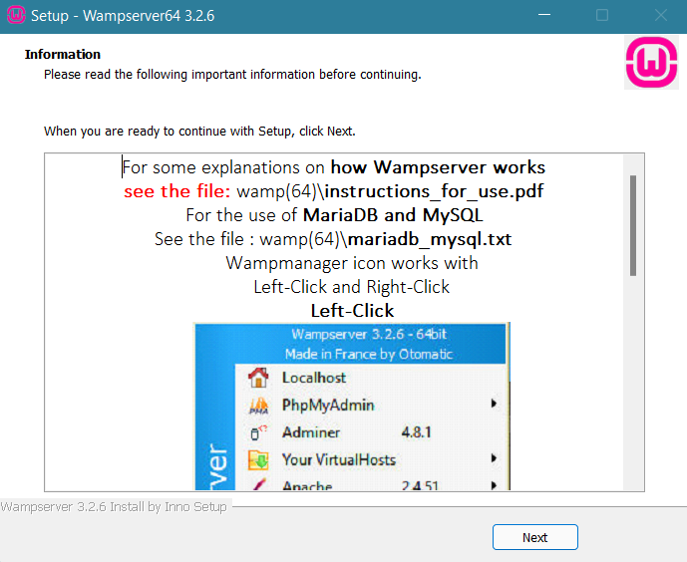

Figure 228: WampServer setup wizard 12

Click on “Finish” to complete installation process.

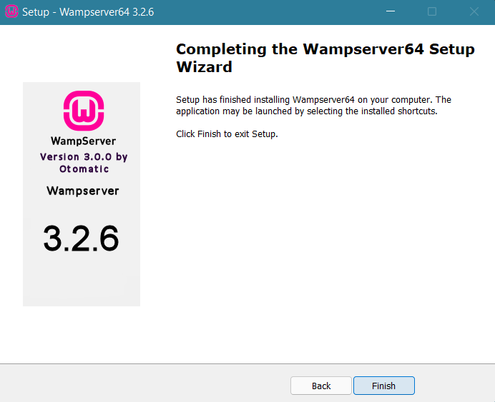

Figure 229: WampServer setup wizard 13

After the installation is completed, user would need to launch Wampserver by clicking on the Wampsever shortcut application on the screen. After multiple black window flash on the screen for a few seconds, a Windows Firewall notification would show up. User would need to allow WampServer to connect private network of the computer.

Next, user would need to check the status of Wampserver through system icon tray. If the icon of Wampserver is green in colour, this would represent the Wampserver is active and ready for operations.

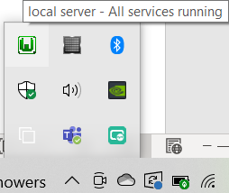

Figure 230:Green Icon of Wampserver

However, if the icon is in orange or read in colour, it would represent the Wampserver is not running properly due to certain inferences. Thus, user would be advised to restart the computer and reactivate Wampserver.

Next, user would need to extract (unzip) the gfg zip file into a folder called GFG.

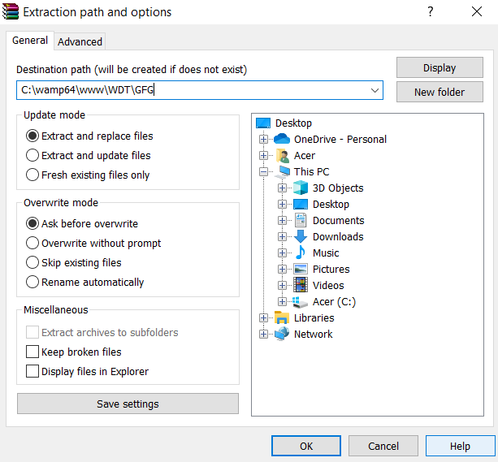

Figure 231: GFG Folder

When the icon is green in colour, user would need to open web browser and enter “localhost” in the address bar and press on Enter button on the keyboard. User would be directed to homepage of Wampserver.

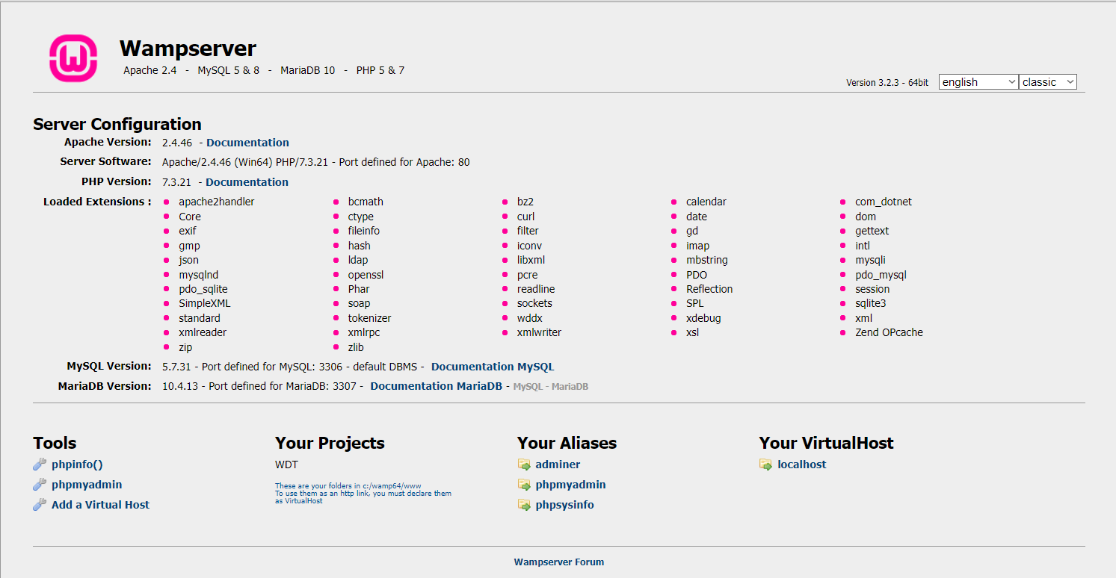

Figure 232: Homepage of Wampserver

Next, user would need to install the database into the phpMyAdmin. User would need to click on the phpMyAdmin hyperlink under the Tools section.

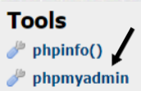

Figure 233: phpMyAdmin Hyperlink

After clicking on the hyperlink, user would be directed to the login page of phpMyAdmin. User would need to enter “root” at Username text field and click on “Go” button to proceed.

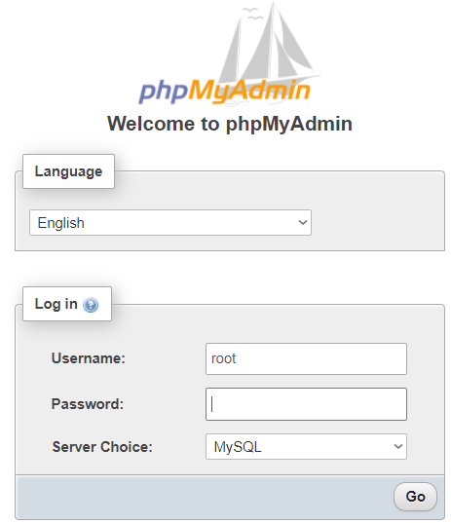

Figure 234: Login Page of phpMyAdmin

After accessing the phpMyAdmin, user would need to click on the Choose File button in green box, upload the database file with name of “gfg” in the black box followed with clicking on Go button in the red box.

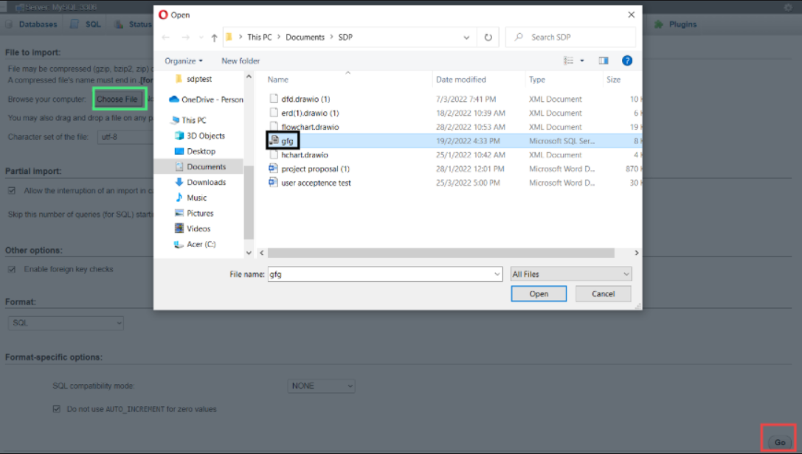

Figure 235

User would need to wait for the message which shows the import is successful to be shown and the import of database is complete.

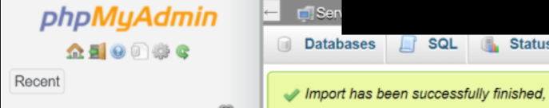

Figure 236

Finally, user would need to place the gfg folder into an appropriate location of Wampserver folder. First, user would need to access the wamp64 folder in the grey box in Acer(C:).

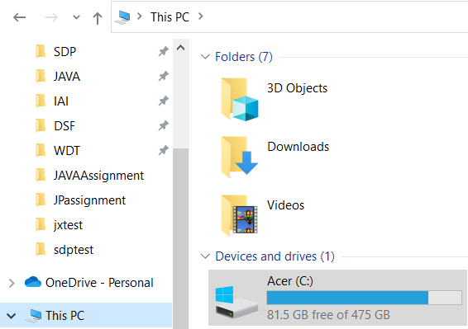

Figure 237

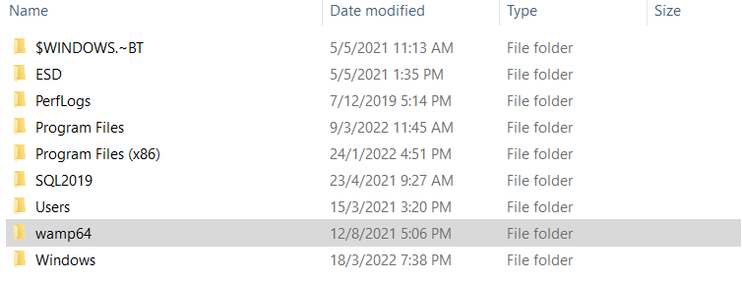

Figure 238

User would need to create a folder in the www folder of wamp64 inside Acer(C:). For the demonstration, a folder called WDT is created. Next, user will need to move the GFG folder into the WDT folder as shown in the black box.

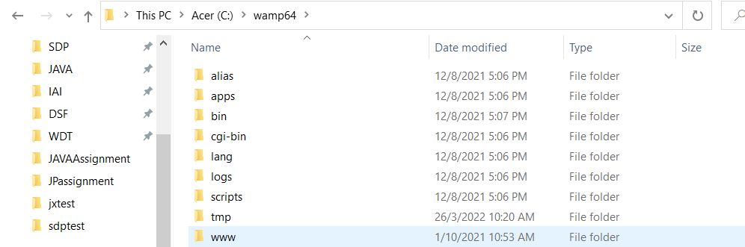

Figure 239

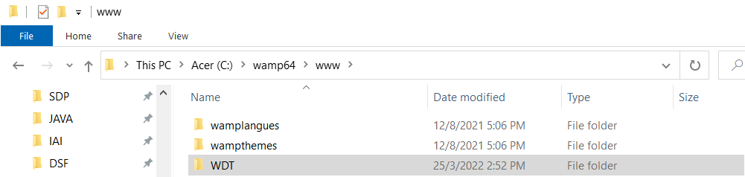

Figure 240

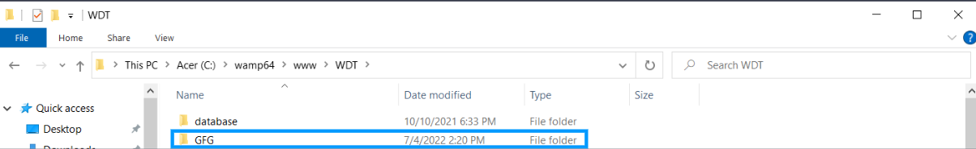

Figure 241

After completing the steps above, user will need to enter localhost/wdt/ in the web browser address bar which leads user to screen with title of Index of WDT. Finally, user would need to click on the GFG folder in the black box to run the system.

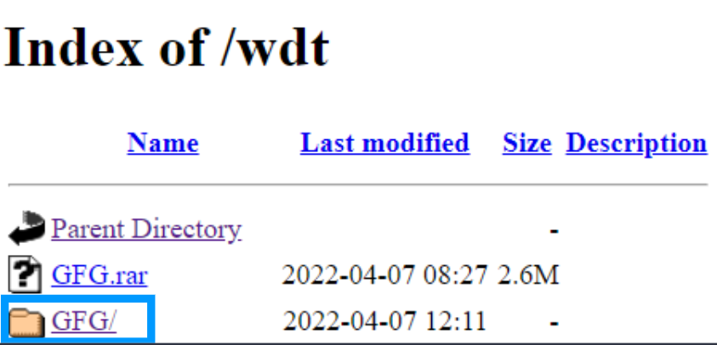

Figure 242

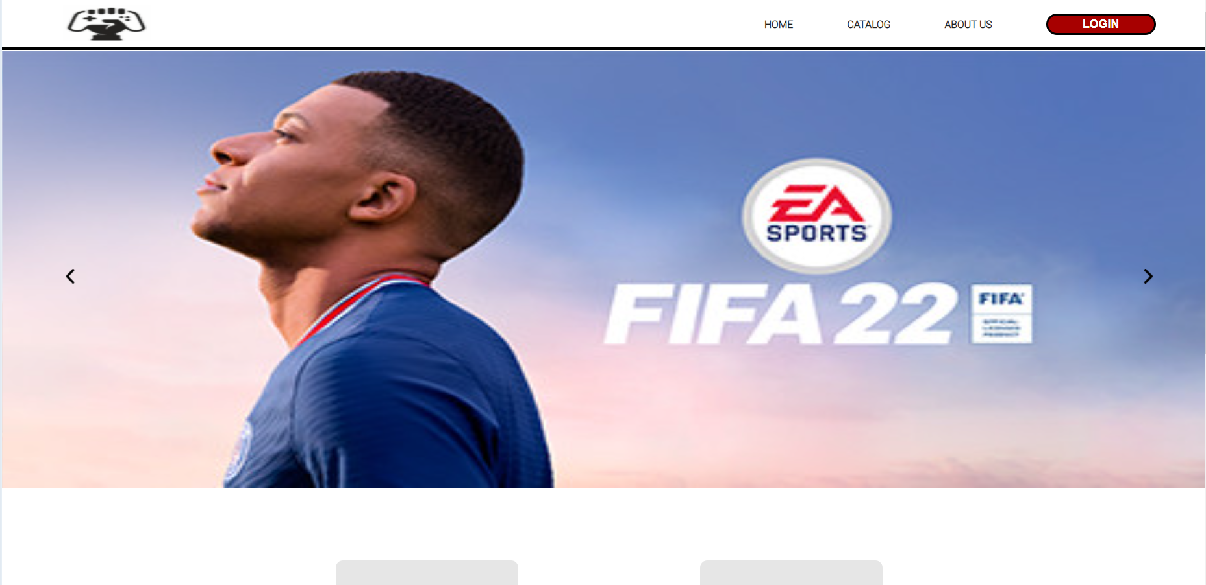

Figure 243

## 19.2 Meeting Minutes

|  |  |  |  |  |  |  |  |  |  |  |
| --- | --- | --- | --- | --- | --- | --- | --- | --- | --- | --- |
|  | **Milestones / Project Progress Group 1** | | | | | | | | | |
|  |
|  |  |  |  |  |  | |  |  |  |  |
|  |  |  |  |  |  | |  |  |  |  |
|  |  |  |  |  | |  |  |  |  |  |
|  | **Task Name** | **Start Date** | **End Date** | **Priority** | **Assigned To (Full Name)** | | **Completion Status** | **Lecturer Comments** | **Group Leader Comments** | **Document Link** |
| 1 | **Requirement Gathering** | 10/1/2022 | 22/1/2022 | High | All | | Complete |  | Nil |  |
| 1.1 | Perform Preliminary Investigation | 10/1/2022 | 15/1/2022 | High | All | | Complete |  | Nil |  |
| 1.2 | Define Problem | 16/1/2022 | 17/1/2022 | High | All | | Complete |  | Nil |  |
| 1.3 | Determine Project Objective and Scope | 18/1/2022 | 19/1/2022 | High | All | | Complete |  | Nil |  |
| 1.4 | Requirement Analysis | 20/1/2022 | 21/1/2022 | High | All | | Complete |  | Nil |  |
| 2 | **Proposal** | 22/1/2022 | 13/2/2022 | High | All | | In Progress |  | Nil | shorturl.at/jIRY5 |
| 3 | **System Design** | 14/2/2022 | 28/2/2022 | High | Foong Wai Keat | | Complete |  | Nil |  |
| 3.1 | Context Diagram | 14/2/2022 | 15/2/2022 | High | Foong Wai Keat | | Complete |  | Nil |  |
| 3.2 | Data Flow Diagram Level 0 | 16/2/2022 | 17/2/2022 | High | All | | Complete |  | Nil |  |
| 3.3 | Data Flow Diagram Level 1 | 18/2/2022 | 19/2/2022 | High | All | | Complete |  | Nil |  |
| 3.4 | Data Dictionary | 20/2/2022 | 21/2/2022 | High | Foong Wai Keat Lim Jia Xuan | | Complete |  | Nil |  |
| 3.5 | Entity Relation Diagram | 22/2/2022 | 23/2/2022 | High | Foong Wai Keat | | Complete |  | Nil |  |
| 3.6 | Pseudocode/Flowchart | 24/2/2022 | 26/2/2022 | High | (Foong Wai Keat, Lee Jian Wen, Lim Jia Xuan ) status of vanness is unsure | | (Complete) status of vanness is unsure |  | (Nil) status of vanness is unsure |  |
| 3.7 | Screen Design and User Manual | 26/2/2022 | 28/2/2022 | High | (Foong Wai Keat, Lee Jian Wen, Lim Jia Xuan ) status of vanness is unsure | | (Complete) status of vanness is unsure |  | (Nil) status of vanness is unsure |  |
| 3.8 | Report Design and User Manual | 1/3/2022 | 4/3/2022 | High | Foong Wai Keat | | Complete |  | Nil |  |
| 4 | **Implementation** | 5/3/2022 | 30/3/2022 |  |  | |  |  | Nil |  |
| 4.1 | Coding | 5/3/2022 | 26/3/2022 | High | All | | Complete |  | Nil |  |
| 4.2 | MySQL | 27/3/2022 | 30/3/2022 | High | All | | Complete |  |  |  |
| 5 | **Testing** | 1/4/2022 | 6/4/2022 |  | All | |  |  |  |  |
| 5.1 | Test Plan | 1/4/2022 | 6/4/2022 | High | (Foong Wai Keat, Lim Jia Xuan) status of vanness is unsure | | Complete (status of vanness is unsure) |  | Nil(status of vanness is unsure) |  |
| 6 | **Maintenance** | 7/4/2022 | 8/4/2022 | High |  | |  |  |  |  |

Link: <https://cloudmails.sharepoint.com/:x:/s/SDPassignment458/EVO0KBzgJsBFl7lZKFMzvEwB9O3fjbqiSKJ0kLqryaLAqA?e=SVxTf0>

## 19.3 Issues

This the actual workload matrix (if Vanness did not beg for me to spare some marks for others this will be implemented as I am really annoyed with him and lim jia xuan)

(special case with Lee Jian Wen, explained later..)

You might have noticed, there may have some parts repeated, I did not remove them as some team members claimed and insist those parts to be different which result me to keep those parts in the documentation. (Truly sorry for causing inconveniences…)

|  |  |  |  |  |
| --- | --- | --- | --- | --- |
| **Tasks** | **Foong Wai Keat TP 060033** | **Lee Jian Wen TP 060729** | **Lim Jia Xuan**  **TP 059385** | **Vanness Goh Ching Yi**  **TP 061175** |
| **Introduction** | 50% | 50% | 0% | 0% |
| **Abstract and Acknowledgement** | 100% | 0% | 0% | 0% |
| **Gantt Chart** | 45% | 20% | 0% | 0% |
| **Methodology** | 50% | 50% | 0% | 0% |
| **Context Diagram** | 100% | 0% | 0% | 0% |
| **Level 0 DFD** | 100% | 0% | 0% | 0% |
| **Entity Relationship Diagram** | 100% | 0% | 0% | 0% |
| **System Hierarchy Chart** | 100% | 0% | 0% | 0% |
| **Data Dictionary** | 60% | 10% | 20% | 10% |
| **Screen design and User Manual** | 25% | 25% | 25% | 25% |
| **Report Design and User Manual** | 100% | 0% | 0% | 0% |
| **Unit Testing** | 40% | 10% | 25% | 0% (haven’t complete at 9th April) |
| **User Acceptance Test** | 30% | 15% | 25% | 25% |
| **Significant Codes** | 60% | 0% | 20% | 20% |
| **Perceived Limitation** | 100% | 0% | 0% | 0% |
| **Perceived Assumption** | 100% | 0% | 0% | 0% |
| **Group Effort** | 45% | 15% | 20% | 20% |
| **Compilation and other tasks** | 100% |  |  |  |
| **Signature** | Foong | Jian Wen |  | Vanness |

(Actually, lee jian wen’s would be lesser, but he is special case. (Does not know coding…)

I am serious, I have completed most (about 70% for proposal and most of documentation), this include

2/3 for data dictionary

60% codes (consider gui)

Most introduction (90%)

A little for methodology (15% paraphrase)

Gantt chart (40%, excel Gantt chat build by me, we fill contents for in the progress sheet),

Context diagram (100%)

Dfd lv 0 (100%)

System hierarchy chart (100%)

User manual (50%)

Perceived limitation (100%)

Perceived assumptions (100%)

Conclusion (100%)

Report design (100%)

Abstract and acknowledgement (100%)

All documentations (except user manual) for lee jian wen parts are done by me as there is no point asking him to do explanation as he would not be capable to explain it, so no choice, I have to do it…

As for lim jia xuan’s parts (report design manual) is done by me as the part is done by me there is no point asking her to explain as does not know the structure and validations…

The other 100% parts are parts which no one replies or volunteer to do during meeting… (though vanness tried to help for system hierarchy chart but I refuse as if done by 2 people it is not effective and too slow as there is a few more days for proposal to submit)

P.s: though the gantt chart and the first few meetings, I realise sometime vanness is sort of annoying as keep he would keep give suggestions and instructions while other are doing it (during the gantt chart, he suggests having a meeting which I do gantt chart while others provide opinion, that is really annoying and disgusting, luckily it become everyone do gantt chart) (why not 1 person do gantt chart? It will only take1 hour to complete it)

Another time when deciding the topic for the assignment, when I suggest e-commerece, and have asked for permission lecturer about doing e-commerce platform, he keeps providing his point of view and keeps questions about is e-commerece really allowed by lecturer by saying things such as “is e-commerece really allowed by lecturer? You see the other topics; they are providing services” and so on… This results the progress of the proposal to be delayed by 2 weeks(not sure, I do not remember it clearly) as I have to confirm with lecturer after holidays and almost result the proposal cannot be complete within targeted period. Sadly, I have no proof as I did not record any meeting sessions…

(p.s: I normally ask who do which part in meetings, but meetings are not recorded… My style is dfd, context diagram, erd should be done by same person to ensure the accuracy of features of system, system data and contents of system data)

(p.s: I would not ask team members to do documentations for coding parts that they did not do, this include )

(I prefer the proposal to be complete by weeks before due date)

All member are expected to do the documentation for their parts (user manual, code snippets, unit testing, flowchart (except lee jian wen) and I have stated it in meeting (no meetings are recorded…)

My part for coding:

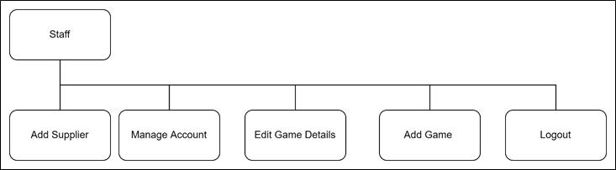

And purchase related part (include cart system, purchase system, review system, validation for some parts, some gui, view report)

Since I have done so many parts, it should be impossible for you guys to complete you own very basic parts, right? Next, the reality slapped me really hard.

### Lee Jian Wen

Largest issue: Does not know how to code… (completely on documentations last semester…)

Proof:

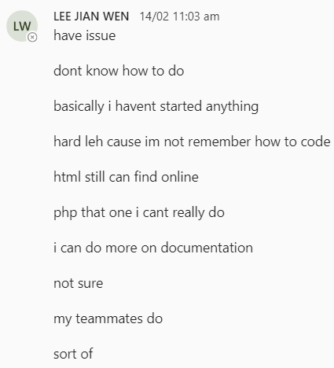

Effect: Which result me (Foong Wai Keat) to complete his overall coding part and parts related with coding such as flowchart, data dictionary, unit testing, code snippets and so on…)

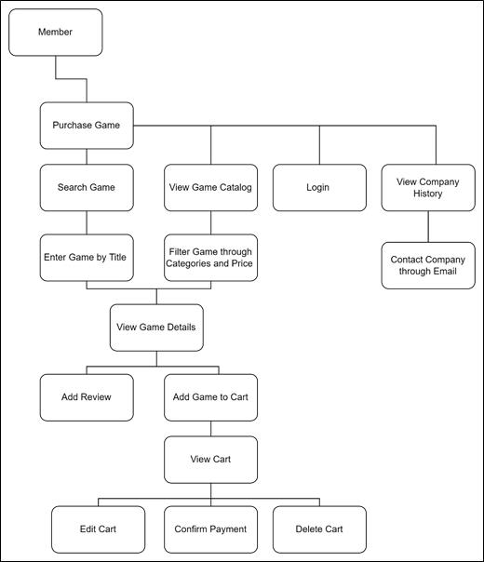

These are the codes which I have to develop… (included in the uploaded sdptest zip file which will be explained later)

However due to unsatisfaction of his introduction, I have modified it overall (about 80-90% as some expectation of system, purpose of system, problem statement and so one is done pretty weird and I am very sure the group does not have the skill to reach the capability of his expectations…

His introduction through some editing by me (not used, at last use my version in the report)

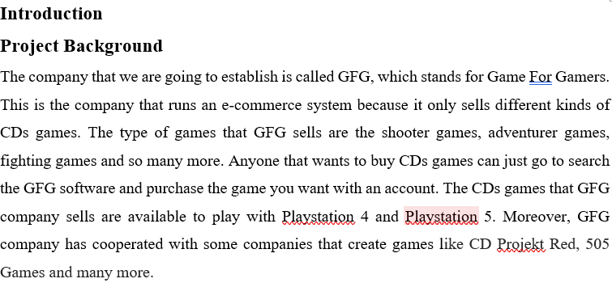

Not bad, very creative, cooperate with other company, but how do we show out GFG company cooperate with other companies, by showing logos of other company, how should the gui be designed? Will we able to complete in time or do we have the skill?

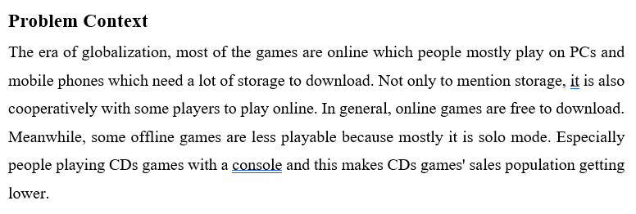

Kindly state out the problem which result the GFG website is required…

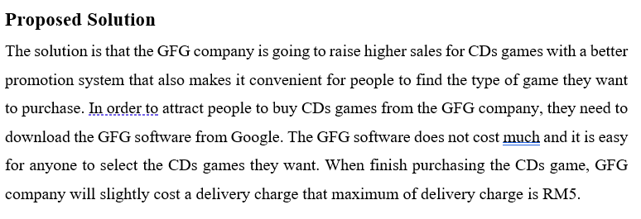

I though the solution should create the GFG website and how the website solves the issues? Users need to pay to download… Who would download the software and there is no purpose of the guest interface…

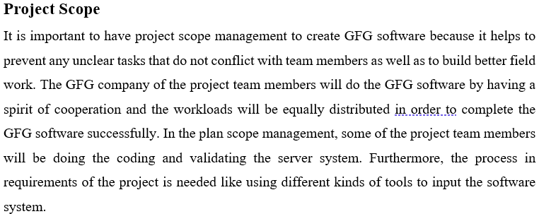

Project scope is what the project should achieve… (why not read the given slides (Recap 1) from lecturer in SDP channel to know what content to write…)

In return, he is assigned with more work on documentations. This includes introduction, methodology, installation guide, some user manual for his part, Gantt chart. Some parts is not fully complete which result me again to complete (lack of installation of GFG system into localhost and wampserver which is completed by me again…)

I am satisfied with his quality for methodology though… (slightly edited by me and him again to add contents and to be different from proposal)



A very rare occasion he did not reply which result me to edit methodology, intoduction and conclusion myself…

And result…

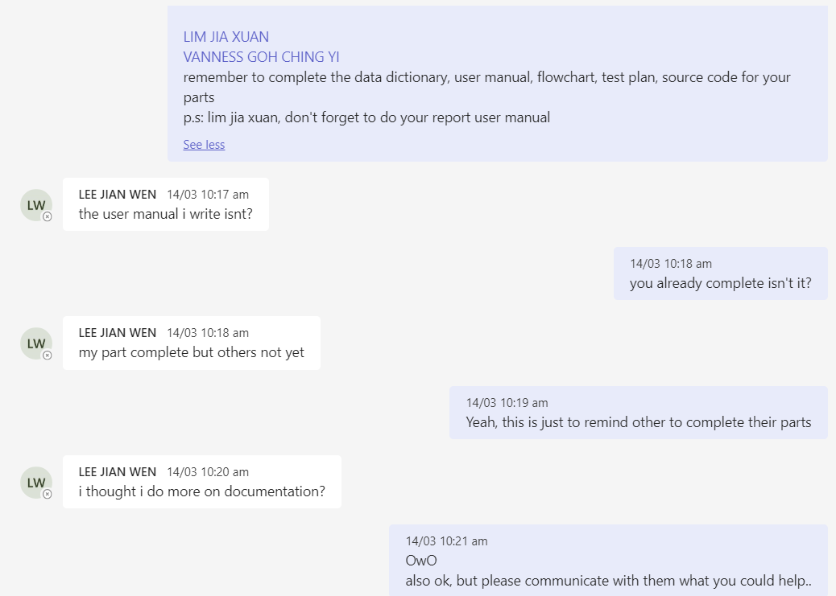

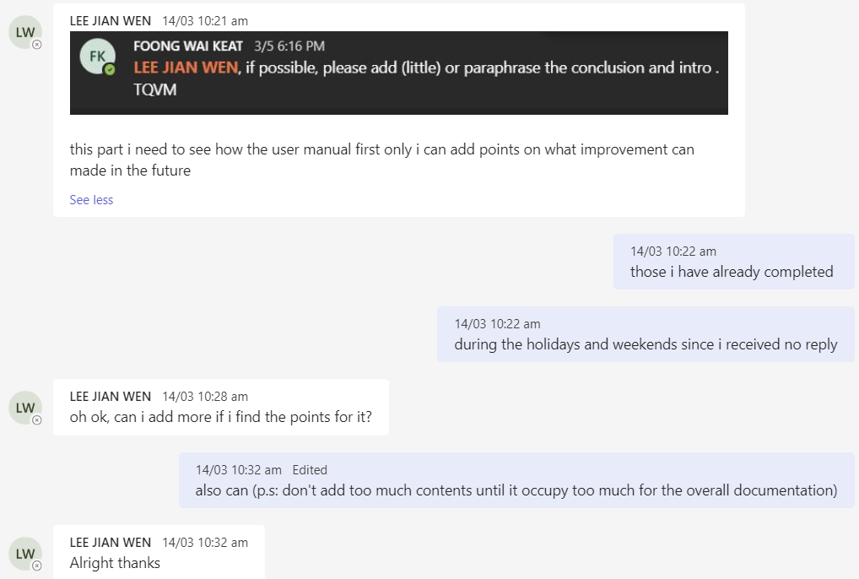

Lastly replied a few days later… (after holiday)

Conclusion:

Overall ok, no big issues with his, will complete work and may response when called (sometimes would not…, but most of the time will (may be affected by rushing time to do other assignments). The quality of work completed may not be stable which results sometimes high quality of work and sometime low quality (may be due to uncertainty of what contents is needed for the part and too busy with other assignments, reasonable…).

Way to improve for his vocabulary and grammar (same goes to me too…)

Please go learn coding or else he is doomed if his internship involves software developing…

### Lim Jia Xuan

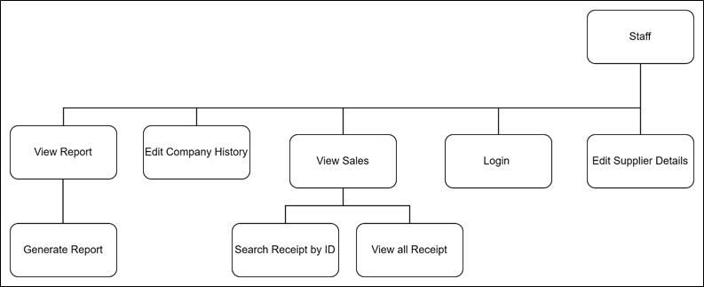

Her coding parts to develop

Can’t understand her…

She have guts to call through teams and cry to me and ask me why complete he part on about end of March (25th) (well, I only help to develop a search feature for her receipt part and ask if she want to implement my version or not, the she called me through teams and ask me why complete her part as say about her efforts on developing the code (whoch takes her 1 week as she say)

But, seriously? My main objective is to complete this system during Chinese New Year holidays… (I have informed in meeting, sadly, the meeting is not recorded…) As I have been asking for countless time abou the progress but no responses… No issues stated either…

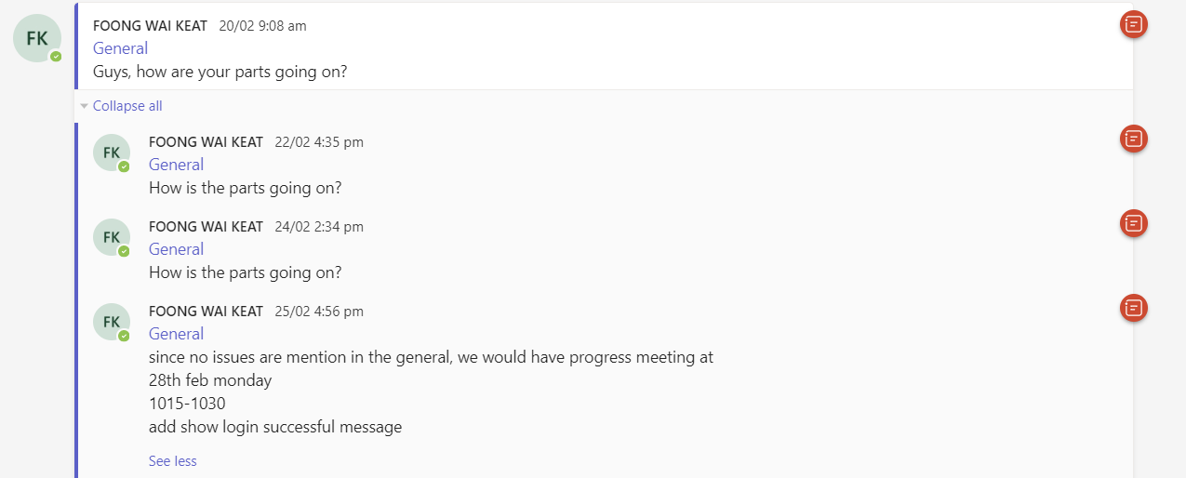

Evidence of not issues informed by anyone…

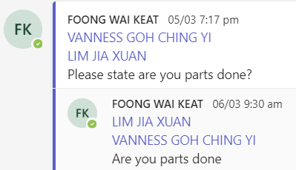

Ignore to report progress

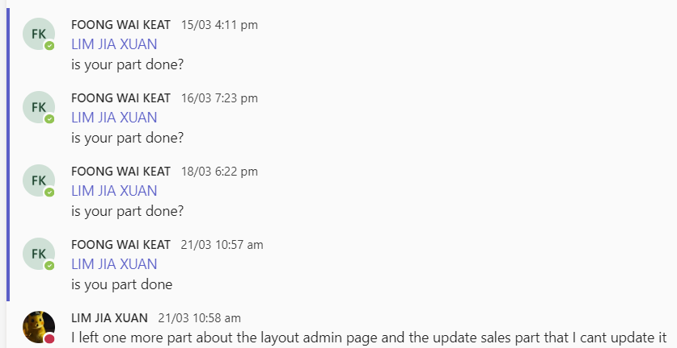

Again ignore…

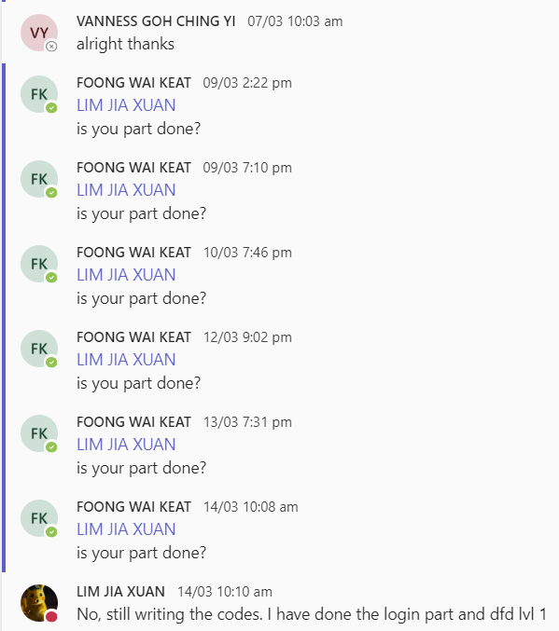

No responses for days…

You serious? Develop login?

Which is already completed by me since February? Why not just try to implement the login.php in the zip file? Like this you would not need to develop code to login… You can have more time to complete your other works…

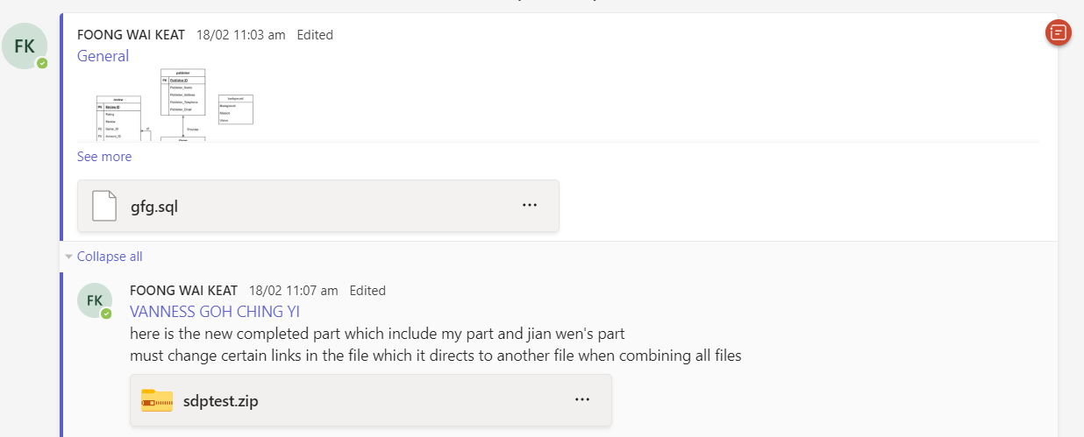

First upload of zip file whiich have some basic function of system (login.php imcluded)

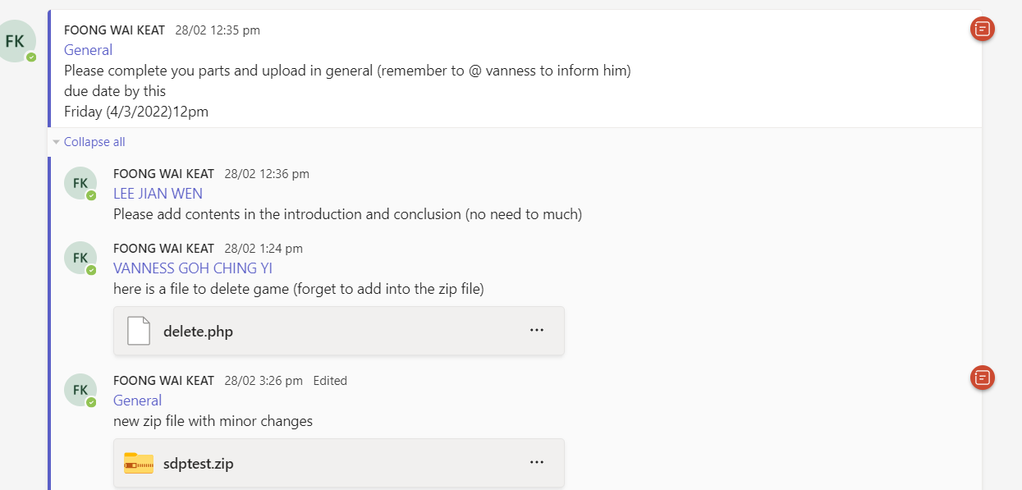

Forced to delay the complete of system from February to March and second upload of zip file which have more basic function of system (login.php included)

Finally start to actively reply after lecturer informed…

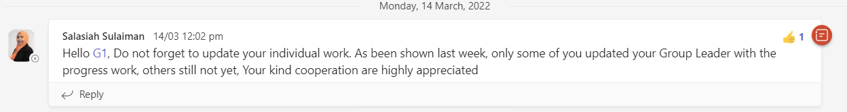

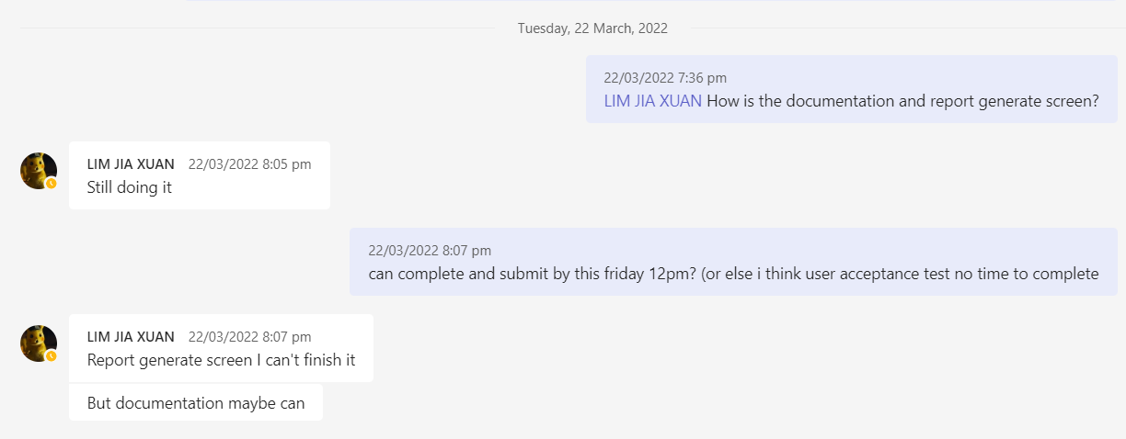

Issue: lack of response, sometimes work lack of quality, very careless…

Coding does not have of validations (all date validations of for viewreceipt.php (features modified by me) and viewreport.php are created by me…(viewreport.php is created by me through viewreceipt.php)

Evidence:

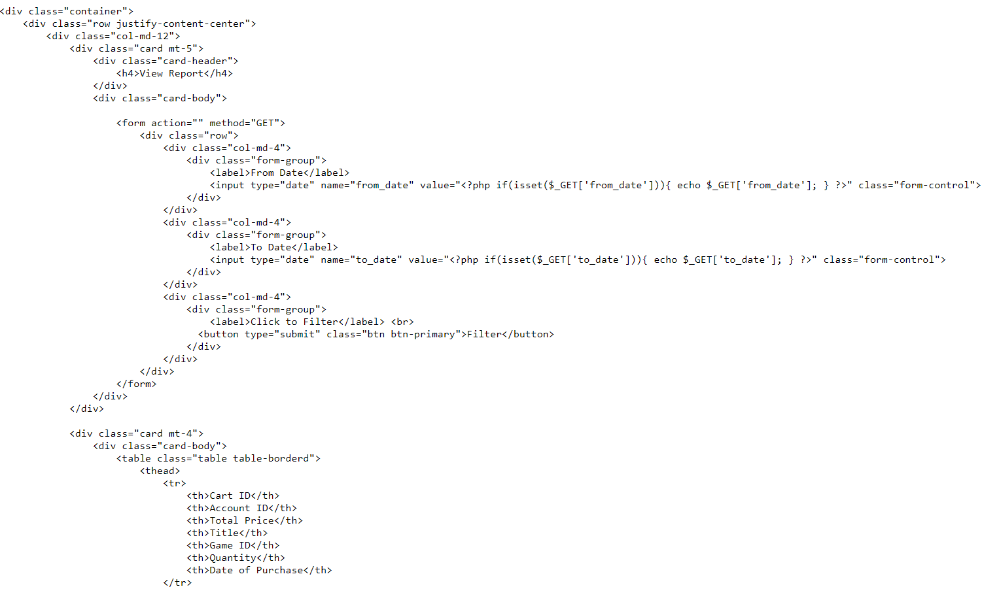

Directly collect date, no validations…

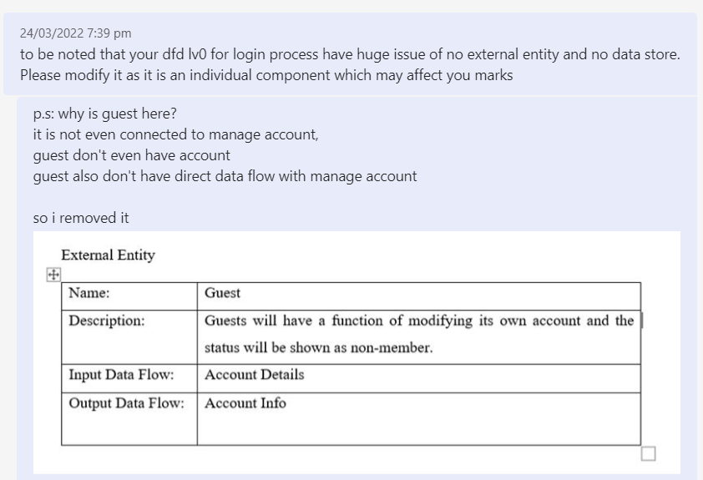

Proof for work lack of quality

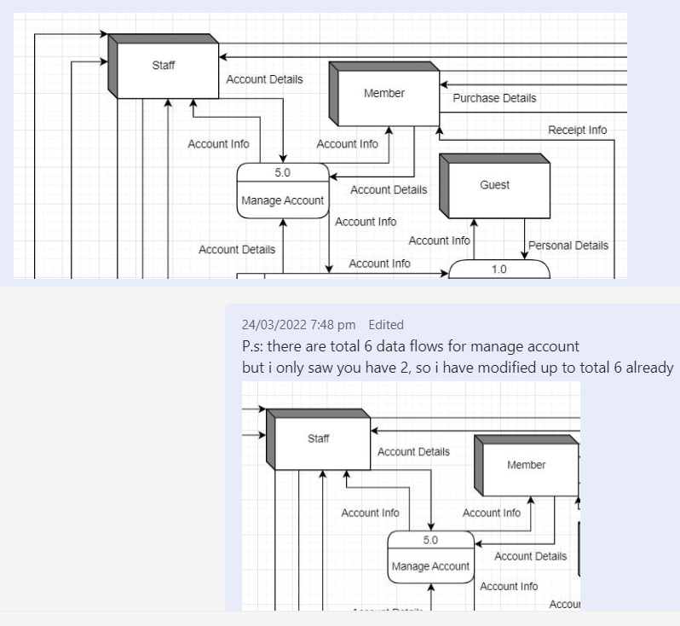

Proof for work lack of quality

Until now net yet edit dfd lv 1 too…

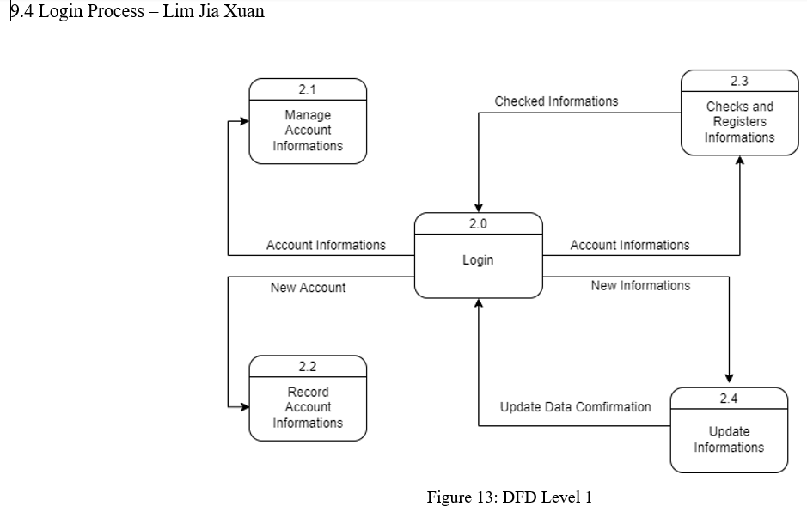

I have to admit there is bad naming from me that for her part to state view receipt, it should be named as” view Receipt”, not “View Sales”.

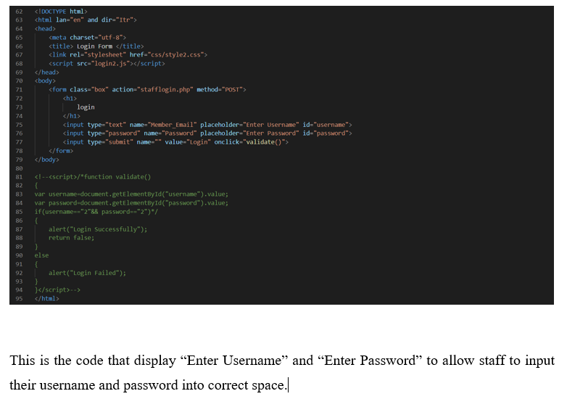

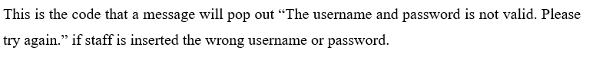I remember we are using email and password, not username and password…

She completed some parts of documentation, this includes, Gantt chart, data dictionary, user manual for her parts, flowcharts for her parts, unit testing for her parts,

(Although quality might be worrying, though most are ok, and fixed by me…)

Overall comment:

Could not understand her, careless, unstable work quality, coding does not have of validations.

At least I could see her effort in active communication, coding and documentation after lecturer had informed in the group. Weak in coding? Please put more effort in coding, prepare a few weeks in advance for your part? Do some research on coding during you free time? Try to complete additional features for coding projects or try to do coding projects during free time. Impressed by her guts, will succeed in future if she put more effort and do more preparations to overcome her weakness in the future.

### Vanness Goh Ching Yi

The major issue for him and me is most probably our different personalities, he is happy go lucky type and very optimistic but I am setting up objectives and plannings, very serious type and pessimistic due to past assignment experience (assignment submission on 11:38 pm due to teammate).

His part

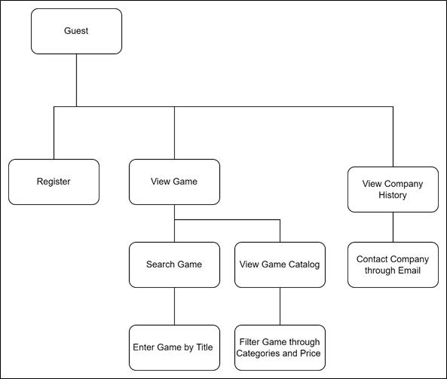

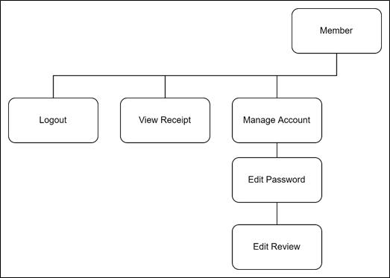

Issue: lack of reply, delay submission, poor quality of work

Evidence for late reply and delay submission:

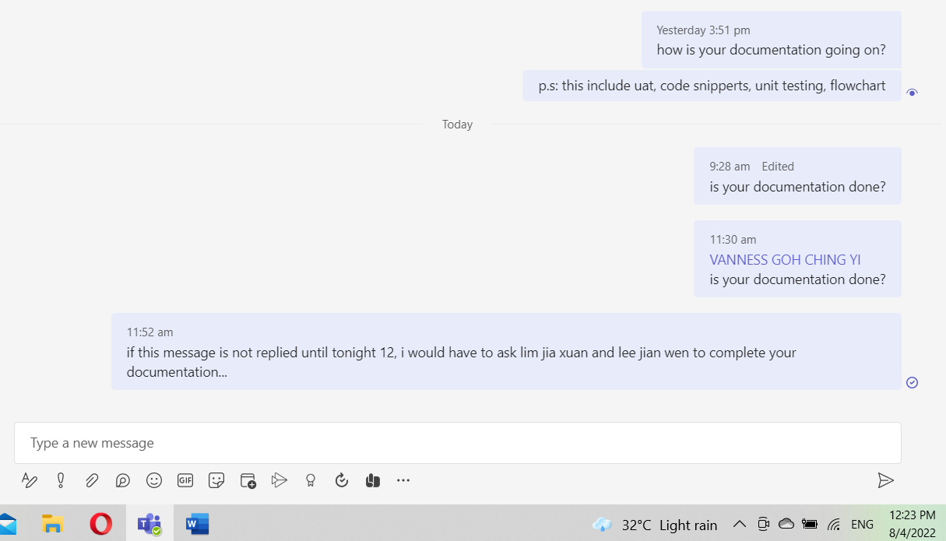

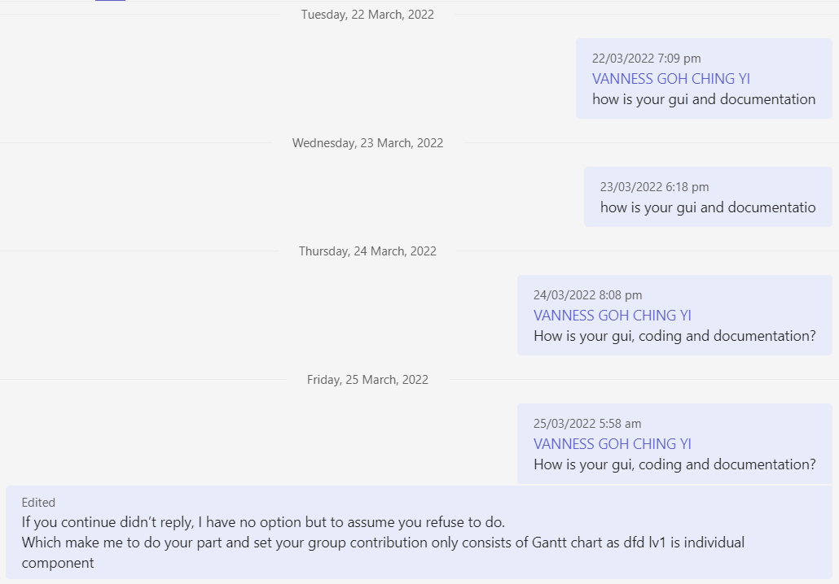

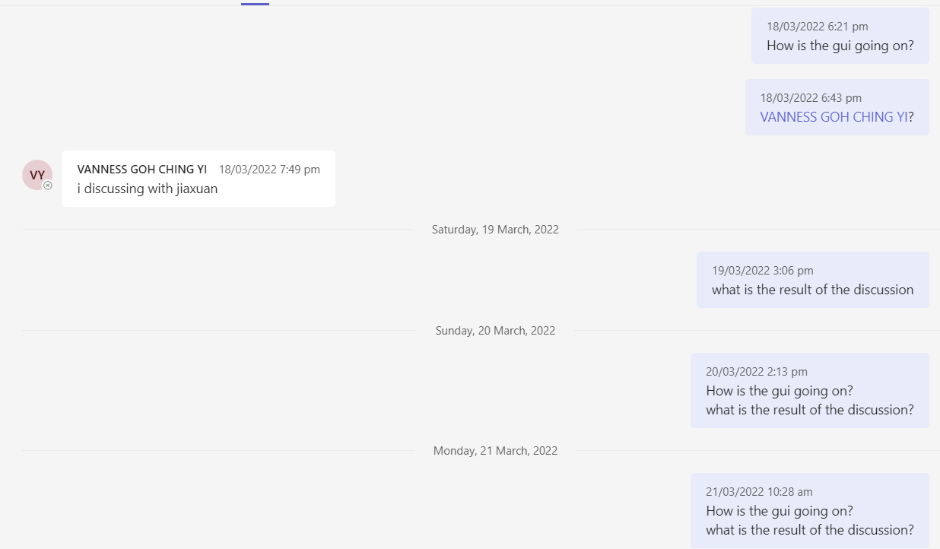

There is too much of evidence he did not reply which I had enough of counting them…

Link to channel to view more:

<https://teams.microsoft.com/l/channel/19%3aitz8e9qp_70jwwaqdgotqnfqjwyqczi25sc4a9n9y9a1%40thread.tacv2/General?Groupid=c723cace-0dad-4a9e-91aa-1aac5b51e82b&tenantid=0fed03a3-402d-4633-a8cd-8b308822253e>

Terrible behaviour (for me)

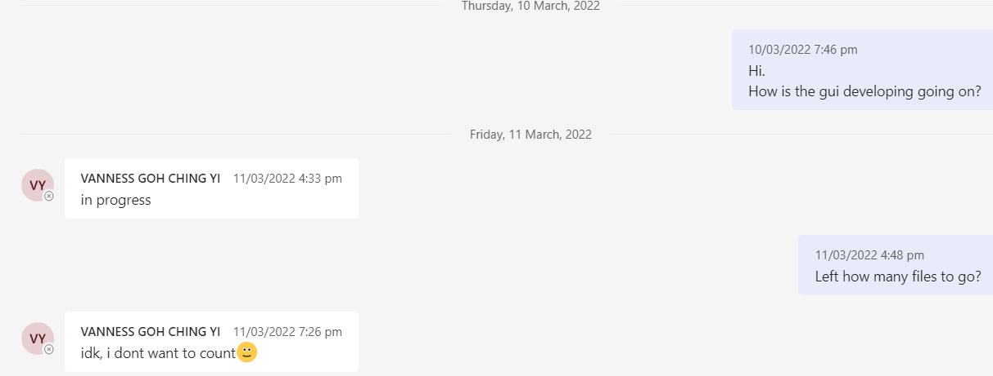

Serious? It would only take about 5 minutes at most for your 100 years life to count and reply me… You do not look like people who will sleep as early at 7 pm as you would normally view my message on midnights. I could not tolerate with this attitude…

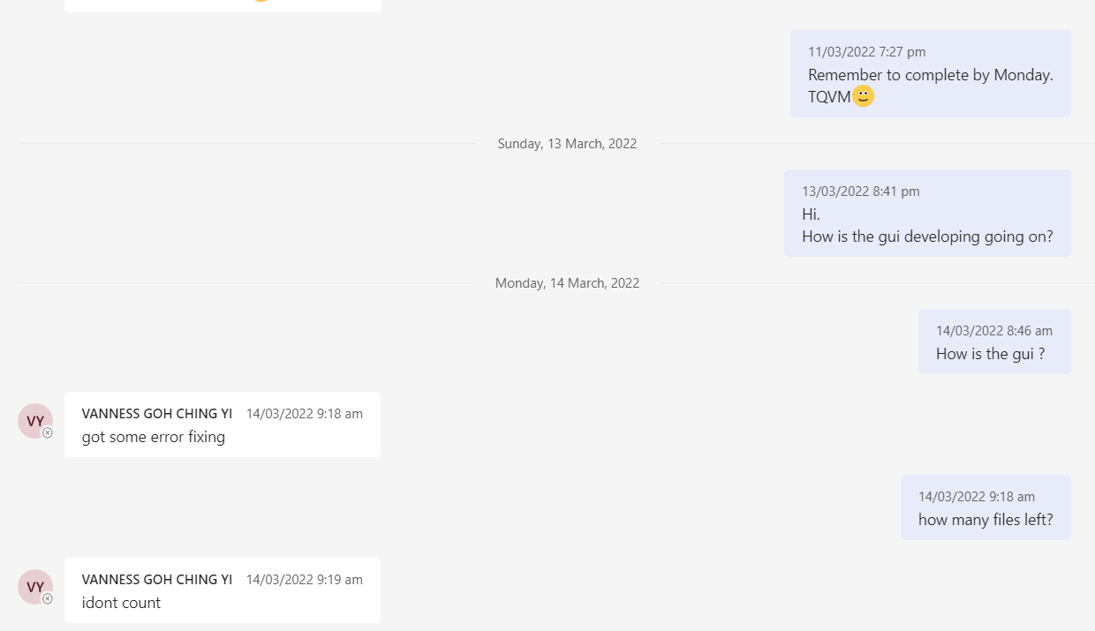

Another evidence of terrible attitude…

Part of reason for delayed work is due to late complete of code by lim jia xuan but he is responsible too… Though I think he has overdone the gui for the system, no need to be so special, all I need is just some buttons in regular shapes…

Until 10 th April he has not complete all of his documentations…

I have no idea what he is onto since February as i have already provided my code since February with sdptest.zip.

His product is not very satisfying as most of the system background are too white in colour… And he did not do any improvements for gui for some screen until I informed him…

His edit profile is not include change address and bank card number feature for members which result me to complete these features in 10th April 2022..

Also, I have to complete his documentations (unit testing, code snippets, unit testing, flowchart on 9th April as he keeps on saying he is progressing since start of April but I didn’t see any progress certain parts on the document until 10th April)

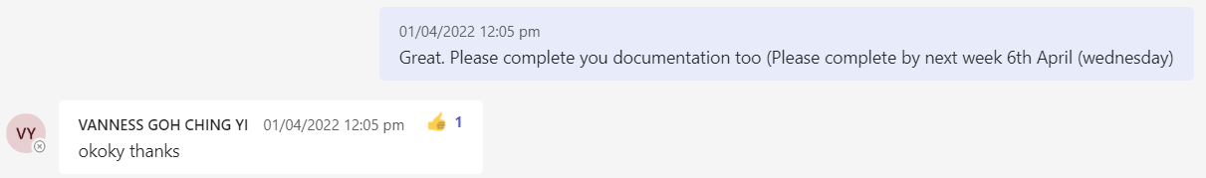

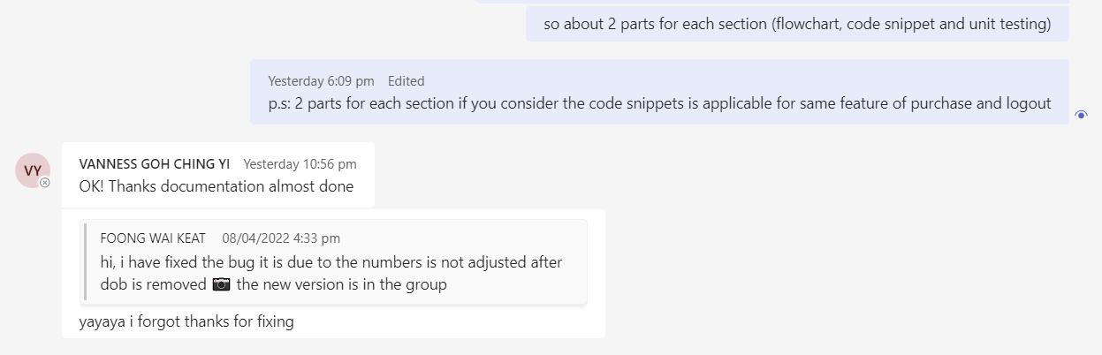

Poor quality of work

I believe you have witness his terrible flowchart…

He completes part of the coding, user acceptance testing, flowchart, unit testing, but with weird and poor quality as he did not use the format or example provided by lecturer.

On 9th April, I found out he did not provide address editing features for member which make me to do it for him as he could not be contact easily on daytime.

To add on, I did not apply his version of unit testing as it is horrible… (his flowchart is horrible too…)

So, I have to apply my version which refers user acceptance test provided by lecturer, do unit testing and other parts he did not do (user manual, code snippets and so on myself.)

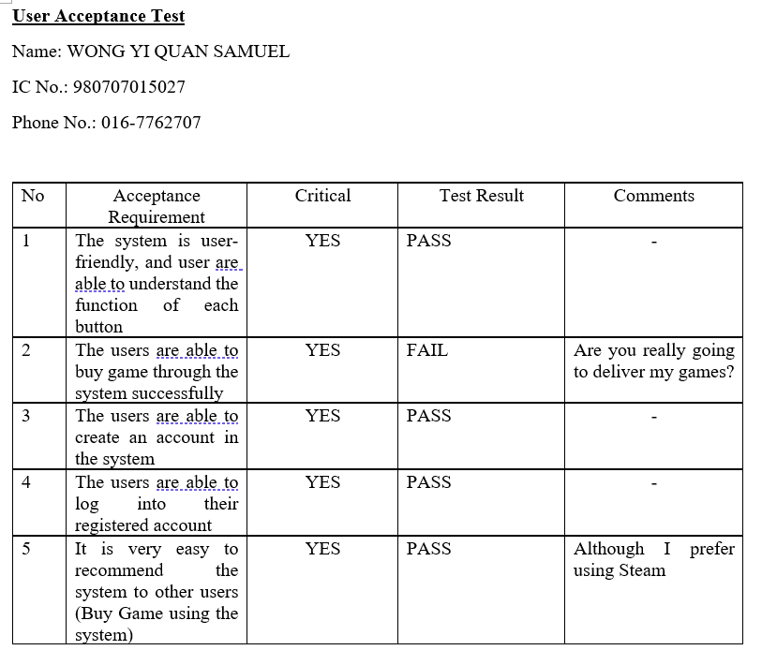

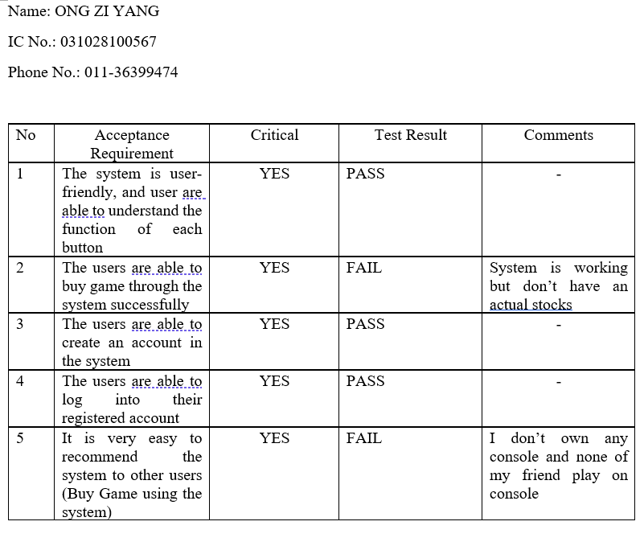

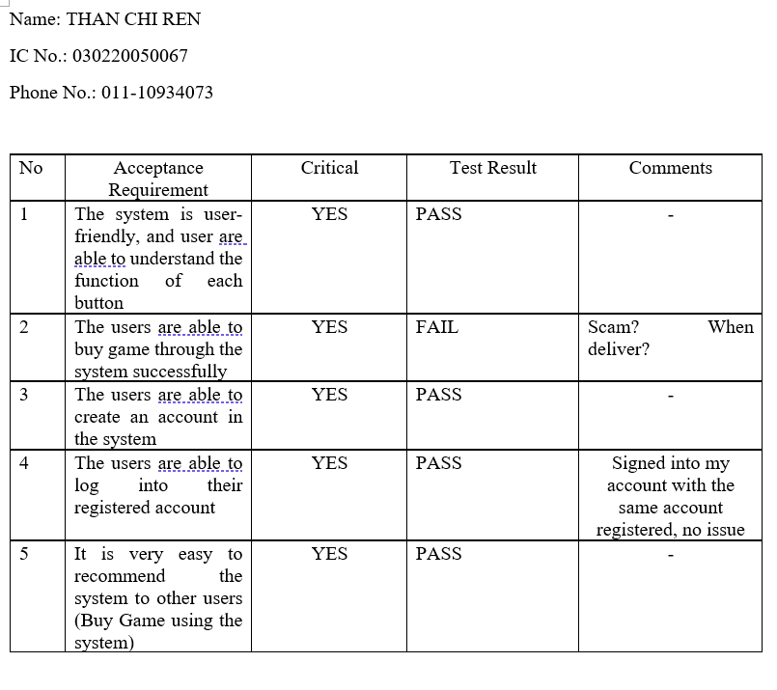

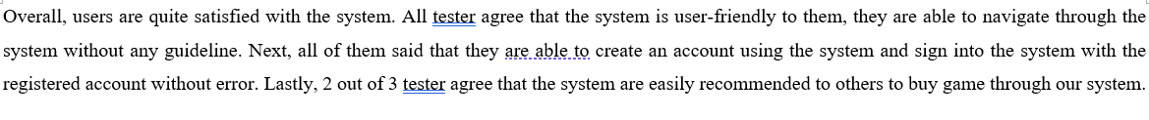

Unit testing (vanness)

|  |  |  |  |  |  |  |  |
| --- | --- | --- | --- | --- | --- | --- | --- |
| Test Case | Test Unit | Test Procedures | Test Data | Expected Result | Actual Result | Status | Remarks |
| 17  (vanness) | View Receipt | 1. Login As [ali@mail.com](mailto:ali@mail.com), with password 123456 | Email: [ali@mail.com](mailto:ali@mail.com), Password: 123456 | Logged as Ali | Logged as Ali | Pass | - |
| 1. Click Account Icon | - | Menu Pop up | Menu Pop up | Pass | - |
| 1. Click Order | - | Receipt Shown, FIFA 2022 & Battlefield 1 shown with Quantity of 1 | Receipt Shown, FIFA 2022 & Battlefield 1 shown with Quantity of 1 | Pass | - |
|  |  | 1. Login As kayaball, with password kayaball | Email: kayaball, Password: kayaball | Logged as kayaball | Logged as kayaball | Pass | - |
|  |  | 1. Click Account Icon | - | Menu Pop up | Menu Pop up | Pass | - |
|  |  | 1. Click Order | - | Receipt Shown, 1 FIFA 2022 & 2 Battlefield 1 & 1 Dying Light 2 shown | Receipt Shown, 1 FIFA 2022 & 2 Battlefield 1 & 1 Dying Light 2 shown | Pass | - |

|  |  |  |  |  |  |  |  |
| --- | --- | --- | --- | --- | --- | --- | --- |
| Test Case | Test Unit | Test Procedures | Test Data | Expected Result | Actual Result | Status | Remarks |
| 18 | Customer Manage Account | 1. Login As [ali@mail.com](mailto:ali@mail.com), with password 123456 | Email: [ali@mail.com](mailto:ali@mail.com), Password: 123456 | Logged as Ali | Logged as Ali | Pass | - |
| 1. Click Account Icon | - | Menu Pop up | Menu Pop up | Pass | - |
| 1. Click Account | - | Account Information Shown | Account Information Shown | Pass | - |
|  |  | 1. Edit Name 2. Enter New Name 3. Enter Password | Name: ali abu Password: 123456 | Name changed into ali abu | Name changed into ali abu | Pass | - |
|  |  | 1. Edit Phone Number 2. Enter New Name 3. Enter Password | Phone Number: 0143135088 Password: 123456 | Phone number changed into 0143135088 | Phone number changed into 0143135088 | Pass | - |
|  |  | 1. Edit Password 2. Enter Current Password 3. Enter New Password 4. Confirm Password | Email: ali abu Password: 123456  New Password: 123 | Password changed into 123 | Password changed into 123 | Pass | - |
|  |  | 1. Edit Email 2. Enter Current Email 3. Enter New Email 4. Enter Password | Current Email: [ali@mail.com](mailto:ali@mail.com)  New Email: [aliabu@mail.com](mailto:aliabu@mail.com)  Password: 123456 | Email changed into [aliabu@mail.com](mailto:aliabu@mail.com) | Email changed into [aliabu@mail.com](mailto:aliabu@mail.com) | Pass | - |

However, he has done an impressive job for coding in navbar,php. His navbar has customersession included which makes customer session is not required to be inserted for all member files. To add on, I am very impressed with his design and structure of edit account. He is capable to build and interface to show the account profile while edit profile in a similar screen! I did not though of this idea before due to limited coding skills… Moreover, he makes members must enter password to change profile details. (However, I do not focus too much on profile screens which result me to feel he does not contribute too much on assignment…)

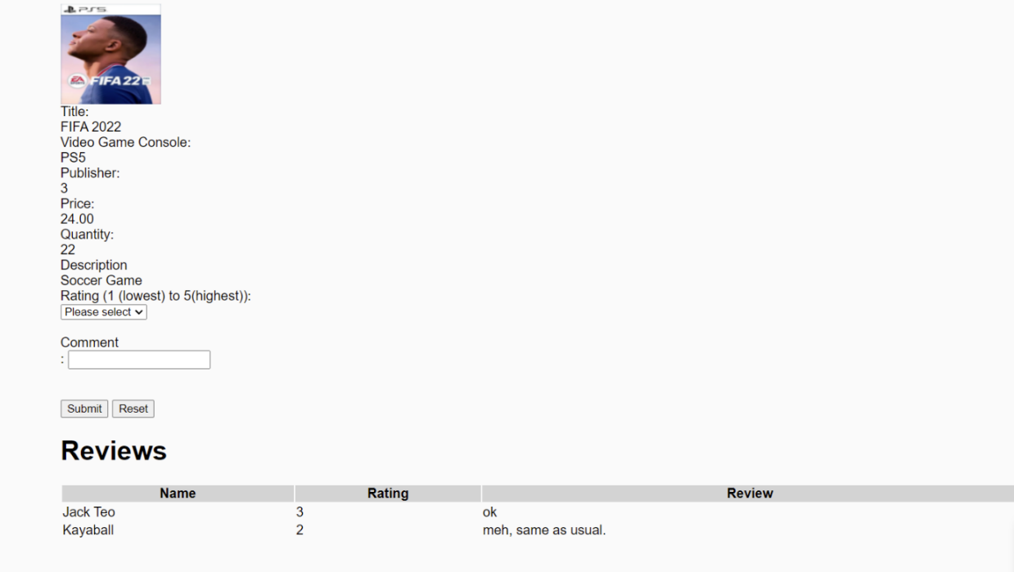

Serious, since February you did not make it place at centre???

Lastly have to be done by me… On 7th April and he add into the system (same day)

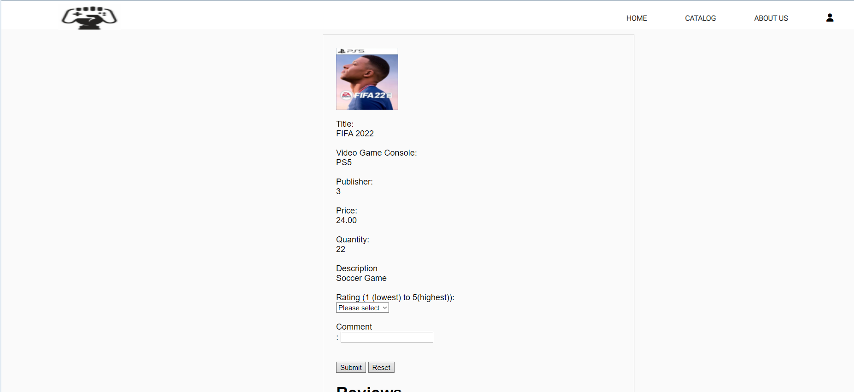

He have guts to convince me to give everyone 25% for contribution only because this is last semester.

When I ask why not only fill in 25% for group effort and other remain same, he said it is to make lecturer to mark easily, please change the other parts too and said the percentage for other parts is only a decoration which will not affect, it does not matter the overall marks. When I ask since it is a decoration only, why not keep it same? He could not reply. He said he have confirmed with miss but did not show any photos as evidence which makes me feel suspicious. The when I ask what have been doing since February while I have been busy with the assignment, he said other would need to spend time with their family members, not everyone like me. This totally makes me unacceptable, I also had to minimize time spend with family too. What did he think I am? A tool only to complete all assignment and give credits to those who are lazy, less contributions? He even have guts to convince me to give equal marks as I have learned may things due to this assignment.

Lastly, he could only plead me to give everyone marks to pass for the last semester.

He also always demands to have meeting which I see there is no meaning for meeting as everyone is clear with their tasks with the system hierarchy chart and knows what their parts will involve with others’ parts with the dfd lv 0 diagram. Serious? A dfd diagram is used to enable you to understand the system and you tell me you can’t understand the system? Which has clearly stated which part will interact with which part and what is the data flows through it. The content of the data is understood with erd. The data flow of erd could help you to understand interactions between parts. If have time to do meeting, better use time to do assignment as it is not easy for everyone to find time to gather a pointless meeting.

I could, but for lee jian we only due to lee jian wen as he does not know coding while other knows and the attitude of not replying, refuse to reply his progress in March (in dragram above), low quality of work (the screen above), late completion of work (not yet complete and no reply on 9th April about his documentation).

At least please learn lim jia xuan, active reply and complete coding and documentations days before submission or like lee jian wen who have actively reply and state his issue early in march and allow me to do early preparations. Not disgusting me with concept of only because this is last semester or to help lecturer mark easily. Last semester no need to do assignment? Can have bad attitude? No need to response, no need to report progress? Well, in that case I can tell you I am ready to help you fail in last semester with 0 contributions.

Luckily, he really completes the system by 7th April (actually is on 6th April although have certain bugs as he is implementing my old erd in February, my mistake (I though he used the new erd which I send in general in March).

Though he has not completed his documentations on 9th April.

Conclusion: Please improve your behaviour, attitude and try not have contact with me next time after causing all sort of troubles, making me to complete the backup GFG system for assignment submission, dreaming of incomplete assignments, dreaming of helping other to develop code, dreaming of fixing other’s documentation and code errors, dreaming of Vanness to reply me that he have complete the system and documentation for 2 whole months (yes, it happens). By the way, I think he put too much effort on coding and parts (especially on member profile which is very impressive for me, but I do not prioritize much on member profile screen) and result me to feel he does not put sufficient effort however he does. Nice talking skills though.

P.s: Please give them at least a pass as this is their last semester although some members caused me a lot of troubles but most of them are really putting effort for the assignment by willing to communicate, reply actively and completing the assignment in both coding and documentation when almost assignment due date.

Thank you for viewing all these grumbling from me about issues since February to April.